Rproduced analysis of FARS data

**Results**

**Percentages of drivers testing positive by drug type, sex, and year group**

|  |  |  |  |  |  |  |
| --- | --- | --- | --- | --- | --- | --- |
| Drug type | F 1999-2002 | F 2003-2006 | F 2007-2010 | M 1999-2002 | M 2003-2006 | M 2007-2010 |
| Alcohol | 26.4 | 24.3 | 27.1 | 43.2 | 42.9 | 43.3 |
| Cannabinoid | 2.8 | 5.8 | 7.4 | 6.0 | 10.7 | 12.2 |
| Depressant | 3.5 | 3.9 | 4.9 | 2.0 | 2.5 | 3.2 |
| Narcotic | 4.3 | 5.0 | 7.3 | 2.2 | 3.4 | 4.0 |
| Other | 5.8 | 6.8 | 7.5 | 4.4 | 4.6 | 4.3 |
| Stimulant | 7.3 | 9.3 | 8.9 | 10.7 | 12.3 | 9.5 |

**Figure 1**: Prevalence of nonalcohol drugs in fatally injured drivers by year and age group

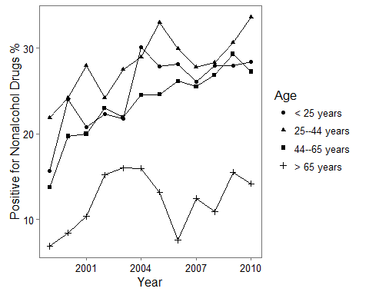 *Figure 2: Prevalence of nonalcohol drugs in fatally injured drivers by year and drug type* 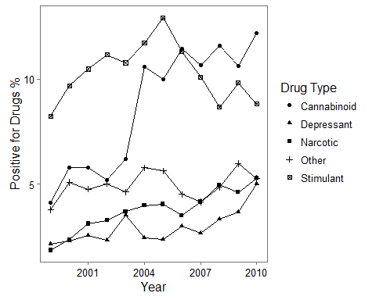 **Figure 3: Prevalence of cannabinoid drugs in fatally injured drivers by year and age group**

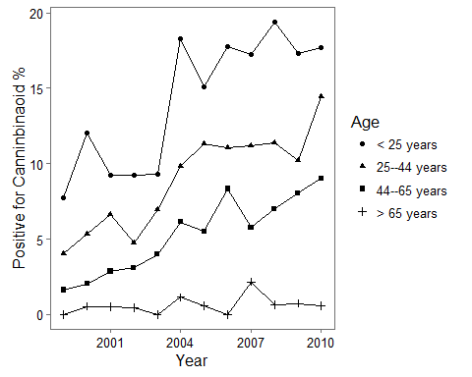 **Figure 3. Prevalence of drugs in fatally injured drivers for 1999 and 2010 by drug type**

|  |  |  |
| --- | --- | --- |
| Drug type | 1999 | 2010 |
| Alcohol | 38.7% (36.5%,40.9%) | 39.1% (36.7%,41.5%) |
| Cannabinoid | 4.1% (3.2%,5.1%) | 12.2% (10.5%,13.8%) |
| Depressant | 2.2% (1.5%,2.8%) | 5% (3.9%,6.1%) |
| Narcotic | 1.9% (1.2%,2.5%) | 5.3% (4.2%,6.4%) |
| Other | 3.8% (2.9%,4.7%) | 5.3% (4.2%,6.4%) |
| Stimulant | 8.2% (6.9%,9.5%) | 8.8% (7.4%,10.2%) |

**Statistics for testing for trend in prevalence of drugs over study years by drug type using Cochran-Armitage trend test**

|  |  |  |
| --- | --- | --- |
| drug | Z | p.value |
| Alcohol | 1.21 | 0.227 |
| Nonalcohol | 11.52 | 0.000 |
| Narcotic | 6.81 | 0.000 |
| Depressant | 4.85 | 0.000 |
| Stimulant | 0.35 | 0.724 |
| Cannabinoid | 13.75 | 0.000 |
| Other | 1.45 | 0.146 |

**Statistics for testing for trend in prevalence of drugs over study years by drug type using Wald test of logistic regression coefficient for "year"**

|  |  |  |
| --- | --- | --- |
| drug | Z | p.value |
| Alcohol | 1.21 | 0.227 |
| Nonalcohol | 11.50 | 0.000 |
| Narcotic | 6.77 | 0.000 |
| Depressant | 4.83 | 0.000 |
| Stimulant | -0.35 | 0.724 |
| Cannabinoid | 13.62 | 0.000 |
| Other | 1.45 | 0.146 |