#### PASSGEN

#### User Interface Description

# Table of Contents

Table of Contents 2

Version Information 2

Introduction 3

About this document 3

Structure and Navigation 4

Navigation 4

Issues 6

## Version Information

Version 1.0 APR 8, 2024  
Version 1.1 APR 21, 2024

# Introduction

This document describes the User Interface for the PASSGEN Application.

## About this document

The remainder of this document is divided into the following sections:

* *Structure and Navigation* describes the application's structure and how users can navigate it.

# Structure and Navigation

The overall structure of the application is relatively simple, as shown in the following diagram.

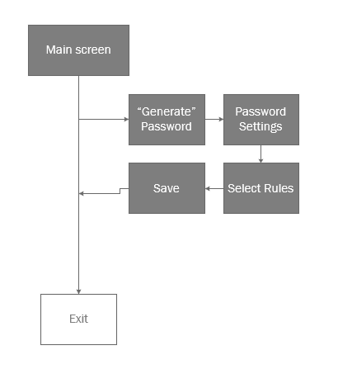

The application has four primary elements, which may be accessed directly from the home screen.

## Navigation

Within the application, a stacked button layout provides primary navigation on the home screen.

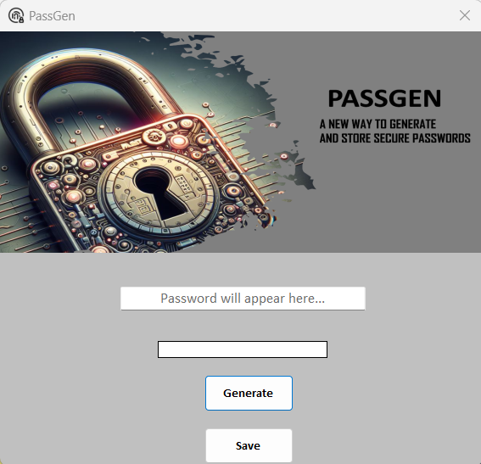

The “Generate” button brings up the password settings where users can select rules to enforce when generating a random password.

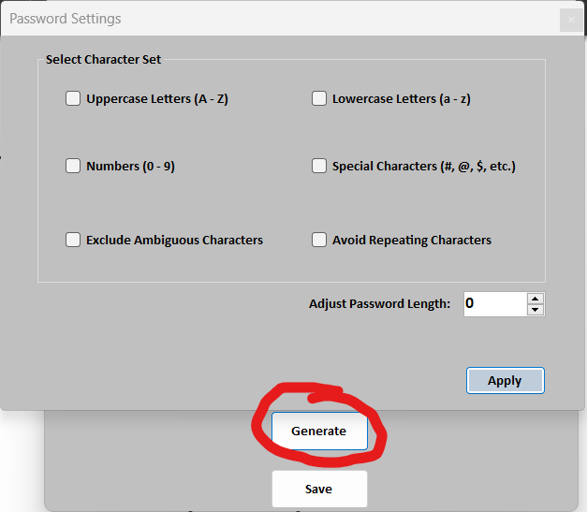  
Pressing “Apply” once rules are selected will bring users back to the home screen, where the generated password and determined password strength will be displayed.  
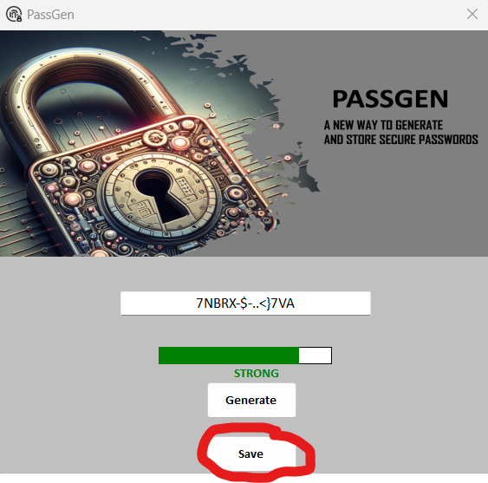  
Users can now save the password, and encryption will occur.

## 

## Issues

1. The application is still in development, and passwords cannot be fully saved. Integration with a database will soon take place to enable the feature.