Iteration 1
Goals:
- Display standards for VSC and CC in their proper hierarchy
- Let user select State/Grade

Grade | K | 1 | 2 | 3 | 4 |  | 5 | 6 | 7 | 8
State | Maryland VSC |  |  |  |  | Common Core

Standards
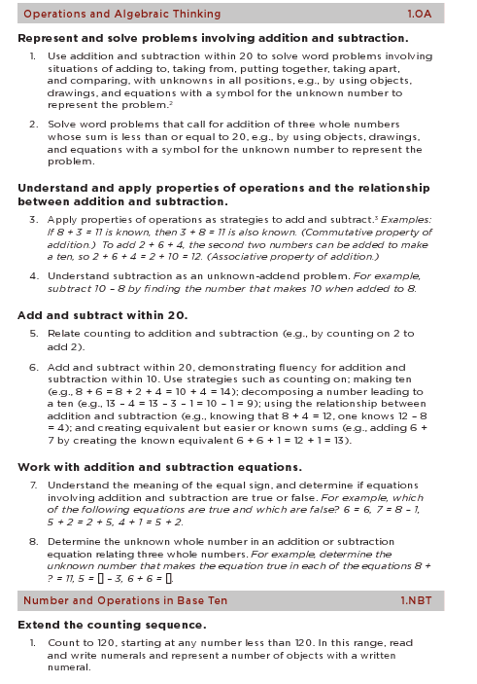
Iteration 2
Goals:
- Compare CC to VSC and vice versa
- Add type of alignment: equal to, greater than, or less than.
- Enable admin rights to add/delete related standards
Note about alignments:
- An alignment can have more than one standard.
- An alignment needs to work both directions—CC to VSC and VSC to CC
- An alignment has a type and a note to explain.
- Possible types are: perfect alignment, almost alignment with a note

Grade | K | 1 | 2 | 3 | 4 |  | 5 | 6 | 7 | 8
State | Maryland VSC |  |  |  |  | Common Core
View | Just VSC |  |  |  |  | VSC to Common Core

Standard 1.0 Knowledge of Algebra, Patterns, and Functions
- Patterns and Functions
  - Identify, describe, extend, and create numeric patterns
- Represent and analyze numeric patterns using skip counting by multiples of 2 and 10 starting with any whole number, and using manipulatives and the 100 chart | 2.NBT.2  Count within 1000; skip-count by 5s, 10s, and 100s.
- Represent and analyze numeric patterns using skip counting backward by 10s starting with a multiple of 10, and using manipulatives | 1.NBT.5  Given a two-digit number, mentally find 10 more or 10 less than the number, without having to count; explain the reasoning used.
2. Identify, copy, describe, create and extend non-numeric patterns
- Represent and analyze growing patterns kinesthetically such as: clap/snap, clap/snap/snap, clap/snap/snap/snap, … | Not in Common Core
- Represent and analyze repeating patterns using no more than 3 different objects in the core of the pattern | Not in Common Core
- Transfer a repeating pattern from one medium to a different medium using no more than 3 different objects in the core of the pattern | NOTE: In the VSC, students need to learn 4 different objects  1.NBT.5  Given a two-digit number, mentally find 10 more or 10 less than the number, without having to count; explain the reasoning used.
- Identify patterns in real-world situations | Not in Common Core

