Scott Morris

TAFEID: Scott.Morris3

ICTWEB431

Assessment 1: Project

**Task 1**

**Development Timeline**

The client has indicated that the timeframe for this project is four weeks. The initial estimated time to complete all the tasks is approximately 4.5 hours. University projects and/or my job are going to take up a large portion of my day during the week and may only allow me about 1 hour during this period but on the weekends I would expect up to 3 hours could be completed per day. This should allow me to complete the project with a generous amount of extra time to spare. The table below takes all these factors into account and displays the schedule that I would want to abide by.

|  |  |  |
| --- | --- | --- |
| Date | Tasks Requiring Completion (Expected Completion time) | Personal Workload |
| Tuesday 9th June | * Development timeline (10 mins) * Build Sitemap (25 mins) | * Typing Course (60 mins) * Football Training (120 mins) * University (450 mins) |
| Wednesday 10th June | * Build wireframe (20 mins) * Develop tests (15 mins) * Discuss mark-up choice | * Basketball (60 mins) * Java course (60 mins) * University (540 mins) |
| Thursday 11th June | * Identify and write down the client needs (10 mins) * Write a script for the video (5 mins) * Film the interview (5-10 mins) | * Personal workout (60 mins) * Typing course (60 mins) * University (360 mins) |
| Friday 12th June | * Build the basic structural elements of the index page (10 mins) * Develop the other pages (at least two) in the sitemap (10 mins) * Add images to the pages (5 mins) * Add content into each page (10 mins) | * Job (540 mins) * University (120 mins) |
| Saturday 13th June | * Style the page using CSS (15 mins) * Test in Chrome and Firefox (5 mins) * Correcting issues and documentation (15 mins) | * Job (540 mins) * Java course (60 mins) * Typing course (60 mins) |
| Sunday 14th June | * Develop script for website hand over (15 mins) * Record hand over video (10 mins) | * Basketball (60 mins) |
| Monday 15th June | * Correct the error in the webpage (30 mins) | * University (540 mins) * Typing course (60 mins) |

**Sitemap**

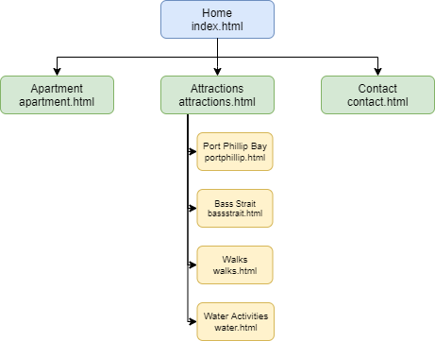The following sitemap was developed in order to meet the client’s specifications. It includes a home and contact page as per the specifications but also has attractions and apartment pages in order to show off more of the uniqueness that the clients are trying to push for in terms of activities and the living space.

**Wireframe**

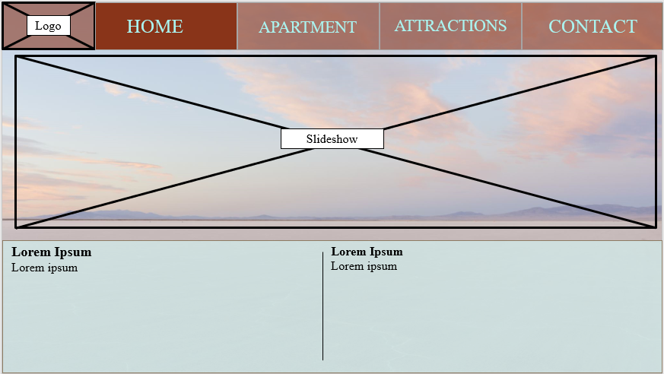The wireframe for the home page was initially developed and is shown below. A light colour scheme and minimalistic design was chosen to appeal to the user and convey the light-hearted and relaxed nature of the setting at Serrento by the Sea.

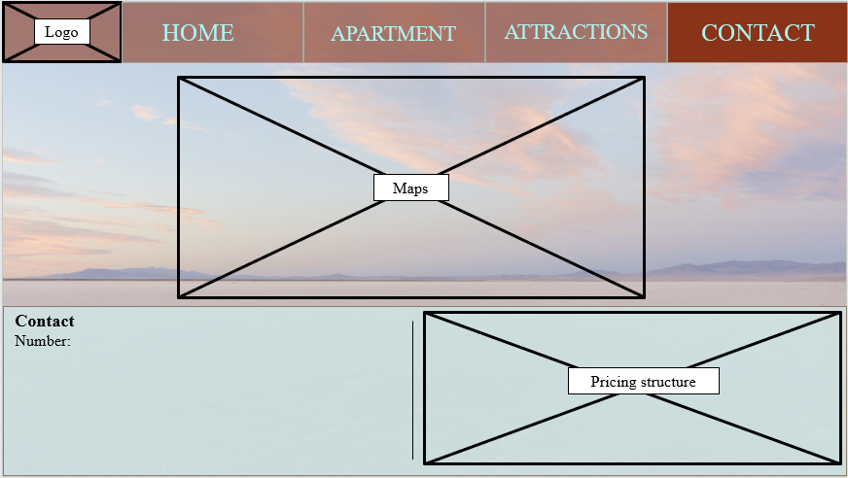The contact page was also put into a wireframe. The dominant feature would be the map in order to emphasise the location which was what the client specified. A similar style to the home page was retained to produce some continuity in the site navigation.

**Testing and debugging**

Our testing approach will be based around a few key areas; functionality, compatibility, and usability. The functionality of the website is most important, if the user cannot click links and explore what the apartment has to offer then the main purpose of the site is void. Secondly, the usability of the site will be tested as this will determine what information comes first to the user. As discussed previously we want to highlight the features that make Sorrento by the Sea standout and this will be important when testing usability. Finally, we want to test compatibility as we do not want to restrict the users from entering the site.

|  |  |
| --- | --- |
| **Focus Area** | **Test Case** |
| Usability | No spelling or grammatical errors in the page |
| Usability | Font in body and headings should be as specified |
| Usability | Formatting should be as specified |
| Usability | All navigation links should be displayed |
| Usability | Images should be displayed |
| Usability | Scroll bar should function properly |
| Compatibility | Ensure website displaying correctly in Chrome |
| Compatibility | Ensure website displaying correctly in Microsoft Edge |
| Functionality | Ensure all pages are displaying |
| Functionality | Test that all links redirect to the correct pages |
| Functionality | Make sure browser runs with enabled and disabled cookies |
| Functionality | Validate the HTML5 code |

**Mark-up language**

The mark-up language we will be using to create this website will be an HTML which is a SGML. The main focus of the website would be the information and images that we are displaying, and the appearance can be modelled to the content and can be adapted if needed. The website would not need to use a more complex DHTML but the flexibility that an SGML offers would allow creativity with the website in order to capture the attention of potential guests.

**Part 2**

**Identify and refine client requirements**

*See https://youtu.be/10dLKM49fFg*

**Part 3**

**Creating and styling the website**

*See Part3SbtSWebsite file*

**Part 4**

**Testing and validation**

The testing areas that we constructed in a previous segment are listed below. In an additional column we have created a space to describe our testing results, including screenshots where relevant.

|  |  |  |
| --- | --- | --- |
| **Focus Area** | **Test Case** | **Results & Explanation** |
| Usability | No spelling or grammatical errors in the page | All text has been previously interrogated by a spell checker. A dedicated tester was tasked to oversee that all text was grammatically correct. Various testers (at least 5) have used the page in its entirety, one of their focuses being checking for grammatical errors |
| Usability | Font in body and headings should be as specified | In the CSS file, the overarching font is specified as Helvetica (as requested). The body command will override any more specific changes in font (of which there are none).  In terms of headings the following font (and other aesthetic features were specified and integrated into the website.    When comparing the results on the actual website, this can be confirmed. |
| Usability | Formatting should be as specified | Other formatting features apart from font were also included.    Here is an example of the other major specifications made by the client. The full list of styling choices can be seen in the *homestyle.css* file. |
| Usability | All navigation links should be displayed | The title bar displays as shown in the image above. This clearly shows that all 4 pages are represented simply in the title bar. Hence this condition was met. |
| Usability | Images should be displayed | All images were examined by various testers at multiple stages throughout the process. Two examples are shown and more can be viewed by displaying the website.    The slideshow that was proposed to be on the front page has not been completed but can be developed in the future if the client desires. |
| Usability | Scroll bar should function properly | Here the scroll bar is shown in two different positions. Testers also used the scroll bar on each page, validating its correct function. |
| Compatibility | Ensure website displaying correctly in Chrome | Above are 4 images the demonstrate how all 4 of the website’s pages function properly on the chrome web browser |
| Compatibility | Ensure website displaying correctly in Microsoft Edge | Above are 4 images the demonstrate how all 4 of the website’s pages function properly on the chrome web browser. Styling was a bit different in the Edge version. This might be an area for further investigation. |
| Functionality | Ensure all pages are displaying | As in the above 2 sections, we can see that all pages are displaying correctly and as planned. Testers have visited each page several times each to ensure that all pages are being displayed as we have designed. |
| Functionality | Test that all links redirect to the correct pages | Links have been appropriately styled and have been vigorously tested individually and in the 2 different browsers we have chosen. Below is the html5 code that has been used to ensure the correct functioning of the links. |
| Functionality | Make sure browser runs with enabled and disabled cookies | This setting in chrome (and a similar one in Edge) was toggled on and off and then the website and its pages were loaded to their full extent. This had no effect on the overall function of the site nor its aesthetical features. |
| Functionality | Validate the HTML5 code | Initially attempting to validate the home page produced several warnings. These were mostly related to the syntax used and did not influence the way the website was displayed. However, to ensure the stability of the website, these were corrected.    \    This process was repeated until all four pages and the style sheet produced no errors or warnings as shown in the images. |

**Part 5**

**Website hand over**

*See Part5WebsiteHandover.mp4*

**Part 6**

**Correcting an error**

*See Part6WebsiteFix file*