#### 

Software Test Report

Red Opal Innovations

Version 1

# Overview

This document is the software test report of the testing phase of the Marks Calculation software development project. It contains the results of tests, which were executed during the testing phase.

# Test cases

|  |  |  |  |
| --- | --- | --- | --- |
| Test case ID | Test case name | Summary  (mark1, mark2, mark3, mark4, mark5) | Expected results  (sum, average) |
| T01 | Lownum | (10, 12, 16, 14, 18) | (70, 14) |
| T02 | Letters | (A, B, D, A, C) | (n/a, n/a)  The program is not equipped to deal with variables outside of numbers |
| T03 | Highnum | (17, 17, 19 20, 17) | (90, 18) |

# Test process

The tests (T01, T02 and T03) were performed in order after the initial build of the Marks calculation project. Existing bugs in the code were then analysed after each test through their error type and through variable interrogation. The solutions to the bugs were then implemented into the existing code and the tests were performed again. This process was repeated until any bugs arising from tests T01, T02 and T03were eliminated.

The teams working on this stage of the software development life cycle were Testers and Developers both from the development team.

The software used was Python 3.7 (32 bit) and the Platform used to edit and run the code was PyCharm.

# Test results

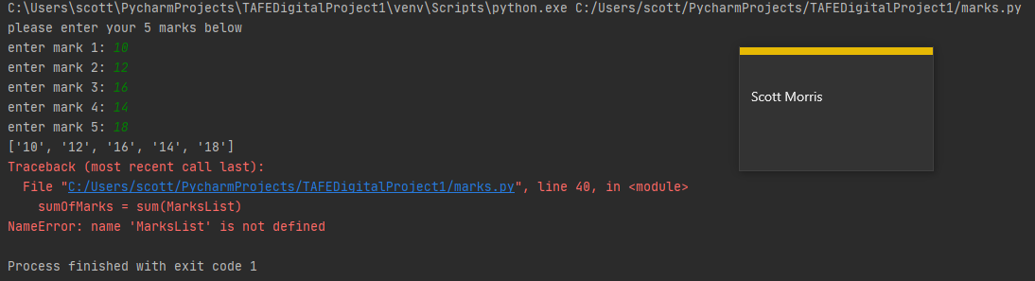The first test to be completed was Lownum. The following error was produced.

The NameError suggests that a variable was incorrectly named with the error message indicating that the incorrect variable was MarksList. As python is a case sensitive language and previously, the ‘m’ in MarksList had been uncapitalized, the error is easily fixed by changing this. T01 was run 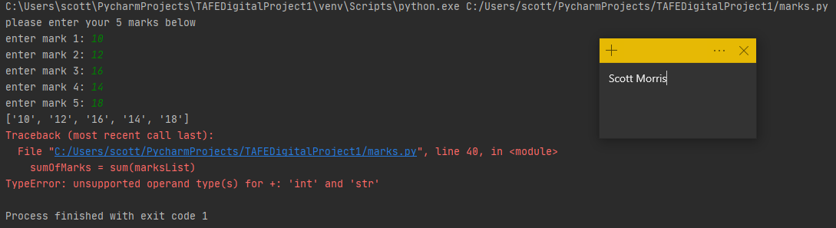again with the new changes implemented. The following error was received.

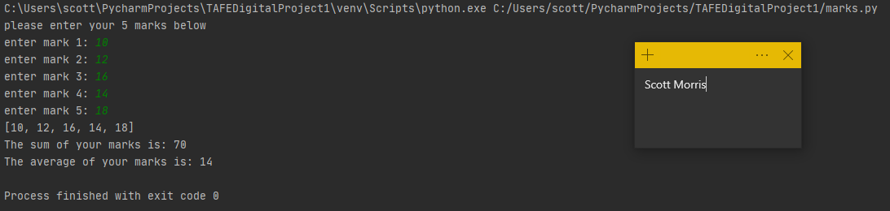The type error now indicates that there is an operation performed between incompatible types in the program. The error points out the this occurs in the summation statement. The sum library function takes in number types whereas the list is composed of strings. To fix this, the marks are converted into int types as they input into the list of marks. However, now the average of the marks is presented as a decimal number, whereas the test criteria has the average as an integer. We can easily convert this by casing the result as an int, rounding the number.

The testing of the debugged code passes T01.

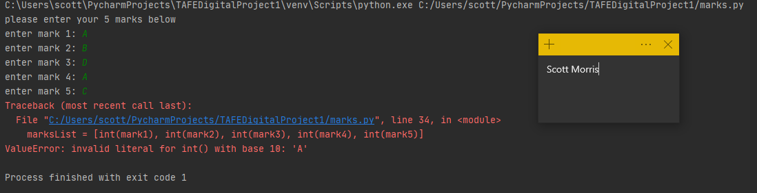When T02 is run, we are presented with the following output.

The exception ValueError is the output expected from this test. As our inputs are not numeric values, our sum and average cannot be calculated and hence our program should return an error.

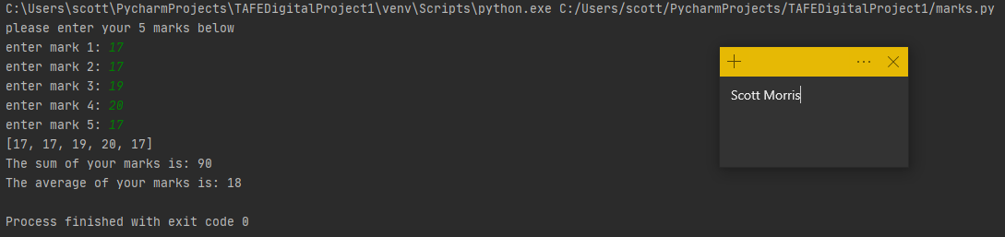The final prescribed test T03 was run and produced the following.

This is the expected output of our program.

# Software evaluation

|  |  |
| --- | --- |
| Software specification | Evaluation |
| Asks the user to input the marks for the five subjects in a list/array. | This condition was met from the beginning. Five different prompts with appropriate prompts |
| Displays the list/array of marks entered | Again, this specification was met from the first version of the program and remained throughout all the tests |
| Finds the sum of all the marks in the list (all five subjects) and display the output as [The sum of your marks is: [sum]] | Initially, this specification was not satisfied as the program produced a name error and hence could not display the sum. A further type error needed to be fixed before the specification was met |
| Finds the average of all the marks in the list (all five subjects) and display the output as [The average of your marks is: [averagemark]] | averagemark in the first version was displayed as a decimal number. This was changed to an int to match the given data |

# Software approval

Software is approved for installation by:

Name: John Smith

Role: Head Of Development

Signature: John Smith

Date: 31/05/20