Scott Morris

TAFEID: Scott.Morris3

ICTPRG301

Assessment 1: Project

**Task 1**

**Development Timeline**

The indicative hours for the completion of this assessment is 3 hours. I plan to finish all tasks within 5 days, allocating at least 45 mins each day to working on the assessment. This timeline was chosen as the new university semester begins on the 1st of June and I would like to finish this assessment before then.

|  |  |  |
| --- | --- | --- |
| Date | Tasks Requiring Completion (Expected Completion time) | Personal Workload |
| Wednesday 27th May | * Development timeline (15 mins) * Simple application (35 mins)   + Algorithm (20 mins)   + Syntax conversion (15 mins) | * Typing Course (60 mins) * Football Training (120 mins) |
| Thursday 28th May | * Apply variable scope (20 mins) * Debug and test (25 mins)   + Create and apply tests (15 mins)   + Debug code (10 mins) | * Basketball (60 mins) * Java course (60 mins) |
| Friday 29th May | * Game development (40 mins)   + Algorithm (25 mins)   + Syntax conversion (15 mins) | * Personal workout (60 mins) |
| Saturday 30th May | * Debug and test (35 mins)   + Create and apply tests (20 mins)   + Debug code (15 mins) | * Job (540 mins) |
| Sunday 31st May | * Review   + Format documentation   + Check programs | * Family dinner (120 mins) * Java course (60 mins) * Typing course (60 mins) |

I have put less of the workload over the weekend (Saturday and Sunday) due to the amount of personal activities that I have scheduled for those 2 days in comparison to the weekdays

**Task 2**

**Conference Program**

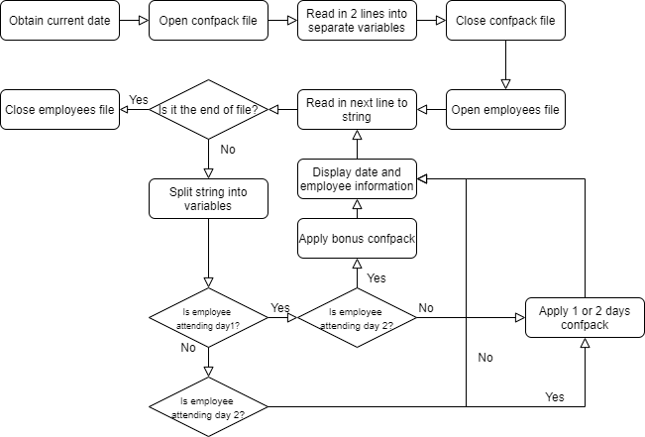A flowchart was developed to easily demonstrate the flow of the program being developed.

This was then translated to python syntax in the file EmployeeConfpack.py. The date library function from the datetime module was used to achieve the current date in the appropriate format.

*See EmployeeConfpack.py*

**Task 3**

**Applying a variable scope**

A variable scope was applied to the file scope.py for the program to properly function. This was achieved by simply declaring the variable firstName as a global variable inside name_function, allowing the variable to be called by the print statement outside of name_function

*See scope.py*

**Task 4**

**Testing and debugging**

*See ROISoftwaretestreportmarks.docx*

**Game Software**

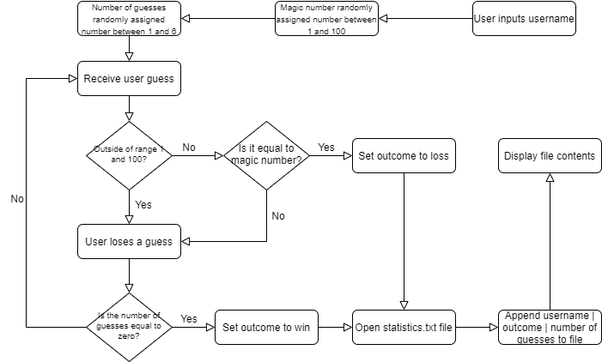First a flow chart was developed to conceptualise how the program would function.

*See software in SimpleGame.py*

*See testing and debugging in ROISoftwaretestreportSimpleGame.docx*