**Proposal for a Vertical Farming Division for Company A**

**Scott Morel**

**2023**

**Table of Contents**

**Introduction………………………………………………………………………………………………………………………….3**

**Required Resources……………………………………………………………………………………………………………….3**

**Physical Structure………………………………………………………………………………………………………………….3**

**Sensors………………………………………………………………………………………………………………………………….4**

**Automation of Plant Care………………………………………………………………………………………………………4**

**Monitoring, Inspection, and Data Collection………………………………………………………………………….5**

**Autonomous System Design…………..……………………………………………………………………………………..6**

**Conclusion…………………………………………………………………………………………………………………………….8**

**Works Cited…………………………………………………………………………………………………………………………..9**

**Introduction:**

The goal of this proposal is to present a plan to create an automation and machine learning solution for a vertical farming facility. It will be divided into sections related to each aspect of the plan.

**Required resources:**

There are many resources that will be required for the vertical farming project. We will need at minimum 1 greenhouse that is 200x100 and roughly 40 feet tall. We will also need a building for offices, an operation control center, and a dock for loading and unloading shipments. There will be multiple sensors needed to evaluate the conditions and adjust the automation systems accordingly and in real-time. These sensors include temperature sensors, oxygen sensors, carbon dioxide sensors, and nitrogen sensors. We will require multiple sprinklers, lights, and robotic devices to water and fertilize the soil and ensure proper lighting conditions throughout the facility, as well as select samples for more in-depth evaluation. Also, we will need a system in place to remotely inspect and evaluate conditions within the facility. I have included some rough sketches to help visually display my ideas.

**Physical Structure:**

As stated earlier a greenhouse will be required. I propose a minimum 200 feet long, 100 feet wide, and 40 feet tall. We will have multiple plant beds stacked and spaced vertically and roughly 3-6 feet apart and horizontally 1-2 feet apart. I also suggest we make the plant beds 4-6 feet in length and 1 foot in width. There is also a need for an office building with an operation control center and attached dock for shipments. The operation control center would be outfitted with multiple video monitoring displays, as well as any input or control surfaces required. I propose we add 4-6 backup generators as well. This will provide redundancy in the event of a power outage. See below for some sketches. The first is a rough layout for the building and the other is a visual representation of the setup for the plant beds.

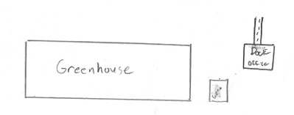

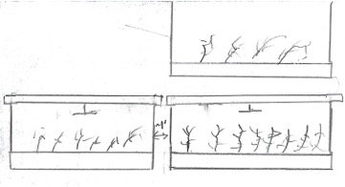

**Sensors:**

To ensure the proper conditions for effective plant growth, there are several sensors we will require. We will need temperature sensors with infrared capabilities to monitor temperature conditions to avoid unneeded stress on the plants. At minimum, I propose having a temperature sensor per plant bed. We will also need multiple oxygen, carbon dioxide, and nitrogen sensors to ensure the correct amount of each gas needed to promote faster and denser growth. I suggest we use the same placement plan as the temperature sensors.

**Automation of plant care:**

I propose the use of robotic devices that can aerate, fertilize, and water the soil. I plan to have one robotic device per plant bed. It would run across rails stationed above each plant bed and would move back and forth performing the tasks previously mentioned. They will need to be about 6” longer on each side to provide enough room for all tasks to be performed. Below is a rough illustration of how these robotic devices would work.

I also suggest that we have sprinklers located to the side of each bed to ensure proper watering of all plants.

**Monitoring, Inspection, and Data Collection:**

A few things we need to be vigilant about are monitoring, inspection, and data collection. I suggest purchasing some Spot robots from Boston Dynamics as well as drones with video capability. The ability to inject custom payloads into the Spot robots will save us the time and cost associated with creating our own robotics for data collection. We would use the Spot robots for inspections such as equipment inspections, checking heating and cooling systems, and inspecting the backend of the greenhouse (HVAC, valves, temperatures, general maintenance etc.). We would also use the Spot robots to monitor the plants on the lower level. Drones would also be loaded with a custom payload and will be used to monitor the health and environment of the plants higher off the ground. Below is a picture of the Spot robot.

Spot, Boston Dynamics, 2023

As far as monitoring, I suggest using a mix of stationary desktops and mobile devices. We could use iOS/Android devices to allow real time monitoring while roaming throughout the facility. An additional benefit of using iOS/Android devices is people are very familiar with them at this point. The stationary desktops would be housed in the operation control center. I suggest a 24x7 rotation in relation to the operation control center. The control center would also have the capability of adjusting temperature and other environmental conditions for the plant beds on an individual and group basis.

**Autonomous System Design:**

To create a consistent workflow there are certain requirements that will need to be met. I propose the following workflow:

**Business objective alignment:**

As stated previously our objective is to create a vertical farming division for our company.

**Product definition:**

We aim to create a product that will automate and maintain day to day operations within the division.

**Data preparation:**

We will provide data on all plants being grown, the soil composition, and any other environmental conditions such as temperature and moisture. We will continue to collect data via autonomous data collection and manual data collection done by human operators.

**Feature engineering:**

I suggest engineering instructions for plant maintenance (water, fertilize, aerate) as well as instructions to continually collect data to fine tune the system.

**Model Training and Scoring:**

We should use a testing and scoring model that awards points based on plant size, texture, flavor profile, and overall yield.

**Model Evaluation:**

We will use the scores from the previous step to provide guidance for the model going forward and to reinforce the strongest aspects of the model. This information will be used for continued development.

**Model Productization, Deployment, and Execution:**

Once we feel comfortable with the quality of the plants, we will deploy the model into full production. We will continue to use any data collected to better train the model.

**Model Monitoring:**

We will monitor the same things mentioned in the training and scoring section and continue to use that data to fine tune the model.

**Feedback and Reporting:**

We will use a combination of data collected autonomously and by human operators. I suggest using the autonomous systems to collect data on plant size and yield and using human operators to evaluate texture and flavor profile. This information will then be sent to the engineering staff and used to improve the model.

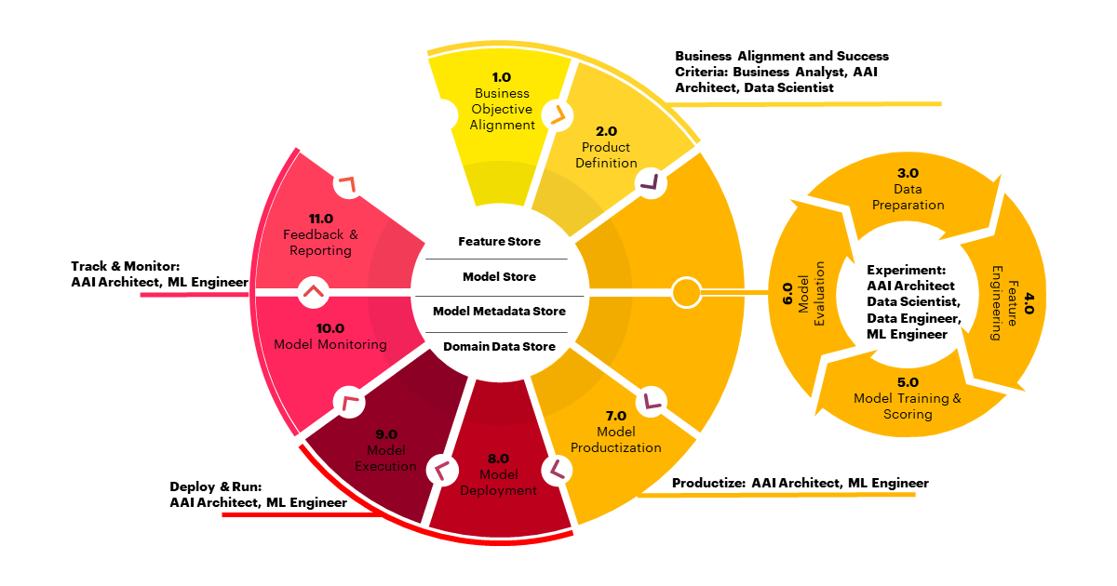

Pudipeddi, 2023

**Conclusion:**

Using the information and performing the steps outlined in this proposal, I believe we can create and maintain a successful vertical farming division for our company. Once the initial model has been developed and deployed everything should be straightforward from there. Thank you for your time and for considering this proposal.

Works Cited

Pearson, Simon, et al. “Robotics and Autonomous Systems for NET Zero Agriculture - Current Robotics Reports.” *SpringerLink*, Springer International Publishing, 28 Apr. 2022, link.springer.com/article/10.1007/s43154-022-00077-6.

Pudipeddi, Sridevi (2023). *Machine Learning Development Lifecycles* Slide 4.

School of Computer Sciences, Kansas State University

Rose, David Christian, et al. “Responsible Development of Autonomous Robotics in Agriculture.” *Nature News*, Nature Publishing Group, 20 May 2021, [www.nature.com/articles/s43016-021-00287-9](http://www.nature.com/articles/s43016-021-00287-9).

“Spot.” *Boston Dynamics*, 3 Oct. 2023, bostondynamics.com/products/spot/.