ACTIVATION FUNCTIONS

We’ll be discussing non-linear activation functions, because they’re sexy, at least compared to linear functions. I won’t be going overall all possible activation function, instead I’ll just focus on the two main ones, Rectified Linear Activation Function (ReLU), and Softmax. If our input data is non-linear it make sense to use a non-linear activation function to get an output. Genius.

For sake of completeness here’s a broad overview of a few activation functions. These are not all the possible functions available, and there are functions that are based off of these major ones.

1. Linear Activation Function
Formula:
Input equals the output. Typically seen in the output layer of a regression model, e.g., house prices. Not used in hidden layers, or if the network needs to learn non-linear relationships. It’s like trying to predict the curvature of a cooked piece of spaghetti (or a sine wave) with a raw piece of spaghetti.

2. Sigmoid Activation Function
Formula:
The Sigmoid takes all possible input values and squishes the output between 0 and 1. Handy for binary classification problems. It was the OG in the hidden layers of a network until the ReLU showed up. The negative of this function is the ‘vanishing gradient problem’ i.e,. gradients used for updating the weights become extremely small as the back-propagation happens through the layers. The derivative of the Sigmoid function will never be greater than 0.25. And those small updates slow down the neural networks ability to learn.

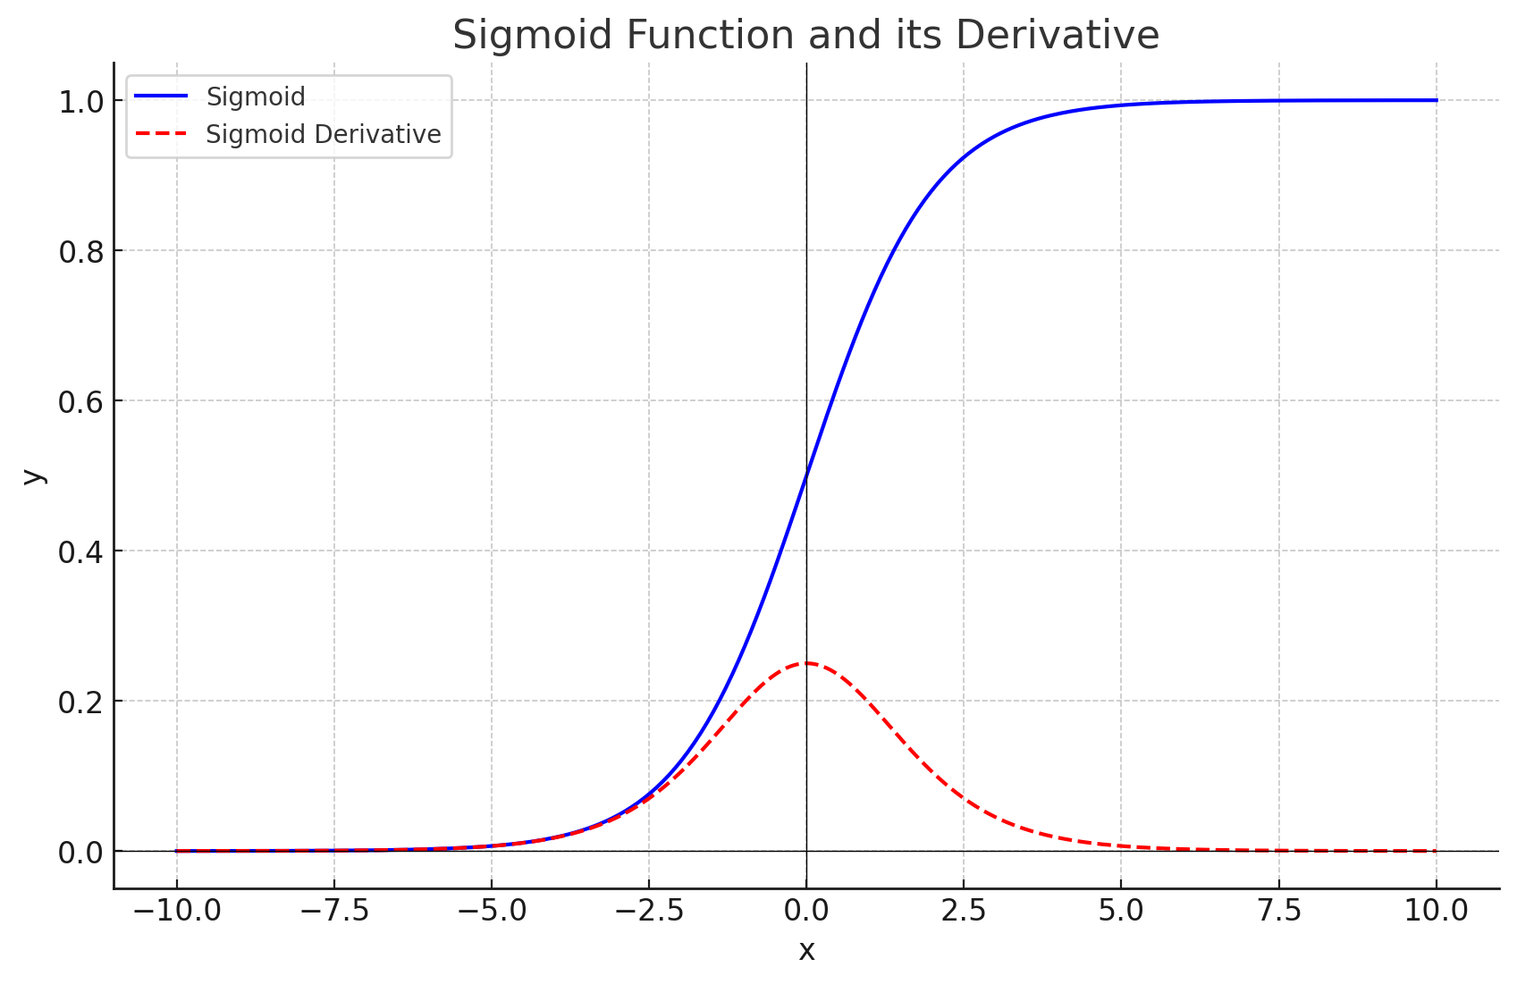

3. Rectified Linear Activation Function (ReLU)
Formula:
Most commonly used function in hidden layers. There are modifications to this e.g., Leaky ReLU and ELU (Eponential Linear Unit), which try to fix the issues that ReLU has (nothing is perfect), but I won’t be covering those here. This function takes any number below zero and flattens it to zero, or raises it to zero, depending on how you look at it.
Forward Pass:
- Positive numbers are unchanged.
- Any number zero or below deactivates the neuron
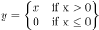
It has both linearity and non-linearity combined.

Backward Pass:
- The derivative of ReLU will be either 1 for positive outputs or 0 outputs less than 0.
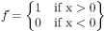
Which acts exactly like the output of a Step Activation Function. Just to be clear, the ReLU is not a step activation, but functions like one in back-propagation.
The downside, and there’s always a downside is that the neuron can stop learning if it’s output is consistently zero. It’s called the ‘dying ReLU’ problem. Another possible negative for ReLU is that it is non-zero centered, because its output is always positive and not balance between outputs -1 and +1 like the tanh function it could lead to some gradients being biased. But it does solve the vanishing gradient problem since all positive outputs have a constant gradient which increases the neural networks efficiency/ speed.
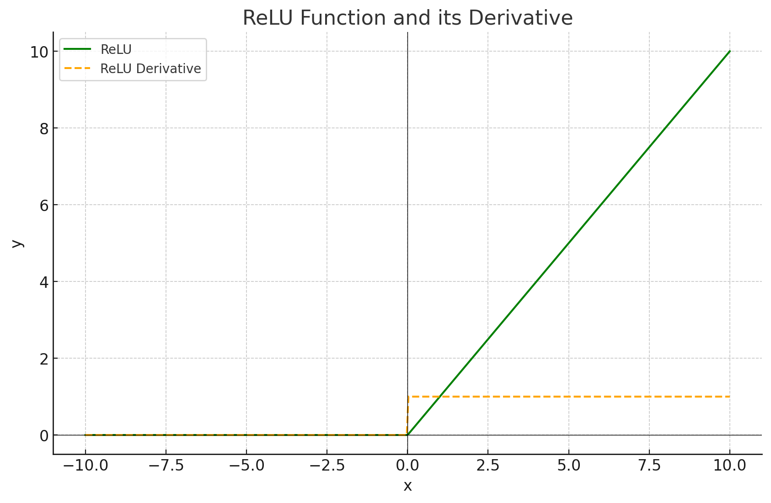

4. Softmax
Formula: 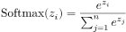
On the surface softmax is relatively easy to understand. The question is how far down the rabbit hole do you want to go?
The numerator is the current output of one result, out of many, which is the exponent of Euler's number (2.71828…), then normalize by dividing by the sum of all exponentials of each possibility.
Most commonly used as the final output of a neural network, particularly in classification problems, where it produces an output between 0 and 1. It’s a multi-class classification probability and all classes will add up to 1.
Softmax (somehow) reminds me of Forest Gump’s quote about life, chocolates, and not knowing what you’re going to get. True, but if you get a box of See’s candies with that little graphic showing you which chocolates are which your probability of getting one with a caramel interior (awesome!) vs. one with a coconut interior (disgusting!) improves vs choosing blindly. While your probability improves, your confidence level may not be very high, as with the softmax function the probabilities are dependent on the initialization and weights used. Change those and the probabilities change too. If you want to go down the rabbit hole further, here are some links
The SoftMax Derivative, Step-by-Step!!! https://www.youtube.com/watch?v=M59JElEPgIg
The Sigmoid Function Clearly Explained https://www.youtube.com/watch?v=TPqr8t919YM
Krish Naik, https://www.youtube.com/@krishnaik06
Why do we use "e" in the Sigmoid? https://www.youtube.com/watch?v=1GqYpmLjTRQ

Resources:

Neural Networks from Scratch in Python, Harrison Kinsley & Daniel Kukiela
StatQuest with Josh Starmer, https://www.youtube.com/@statquest
Krish Naik, https://www.youtube.com/@krishnaik06
The SoftMax Derivative, Step-by-Step!!! https://www.youtube.com/watch?v=M59JElEPgIg
The Sigmoid Function Clearly Explained https://www.youtube.com/watch?v=TPqr8t919YM
Why do we use "e" in the Sigmoid? https://www.youtube.com/watch?v=1GqYpmLjTRQ

