**DetroitSat Air Bearing**

Compiled by: Matt Schmotzer

**Overview**

Air bearings are expensive. When developing open source components on a budget it is impractical to spend thousands of dollars on a component just to troubleshoot mechanical and electronic systems. To test our reaction wheels and magnetorquer in a frictionless environment our team developed an air bearing that could be constructed using a 3D printer. The satellite would then sit in a wooden cradle within a half spherical bowl that was purchased online with the shop compressor suppling enough air for the bowl to levitate.

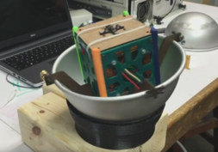

*Fig. 1 – Cubesat model mounted inside air bearing*

**Design**

The basic construction of the 3d printed portion was sized to match the acquired spherical bowl. The sphere used is eight inches in diameter with the cradle spanning it. Currently our team has created two iterations of the air bearing. Version 1 included twelve ports that were fed from an internal plenum. The ports were distributed equally around the air bearing roughly ¾ up the outer wall. Figure 2 shows a cross section view of the manifold and runners that supply the air stream. The sphere itself is 8 inches in diameter. Air is supplied at the bottom of the bearing into a manifold that will equally distribute air pressure to create a small film of air between the surface of the 3d printed mount and the spherical bowl.

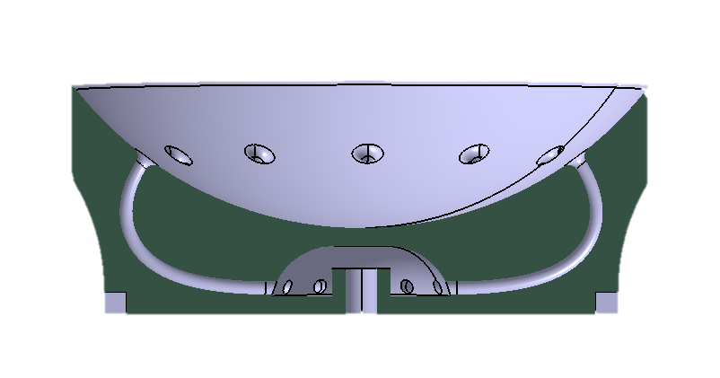

*Fig. 2 – Cross-section view of version 1*

**Operation**

Multiple tests were run to determine the maximum load the bearing could support at different line pressures. The test involved setting the air pressure to the desired value for the run with the bowl set up inside the air bearing. Masses were added to the bowl in fifty gram increments until the bowl no longer moved freely on the cushion of air. In our testing, we used a maximum of 120 psi to test the air bearing. It can be seen in Table 1 that using this bowl and 120 psi air our bearing can create a frictionless environment with a satellite mass under 700 grams. Those hoping to test satellites with higher masses will need a compressor capable of supplying higher pressures.

|  |  |
| --- | --- |
| **Air Pressure (psi)** | **Max Load w/o Bowl (g)** |
| **120** | 700 |
| **100** | 600 |
| **80** | 400 |
| **60** | 200 |
| **40** | 0 |
| **20** | - |
| **Bowl Mass:** 218 g | |

*Table 1 – Pressure versus max load results from testing*

**Further Development**

DetroitSat did not stop the development of our air bearing with just one iteration. The knowledge gathered from the first bearing was used to refine the geometry for Version 2. At this point in development we are still proving out the new design. This design incorporates valleys in which pockets of air are formed in order to help enhance the air film between the spherical bowl and 3d printed mount.

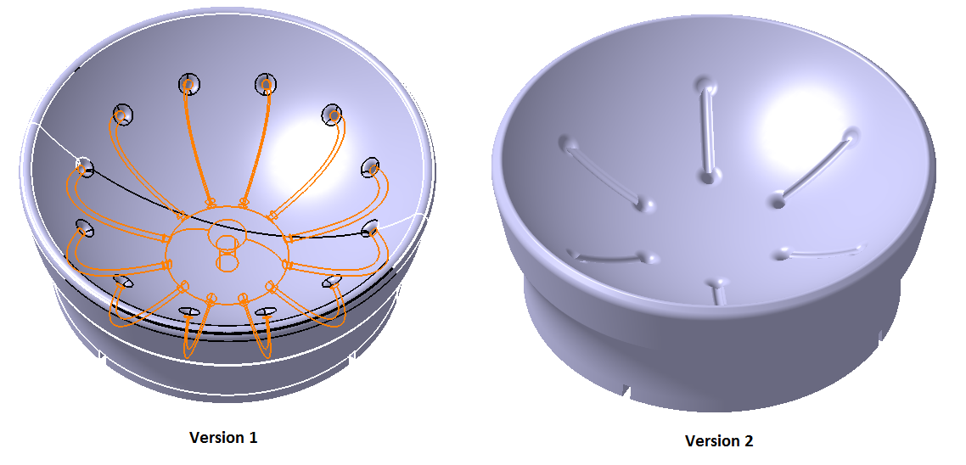

*Fig. 3 – Physical design of Versions 1 and 2*

**References:**

8 in. Aluminum Hemisphere Pan:

<https://www.amazon.com/Fat-Daddios-Aluminum-Hemisphere-Inches/dp/B001VEI0AQ/ref=sr_1_1?ie=UTF8&qid=1479310670&sr=8-1-spons&keywords=fat%2Bdaddios%2Baluminum%2Bhemisphere%2Bpan&smid=A2FQ5GG01HBOZ1&th=1>