Quiz 3

For the first part of this lab we were supposed to create a triangle wave. The code I used is below:

x1 = 2\*(0:dt:.5)

x2=zeros(1, .5/dt)

X=[x1 x2]

The next step was to make a generic pulse, or in other words: make it repeat. This is very simple using the repmat() function and then graphing that. The code I used is below and based on the code above:

XT=repmat(X,1,3)

The last step of this lab was to find and plot 10 Fourier coefficients and display them. This was very easy. All you have to do is make an indicator and display a value at each loop iteration. The code I used is below:

for i=1:N

cosfn=cos(2\*pi\*(i/M)\*(1:M));

an(i)=(2/M)\*sum(X.\*cosfn);

sinfn=sin(2\*pi\*(i/M)\*(1:M));

bn(i)=(2/M)\*sum(X.\*sinfn);

end

Overall this was an easy and simple lab using Fourier series that taught me more than the class itself. Below are some screenshots of my lab:

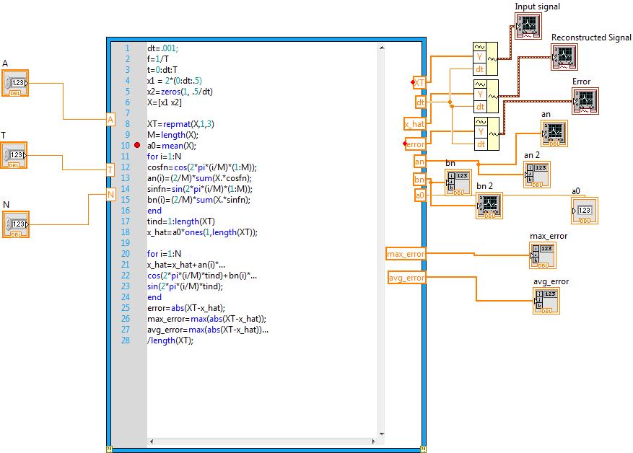

This is my Block Diagram with the Mathscipt code.

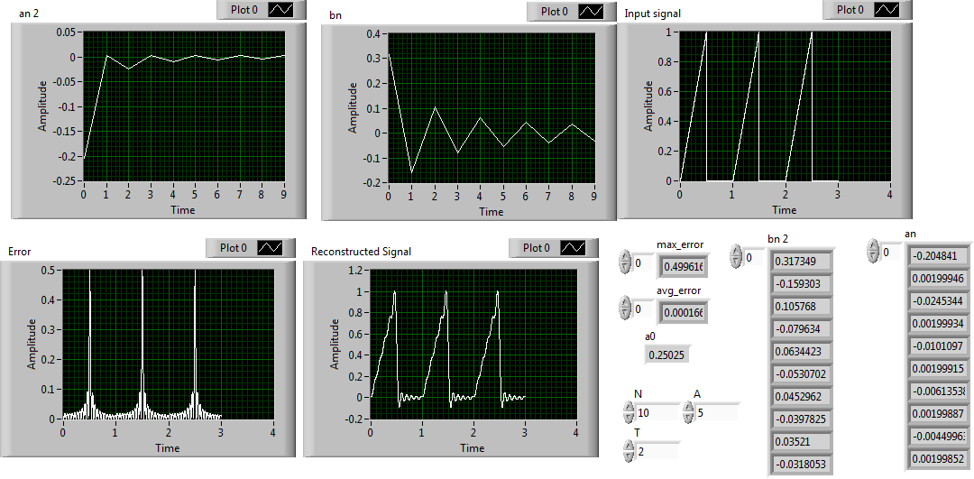

This is my Front Panel with my graphs of the error values, reconstructed signal, bn, an, and the indicators.