Lab Report 4

**PART 1**

In this lab we were asked to do two assignments. The first assignment was to construct the given signal and then find the Fourier coefficients of the signal and then reconstruct the signal based on the Fourier coefficients. After doing this, we had to overlay the waveforms so that we could see them together and compare the accuracy of the reconstruction. One thing that you will notice is that if you change T it will change the frequency and you will get some weird looking graphs. If you increase the value of n, the number of Fourier coefficients to calculate, you will get a more accurate looking graph. For instance, one hundred Fourier coefficients looks a lot smoother than ten coefficients. The basic teaching of this first part of this lab was to teach us that you can reconstruct a signal using Fourier coefficients. A graph using Fourier coefficients is accurate at about ten.

The code below is the code I used in Mathscript:

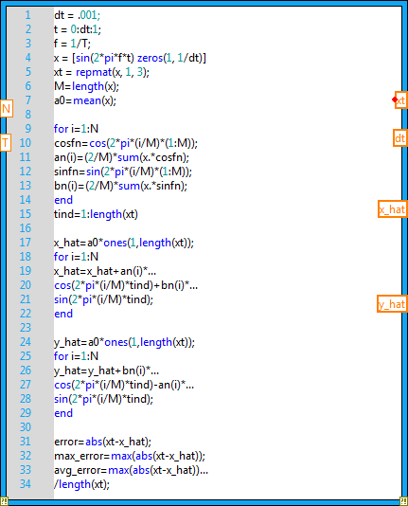

The picture below is a picture of what my code generates:

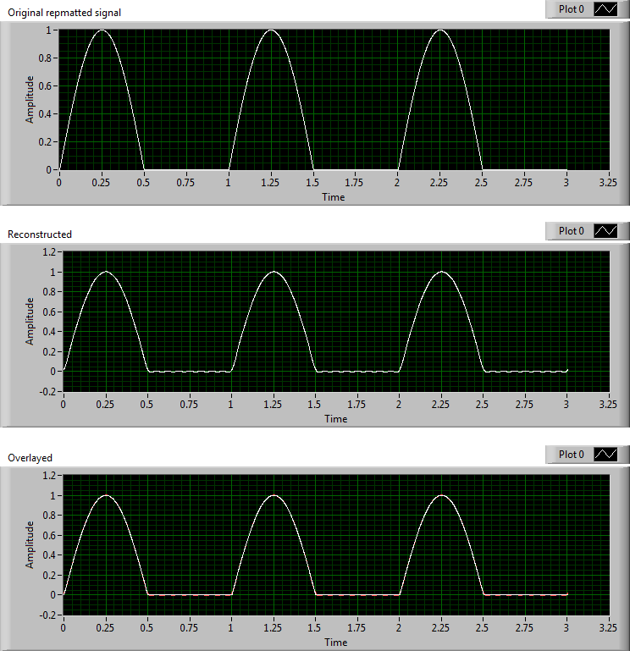

As you can see in the above picture, although it may be small, the orange is not even showing on the overlayed graph. This is because the reconstruction is so accurate that the signals cover eachother. To calculate this, I used n = 15. However, as you will see on the next picture, if I were to use n = 5, I would get a much less accurate graph and you will see more orange on the reconstructed graph because five Fourier coefficients is not enough to accurately reconstruct the signal.

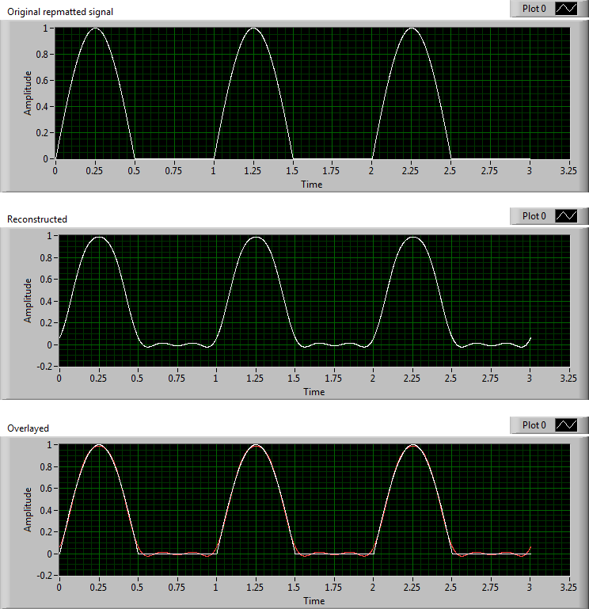

**PART 2**

In part 2, we were told that our system converted sin waves to cosine waves. We were also supposed to construct a given signal, convert that signal to all sine waves because our system only accepts sine waves. After we do that, we then display the reconstructed sine only signal on a graph.

The code below is the code that I used:

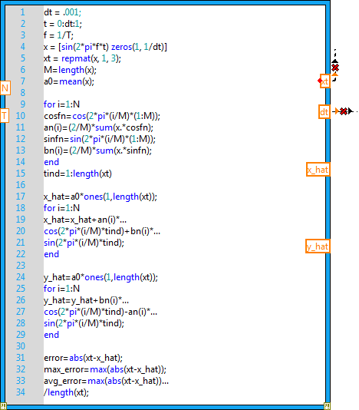

The waveforms below were generated using the code above:

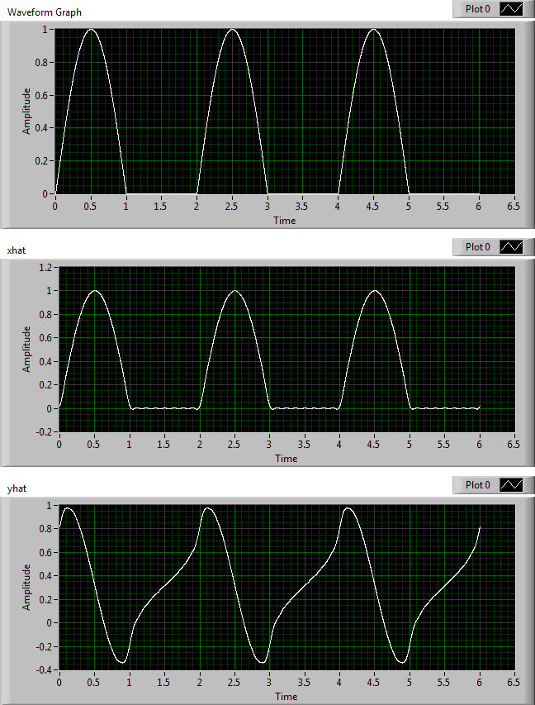

As you can see by looking at yhat, which is the sine only signal, it is a very different signal than xhat. This is because we have changed the signal to be sine only. We cannot verify the accuracy of this because I did not graph the input of this signal.