**Uncle Grandpa and tree diameter**

Uncle Grandpa is participating in a series of challenges called Binary Tree Challenge. To win this challenge, Uncle Grandpa will have to solve 3 problems, and this is the first of them:

“Given a binary tree, find its diameter.”

Well, Uncle Grandpa aced the problem in just 5 mins, can you do the same?

**Definition:** The diameter of a tree (sometimes called the width) is the number of nodes on the longest path between two end nodes.

## Input

The first line contains a single integer $n (1≤n≤1000)$– the number of nodes of the tree

The second line contains $n-1$ integers $p_{i}$ $\left(1≤p_{i}≤n\right)$- $p_{i}$ is the parent node of the $(i+{1)}^{th}$ node.

The tree’s root is node 1. It’s guaranteed that the given tree will be a binary tree.

## Output

A single integer is the diameter of the tree

## Examples

|  |  |
| --- | --- |
| Input (diameter1.in) | Output (diameter1.out) |
| 7  1 1 2 2 3 6 | 5 |

## Explanation:

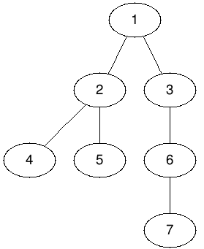For the 1st example, one of the possible diameters is the path from node $4$ to node $7$, which has a length of 5.

## Note:

1. A skeleton file has been given to help you. You should not create a new file or rename the file provided. You should develop your program using this skeleton file.
2. You are free to define your own helper methods and classes (or remove existing ones) if it is suitable but you must put all the new classes, if any, in the same skeleton file provided

## Skeleton File

You can find the skeleton file Diameter.java in the lab package.