**GS6**

# 25th Avenue & Union Pacific Grade Separation

### GS6.2 – 25th Ave North looking South Just south of Lake Street

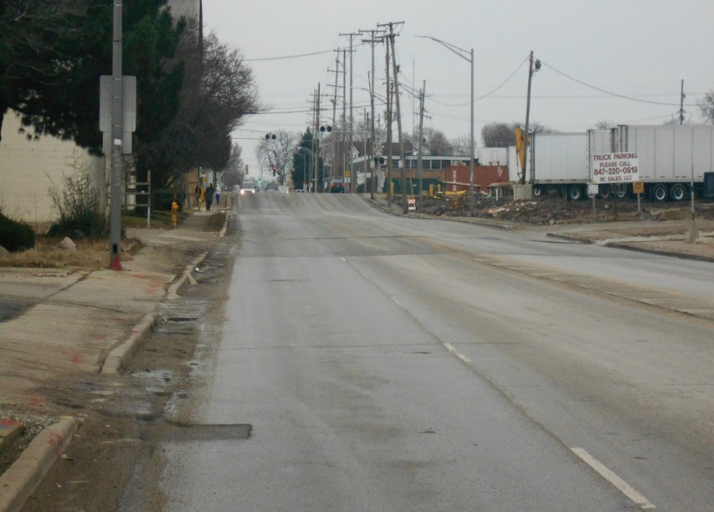

**After (06/16/17)**

**Before (12/10/12)**

### GS6.5 – 25th Ave East looking West North side of UPRR

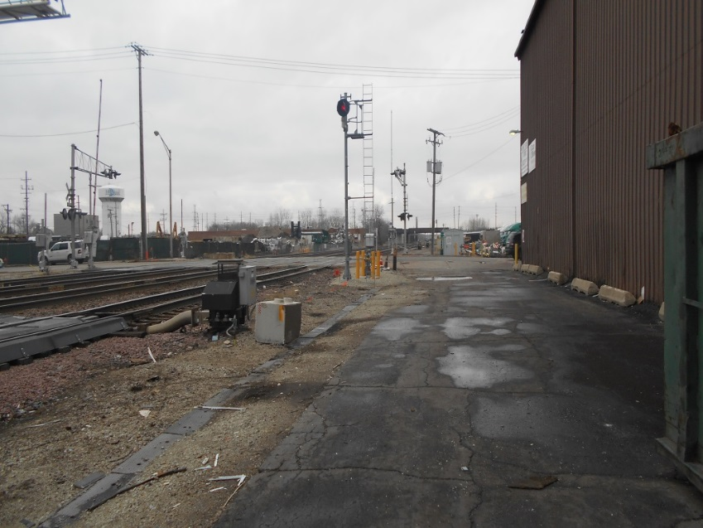

**Before (12/24/11)**

**After (06/30/17)**

### GS6.7 – 25th Ave East Looking West Main Street

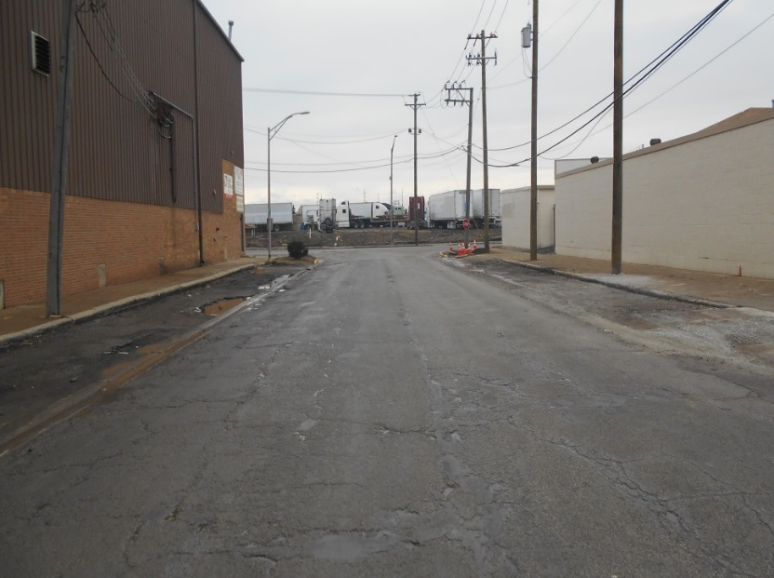

**After (06/16/17)**

**Before (12/24/14)**