How to setup the rune optimizer to run on your locally hosted web server

1. Install on your machine **XAMPP** or **LAMP**.

(Or if you want you can separately install Apache or nginx + PHP version >5.4 and MySQL) If you are using MAC or Windows or you are not experienced with Web Servers and configuration, I recommend you install XAMPP, because it’s easier and installs in a bundle all needed resources.

Links:

**Xampp**: <https://www.apachefriends.org/index.html> (a bundle with Apache server, MariaDB or MySQL, PHP, PERL) Needed PHP version >= 5.4; if you install the latest version with PHP 5.6.15 and it does not work, try older setup with PHP 5.5

**Lamp** on UBUNTU: <https://www.digitalocean.com/community/tutorials/how-to-install-linux-apache-mysql-php-lamp-stack-on-ubuntu>

**Nginx**: <http://nginx.org/en/download.html>

1. IF YOU USE **WINDOWS**! After installing XAMPP go in **skype->tools->options->advanced** and UN-check “use ports 80 & 443”.

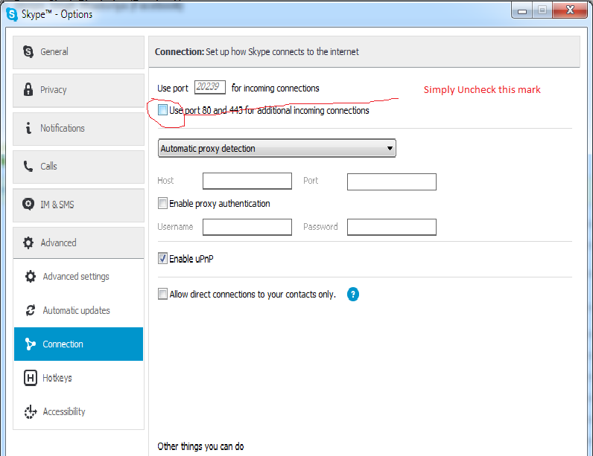

1. Go to your php.ini file and modify those lines:

**max_execution_time=900**

**max_input_time=90**

**memory_limit=512M**

**post_max_size=16M**

You can find php.ini in **<xampp install folder>/php/** .On my machine it is located in **C:\xampp\php\php.ini**  (I have installed xampp in **c:/xampp**)

1. Copy folder swrunes from the provided archive in **<xampp install folder>/ htdocs /** (Mine is in **C:\xampp\htdocs\**)
2. Start XAMPP (or LAMP)
   1. On windows go to Start ->All Programs -> XAMPP -> Xampp Control Panel 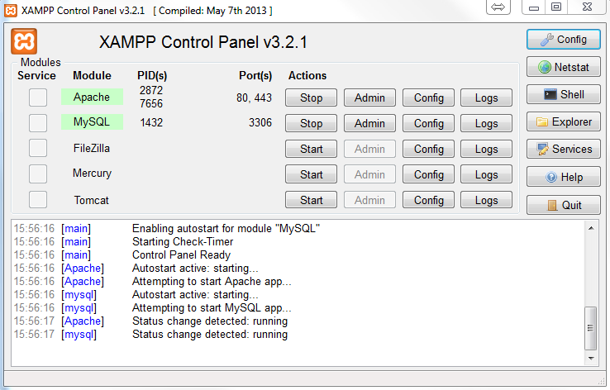

If Modules Apache and MySQL (or MariaDB) do not start automatically after a few seconds, start them manually.

* 1. For **nginX or separate installs of Apache or on Linux** – run their services from the CLI. Also run MySQL service

1. Check if your server works. Open your browser and go to <http://localhost/> You should see the Apache or nginX welcome page

Open <http://localhost/info.php> to see if php works too.

1. Create the database, tables and user for them.
   1. If you have no problems on step 6 and you use XAMPP go to <http://localhost/phpmyadmin/> There log with user: “root” and no password (if you can’t login with root check this <http://stackoverflow.com/questions/17759776/how-to-get-login-option-for-phpmyadmin-in-xampp> )

Go to tab “SQL” and copy paste the contents of file **sqls.txt** into the field. Press “Go”

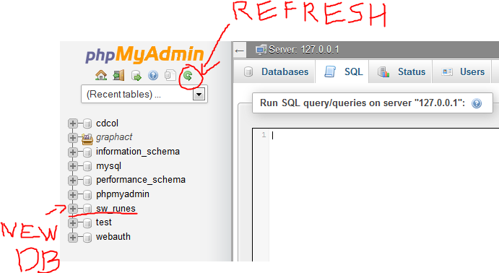

You should see similar result “# MySQL returned an empty result set (i.e. zero rows)”. Then, after refreshing, you should see the new Database “sw_runes”.

* 1. If you use separate installation of MySQL or MariaDB, and do not have phpMyAdmin, just run the commands one by one using the CLI.

1. Now just go to <http://localhost/swrunes/> and you should be able to use the tool ☺
2. When the tool starts to work slow or you see too many records in the database or after every few hours of use it is good to open these pages:

<http://localhost/swrunes/maintenance.php>

They delete the old records and get rid of oversize. (If you can you can schedule or make cron jobs that call those scripts.)