How to setup the rune optimizer to run on your locally hosted web server

1. Copy folder swrunes from the provided archive in **<xampp install folder>/ htdocs /** (Mine is in **C:\xampp\htdocs\**)
2. Start XAMPP (or LAMP)
   1. On windows go to Start ->All Programs -> XAMPP -> Xampp Control Panel 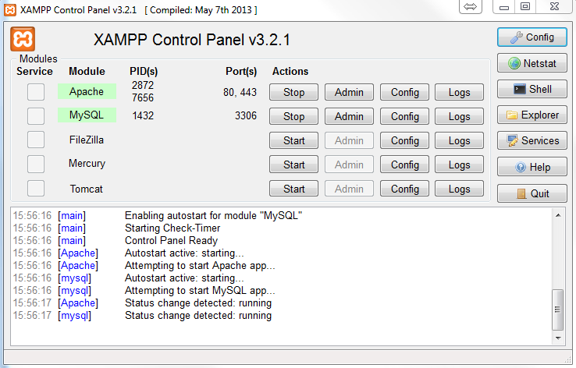

If Modules Apache and MySQL (or MariaDB) do not start automatically after a few seconds, start them manually.

* 1. For **nginX or separate installs of Apache or on Linux** – run their services from the CLI. Also run MySQL service

1. Update the database.
   1. If you use XAMPP go to <http://localhost/phpmyadmin/> There log with user: “root” and no password (if you can’t login with root check this <http://stackoverflow.com/questions/17759776/how-to-get-login-option-for-phpmyadmin-in-xampp> )

Go to tab “SQL” and copy paste the contents of file **sqls.txt** into the field. Press “Go”

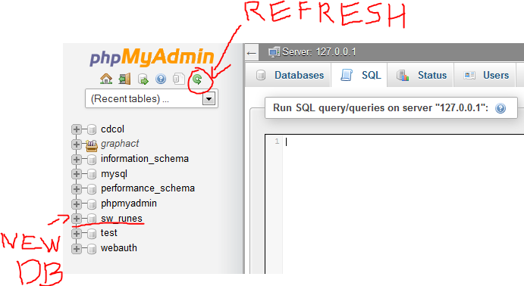

You should see similar result “# MySQL returned an empty result set (i.e. zero rows)”. Then, after refreshing, you should see the new Database “sw_runes”.

* 1. If you use separate installation of MySQL or MariaDB, and do not have phpMyAdmin, just run the commands one by one using the CLI.

1. Now just go to <http://localhost/swrunes/> and you should be able to use the tool ☺
2. When the tool starts to work slow or you see too many records in the database or after every few hours of use it is good to open these pages:

<http://localhost/swrunes/maintenance.php>

They delete the old records and get rid of oversize. (If you can you can schedule or make cron jobs that call those scripts.)