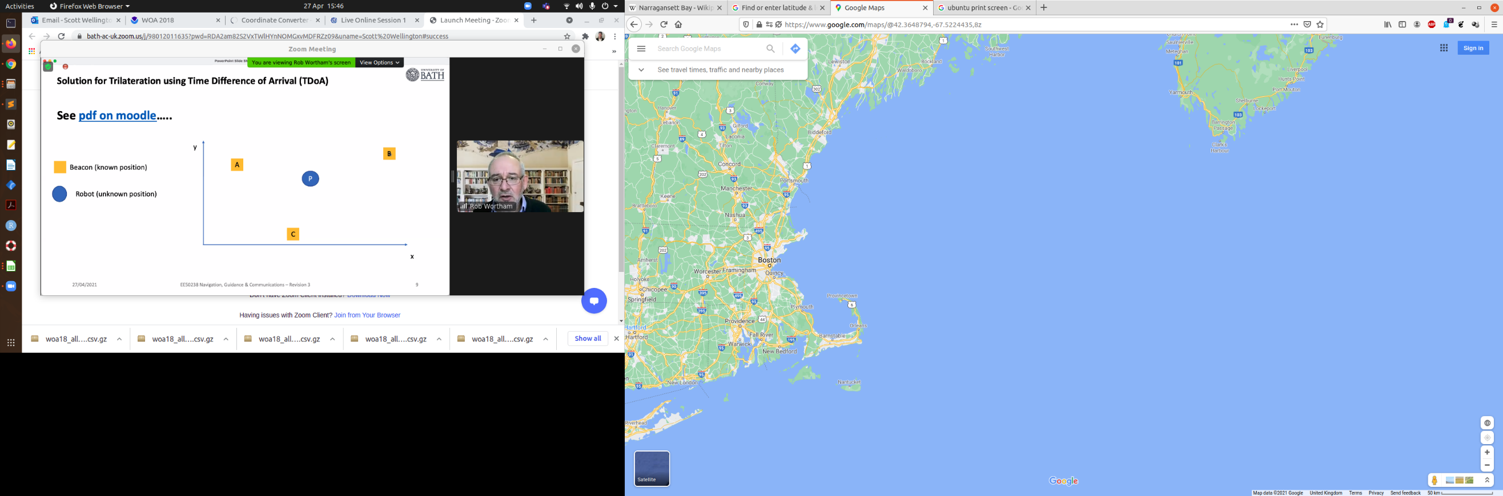

WOA18 phosphates, 1°

41.5° N, 62.5° W

Point Judith Pond

41.3998° N, 71.5056° W

Narragansett Bay

41.6220° N, 71.3527° W