# Assets.

This document contains a list of assets and their corresponding licenses which I may use in the project. It should help keep track of where assets come from, and what are the terms of the license when I need to use an image in the project.

All of the following images were sourced from Unsplash, a website with extremely high quality public domain images. I primarily used these images throughout the site. The cover photo, all the pictures in the grid on the homepage, as well as an assortment of clothes on the product list were sourced from here.

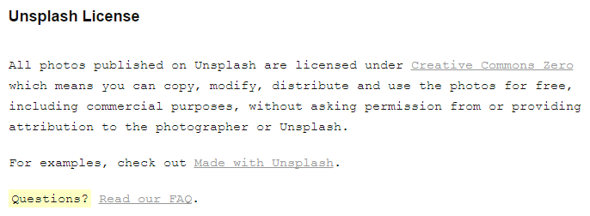

Cover, <https://unsplash.com/photos/tBtuxtLvAZs>

Grid 1, <https://unsplash.com/photos/d57LGwGacF8>

Grid 2, <https://unsplash.com/photos/INlsVpSEWTs>

Grid 3, <https://unsplash.com/photos/GYF8ipxBPg4>

Grid 4, <https://unsplash.com/photos/K2NlO4hFVeQ>

Grid 5, <https://unsplash.com/photos/Oi_Utj7dKZg>

Grid 6, <https://unsplash.com/photos/8vAdE1jdtFk>

Shoes 1, <https://unsplash.com/photos/OfvV-jkgrfQ>

Shoes 2, <https://unsplash.com/photos/0bFvWOh1tgI>

Shoes 3, <https://unsplash.com/photos/-YYSC6kwPF8>

Jacket 1, <https://unsplash.com/photos/C-mxLOk6ANs>

Jacket 2, <https://unsplash.com/photos/GsQwzPaqGB0>

Melbourne 1, <https://unsplash.com/photos/o3TZx8_j7FE>

Melbourne 2, <https://unsplash.com/photos/09eoscPYdHU>

Melbourne 3, <https://unsplash.com/photos/GH7g8Ve-Ubw>

France 1, <https://unsplash.com/photos/moognyOQ1nE>

France 2, <https://unsplash.com/photos/EIO_ZytZm8Y>

France 3, <https://unsplash.com/photos/1DeZnSDNeRU>

The travel icons which were used in the logo, as well as the page dividers were sourced from a Smashing Magazine article.

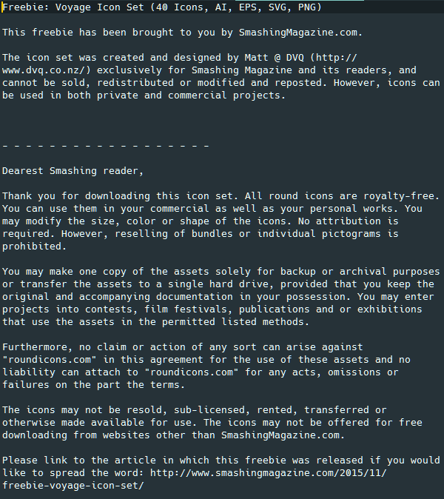

<https://www.smashingmagazine.com/2015/11/freebie-voyage-icon-set/>

The globe icon, which was also experimented with in the logo was sourced from the Wikimedia Commons website, which lists the image as licenced to the public domain.



<https://commons.wikimedia.org/wiki/File:Globe_icon.svg>

Several of the mock-ups came from the Graphic Burger website, which contains a large assortment of free mock-ups.

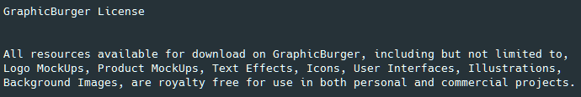

Jumper 1, <http://graphicburger.com/jumper-mockup-psd/>

Hoodie 1, <http://graphicburger.com/hoodie-mockup-psd/>

Signs and facades, <http://graphicburger.com/5-signs-facades-mockups/>

The t-shirt mock-ups came from the PixelBuddha website. This resource came with both a single t-shirt image, and a four t-shirt image.

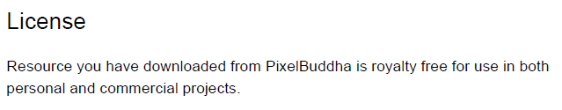

T-shirts, <https://pixelbuddha.net/freebie/t-shirt-mockups>