# Business identity.

Jean Stefano requires a business identity which reflects his experience, and expertise within the fashion industry. His new business, in the area of “streetwear” is a distinctive style of fashion, with a distinguishable target audience.

Quora user, “Adventure88” describes streetwear as a “grassroots cultural movement”, which is “notoriously difficult to define” due to its “constant state of evolution of style and creative direction” which aims to produce “casual, comfortable, pieces such as jeans, t-shirts, baseball caps, and sneakers”. He explains that streetwear is “rooted in Californian surf and skate culture”, whereby the integral components of a streetwear brand, is defined by “T-shirts and exclusivity”.

This means that the business identity Jean is looking to present, must be unique and demonstrate the exclusive, but creative and constantly evolving culture of the industry. A streetwear company is defined by its exclusive, and symbolic logos which are placed on almost all products, and used by customers as a marker of identity.

Clothes are not meant to be innovative, or experimental, but instead aim to be comfortable, casual and practical. The designs must be unique, but they also must blend in. The art of streetwear is to “mimic the limited feel of a high-end luxury brand”.

# Business design.

In order to design a website, which meets the needs of Jean’s business, it must reflect his needs, and the culture surrounding streetwear.

The colours which I believe will suit this the best, are a saturated palate of white, grey and black. It is not the colours that will define the website, but the well-crafted logo and typography. Despite the common trend in the streetwear industry to avoid colours, I will experiment with the use of one theme colour will be used sparingly through the website.

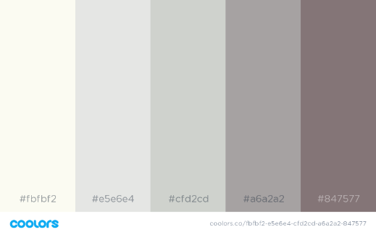 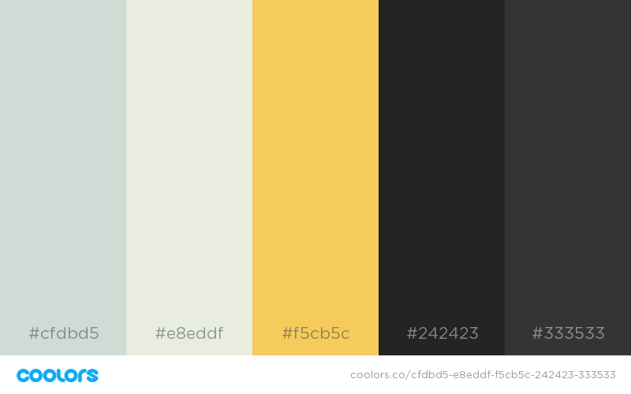

A sans-serif font will comprise almost all typography throughout the website in order to create a user friendly experience. It is common however, for iconic streetwear logos to use serif, and sketchy fonts. In my logo design experimentation, I will have to play around with these fonts in order to decide which will work the best for Jean. I also must ensure that all font choices are web safe, apart from the logo which can be exported as an image, or vector graphic.

