# Logo development.

I began the logo development by copying my favourite fonts into a new document. I decided that I would need some kind of iconography in order to make them appear more unique, as well as being less bland. The licenses for the icons can be found in the assets document.

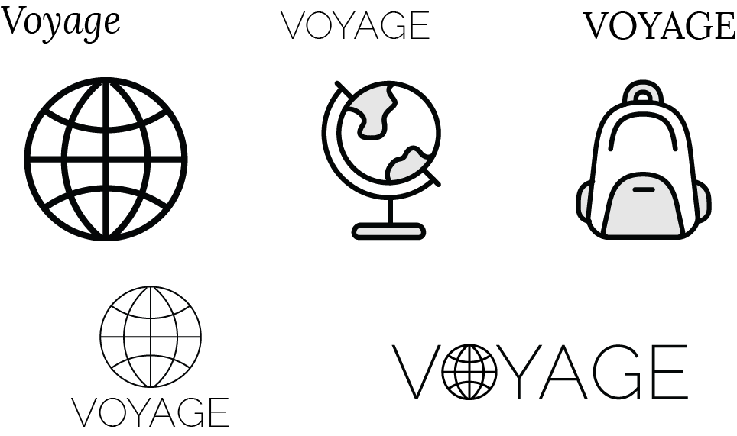

I began by trying to incorporate the icons with the word. I played around with the globe icon, and attempted to place it in a variety of positions around the typography. I found that placing it inside the word in place of the “o” looks the best, as it is seamlessly incorporated.

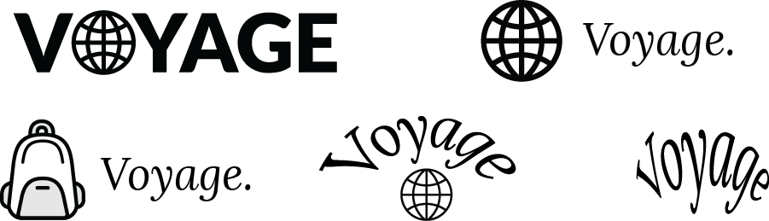

I attempted to use the bag icon, however I didn’t feel like it combined very well with the typography.

I also played around with Illustrators warp tool, in order to try and find an interesting effect. However, while it made the text far more unique, and interesting than the original plain text, I thought that the warp effects destroyed the readability of the text too much.

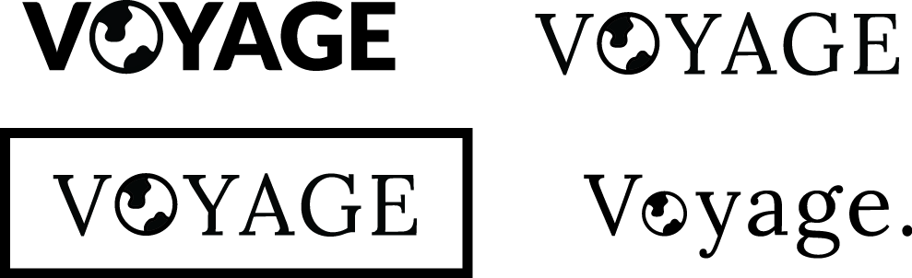

Taking the idea from the globe icon, I decided to just take the world part from the world icon, and use that as I was trying to use the globe. I believe it looks better than the globe icon, as the world icon contains far fewer lines, and is much less distracting. I also found that it looked good when combined with a serif font.

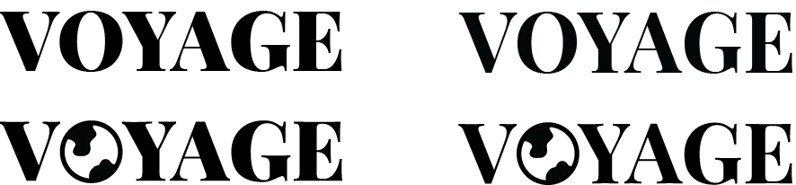

In the end, I decided on keeping it relatively simple, and using a large, capitalised, serif font combined with the world iconography. I settled on using the Google font, Playfair Display over other choices such as Times New Roman and Lora. I made this decision, because it has a good bold, chunky feel to it, and hence fit in with the world icon the best.