# Storyboards.

I began developing my storyboards by sketching a variety of very simplistic website structures which I could use for this project. Most of these designs were based upon, or influenced by other websites from my research or I thought would look appealing. The sketches were kept small and simple so I could explore a wide range of layouts.

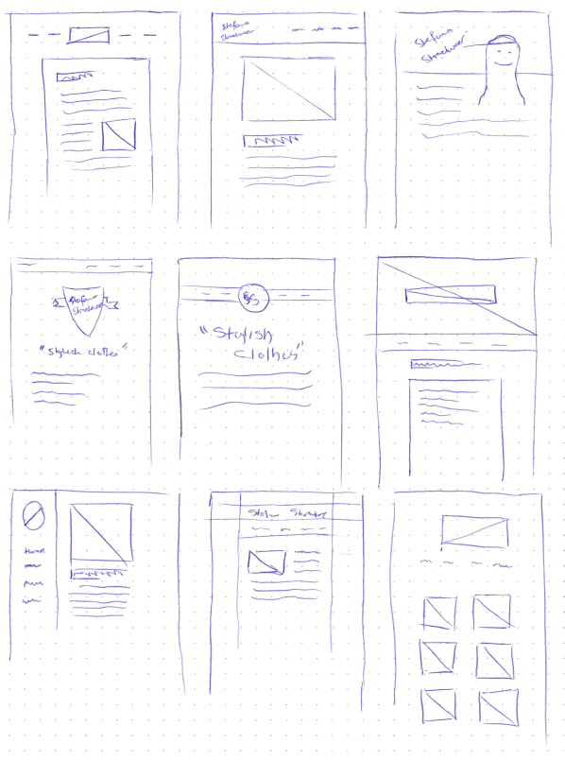

In the end I decided that a handful of these designs were good enough to continue exploring so I selected four to do a more detailed drawing of. I chose the layouts which I believed would best fit the theme of a fashion designer. This meant that layouts with large header images, or large slogans I tended to favour over more text heavy layouts. Some of the layouts such as the top right storyboard, I believe if done right would look really good but due to the scope of this task I decided to only choose relatively simple layouts.

I began refining these two layouts, as I liked the unique look that the vertical navigation bar display, and placed the focus on the content. Despite this, I didn’t feel like this layout would be a good match, as it relies on much more textual content.

The second layout was much more promising for a fashion designer, and while there is no intrinsic quality I disliked, I felt as if that layout is far too basic, and is seen in most webistes. Since the design isn’t very unique, I felt other designs may be a better fit.

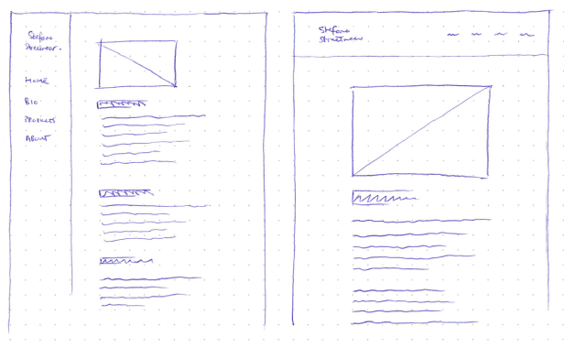

This first layout was my favourite, as I believed a large banner image with the logo and navigation placed on top would be the most punchy, and appealling. The design isn’t that unique, but it puts the products, and imagery at the front of the users perspective, which is what we want in our fashion website.

The second layout is quite similar to the first layout, except moves the navigation off the cover image to down below. I also don’t mind this layout, however I the website will probably feel far more compact if the navigation is placed on top of the cover image. It is not like we need to fit that many links onto the cover image, as the website is relatively small.

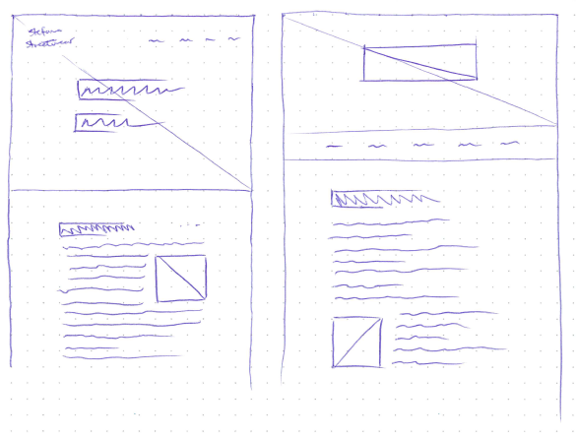

In the end I went for this design, as I thought it captured the imagery and brought it to the front of the users attention. The logo and navigation are tucked away, while our eyes are drawn to the focal point containing the slogan.

The rest of the website is fairly standard, and will contain primarily text and the occasional image, which will be used to assist the text content.

I don’t feel like there is much more that can easily be explored on paper, so it is probably best to start playing around with this design digitally to get a better idea of the colours and pallate.

