# Website research.

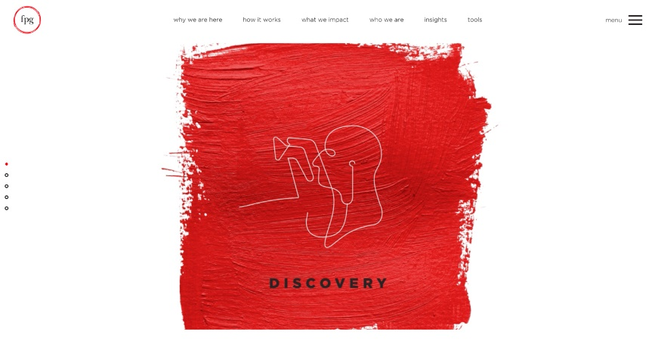

This website utilises an extremely minimal, but powerful colour palate, of only red, black and white. The centre image, clearly acts as a focal point, which is enhanced through the textured style. In Jean’s website I could attempt to achieve a similar effect, through the use of a minimal colour palate and perhaps include a gravelly, road texture which enhances the “street” icon of Jean’s business.

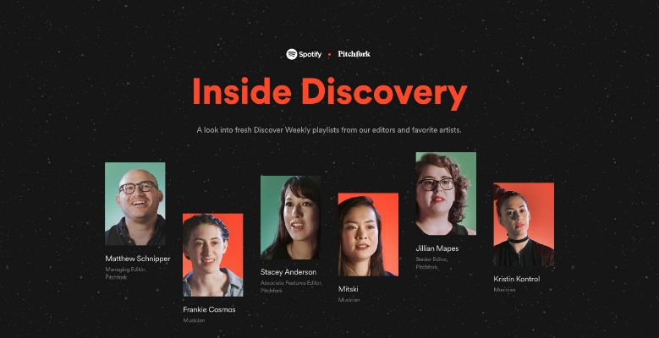

The colour palate used in this website is again extremely simple, and uses bright, contrasting colours to bring key elements into the view of the user. Asymmetric balance is seen in the wall of images, which makes the website feel less imposing, and boxy. When designing Jean’s website, I could attempt to use a bright, contrasting colour palate, and incorporate more asymmetry into the layout of elements, rather than going for the standard rectangular layout.

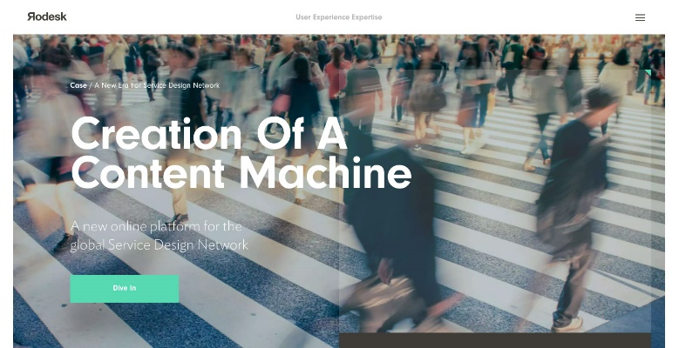

I chose this website, because of its strong use of typography. The logo is extremely minimal, yet it remains unique and still displays a lot of character. The font choice of the jumbotron text, is extremely bold and easy to read. This theme of bold, readable, serif fonts create a more user friendly experience.

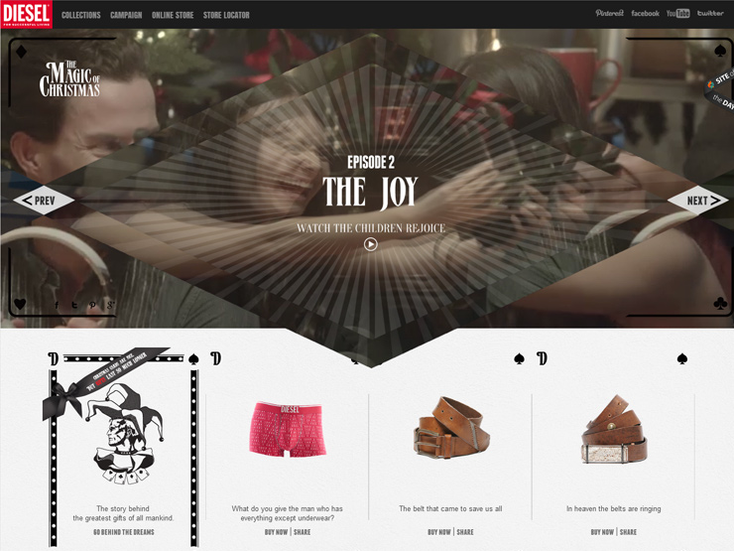

While this page has quite a lot going on, I included it because the navigation appears really simplistic and tidy. The business logo, has been clearly separated from other links, and the typography and colours of the navigation allow it to blend into the page. It doesn’t take away from the main content, but it is easy to find if the user wants to find it. I should ensure that when designing Jean’s website that I adopt this ideology.

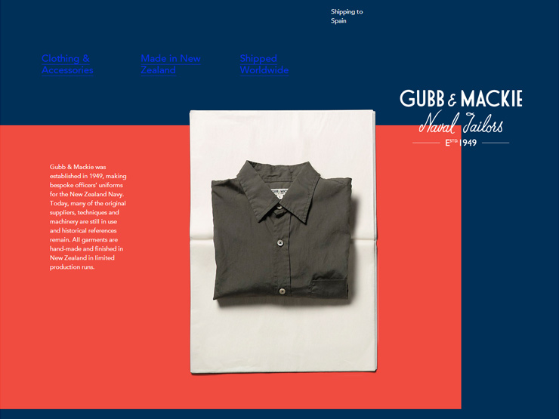

This page was chosen because of its creative layout and striking colour scheme. The layout uses asymmetrical rectangles which makes it unique from almost all other websites. The imagery is well chosen, and integrates into the page well. When designing Jean’s website, I will need to attempt to integrate a variety of images into the website seamlessly. Unfortunately, due to my inexperience with photography, and the varying quality of public domain images, it will be much more difficult to create this level of quality.

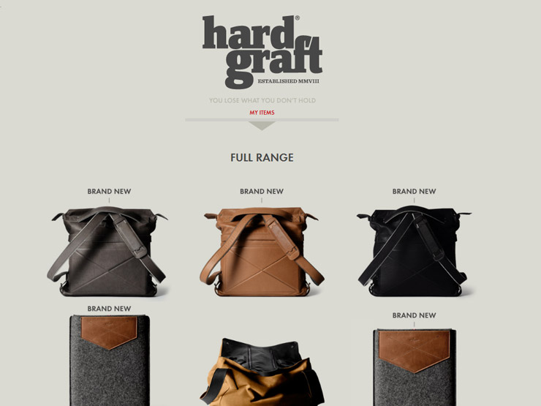

This website is powerful, because it is extremely simple, yet it shows exactly what the user wants to see. The use of a plain coloured background works well, and helps bring the focus to the images of the bags, as well as the logo. The logo is well designed, and holds the character of the business well. When creating Jean’s logo, it is important to reflect the type and culture of the business. I should also play around with using simple colours, to place the focus on the content.

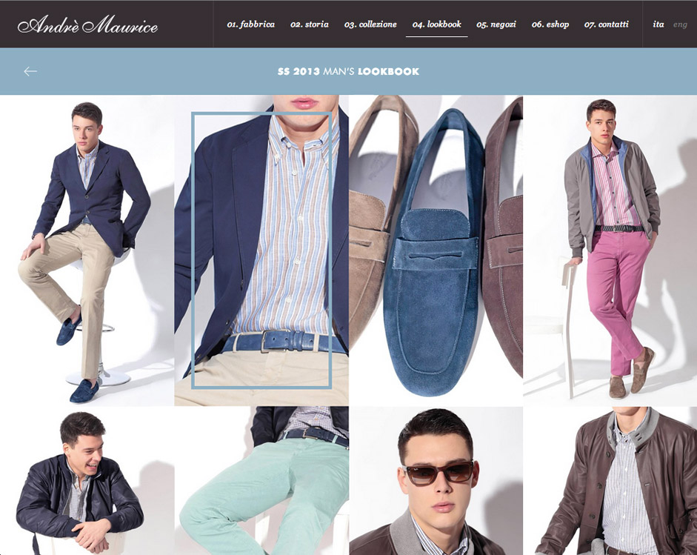

This website employs the use of a sans-serif, handwritten typographic style. The style gives the website a more “handcrafted” feel. Along with the incorporation of a collage of interactive images, which display the type of products being sold. While the use of a sans-serif font may not be appropriate for Jean’s “streetwear” website, it might be a good idea to experiment with a few.

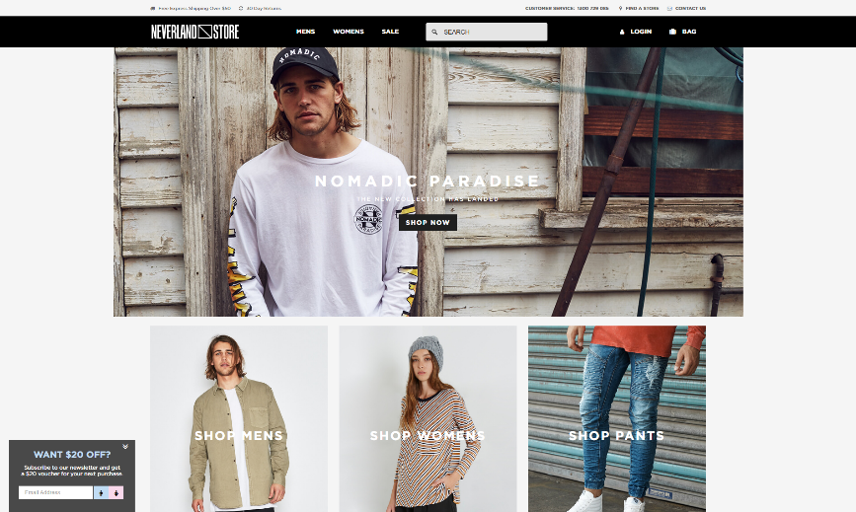

This website also is in the business of “streetwear” and has opted to use bold, serif typography, with large images to direct users throughout the website. The use of clickable images, may be more effective than just using text to link between pages. When building Jean’s website, I should try and create links using images, which could be a more effective, and user friendly way of linking between pages. It is also more modern, and mobile friendly.

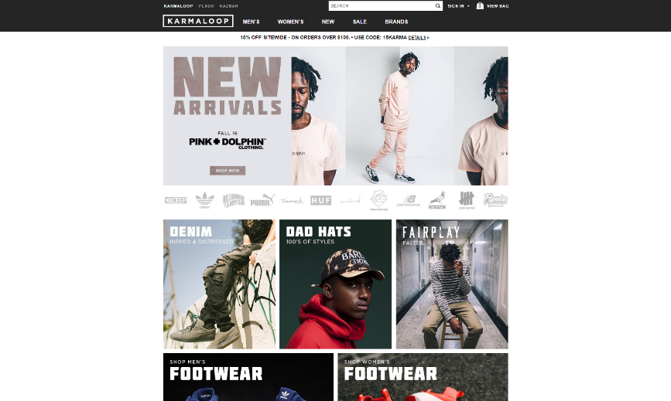

This is another website, which is in the “streetwear” domain, and uses a dark, and minimalistic colour scheme. Instead of using bright colours, charcoals and whites are used, and combined with photos and crisp typography. When building Jean’s website, I should be conscious, that a minimal, grey colour scheme will suit the target audience better than a bright, abstract colour scheme.