Scott Tornquist
Abstract Data Structures
Hw# 4
Write-up
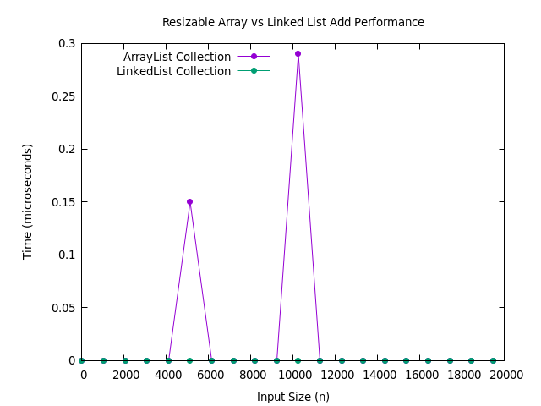
The add function is constant time for the linked list because the Linked collection used the add-to-end function from linked list which is constant time because there is tail pointer, so it add directly to the end of the list withou having to iterate through the list. Therefore it is same amount of time to add no matter the length of the list, so it is constant time. O(n) = 1

The same logic follows for the array list except for how we account for the spikes. The spikes are caused by resized when the array gets too big. However we account for thess spikes by using amortized analysis which essentialy proves that the spikes can be averaged out over the course of time. This gives a stlight higher cost 3n instead of 3n-1. However this is still constant. So O(n) =1

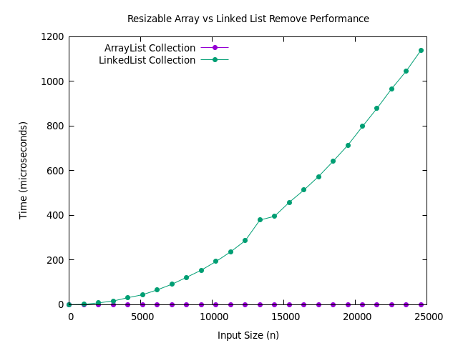
The remove() function for Linked List collection is very slow because it must iterate through the list to find the key where it calls get() which iterates through the kv_list to find each key and check it to finally remove. In the worst case this becomes a nested for loop which is O(n^2).

The remove() function for Array List collection is much faster because get() goes straight to the value and does not have to iterate through the list. Array list Remove() does have a worst case of O(n) but this worst case is not possible because there can not be repeated keys. So in the worst case, it is O(n).

O(1) = Constant time
O(log(n)) = when spliting work load in half
O(n) = when going through entire list
O(nlog(n)) =when spliting in half and sorting through list (merge sort and quick)
O(n^2) = nested loops (quick sort worst case: sorted or reverse sorted)

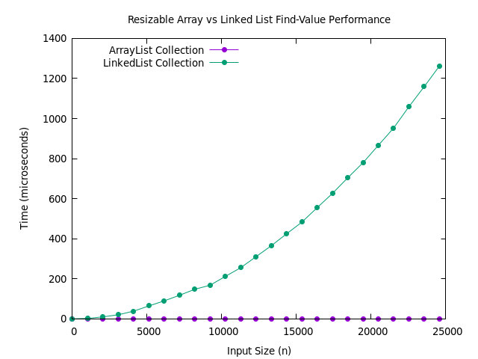
The find-value() function for Linked List collection is very slow because it must iterate through the list to find the key where it calls get() which iterates through the kv_list to find each key and check it. In the worst case this becomes a nested for loop which is O(n^2).

The find-value() function for Array List collection is much faster because get() goes straight to the value and does not have to iterate through the list. So in the worst case, it is O(n).
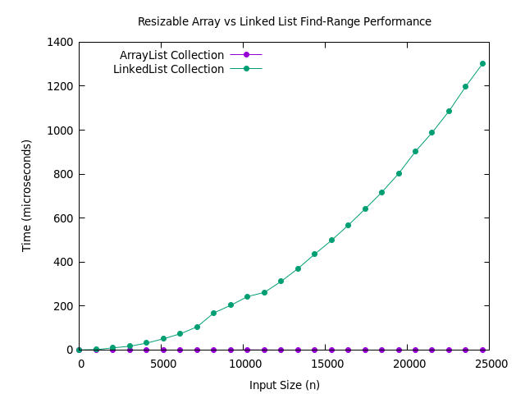
The find-range() function for Linked List collection is very slow because it must iterate through the list and call get() on all values which iterates through the kv_list to find each key and check if it within the range. In the worst case this becomes a nested for loop which is O(n^2).

The find-range() function for Array List collection is much faster because get() goes straight to the value and does not have to iterate through the list. So in the worst case, it is O(n).
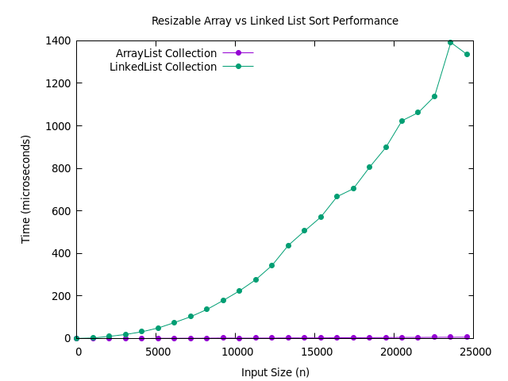
The sort() function for Linked List collection is very slow because it must iterate through the list to call get() on every key to add them to the arraylist to be sorter, which iterates through the kv_list to find each key. In the worst case this becomes a nested for loop which is O(n^2). The sort function is merge sort which has a worst case of nlog(n). So big-o is n^2 + nlog(n) which is O(n^2).

The sort() function for Array List collection is much faster because get() goes straight to the value and does not have to iterate through the list. So adding the keys to the array is much faster. So in the worst case, it is O(n). The sort part of the function is quick-sort which has a worst case of O(n^2).
So big-o is n^2+ n which is O(n^2).

Operation | Collection Implementation
Operation | Array List | Linked List
Add | O(1) | O(1)
Remove | O(n) | O(n^2)
Find-Value | O(n) | O(n^2)
Find-Range | O(n) | O(n^2)
Sort | O(n^2) | O(n^2)

I learned a lot about setting up classes on my own and I felt like I really understood what was going on with the inheritance for the first time. The hardest part of the hw was wraping my head around what the collection really was. Which is just a way of using old code to do a new thing. We really did not creat anything that complex. Under the hoood there is a lot goin on but object oreineted programming makes it seem very simple.

