Scott Young
CSD 310 – Assignment 1.2
GitHub Repository Setup
October 18th, 2026

Local Directory Screenshot
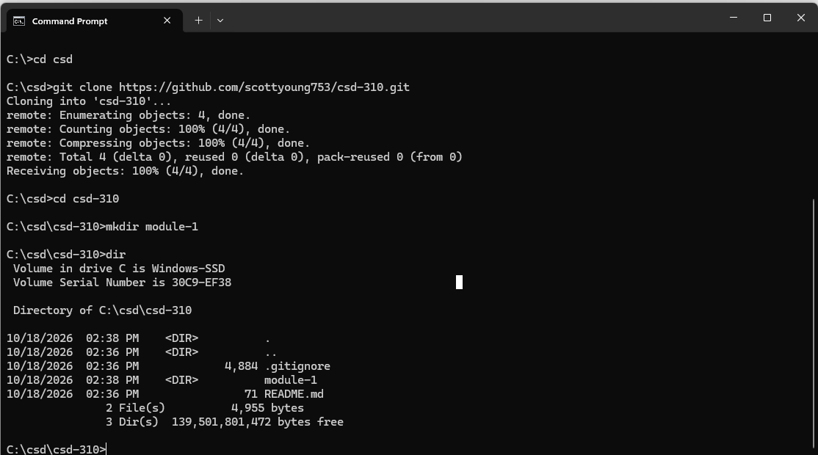
GitHub Repository Screenshot
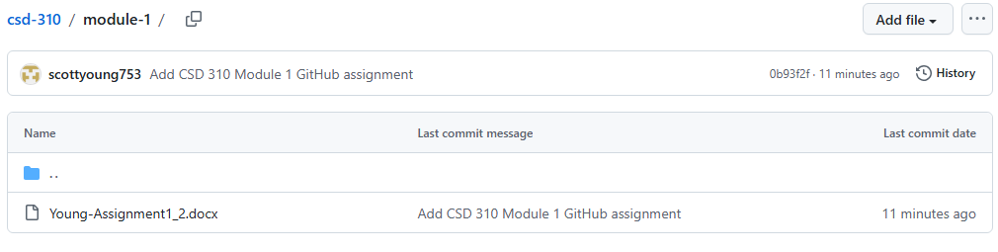
GitHub Repository URL:
https://github.com/scottyoung753/csd-310

