CSD 310 – Module 2.3: Data Models
Scott Young
October, 30 2026

Entity Relationship Diagram (ERD):
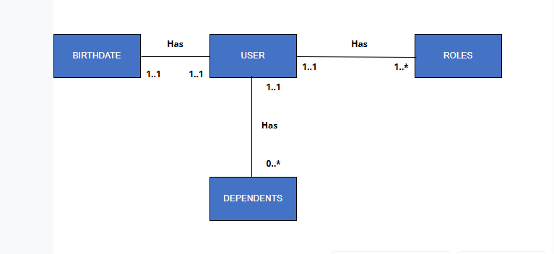
NoSQL Data Structure:
