Scott Young
CSD 325 – Module 2.2
Documented Debugging
Screenshot 1 – Breakpoint
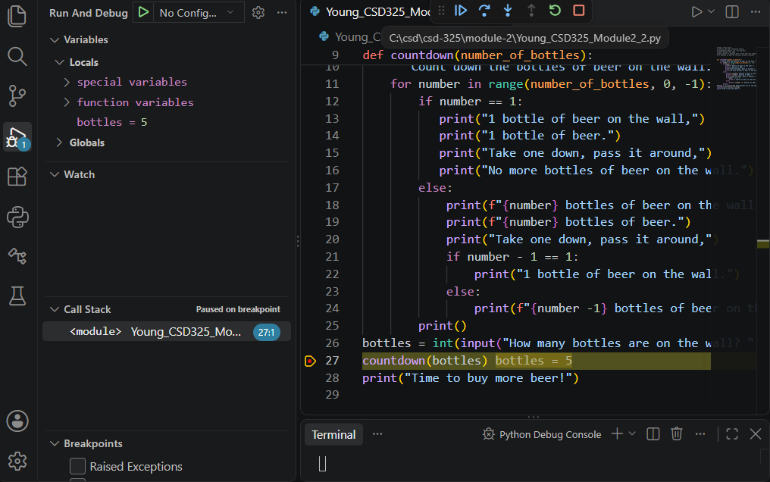
I placed a breakpoint on line 27, where the program calls the countdown function. When I started debugging, Python paused before executing that line. The Variables panel shows that the user entered 5 bottles, confirming that the value was stored correctly before being passed to the function.

Screenshot 2 – Step Into Function
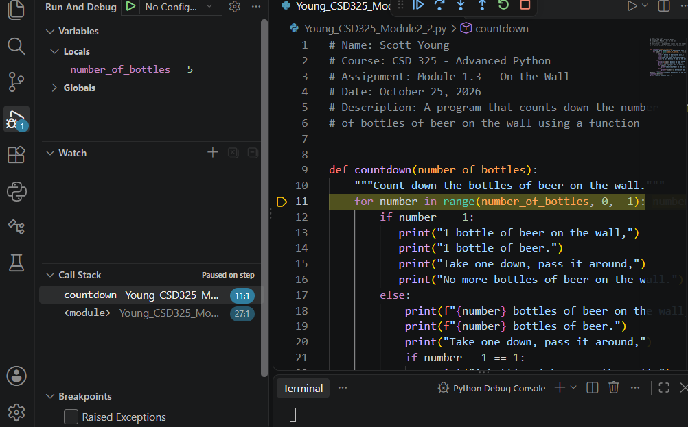
I used the Step Into command (F11) to enter the countdown function. The debugger moved from line 27 to line 11, where the for loop begins. This allows me to examine how the function processes the number of bottles entered by the user.

Screenshot 3 – Stepping Through the Loop
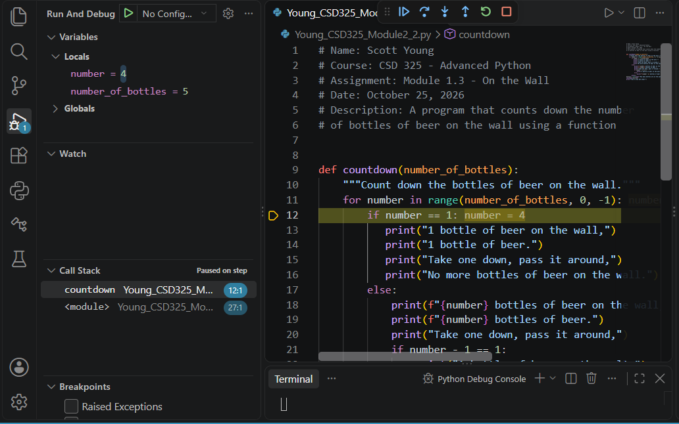
I used Step Over (F10) to follow the program as it executed the countdown loop. The Variables panel shows that the value of number changed from 5 to 4, while number_of_bottles remained at 5. This demonstrates how the loop processes each number in the countdown and how the debugger allows me to monitor variable values during execution.

