Scott Young
CSD325 – Advanced Python
Assignment 1.2 – GitHub Repository Setup
October 19th, 2026

Local Directory Screenshot:

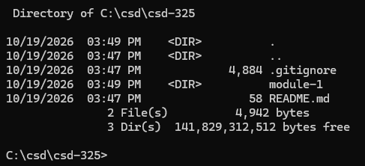

GitHub Repository Screenshot:

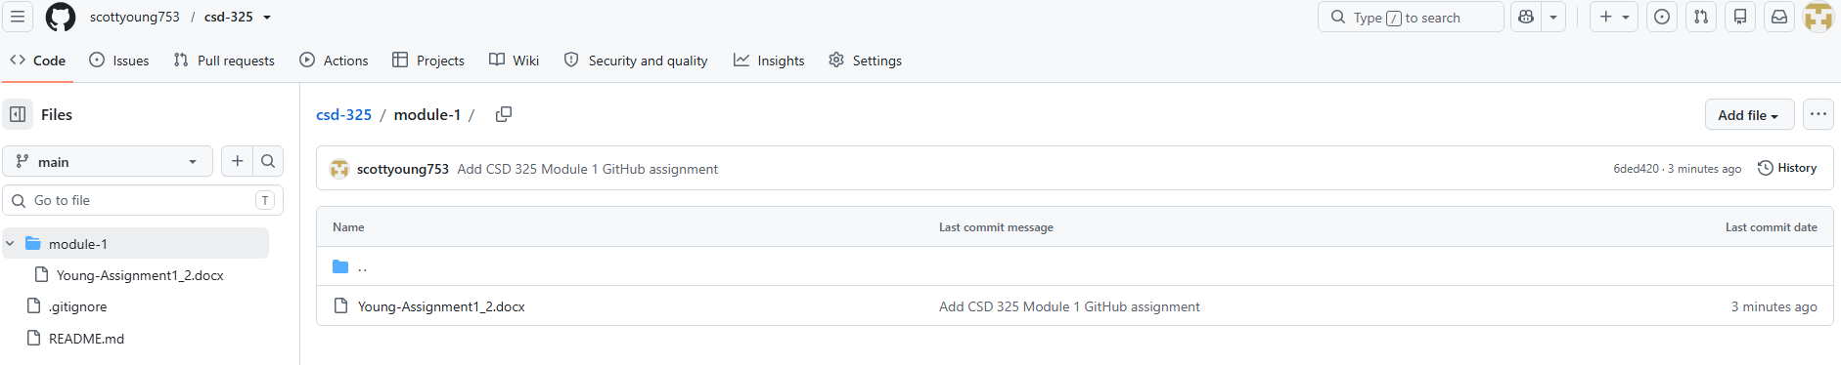

GitHub Repository URL:
https://github.com/scottyoung753/csd-325

