IFQ557 Rapid Web Development
Assignment 1: Design

Student: Scott Sadler
Student ID: N0933503
Date: 28 November 2025

1. DESCRIPTION
Mr Stickerman is a fictitious online sticker store based in Bundaberg, Queensland. It sells themed sticker packs. The store offers a variety of high-quality vinyl stickers in many categories, including: TV shows and movies, anime, gaming, pop culture, and nature themes. Each sticker pack contains between 50-100 individual stickers with detailed specifications including: size (usually 3 to 8 cm), finish type (glossy or matte), and material (usually premium waterproof vinyl). Customers can browse products by theme, view detailed product information, add items to a shopping basket, and complete purchases. Delivery is available anywhere in Australia. The inspiration for this store came from my granddaughter, who is obsessed with stickers, and reminded me of how many of my students (over the years of teaching) also loved stickers related to their interests.

2. USER STORIES
[1] Homepage Layout
As a new visitor, I want the homepage to focus on the different Categories and the New Arrivals section rather than dumping the whole catalogue on me. This helps me find the sections I'm actually interested in without getting overwhelmed.
Acceptance Criteria:
- There's a clear "Shop by Category" section on the landing page.
- A "New Arrivals" block highlights fresh stock.
- I shouldn't see the full product list immediately; the page should guide me to these sections.

[2] Product Details
As someone who puts stickers on things like water bottles and laptops, I need to see specific details about the material and finish before I buy. I have to know if it's durable vinyl or just paper so I don't waste money on something that won't last.
Acceptance Criteria:
- Clicking a sticker pack opens the full details page.
- Needs to list size, material type, and sticker count clearly.
- Make sure the "Add to Basket" button is easy to find here.

[3] Adding to Basket
As a shopper, I want to be able to add multiple packs to a basket so I can build up an order while I keep looking around the store.
Acceptance Criteria:
- Every product needs an active "Add to Basket" button.
- The basket needs to save my items while I navigate away.
- Show me a running total so I know where I'm at.

[4] Adjusting Quantities
As a customer on a budget, I need an easy way to change the number of items in my basket. Sometimes I decide to grab extras for friends or cut back if the price gets too high, and I don't want to navigate back to the product page to do it.
Acceptance Criteria:
- Simple plus/minus or input field for quantity in the basket view.
- The total price needs to update the second I change the number.

[5] Removing Items
As a decisive shopper, I want to delete items from my cart if I change my mind. It needs to be quick, but I’d like a prompt just to make sure I didn't click it by accident.
Acceptance Criteria:
- Include a "Remove" or trash icon next to each line item.
- Ask me "Are you sure?" so I don't accidentally delete stuff.
- Update the total cost immediately after it's gone.

[6] Cost Visibility
As a customer ready to pay, I need to see the exact total of my order before I hit checkout. I need to know the full cost upfront so there are no surprises.
Acceptance Criteria:
- The basket page must show the subtotal clearly.
- Make sure the math updates instantly if I add or remove things.
- Format it like currency ($0.00) so it's easy to read.
[7] Search Function
As a user looking for a specific character, I want to use a search bar to find packs by name. It’s much faster than browsing if I already know what I want.
Acceptance Criteria:
- Put a search bar on the homepage.
- It should pick up keywords from the product name or description.
- Results should look the same as the normal shop view.

[8] New Arrivals
As a returning customer, I want a dedicated spot to see just the newest products. I check in often to see what's new, and I don't want to have to hunt for the latest designs.
Acceptance Criteria:
- A specific "New Arrivals" section on the home page.
- Mark these items with a "NEW" badge or similar.
- Show at least the last 3 to 6 uploaded products.

[9] Checkout Address Input
As a customer, I need a simple form to enter my delivery address. It’s crucial that I can put in my details clearly so the package actually makes it to my house.
Acceptance Criteria:
- Ask for Name, Email, Phone, and the full Address.
- Mark the important fields as "Required."
- Don't let me submit if I've missed a mandatory field.

[10] Order Review
As a careful buyer, I want to see a summary of everything—items, quantities, and the address—on one screen before I make the payment. I need to double-check I haven't made a mistake.
Acceptance Criteria:
- Show a final list of what I'm buying and how much it costs.
- Display the shipping address I just typed in so I can check it.
- Give me a "Back" button in case I need to fix something.

[11] Order Confirmation
As a customer, I want to see a confirmation screen with an order number as soon as the payment goes through. It gives me peace of mind that it actually worked.
Acceptance Criteria:
- Load a "Thank You" page immediately after purchase.
- Show a unique Order ID number.
- Include a brief summary of what I just bought.

[12] Image Quality
As a visually driven buyer, I need to see high-quality images of the stickers. I'm buying art, basically, so I need to check the quality and colors before I commit.
Acceptance Criteria:
- Every product page needs at least one good image.
- No blurry or tiny thumbnails; they need to be clear.
- Let me see a larger version on the details page.

[13] Site Navigation
As a user, I want a consistent menu bar on every page. I need to be able to jump between the Home, Basket, and Categories sections without getting lost or having to hit the "Back" button on my browser constantly.
Acceptance Criteria:
- Keep the main navigation visible on all pages.
- Include links to Home, Categories, New Arrivals, and Contact.
- Highlight the tab I'm currently on.

[14] Trust & Info
As a new customer, I want to easily find the "About Us" and contact info. It helps me trust that this is a real business, and I need to know how to reach you if something goes wrong with the shipping.
Acceptance Criteria:
- Have an "About Us" page that explains who runs the shop.
- Put contact details (email/phone) in the footer.
- Make sure links to Shipping and Return policies are easy to find.

3. CONCEPTUAL MODEL
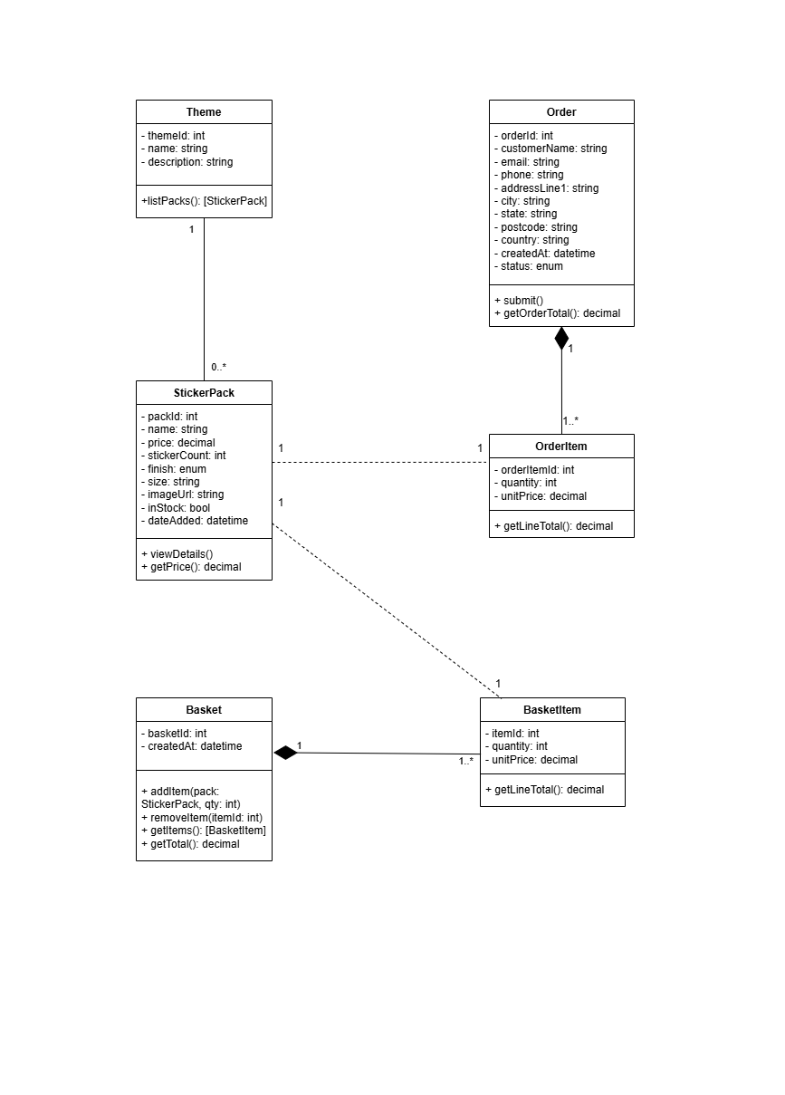

4. DATABASE DESIGN

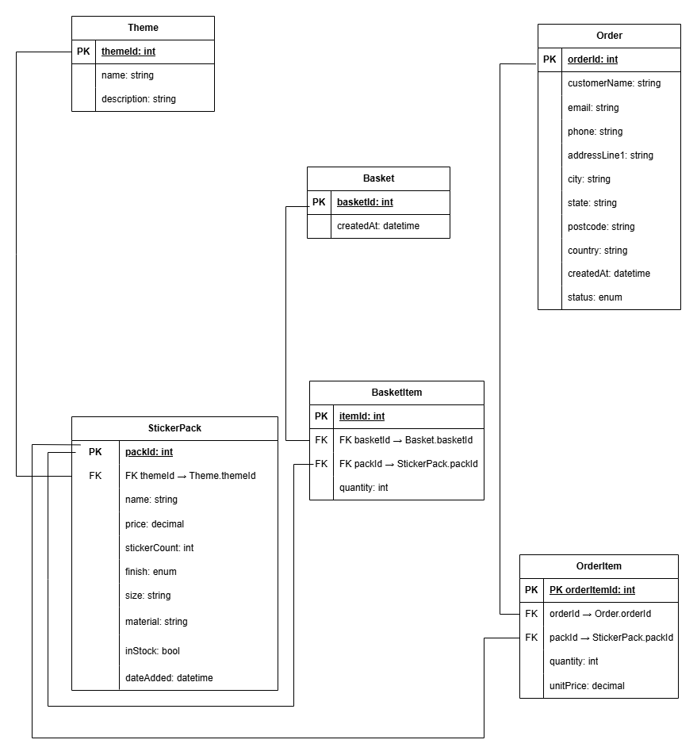

References

Bootstrap. (n.d.). Components. https://getbootstrap.com/docs/4.3/components/

Diagrams.net. (n.d.). Draw.io. https://www.drawio.com/

