PROJECT IN AUTOMATA AND LANGUAGE THEORY
GENDER NEUTRAL LANGUAGE RECOGNIZER
Submitted by:
Denver Ugay
Lean Naive
Rovilyn Castrodes
Krisha Joyce Gulay
BSCS 3B
Submitted to:
ALMA MAE B. AUXTERO
Instructor
Date submitted: October 26, 2026

1 Project overview
NeutralScan FSA is a web application that reads a text document, finds predefined gender-specific words and phrases, and suggests gender-neutral alternatives. It shows the detected terms in a results table with the number of occurrences and suggestions, highlights the matches in the text, and displays the automaton states used to recognize a selected term. Suggestions are for review only; no automatic replacement is done.

2 Tools and recognition approach
Language and tools: HTML, CSS and JavaScript (runs in any modern browser, no installation). Optional readers: mammoth.js (.docx) and pdf.js (.pdf).
Approach: Finite State Automaton (trie-based DFA).
All terms in the dictionary are inserted into a trie. Each node is a state, each character is a transition, and a node where a term ends is an accepting state. State q0 is the start state. Formally, the DFA is M = (Q, Σ, δ, q0, F) where Q is the set of trie nodes, Σ is the set of lowercase characters, δ(q, c) moves to the child of q labelled c, q0 is the root, and F is the set of nodes that end a term.
Ignoring capitalization: every input character is converted to lowercase before the transition (text[i].toLowerCase()).
Whole-word matching: a scan may only start where the previous character is not a letter or digit, and an accepting state is reported only if the next character is not a letter or digit. This is why "he" is not detected in "the" (the scan cannot start at the "h" of "the" because the previous character "t" is a letter).
Sample transition table for the term "fireman" (all other inputs go to the dead state and the scan restarts):
State | q0 | q1 | q2 | q3 | q4 | q5 | q6
Next on → | 'f' → q1 | 'i' → q2 | 'r' → q3 | 'e' → q4 | 'm' → q5 | 'a' → q6 | 'n' → q7 (accept)
Reading "Fireman": q0 -f→ q1 -i→ q2 -r→ q3 -e→ q4 -m→ q5 -a→ q6 -n→ q7. q7 is accepting and the next character is a space, so the term is recognized.
Predefined terms and suggested alternatives:
Term | Suggested alternative
he | they
she | they
him | them
her | them/their
chairman | chairperson
stewardess | flight attendant
policeman | police officer
fireman | firefighter
manpower | workforce
mankind | humankind
ladies and gentlemen | everyone
salesman | salesperson
businessman | businessperson
spokesman | spokesperson
mailman | mail carrier
waitress | server

3 Application screenshots
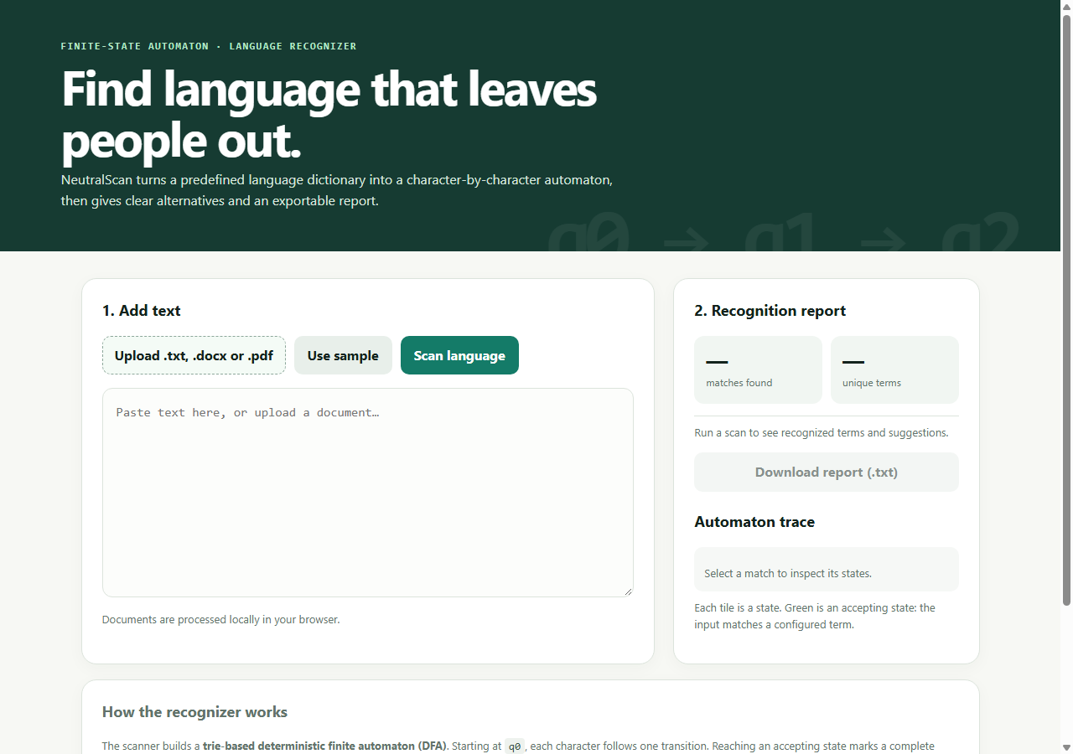
Figure 1. Application start screen with the file upload button.
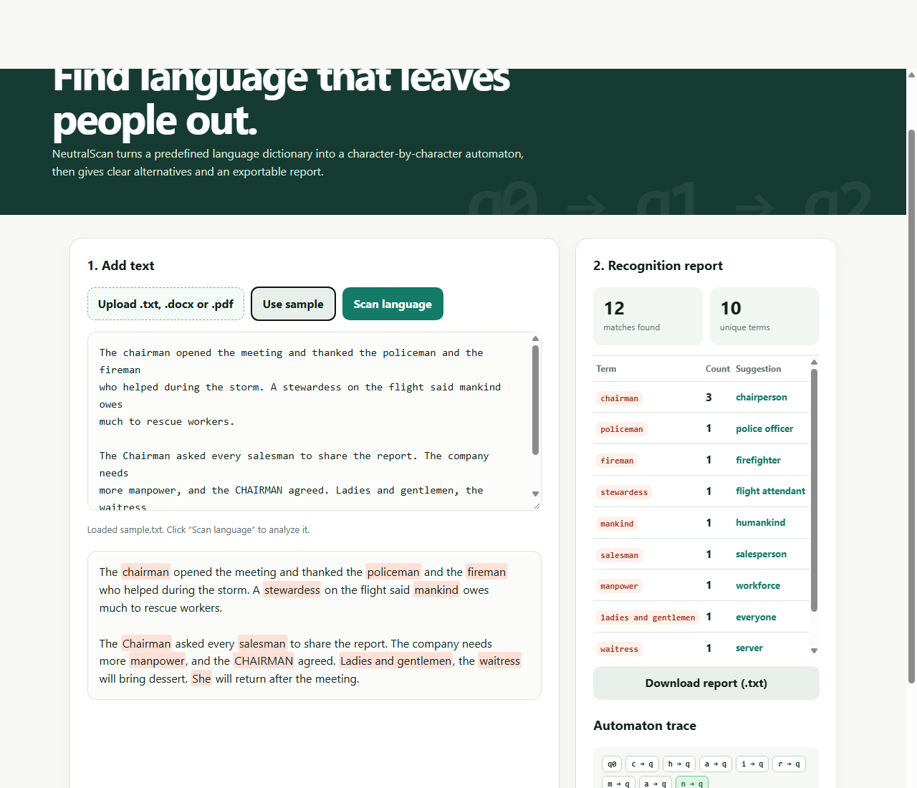
Figure 2. sample.txt loaded: detected terms, counts and suggestions, with highlighted text.
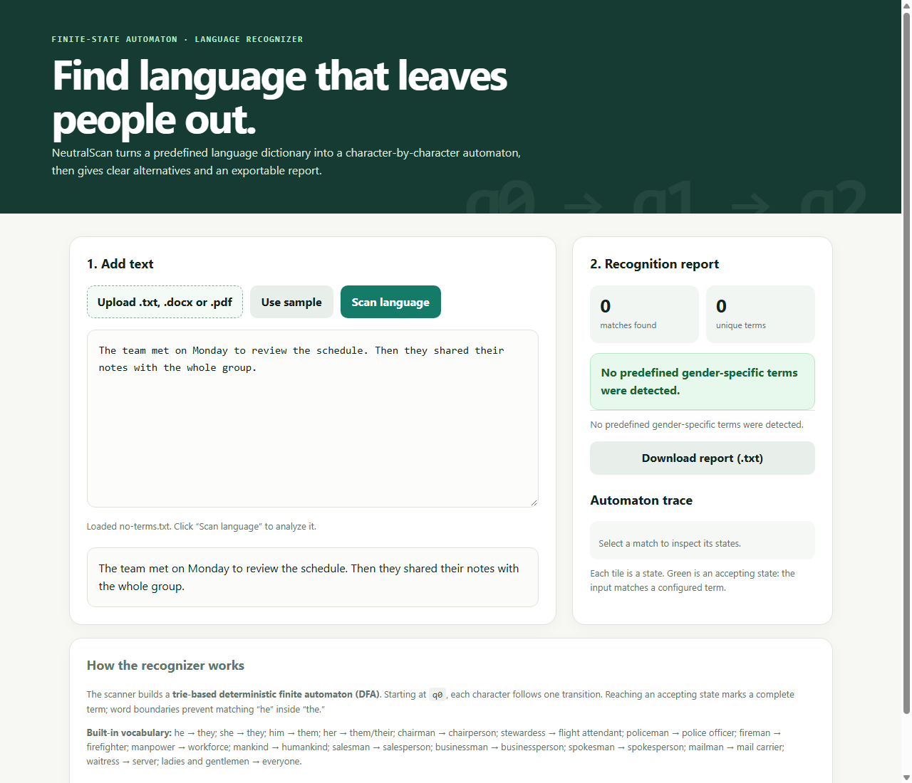
Figure 3. A document with no detected terms.
Source code / GitHub link: https://github.com/scotzf/Gender-Neutral-Language-Recognizer

4 Testing
Test situation | Expected result | Actual result | Passed?
1. Document with listed terms (sample.txt) | Terms detected with counts and suggestions | chairman 3, policeman 1, fireman 1, stewardess 1, mankind 1, salesman 1, manpower 1, ladies and gentlemen 1, waitress 1, she 1 (12 matches, 10 unique) | Pass
2. Same term repeated with different capitalization | "The CHAIRMAN and the chairman met. Chairman Lee said the policeman was there." → chairman = 3, policeman = 1 | chairman 3 (chairperson), policeman 1 (police officer) | Pass
3. No listed terms, includes "the", "then", "they" | "No predefined gender-specific terms were detected." | Message shown; "he" not detected inside "the"/"then"/"they" | Pass
4. Empty .txt file | Clear message for an empty file | "The file is empty." | Pass
5. Unsupported format (.csv) | Clear unsupported-format message | "Unsupported file format. Please upload a .txt, .docx or .pdf file." | Pass

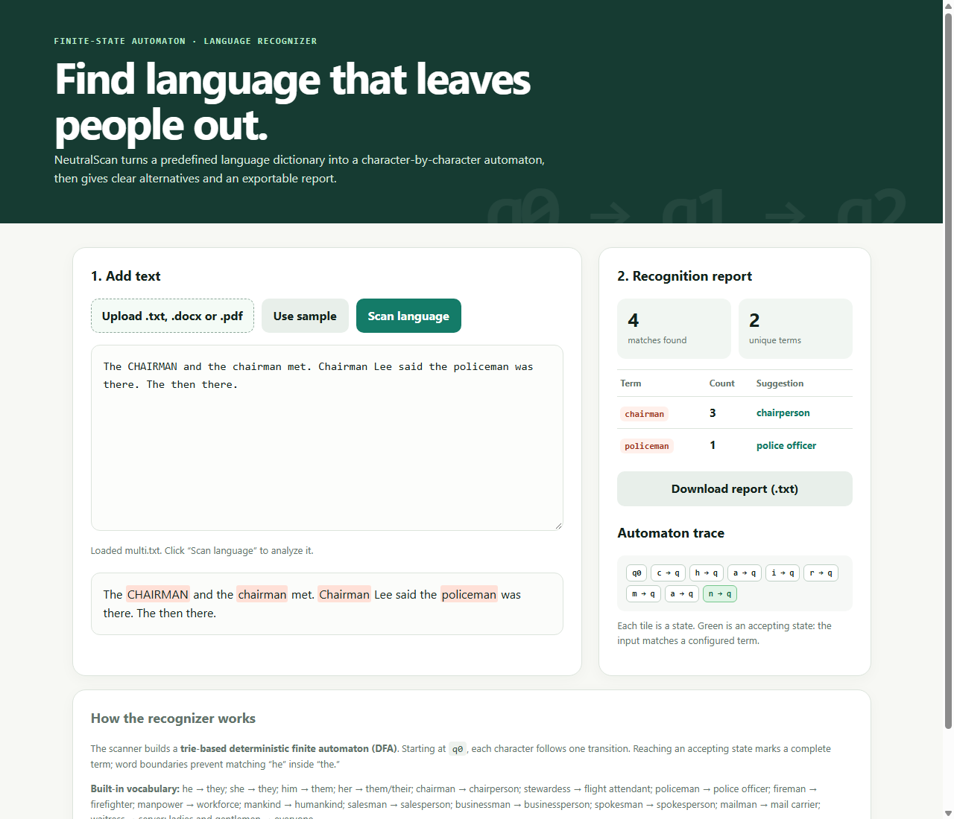
Figure 4. Test 2: repeated term with different capitalization.
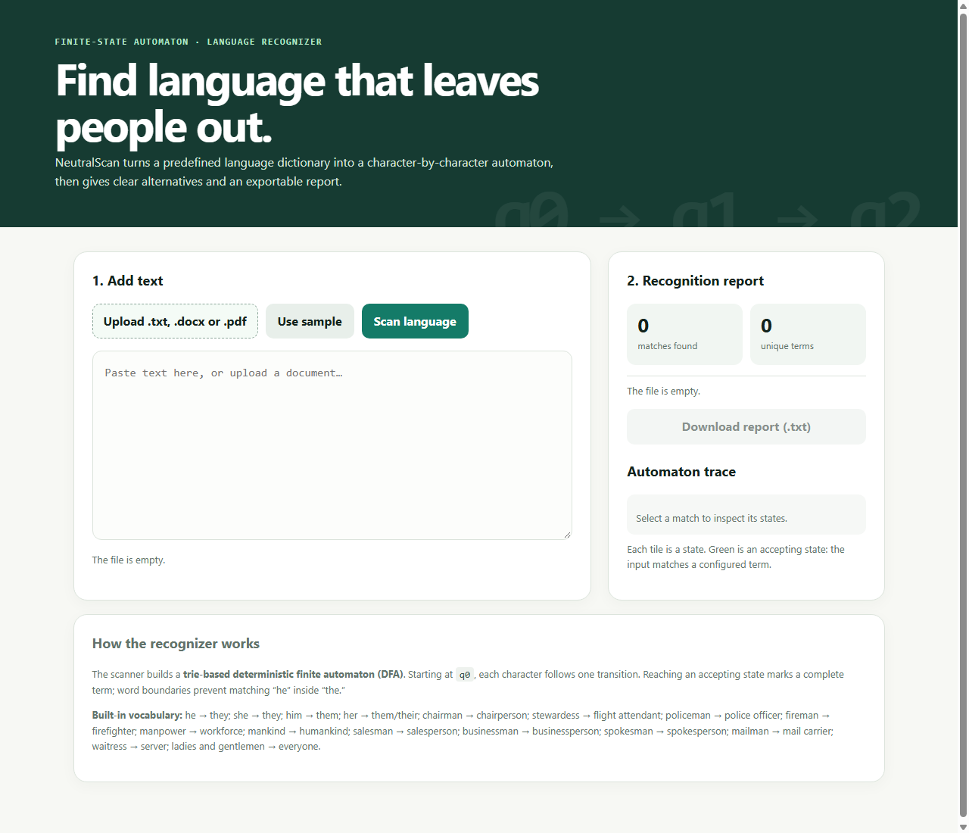
Figure 5. Test 4: empty file.
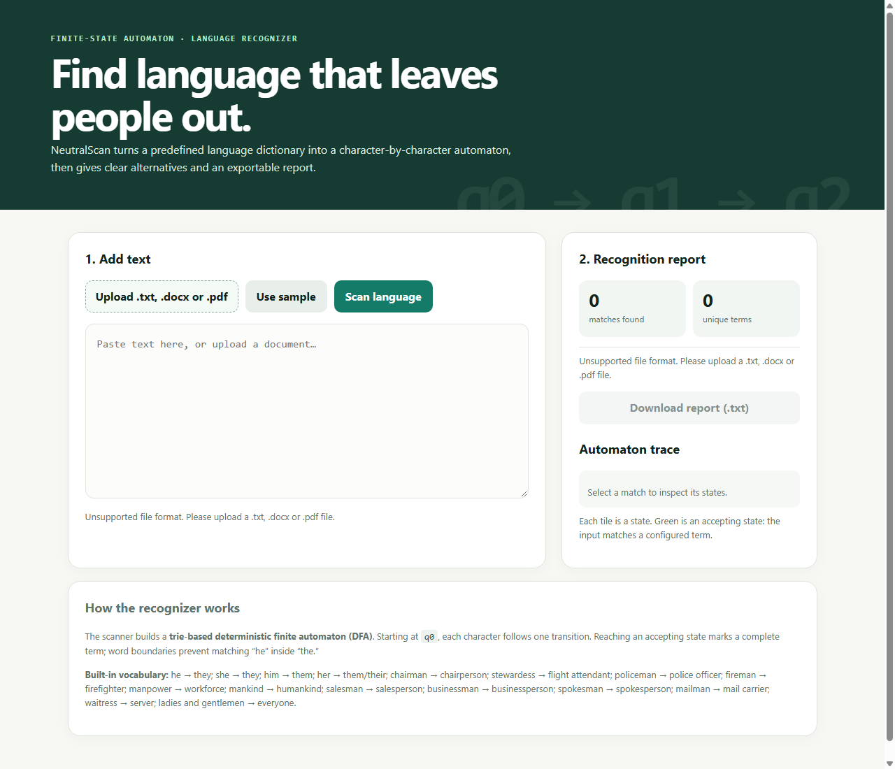
Figure 6. Test 5: unsupported file format.

5 Conclusion
We completed a working gender-neutral language recognizer that uses a trie-based finite automaton to detect predefined terms case-insensitively and as whole words, then reports counts and suggested alternatives. We learned how a dictionary of words can be converted into a DFA and how word-boundary checks prevent false matches such as "he" in "the". Limitations: the dictionary is fixed and small, pronouns such as "he" and "she" are flagged even when they refer to a specific person, plural or irregular forms (e.g. "policemen") are not included, and suggestions need human review because the right replacement depends on context.

6 Sources and contributions
References: course notes on finite automata; mammoth.js (docx reading) and pdf.js (PDF reading) via cdnjs. AI assistance: Claude (Anthropic) was used to help build and test the application and draft this document.
Member | Contribution
Denver Ugay | [Describe contribution]
Lean Naive | [Describe contribution]
Rovilyn Castrodes | [Describe contribution]
Krisha Joyce Gulay | [Describe contribution]

