A script for changing the nickname, username, and description for accounts in tg. First you need to enter here
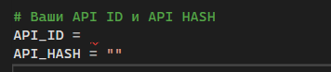
Your API_ID and API_HASH can be obtained on the website https://my.telegram.org/apps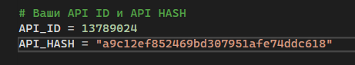
After that, in the database accounts.txt you also need to enter API_ID and API_HASH and data from Telegram accounts.
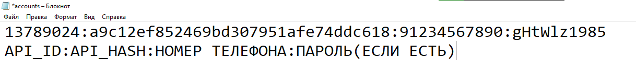
Besides accounts.txt there are 3 databases. Nicknames.txt bios.txt and base_usernames.txt
You can enter your data in them. It is IMPORTANT that each nickname / username / bio must be entered from a new line.The values are selected randomly from the presented options.If successful, you will see the following message
