

# CALIFORNIA Comprehensive State Literacy Plan

March 2021

California Department of Education



## Contents

Contents 1

Acknowledgments 2

Preface 7

Executive Summary 8

Introduction 9

Plan Purpose 10

How to Read this Document 12

California’s Diversity 13

Comprehensive and Integrated Literacy Model 16

Best First Instruction 16

Supporting Best First Instruction 33

SLP Continuous Improvement Process 49

Step 1: Set Direction and Purpose 50

Step 2: Assess Local Needs and Determine Causal Factors 55

Step 3: Plan for Improvement 71

Step 4: Implement and Monitor Work 98

Step 5: Reflect and Adjust Course 99

Works Cited 100

Appendix A: Glossary 102

Appendix B: Data Tables 107

Appendix C: CAASPP Trend and Cohort Results 120

## Acknowledgments

The California Department of Education (CDE) wishes to thank members of the public for their engagement and thoughtful feedback in the development of the Comprehensive State Literacy Plan (SLP).

The SLP was developed with the support of the following members of the State Literacy Team (SLT). The CDE extends great appreciation for their efforts.

**Jessica Bammerlin**, Resource Teacher, Yreka Union Elementary School District

**Tina Cheuk**, Assistant Professor in Elementary Science Education, California Polytechnic State University

**Deborah Costa-Hernandez**, Executive Director, California Reading and Literature Project, California Subject Matter Project

**Nancy Cushen-White**, Clinical Professor of Pediatrics, University of California, San Francisco Dyslexia Research Center

**Sydney Dion**, District Literacy Instruction and Design Coach, Tahoe-Truckee Unified School District

**Tammy Duggan**, District Reading Specialist/Instructional Coach, Thermalito Union Elementary School District

**Jennifer Elemen**, Educational Administrator, Language & Literacy, History-Social Science-Civics, Monterey County Office of Education

**Barbara Flores**, Professor Emerita, California State University, San Bernardino

**Marlene Fong**, Coordinator, Instructional Leadership Corps, California Teachers Association

**Kathy Futterman**, Adjunct Faculty for the Departments of Educational Psychology & Teacher Education, California State University, East Bay

**Margaret Goldberg**, Early Literacy Lead, Oakland Unified School District

**Roni Jones**, Senior Manager for System of Support, California Collaborative for Educational Excellence

**Elizabeth Kaufman**, Associate Superintendent, Educational Services, Sonoma Valley Unified School District

**Gwenn Lei**, Coordinator, Reading Language Arts/History-Social Science, San Mateo County Office of Education

**Lorena Lopez**, Teacher, Azusa Unified School District

**Andrea Marks**, Director of Curriculum, Instruction, and Accountability, Nevada County Superintendent of Schools

**Dana McVey**, Child Development Consultant, First 5 California

**Robin Mencher**, Executive Director, Education, KQED

**Edward “Alex” Mertens**, Teacher, Fresno Unified School District

**Mindy Montanio**, Teacher on Special Assignment, Kern High School District

**Michelle Nieto**, Teacher, San Diego Unified School District

**Melissa Pattullo**, District Literacy Specialist, Huntington Beach Union High School District

**David Pearson**, Evelyn Lois Corey Emeritus Professor of Instructional Science, UC Berkeley

**Lucy Pearson-Edwards**, Director of Continuous Improvement and Academic Support, California County Superintendents Educational Services Association, Napa County Office of Education

**Roxann Purdue**, Consultant, California Commission on Teacher Credentialing

**Alicia Raygoza**, Early Literacy Teacher on Special Assignment, Mountain View School District

**Michelle Rodriguez**, Superintendent of Schools, Pajaro Valley Unified School District

**Nancy Rogers-Zegarra**, Editor for *The California Reader* and Teacher Leader at St. Mary’s College, California Reading Association and St. Mary’s College

**Jeanne Sesky**, Literacy Specialist, Anaheim Union High School District

**Rebecca Silverman**, Associate Professor, Stanford University

**Pam Spycher**, Project Director, WestEd

**Ilene Straus**, Vice President, California State Board of Education

**Becky Sullivan**, Director, K–12 English Language Arts, Sacramento County Office of Education

**Amanda Turkie**, District Librarian, Folsom Cordova Unified School District

**Laurie Virtusio**, K–5 EL Coordinator and Teacher on Special Assignment English Language Development, Beverly Hills Unified School District

**Lauren Walsh**, Language and Literacy Coach, Las Virgenes Unified School District

**Kareem Weaver**, Director of the Education Committee, National Association for the Advancement of Colored People

**Dale Webster**, Chief Academic Officer, Consortium on Reaching Excellence in Education

**Maryanne Wolf**, Director, University of California, Los Angeles, Center for Dyslexia, Diverse Learners, and Social Justice

**Leslie Zoroya**, Reading/Language Arts Coordinator III, Los Angeles County Office of Education

**Carol Conner**, Chancellor’s Professor and Director for the Center for Creating Opportunities through Education, University of California, Irvine, is remembered for her service to California students and her commitment to educational equity.

Gratitude is expressed to the following members of the Comprehensive Statewide Literacy Needs Assessment team who provided feedback on the initial development and the results of the needs assessment:[1]

**Allison Briceño**, Assistant Professor, San Jose State University

**Patrizia Brody**, Teacher, San Bernardino City Unified School District

**Timothy Budz**, Curriculum Specialist, Tulare County Office of Education

**Jennifer Clark**, Director of Curriculum and Instruction, Ontario-Montclair School District

**Virginia (Ginny) Crisco**, Professor, California State University Fresno,

**Nancy Cushen White**, Clinical Professor, University of California, San Francisco, Pediatrics, Adolescent, and Young Adult Medicine and Dyslexia Research Center

**Kelly Dextraze**, Superintendent, Lincoln Unified School District

**Tasha Doizan**, Assistant Director of Elementary Instruction, San Bernardino City Unified School District

**Tammy Duggan**, Reading Specialist, Thermalito Union School District

**Jennifer Duston**, Principal, Academy of Technology & Leadership at Saticoy

**Gwendolyn Friberg**, Teacher, Stream Charter School

**Jennifer Gateley**, Literacy Coordinator, San Bernardino County Superintendent of Schools

**Mary Jimenez**, Teacher, Temecula Valley Unified School District

**Kelly Johnson**, Resource Teacher, San Diego Unified School District

**Barbara Lane**, Curriculum Coordinator, San Bernardino County Superintendent of Schools

**Michele Lenertz**, Principal, Riverside Unified School District

**Daniel Logie**, Principal Lokrantz, Special Education Center

**Aimee Luter**, Academic Coach, Bakersfield City School District

**Julie Maravilla**, Principal, Sylmar Elementary

**Nabila Massoumi**, English Learner Coordinator, San Mateo County Office of Education

**Kimberly Newton**, Director of Educational Services, Modesto City Schools

**Michelle Nieto**, Resource Teacher, San Diego Unified

**Darla O'Leary**, Curriculum Specialist, Capistrano Unified School District

**Sarah Peterson**, Regional Director, California Reading and Literature Project

**Sarah Seymore**, Visalia Unified School District, Director

**Nancy Sipe**, Reading Specialist, Plumas Unified School District

**Rebecca Sullivan**, Director, Sacramento County Office of Education

**Donna Van Allen**, Consultant, Los Angeles County Office of Education

**Nancy Veatch**, Principal, Evergreen Union School District

**Dale Webster**, Chief Academic Officer, CORE

**Natalie Woods Andrews**, Early Learning Director, Sacramento County Office of Education

**Nancy Yin Pollack**, Teacher on Special Assignment, San Francisco Unified School District

**Melissa Zermeno**, Teacher, Leroy Greene Academy

**Leslie Zoroya**, Reading/Language Arts Consultant, Los Angeles County Office of Education

Special appreciation is extended to **Liz Jameyson**, Senior Program Associate II, English Learner and Migrant Education, and the following Region 15 Comprehensive Center at WestEd staff who facilitated and reported on each SLT meeting, analyzed Comprehensive Statewide Literacy Needs Assessment responses, and served as thought partners to the CDE throughout the process:

**Teresa Alonzo**, Associate Director, Quality Schools and Districts

**Margit Birge**, Senior Program Associate, Quality Schools and Districts

**Ruthie Caparas**, Program Associate, Resource Planning

**Kimberly Danson**, School Improvement Facilitator, English Learner and Migrant Education

**Patricia Dienz**, School Improvement Facilitator, Quality Schools and Districts

**Julie Duffield**, Senior Research Associate, Quality Schools and Districts

**Gabriela Garibay**, Identification and Recruitment, English Learner and Migrant Education

**Tammy Hall**, School Improvement Facilitator, Quality Schools and Districts

**Kathy Huntziker**, Program Associate, Quality Schools and Districts

**Christina Johnson**, Project Coordinator, Quality Schools and Districts

**Angie Julien**, School Improvement Facilitator, Quality Schools and Districts

**Marianne Justus**, Improvement Specialist, Improvement Science

**Johnpaul Lapid**, Senior Research Associate, English Learner and Migrant Education

**Melanie Packham**, School Improvement Facilitator, English Learner and Migrant Education

**Delphean Quan**, Program Assistant II, Quality Schools and Districts

**Libby Rognier**, Senior Research Associate, Quality Schools and Districts

**Lisa Severino**, Program Associate, English Learner and Migrant Education

**Ruth Sebastian**, School and District Improvement Facilitator, English Learner and Migrant Education

**Tia Taylor**, Systems Transformation Specialist, Resource Planning

Gratitude is extended to **Linda Friedrich**, Director, Literacy, WestEd, who provided thoughtful feedback on the SLP, and **Kerry Kriener-Althen**, Evaluation Director, Center for Child and Family Studies, WestEd, who provided data and analysis of the Desired Results Developmental Profile.

Appreciation is also expressed for the leadership of State Superintendent of Public Instruction **Tony Thurmond** and Deputy Superintendent **Rachael Maves**. The following CDE staff coordinated and supported the development of this draft:

**Barbara Murchison**, Director, Educator Excellence and Equity Division

**Aileen Allison-Zarea**, Administrator, Professional Learning Innovations Office

**Jennifer Howerter**, Education Programs Consultant, Professional Learning Innovations Office

**Joy Kessel**, Education Programs Consultant, Educator Excellence and Equity Division

**Erika St. Andre**, Education Programs Consultant, Professional Learning Innovations Office

Finally, the CDE gratefully acknowledges the following staff members for their contributions, feedback, and involvement in the development of this draft:

**Veronica Aguila**, Director, English Learner Support Division

**Terra Bennett Brown**, Education Programs Consultant, Educator Excellence and Equity Division

**Pamela Castleman,** Education Programs Consultant, State Board of Education

**Shanine Coats**, Director, Curriculum Frameworks and Instructional Resources Division

**Donna Elmore**, Administrator, Early Learning and Care Division

**Gina Garcia-Smith**, Education Programs Consultant, English Learner Support Division

**Michelle Giese,** Policy Analyst, Government Affairs Division

**Richard Gifford,** Education Programs Consultant, Curriculum Frameworks and Instructional Resources Division

**Jaqueline Matranga,** Education Programs Consultant, Student Achievement and Support Division

**Erica Otiono**, Associate Director, Early Learning and Care Division

**Kyle S. Petty**, Education Programs Consultant, Curriculum Frameworks and Instructional Resources Division

**Rosanne Pitz**, Administrator, Early Learning and Care Division

**Marcela Rodriguez**, Education Programs Consultant, English Learners Support Division

**Dan Sackheim,** Education Programs Consultant**,** Career and College Transition Division

**Sarah Smith**, Education Programs Consultant, Educator Excellence and Equity Division

**Susie Watt**, Education Programs Consultant, Educator Excellence and Equity Division

**Ristyn Woolley**, Child Development Consultant, Early Learning and Care Division

**Serene Yee**, Education Programs Consultant, Early Learning and Care Division

## Preface

In the United States, education is a civil right, and literacy in particular has the power to open doors for historically underserved communities. At this time, the California Department of Education, in partnership with agencies across the state, continues to provide guidance and resources regarding school closures and safe reopening of schools, the digital divide, and support for learning acceleration. It has also continued implementation of initiatives to address implicit bias and racism in schools and bring together prominent leaders, educators, and students in virtual classroom sessions regarding ethnic studies.

While there are no easy answers to the challenges our students face, California educators and schools are poised to answer the call for educational equity in this extraordinary moment in education. This Comprehensive State Literacy Plan aims to bring together the education community in solidarity to improve literacy outcomes for students, so that they may reach their full potential through readiness for college, careers, and civic life, and become producers and consumers of literary works of wonder and new, emerging literacies that have the potential to change our world.

## Executive Summary

In 2019, the California Department of Education(CDE) was awarded $37.5 million through the federal Comprehensive Literacy State Development Grant (CLSD) program. The California Comprehensive State Literacy Plan (SLP) is the foundational element to achieving the objectives of the grant. The purpose of the SLP is to align and integrate state literacy initiatives, content standards, and state guidance documents to support teachers of students, birth through grade 12.

### Comprehensive and Integrated Literacy Model

California has many existing policies, guidance documents, and structures designed to improve literacy for all California students. While several investments and initiatives have focused on their implementation, the SLP provides an opportunity to align and integrate these resources in order to demonstrate how they are connected and best utilized in a coherent way. A comprehensive and integrated literacy model ensures   
high-quality literacy instruction occurs within the context of inclusive and equitable systems of schooling featuring high levels of engagement, a focus on continuous improvement, and application of the California Multi-Tiered System of Support Framework. The Comprehensive and Integrated Literacy Model presented in the SLP sets the direction for literacy programs statewide by aligning and integrating state literacy initiatives. It also sets the direction for activities outlined in the SLP Continuous Improvement Process section.

### SLP Continuous Improvement Process

The CDE, in collaboration with its statewide partners for literacy and stakeholders, is using the continuous improvement process to improve literacy outcomes for students. In this section of the SLP, each step of the continuous improvement process at the state level is detailed, illustrating how the CDE and its partners assessed statewide literacy needs and developed plans to leverage the CLSD Grant funds to address those needs within a Comprehensive and Integrated Literacy Model.

The SLP is not meant to establish new guidance for curriculum and instruction in literacy. It models a process that can serve as an example for developing local literacy plans. Additional literacy program resources, including templates, protocols, and examples, are being compiled as an outcome of this plan.

## Introduction

*California is a vibrant and dynamic state with extraordinary global influence and is unsurpassed in its cultural and linguistic resources, yet too many of its children and youth are ill-prepared for the incredible opportunities that await them. The adoption of the CA CCSS [Common Core State Standards] in ELA [English Language Arts]/Literacy and the CA ELD [English Language Development] Standards and the development of this* ELA/ELD Framework *represent California’s commitment to ensure that all its students receive an education that enables them to take advantage of possibilities, pursue their dreams, and contribute to the well-being of California and the world. The most promising futures await our students—and our society—when we ensure that all individuals acquire strong literacy and language skills in every discipline.* (*ELA/ELD Framework*, p. 12)

The Elementary and Secondary Education Act of 1965 authorizes the Comprehensive Literacy State Development (CLSD) grant program. This competitive grant for state educational agencies advances literacy skills through the use of evidence-based practices, activities, and interventions, including pre-literacy skills, reading, and writing. The grant serves children from birth through grade 12, with an emphasis on disadvantaged children, including children living in poverty, English learners, and children with disabilities. The grant also sets two priorities for state grantees: (1) projects that include evidence-based family literacy strategies, and (2) projects that increase educational options for groups of students who have traditionally been underserved.

The California Department of Education (CDE) was awarded $37.5 million in CLSD grant funds to leverage and expand existing statewide infrastructure, guidance, and expertise to bring coherence to the system of literacy supports to improve student outcomes over a period of five years. For additional information on the CLSD grant proposal, please see Item 10 of the State Board of Education (SBE) July 2019 Agenda.[2] The California CLSD grant program establishes the following objectives:

* Align local and state literacy initiatives through a coordinated effort to build state and local capacity over the life of the project.
* Develop and implement an evidence-based comprehensive state literacy plan that aligns and integrates state literacy initiatives, content standards, and state guidance documents to support teachers of students, birth through grade twelve.
* Build local capacity to establish, align, and implement local literacy initiatives that emphasize family and community involvement to address the needs of California’s most vulnerable children.

The California Comprehensive State Literacy Plan (SLP) is the foundational element to achieving these objectives.

### Plan Purpose

As noted above, the purpose of the SLP is to align and integrate state literacy initiatives, content standards, and state guidance documents to support teachers of students, birth through grade 12. It is not meant to establish new guidance on literacy curriculum or instruction. This plan supports continuous improvement of state and local literacy programs by:

* Connecting essential literacy guidance from state guidance documents to support comprehensive and integrated implementation of high-quality literacy programs at state and local levels.
* Focusing on the age/grade band goals for literacy achievement established by the CA CCSS in ELA/Literacy and the *ELA/ELD Framework*.
* Reporting current disaggregated literacy achievement data and literacy needs assessment results to all stakeholders to evaluate the outcomes the current system is producing.
* Using the continuous improvement process to identify statewide literacy priorities, solidify state-level activities for the Comprehensive State Literacy Development (CLSD) Grant, and serve as a model for local literacy plans.

A major state-level activity supported by the CLSD grant is the Local Literacy Lead Agencies subgrant described in greater detail later in the SLP. State-level activities, including the subgrants, will be aligned to the comprehensive and integrated approach promoted in the CA CCSS in ELA/Literacy and the *ELA/ELD Framework,* support the implementation of culturally relevant and sustaining pedagogies and   
evidence-based family literacy strategies, and address statewide literacy priorities.

It is important to highlight that the SLP addresses birth through grade 12. The SLP endeavors to strengthen relationships and collaboration between early childhood education programs across the mixed delivery system and TK–12 systems to provide a continuum of coherent literacy education.

The SLP Logic Model is provided below to illustrate the inputs and resources that will be leveraged throughout the specified activities of the CLSD grant, the outputs that will be monitored, and the outcomes this plan seeks to achieve.

This plan will be revisited regularly over the five-year grant period to assess whether it is meeting its intended purpose, incorporate any new state-level data or guidance, monitor progress towards goals, and enhance or scale-up state literacy initiatives based on progress.

### State Literacy Plan Logic Model

| **Inputs/Resources** | **Activities** | **Outputs** | **Outcomes** |
| --- | --- | --- | --- |
| California Department of Education  State Literacy Team  Comprehensive Center at WestEd  *CA CCSS ELA/Literacy Standards* and all other SBE-adopted content standards  *CA ELD Standards*  CA Early Learning Foundations and *Preschool English Learners* document  *ELA/ELD Framework* and all other CA Curriculum Frameworks  *CA Model School Library Standards*  *CA EL Roadmap*  *CA Dyslexia Guidelines*  *CA Practitioners Guide for Educating ELs with Disabilities* | Literacy Webinar Series  Local Literacy Lead Agencies Grants  Technical Assistance  Development of State Literacy Plan (SLP), including Comprehensive and Integrated Literacy Model  Compilation of  high-quality literacy and biliteracy program planning tools, templates, protocols, and examples | # of webinar participants  # of positive evaluations for webinars from participants  # of LEAs receiving technical assistance  # of grant applicants  # of grant program participants  # of local literacy plans aligned to State Plan  Relevant, measurable outcomes for students served by the Local Literacy Lead Agencies Grants | Short-term outcomes (1 year after SLP is adopted):   * Definition/diagram of comprehensive and integrated approach to literacy instruction * Local literacy and biliteracy planning tools and resources * Increased local capacity to develop literacy plans * Increased professional learning through Literacy Webinar Series that supports literacy achievement   Mid-term outcomes (2 years after SLP is adopted):   * Local literacy lead agencies identified * Increased capacity to implement local literacy plans   Long-term outcomes (3 years after SLP is adopted and ongoing):   * Improved student achievement in literacy * Deeper knowledge at state and local levels about literacy support strategies * Sustaining literacy supports and professional learning after the life of the local literacy lead agency grant |

### How to Read this Document

The Introduction provides background and context for the SLP, including its purpose and the current demographic diversity of California’s student population.

The Comprehensive and Integrated Literacy Model section brings together essential literacy guidance and resources to establish a vision for comprehensive and integrated literacy programs, birth through grade 12.

The SLP Continuous Improvement Process details how the CDE and its statewide literacy partners are using the continuous improvement process to improve literacy outcomes for students, including the assessment of statewide literacy needs, stakeholder engagement, and plans for leveraging the CLSD Grant funds to address identified needs.

The SLP is not meant to establish new guidance for curriculum and instruction in literacy. It models a process that can serve as an example for developing local literacy plans. Adaptations of this process are provided in the paragraphs that begin "At the local level," which are outlined in dotted blue boxes for convenience. Additional literacy program resources, including templates, protocols, and examples, are being compiled as an outcome of this plan.

### Audiences for the SLP

**Site, District, and County Administrators** will learn how statewide literacy guidance and initiatives are implemented in a coherent way through a comprehensive and integrated literacy model. The SLP also provides a model for local literacy continuous improvement processes and a preview of future statewide literacy activities.

**Teachers and paraprofessionals of all grades and disciplines, teacher librarians, education specialists, ELD specialists, coaches/mentors, and professional learning providers** will also learn about the comprehensive and integrated literacy model and how each of their roles, in collaboration with site, district, and county administrators, contributes to and is responsible for student achievement in literacy.

**University faculty in teacher preparation programs** will find the SLP to be a useful resource for prospective teachers and in-service teachers that brings alignment and coherence to California’s literacy guidance and initiatives.

**Parents and communities** will learn about the big picture of literacy in California, including how resources and guidance are being leveraged across the system to improve literacy outcomes for all students and their important role in that system.

### California’s Diversity

*California’s students demonstrate a wide variety of skills, abilities, and interests as well as varying proficiency in English and other languages. They come from diverse cultural, linguistic, ethnic, and religious backgrounds, have different experiences, and live in various familial and socioeconomic circumstances. The greater the variation of the student population, the richer the learning opportunities for all and the more assets upon which teachers may draw. At the same time, the teachers’ work is more complex as they strive to provide high-quality curricula and instruction that is sensitive and attentive to the needs of individuals.* (*ELA/ELD Framework*, p. 881)

As noted in Chapter 9: Access and Equity of the *ELA/ELD Framework*, the state of California recognizes its deep responsibility to ensure that each and every student receives a world-class 21st century education, one that supports the achievement of their highest potential. Highlighted below and throughout this plan are groups of students for whom it is especially important to acknowledge and value the resources they bring to school. These groups are also addressed to underscore the need for schools to make the shifts necessary to ensure educational access and equity for all students. Though presented separately, **these populations are not mutually exclusive**; many students may be members of multiple groups. Furthermore, it is important that, while teachers inform themselves about the particular aspects of their students’ backgrounds, **each population is a heterogeneous group**. Therefore, teachers should know their students as **individuals**.

In 2019–20, the ethnic distribution of transitional kindergarten through grade 12 students was as follows:

* 54.9 percent Hispanic/Latino
* 22.4 percent White
* 9.3 percent Asian
* 5.3 percent African American
* 4 percent Two or More Races
* 2.4 percent Filipino
* 0.5 percent American Indian/Alaska Native
* 0.4 percent Pacific Islander

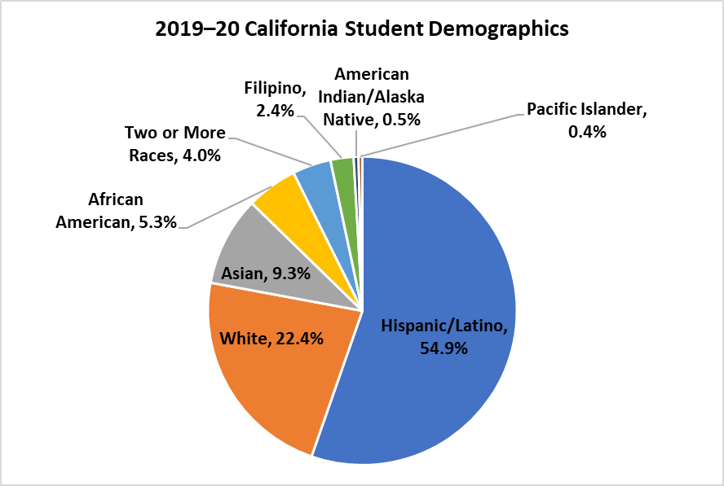

A glimpse into the diversity of the 6.2 million students in California shows that there are 1.1 million (18 percent) English learners; 197,408 (3.1 percent) English learners with disabilities, and 204,000 (3.2 percent) Long-term ELs (LTELs); 177,476 (2.9 percent) immigrant students; and 78,947 (1.3 percent) migratory students. Socioeconomically disadvantaged students make up 60.7 percent of the student population. California has 721,198 students with disabilities between the ages 0–22, which comprises approximately 11.7 percent of the state’s total student population. Of those students, 67.2 percent are male, 27.4 percent are English learners, and 10 percent are LTELs. The top three primary disability categories are Specific Learning Disability (37.8 percent), Speech and Language (20.7 percent), and Autism (15.1 percent).

#### Children in Early Education Programs

In 2018–19, early learning and care services were provided to 427,157 children, where 68 percent were in full day early learning and care programs and 32 percent in part day. The ethnic distribution of California’s early learners was as follows:

* 61 percent Hispanic/Latino
* 17 percent White
* 5 percent Asian
* 15 percent African American
* 1 percent Two or More Races
* 0.5 percent Pacific Islander
* 0.4 percent American Indian or Alaska Native

A glimpse into the diversity of the 400,000 children in early learning and care programs in California indicates there were 27 percent dual language learners and 7,304 with special needs or individualized education programs (IEPs). In terms of care settings, 64.5 percent of children received early learning and care services in a licensed center, 22.5 percent in a licensed family child care home, and 13 percent in a licensed exempt setting.

#### Multilingualism and Multiliteracy in the State Literacy Plan

Over the last decade, California has made great strides towards solidifying a vision for education that affirms the valuable asset of multilingualism for students, our state, the nation, and the world. The *ELA/ELD Framework*, the California Education for a Global Economy Initiative, the State Seal of Biliteracy, and the English Learner Roadmap outline opportunities for building on the linguistic assets that our English learners bring to public schools while also supporting the acquisition of biliteracy and multiliteracy for all students.

The SLP aligns with these efforts ensuring that activities supported by CLSD grant funds utilize evidence-based practices for supporting English learners, including primary language instruction and opportunities to develop biliteracy whenever possible. Throughout the SLP, references to “literacy” include “biliteracy” as an evidence-based practice for improving literacy outcomes for all students. Within SLP activities, California continues its efforts to graduate more students who have acquired the highly desirable 21st century skill of multilingualism.

## Comprehensive and Integrated Literacy Model

California has many existing policies, guidance documents, and structures designed to improve literacy for all California students. While several investments and initiatives have focused on their implementation, the Comprehensive State Literacy Plan (SLP) provides an opportunity to align and integrate these resources in order to demonstrate how they are connected and best utilized in a coherent way. A comprehensive and integrated literacy model ensures **high-quality literacy instruction occurs within the context of inclusive and equitable systems of schooling featuring high levels of engagement, a focus on continuous improvement, and application of the California Multi-Tiered System of Support (MTSS) Framework**. The Comprehensive and Integrated Literacy Model described in this section sets the direction for literacy programs statewide by aligning and integrating state literacy initiatives. It also sets the direction for activities outlined in the SLP Continuous Improvement Process section.

At the local level, the Comprehensive and Integrated Literacy Model can support local educational agencies (LEAs) to consider the degree to which literacy programs are leveraging state guidance and resources to meet the specific needs of students.

### LCFF State Priorities

The Local Control Funding Formula (LCFF)[3] is hallmark legislation that fundamentally changed how all LEAs in the state are funded, how they are measured for results, and the services and supports they receive to allow all students to succeed to their greatest potential. The Local Control and Accountability Plan (LCAP)[4] is a three-year plan that describes the goals, actions, services, and expenditures to support positive student outcomes that address state and local priorities. The State Priorities established in the LCFF legislation are included in the Comprehensive and Integrated Literacy Model to illustrate how local literacy programs can leverage LCFF and the LCAP to support comprehensive and integrated programs.

### Best First Instruction

At the center of California’s comprehensive and integrated literacy model is best first instruction, which is Tier 1 of the Multi-Tiered System of Support.

#### Multi-Tiered System of Support

The California Department of Education (CDE) definition of Multi-Tiered System of Support (MTSS)[5] provides a basis for understanding how California educators can work together to ensure equitable access and opportunity for all students to achieve the California Common Core State Standards (CA CCSS). **In California, MTSS is an integrated, comprehensive framework that focuses on CCSS, core instruction, differentiated learning, student-centered learning, individualized student needs, and the alignment of systems necessary for all students’ academic, behavioral, and social success.** MTSS offers the potential to create needed systematic change through intentional design and redesign of services and supports that quickly identify and match the needs of all students.

MTSS aligns all systems of high-quality first instruction, support, and intervention and includes structures for building, changing, and sustaining systems. The foundational structures of MTSS include high-quality core instruction using Universal Design for Learning (UDL) principles and appropriate supports, strategies, and accommodations. In addition, assessment processes and progress monitoring are employed to allow for a data-based, problem-solving approach to instructional decision making.

Figure 1 illustrates how most state guidance documents are utilized for core, universal supports for all students. The goal of Tier 1 is for all students to receive high-quality, standards-aligned instruction, using culturally and linguistically supportive and responsive teaching that meets the full range of student needs. Tier 1 instruction should result in no less than 80 percent of students achieving grade-level expectations. If less than 80 percent succeed in Tier 1 instruction, schools should engage in close examination of the curriculum and teaching practices and make appropriate adjustments.[6]

**Figure 1 Multi-Tiered System of Support**

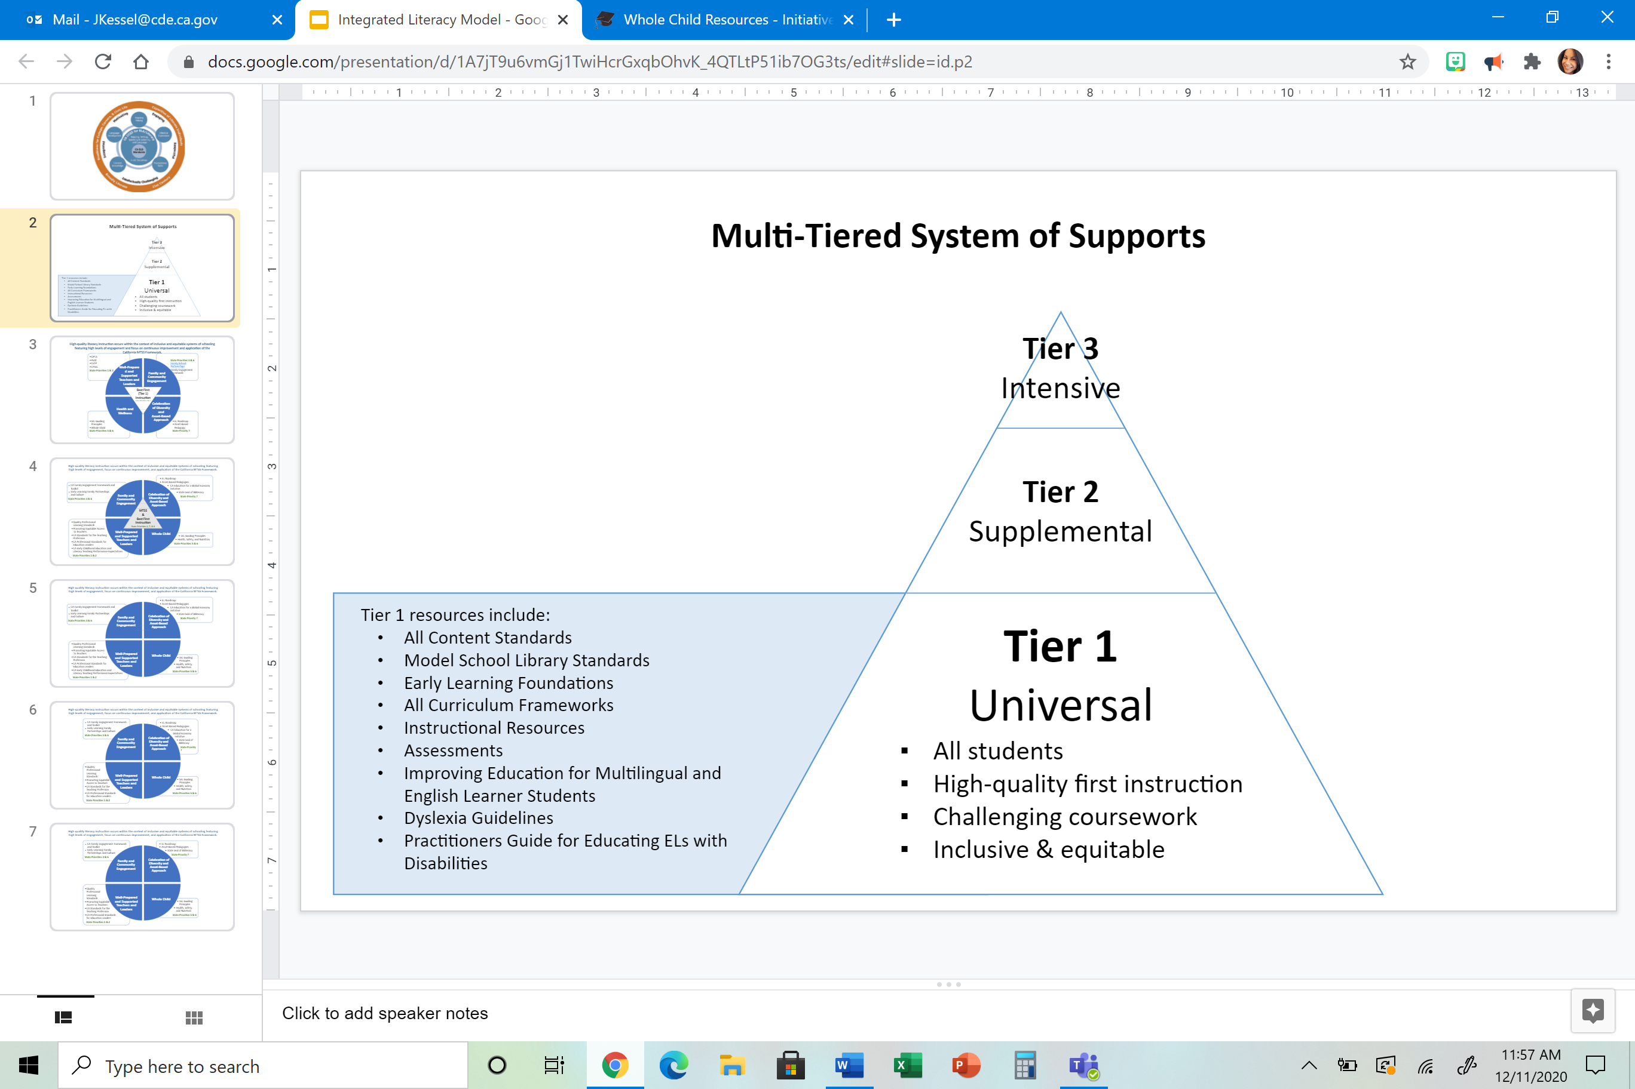

Tier 2 is strategic, targeted instruction and support provided to some students—those who are not progressing or responding to Tier 1 efforts as expected. Generally, no more than 15 percent of students receive support at this level because Tier 1, first teaching, meets the needs of individual learners. Tier 2 instructional supports are provided to students in addition to what they receive in Tier 1. The supplemental instruction provided in Tier 2 may be an extension of the core curriculum in Tier 1 or may include instruction and materials specifically designed for temporary intervention.

Tier 3 consists of intensive intervention. It is necessary for very few students, approximately five percent. Students who receive these services are those who have experienced difficulty with the grade-level standards in the general education curriculum and have not benefitted sufficiently from Tier 2 supplemental instruction. More intensive, Tier 3, intervention occurs in a learning center or is provided at a different pace than Tier 2 instruction. In both elementary and secondary settings, the instructional goal is to provide research-based intervention more often and for longer periods of time with reduced student/teacher ratios. The intention is to accelerate students’ progress so they can return to and succeed in the core instructional program, that is, Tier 1.

More information regarding MTSS in the context of literacy programs is available in Chapter 9: Access and Equity of the *ELA/ELD Framework.* The following sections provide information regarding state guidance documents intended to be leveraged as Tier 1 resources to support all students to meet literacy objectives.

##### Standards and Frameworks

###### Content and English Language Development Standards

The California CCSS for English Language Arts & Literacy in History/Social Studies, Science, and Technical Subjects (CCSS for ELA/Literacy) [7] define what transitional kindergarten through grade 12 students should know and be able to do in ELA and literacy in other content areas. The standards establish what it means to be a literate person in the 21st century. These standards are divided into strands: Reading, Writing, Speaking and Listening, and Language. The CCSS literacy standards set an interdisciplinary expectation that the development of each student’s literacy skills is a shared responsibility with teachers across the content areas, each supporting disciplinary literacy in their subject. The CCSS literacy standards are used in tandem with the following California content standards:[8]

* CCSS for Mathematics
* Next Generation Science Standards
* History-Social Science Content Standards
* Physical Education Model Content Standards
* World Languages Standards
* Health Education Content Standards
* Arts Standards
* Career Technical Education Model Curriculum Standards
* Model School Library Standards

A project of the Council of Chief State School Officers, the CDE, and the San Diego County Office of Education, Common Core en Español[9] provides Spanish translations and linguistically augmented versions of the CA CCSS to support equitable assessment and curriculum development.

The California English Language Development Standards (CA ELD Standards) [10] are to be used in tandem with all content standards when developing lessons and in designing instruction to teach literacy to English learners (ELs). The Spanish Language Development Standards[11] are the Spanish translation of the California English Language Development Standards with linguistic augmentations.

###### Model School Library Standards

The SBE-adopted *Model School Library Standards for California Public Schools, Kindergarten Through Grade Twelve* (*Library Standards*) include two types of standards:

* “School Library Standards for Students” that delineate what students should know and be able to do at each grade level or grade span to enable students to succeed in school, higher education, and the workforce.
* “School Library Program Standards” that describe base-level staffing, resources and infrastructure, including technology, required for school library programs to be effective and help students to meet the school library standards.

The *Library Standards* recognize that school libraries have evolved from simply providing print materials to offering rich selections of print, media, and digital resources; from teaching students how to search a card catalog to teaching students strategies for searching a variety of print, media and digital resources; from teaching basic reading literacy to teaching information literacy (the ability to access, evaluate, use, and integrate information and ideas effectively). The student standards also include the legal, ethical, and safe use of information both in print and online, other aspects of cyber safety, and use of technology.

The *Library Standards* are not stand-alone standards taught in isolation but are meant to be taught collaboratively by the classroom teacher and the teacher librarian in the context of the curriculum.

###### Curriculum Frameworks

The *2014 California English Language Arts/English Language Development Curriculum Framework* (*ELA/ELD Framework*) [12] serves as the foundation for California’s Comprehensive State Literacy Plan (SLP). This groundbreaking document represents the first time California combined both ELA and ELD into one comprehensive resource that incorporates evidence-based guidance on curriculum, instruction, assessment, content and pedagogy, access and equity, professional learning, and systems support.

All subsequent Curriculum Frameworks[13] follow the same general structure to ensure that the literacy needs of all learners in California are effectively addressed in every content area and that educators working in all capacities receive the supports they need from a coordinated system at the school, district, county, and state levels.

Circles of Implementation of ELA/Literacy and ELD Instruction

The *ELA/ELD Framework* featured Figure 2.1 Circles of Implementation of ELA/Literacy and ELD Instruction, which illustrates the relationships among the overarching goals of ELA/literacy and ELD instruction, the context in which instruction occurs, and the key themes of the standards. Within the Comprehensive and Integrated Literacy Model, the Circles of Implementation figure exemplifies implementation of best first literacy instruction around which all other student and family supports coalesce to improve student outcomes.

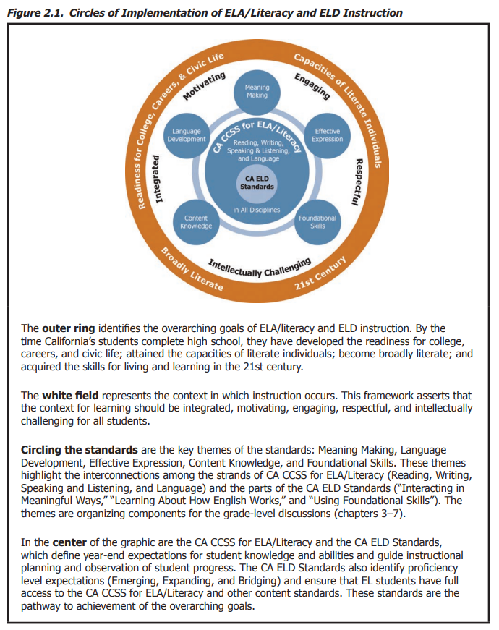

Figure 2.1 Circles of Implementation of ELA/Literacy and ELD Instruction is described in greater detail in Chapter 2 of the ELA/ELD Framework available at <https://www.cde.ca.gov/ci/rl/cf/documents/elaeldfwchapter2.pdf>.

The *ELA/ELD Framework* establishes four overarching and overlapping goals for ELA/literacy and ELD instruction. These goals call for California’s students, by high school graduation, to have developed readiness for college, careers, and civic life; attained the capacities of literate individuals; become broadly literate; and acquired the skills for living and learning in the 21st century.

Curriculum and instruction related to the CA CCSS for ELA/Literacy focus on five key themes of a robust and comprehensive instructional program in ELA/literacy for all students. These themes, as presented throughout the *ELA/ELD Framework*, are described below.

Meaning Making

*Meaning making is at the heart of ELA/literacy and ELD instruction. It is the central purpose for interacting with text, producing text, engaging in research, participating in discussion, and giving presentations. It is the reason for learning the foundational skills and for expanding language. Meaning making includes literal understanding but is not confined to it at any grade or with any student. Inference making and critical reading, writing, and listening are given substantial and explicit attention in every discipline. Among the contributors to meaning making are language, knowledge, motivation, and in the case of reading and writing, the ability to recognize printed words and use the alphabetic code to express ideas.*

Language Development

*Language is the cornerstone of literacy and learning. It is with and through language that students learn, think, and express information, ideas, perspectives, and questions. The strands of the CA CCSS for ELA/ Literacy—Reading, Writing, Speaking and Listening, and Language—all have language at the core, as do the parts of the CA ELD Standards—Interacting in Meaningful Ways, Learning About How English Works, and Using Foundational Literacy Skills. Students enrich their language as they read, write, speak, and listen and as they interact with one another and learn about language. The foundational skills provide access to written language.*

Effective Expression

*Each strand of the CA CCSS for ELA/Literacy and each part of the CA ELD Standards includes attention to effective expression. Students learn to examine the author’s craft as they read, analyzing how authors use language, text structure, and images to convey information, influence their readers, and evoke responses. Students learn to effectively express themselves as writers, discussion partners, and presenters, and they use digital media and visual displays to enhance their expression. They gain command over the conventions of written and spoken English, and they learn to communicate in ways appropriate for the context and task.*

Content Knowledge

*Content knowledge is a powerful contributor to comprehension of text. It also undergirds the ability to write effective opinions/arguments, narratives, and explanatory/informational text; engage in meaningful discussions; and present ideas and information to others. It contributes significantly to language development, and it is fundamental to learning about how English works. Both sets of standards ensure that students can learn from informational texts and can share their knowledge as writers and speakers. An organized independent reading program contributes to knowledge. Content knowledge has a powerful reciprocal relationship with the development of literacy and language.*

Foundational Skills

*Acquisition of the foundational skills enables students to independently read and use written language to learn about the world and themselves; experience extraordinary and diverse works of literary fiction and nonfiction; and share their knowledge, ideas, stories, and perspectives with others. Students who know how to decode and develop automaticity with an increasing number of words are best positioned to make significant strides in meaning making, language development, effective expression, and content knowledge. At the same time, attention to those themes provides the very reason for learning about the alphabetic code and propels progress in the foundational skills.* (ELA/ELD Framework Executive Summary, p. 5)

For more information on the ways these components apply in grade-level contexts, see the *ELA/ELD Framework*’s grade-band chapters.[14]

Designated and Integrated Language Development

California’s EL students shall be provided comprehensive ELD, which includes both integrated and designated ELD instruction. English learners enter school at different ages and with a range of cultural and linguistic backgrounds, socioeconomic conditions, experiences with formal schooling, proficiencies in their primary language(s) and in English, as well as other experiences in the home, school, and community. All of California’s ELs are learning English as an additional language while simultaneously engaging in intellectually challenging and content-rich instruction. It is incumbent upon every educator to understand California's model of comprehensive ELD instruction.

Integrated ELD instruction occurs throughout the school day in every subject area by every teacher who has an EL student in the classroom. The CA ELD Standards are used in tandem with the CA CCSS for ELA/Literacy and other content standards to ensure students strengthen their abilities to use academic English as they learn content through English.

Designated ELD is provided to ELs during a protected time in the regular school day. Teachers use the CA ELD Standards as the focal standards in ways that build into and from content instruction to develop critical language ELs need for content learning in English. Ideally, students are grouped for designated ELD by English language proficiency levels (Emerging, Expanding, Bridging), although schools need to consider their particular student population (e.g., number of ELs at each proficiency level) and make appropriate decisions about grouping.

The *ELA/ELD Framework* provides information regarding integrated and designated ELD including vignettes and snapshots of practice that describe effective practices in ELD instruction.

Disciplinary Literacy and Integrating Curricula

*Speakers and writers make deliberate choices about how they use particular language resources and how they organize their spoken or written texts (e.g. speeches, debates, arguments, stories). These choices depend on the discipline in which they are being produced, among other things. Proficient users of language in particular disciplines make language choices (sometimes unconsciously) to meet the expectations of their audiences. These choices include the use of precise vocabulary, how sentences and paragraphs are structured, and how ideas are connected throughout an entire text so that it is cohesive.* (*ELA/ELD Framework*, p. 532)

As noted in the *ELA/ELD Framework*, the term disciplinary literacy refers to the particular ways in which content areas or disciplines (history/social studies, mathematics, science and engineering, arts, physical education, health, and world languages) use language and literacy (reading, writing, speaking, and listening) to engage with content knowledge and communicate as members of discourse communities (e.g., scientists, historians, artists).[15] A major task for teachers is to support all students in understanding how to shift registers and make informed language choices that meet the expectations of different disciplinary contexts. Thus, there is a need for professional learning for all teachers, not just ELA teachers, in literacy instruction. The Comprehensive and Integrated Literacy Model includes ALL curriculum frameworks.

The CA CCSS for ELA/Literacy call for dual integration, or as stated by the Committee on Defining Deeper Learning and 21st Century Skills, “they promote a double vision of integration—(a) that reading, writing, and discourse ought to support one another’s development, and (b) that reading, writing, and language practices are best taught and learned when they are employed as tools to acquire knowledge and inquiry skills and strategies within disciplinary contexts, such as science, history, or literature” (2012, 114). The strands of Reading, Writing, Speaking and Listening, and Language are integrated among themselves and across all disciplines. Students use the strands of the language arts within their disciplinary learning as they are read, write, speak, and listen to expand their specific disciplinary and integrated learning.

Each grade band chapter of the *ELA/ELD Framework* provides at least ten snapshots and two longer vignettes of practice that illustrate how the CA CCSS for ELA/literacy strands, the CA ELD Standards, and content area instruction can be integrated to create an intellectually rich and engaging literacy program.

The *History-Social Science Framework* also includes guidance for incorporating literacy instruction in secondary history-social science curricula. The framework emphasizes the importance of utilizing the CA CCSS for ELA/Literacy and the CA ELD Standards to create expectations for reading, writing, listening, speaking, and language in   
history-social science. The framework notes that literacy skills—specifically reading, writing, speaking, and listening—are critical components of history-social science instruction. For more information on literacy instruction in grades 6–8, refer to Chapter 9 of the *History-Social Science Framework*. Chapter 13 of the *History-Social Science Framework* includes information on literacy instruction in grades 9–12.

Chapters 11, 12, and 13 of the *Science Framework[16]* include instructional guidance for teachers to effectively incorporate literacy skills and instructional methods as part of their science curriculum.

Another useful concept to consider regarding disciplinary literacy and integrating the curricula is habits of mind. The CCSS for Mathematics capture habits of mind in the CCSS for Mathematical Practice. The Next Generation Science Standards include habits of mind that guide scientists and engineers. A “Habit of Mind” means having a disposition toward behaving intelligently when confronted with problems.[17] The developing competencies—of both disposition and knowledge—are best nurtured by the entire school community, across every discipline, and within each classroom and school setting.

Defining Literacy in the 21st Century

One of the goals of ELA/literacy and ELD instruction established in the *ELA/ELD Framework* is that students become broadly literate, meaning they engage with a variety of books and other texts across a wide range of genres, time periods, cultures, perspectives, and topics for a multitude of purposes, including learning about new ideas and oneself and immersing oneself in the sheer pleasure of reading. Being broadly literate extends beyond reading printed text to encompass viewing live drama or films, listening to lectures or programs on the radio, or enjoying or performing poetry, such as spoken word. A person who is broadly literate appreciates an array of texts—books, plays, radio programs, poetry, film, television, mixed media, and more—for the many possibilities they reveal and the changes (even small ones) he or she makes by interacting with them.

Another goal of ELA/literacy and ELD instruction is that students acquire the skills for living and learning in the 21st century. Technology pervades modern society. It impacts most aspects of the personal and academic/professional lives of youth and adults. Technology as a tool for learning and expression can contribute to progress in each of the themes of the CA CCSS for ELA/Literacy and the CA ELD Standards. The question is not whether technology should be used in classrooms, but rather how best to capitalize on technology to support teachers and learners. Important in the context of the *ELA/ELD Framework* is that the Internet and other forms of information and communication technologies (ICTs) are redefining literacy. Students increasingly engage with search engines, web pages, podcasts and vodcasts, blogs, e-books, wikis, and the ongoing flood of new ICTs in English and other languages. Students should learn how to critically harness and manage the power of these media for accessing, evaluating, creating, and sharing information with local and global others. At the same time, teachers should ensure that students learn how to use technologies safely and ethically.

The *California World Languages Standards* address the literacies of *the 21st Century Skills Map for World Languages*, which provide useful definitions of different literacies global competent students develop:

* **Information Literacy** through which students—as “informed global citizens”—access, manage, and effectively use culturally authentic sources in ethical and legal ways;
* **Technology Literacy** through which students—as “productive global citizens”—use appropriate technologies when interpreting messages, interacting with others, and producing written, oral, manual, and visual messages;
* **Media Literacy** through which students—as “active global citizens”— evaluate authentic sources to understand how media reflect and influence language and culture; and
* **Emotional Literacy** through which students—as “emotionally intelligent global citizens”—develop self-awareness, build community, and interact with understanding and empathy (Partnership for 21st Century Skills 2011).

Chapter 10: Learning in the 21st Century of the *ELA/ELD Framework[18]* provides guidance on technology skills and other 21st century skills, including critical thinking, communication and collaboration, creativity and innovation, and global awareness and competence.

###### Early Learning Foundations

Another groundbreaking series of documents were designed specifically to support educators and caregivers of California’s youngest learners. The *California Preschool Learning Foundations[19]* outline key knowledge and skills that most children can achieve when provided with the kinds of interactions, instruction, and environments that research has shown to promote early learning and development. The companion document, the *California Infant/Toddler Learning & Development Foundations*,[20] describes research and evidence-based expectations for the way most infants and toddlers make progress in the major domains of social-emotional development, language development, cognitive development, and perceptual and motor development. Included in this series is a guidance document for California’s youngest dual language learners (DLL), the *Preschool English Learners: Principles and Practices to Promote Language, Literacy, and Learning: A Resource Guide (2nd Edition)*,[21] which offers guidance on how to support the language development of dual language learners during the preschool years (ages three to five). This document emphasizes the importance of connecting the first and second languages and on creating paths to bilingualism for dual language learners.

All of these documents deliberately set the stage for California to build upon its commitment to early language and literacy. Early literacy development is a crucial element in a comprehensive and integrated literacy model. The CDE and its early learning partners across the state have invested in the development of several resources to support families and early learning and care providers to support early literacy development. These resources are extensively detailed and excerpted in the SLP Continuous Improvement Process section commensurate to the special role early literacy development plays in overall academic achievement in elementary and secondary grade levels.

###### Transitional Kindergarten

Transitional kindergarten is the first year of a two-year kindergarten program that uses a modified kindergarten curriculum that is age and developmentally appropriate. The *Transitional Kindergarten Implementation Guide*[22] focuses on the essential components for school district administrators and teachers to consider as they develop comprehensive transitional kindergarten programs. It also provides resources and guidance in the areas of program design, curriculum, instruction, assessment, and family/community partnerships. Chapter 3 of the *ELA/ELD Framework* [23] also includes guidance for content and pedagogy for transitional kindergarten.

##### Access and Equity

Access and equity are aligned to LCFF State Priority 7,[24] which addresses student enrollment and access to a broad course of study. The Access and Equity chapter of the *ELA/ELD Framework[25]* speaks to the responsibility of California educators to ensure that each and every student receives a world-class 21st century education, one that supports the achievement of their highest potential. In order to accomplish this goal, it describes the steps needed to continuously strive for equity in all classrooms, schools, and districts. Equally important, the framework calls on educators to acknowledge that inequities exist in current educational systems.

The chapter is divided into three major sections. The first section provides information about California’s diverse student population and includes recommendations for attending to specific educational needs, including the needs of English learners, multilingual learners, students with disabilities, students living in poverty, advanced learners, and more. The second major section discusses planning for meeting the needs of diverse learners at the classroom and school/district levels, including UDL, MTSS, and culturally and linguistically responsive teaching. The final section offers research-based instructional practices for supporting students who are experiencing difficulty in reading.

UDL is a research-based framework for guiding educational practice.[26] Rather than call for adjustments in planning to reflect a given student population, UDL focuses on addressing the varied needs of students in the planning instruction stages. UDL is not a special education initiative; it is a framework that allows educators to acknowledge the needs of all learners at the point of planning and first teaching, thereby reducing the amount of follow-up and alternative instruction necessary. When incorporated with specific literacy initiatives, UDL can be a catalyst to achieve in places where progress once stagnated.

California continues to develop resources to support schools and districts to meet the specific needs of their students.

###### Improving Education for Multilingual and English Learner Students

*Multilingualism is a priority in our state…Capitalizing on the assets that our English learner students bring to our vision of a multilingual society is vital for bringing this vision to fruition. The goal is to cultivate English learner students’ language skills and also ensure they meet the high academic expectations that are held for all students, so that they can use their biliterate/ multiliterate skills to thrive and lead in a multilingual state.* (p. 20)

The CDE recently released the publication *Improving Education for Multilingual and English Learner Students: Research to Practice*,[27] which is designed to support LEAs to implement the English Learner Roadmap Policy in schools and improve instruction for both English learners and other students learning multiple languages.

The publication demonstrates how LEAs have implemented research-based practices that positively impact multilingual and English learner students in relation to social emotional learning, early learning and care, integrated and designated English language development, multilingual education, systems improvement, teacher development, and parent engagement. Within the Comprehensive and Integrated Literacy Model, this publication supports the goal of accelerating learning for English learner students.

###### California Dyslexia Guidelines

*Students who have dyslexia are “general education students” first, can be educated in general education classrooms, and benefit from a wide variety of supports. Those supports must include a comprehensive, evidence-based approach to reading and language instruction that is implemented by trained educators.*

*An educational system should address the needs of individual students within an integrated and tiered system of support.* (*California Dyslexia Guidelines*, p.1)

The 2017 *California Dyslexia Guidelines[28]* assist general education teachers, special education teachers, and parents in identifying, assessing, and supporting students with dyslexia. It addresses the neuroscience of dyslexia, characteristics of dyslexia by age group, socioemotional factors, dyslexia in English learners, educator preparation, screening and assessment, effective teaching approaches, and much more. Its inclusion in the Comprehensive and Integrated Literacy Model ensures that students with dyslexia receive the support needed to achieve positive literacy outcomes.

###### California Practitioner’s Guide for Educating English Learners with Disabilities

*Identifying, assessing, and differentiating instruction for English learners with disabilities require educators first to understand the complex interrelationships of language, culture, home, and school factors that affect learning and behavior and then to consider these factors when making decisions about students’ unique characteristics and needs so that they may thrive at school.* (*California Practitioner’s Guide for Educating English Learners with Disabilities*, p. 1)

The *2019 California Practitioner's Guide for Educating English Learners with Disabilities*[29] is a comprehensive resource that provides evidence-based information on how to identify, assess, support, and reclassify English learners with disabilities. The multi-tier system of support and interventions that are in this comprehensive document will assist the LEA to determine effective literacy interventions.

##### Assessment System

MTSS and best first instruction rely on valid assessments to diagnose student needs, differentiate instruction, monitor student progress, and evaluate curriculum and teaching practices. In LCFF, State Priority 4[30] focuses on the importance of student achievement on assessments and the use of their results to reflect on education programs. Chapter 8 of the *ELA/ELD Framework* provides extensive information on assessment, including its purposes, intentional use of assessment cycles, student involvement, assessment of English language development, assessment for intervention, technical quality of assessments, and information regarding assessments mandated in California. As a source of professional learning for teachers and school and district leaders, this chapter plays a critical role in strengthening educators’ assessment literacy—their knowledge and understanding of assessment practices and appropriate uses of assessment evidence to shape powerful instruction.

The *ELA/ELD Framework* notes that, as part of a balanced and comprehensive assessment system, assessment *for* learning and assessment *of* learning are both important. While assessments of learning usually involve a tool or event *after* a period of learning, assessment for learning is a process. Evidence-gathering strategies that are truly formative yield information that is timely and specific enough to assist learning as it occurs and addresses students’ immediate learning needs. Intertwined and inseparable from teachers’ pedagogical practice, formative assessment is a high priority in literacy programs.

The *Desired Results Developmental Profile (2015) [DRDP (2015)]: A Developmental Continuum from Early Infancy to Kindergarten Entry[31]* is a formative assessment instrument developed by the CDE for young children and their families to be used to inform instruction and program development. The DRDP is made up of eight domains:

* Approaches to Learning – Self-Regulation
* Social and Emotional Development
* Language and Literacy Development
* English-Language Development
* Cognition, Including Math and Science
* Physical Development-Health
* History-Social Science
* Visual and Performing Arts

Young dual language learners may demonstrate knowledge and skills in their home language, in English, or in both languages. The adult who is conducting observations and collecting documentation should speak the child’s home language. More information regarding the Language and Literacy Development domain is available in the Step 2 section of the SLP.

The Smarter Balanced assessment system is part of the California Assessment of Student Performance and Progress[32] (CAASPP) System and has three components: summative assessments, designed for accountability purposes; interim assessments, designed to support teaching and learning throughout the year; and Tools for Teachers, designed to support classroom-based formative assessment processes. To improve teaching and learning and achieve the maximum benefit, these three components should be used together. Teacher guides to the Smarter Balanced assessments are available on the CDE web site.[33]

The Smarter Balanced Summative Assessments for ELA/literacy and mathematics are annual assessments of students’ progress towards meeting academic standards and developing critical thinking, analytical writing, and problem-solving skills needed for collage and a 21st century career. The Smarter Balanced Summative Assessments for ELA are administered in grades 3−8 and grade 11. The Smarter Balanced interim assessments are specifically designed to provide meaningful information for gauging student progress throughout the year toward mastery of the skills measured by the summative assessments. Information about specific tools and resources are available on the CDE Smarter Balanced Interim Assessments web page.[34]

Tools for Teachers is the new formative assessment component of the Smarter Balanced assessment system. It is an online collection of resources aligned with the CCSS that supports TK–12 teachers in their use of the formative assessment process to adjust teaching to improve student learning. More information on the purpose, features, and content of Tools for Teachers is available on the CDE web page.[35]

When instruction is provided in English and in an additional language in alternative bilingual or dual language programs, classroom assessment for academic and language development progress in both languages is necessary. State and federal laws require that all students whose primary language is other than English be assessed for English language proficiency (ELP). The English Language Proficiency Assessments for California (ELPAC) is the state’s designated test of ELP. It is administered (1) as an initial assessment to newly enrolled students whose primary language is not English, as indicated on a home language survey (HLS); and (2) annually as a summative assessment to students who have been previously identified as English learners. ELPAC resources for educators and parents are available on the CDE ELPAC web page.[36]

The California Spanish Assessment (CSA)[37] is a new assessment under development for the California Assessment of Student Performance and Progress (CAASPP) System. This assessment, presented in Spanish, serves the more than one million students who speak Spanish as their primary language as well as those who are learning Spanish as an additional language. The purposes of the CSA are to measure a student’s competency in Spanish language arts and provide student-level data in Spanish competency; to evaluate the implementation of Spanish language arts programs at the local level; and to provide a high school measure suitable to be used, in part, for the State Seal of Biliteracy.

Quality literacy programs rely on the data literacy of and data use by teachers and instructional leaders to inform and improve instruction and implementation of programs All members of the system (e.g., administrators, teachers, coaches) should receive professional development on data collection and use, including data analysis, instructional response to data, data literacy, and knowledge on how to administer good diagnostic tools and how to use the results. LCFF widens the focus on more than just state standardized tests through State Priority 8,[38] which focuses on student outcomes in all courses. Districts and schools should have functional systems to use data effectively. Systems should include protocols for analyzing data, a structure for participating in the protocols (e.g., professional learning communities, quarterly data conversations), how to use the analysis to inform instruction, and aligned common assessments, including vertical articulation.

Educators should go beyond data analysis and use the results to inform instruction, effectively monitor students’ academic progress, and make appropriate instructional adjustments. Systems should use screening data to decide which students receive intervention services and use diagnostic assessments to determine the instructional supports students need.

### Supporting Best First Instruction

High quality first instruction is best supported in an educational system where diversity is celebrated through an asset-based approach, the needs of the whole child are addressed, teachers and leaders are well-prepared and supported, and families and the community are engaged. This educational system is set forth in the state priorities defined in LCFF, ensuring systems alignment for implementing and sustaining comprehensive and integrated literacy programs.

Figure 2 illustrates a comprehensive and integrated literacy model in which   
**high-quality literacy instruction occurs within the context of inclusive and equitable systems of schooling featuring high levels of engagement, a focus on continuous improvement, and application of the California MTSS Framework.** The elements of the model are explained in the following sections.

**Figure 2 Comprehensive and Integrated Literacy Model**

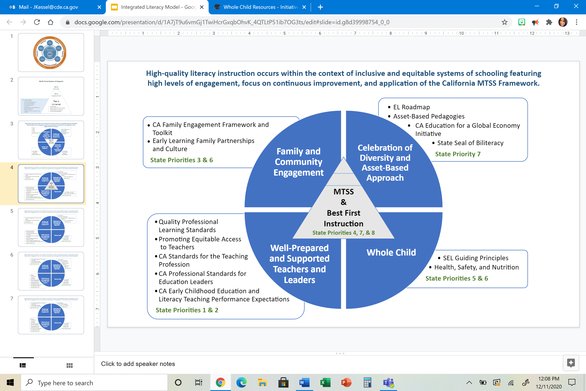

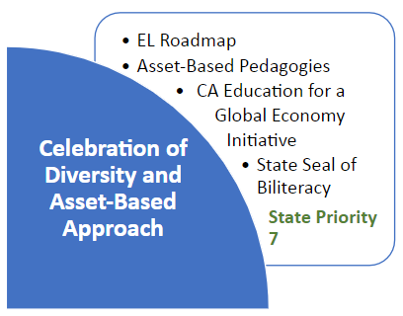

#### Celebration of Diversity and Asset-Based Approach

Within the Comprehensive and Integrated Literacy Model, celebration of California’s diverse student population and honoring the assets students bring with them to school is imperative. These principles result in high levels of student engagement and success.

As noted in the *ELA/ELD Framework*, it is important to acknowledge that inequities exist in current educational systems. Analyses of data have revealed persistent academic achievement gaps for students of color, students with disabilities, and students living in poverty. Current evidence also indicates that some groups of students experience a low level of safety and acceptance in schools for reasons including cultural, ethnic, and linguistic background; disability; sexual orientation; economic status; and other factors. Recognizing the specific inequities that exist helps educators and communities to purposefully and strategically take action to strive for true educational equity for all learners.

Chapter 9: Access and Equity of the *ELA/ELD Framework* is an integral resource to support educators in their efforts to celebrate the diversity of their students and attend to their specific needs. For example, this chapter addresses how African American English speakers and Chicana/Chicano English speakers have been viewed as less capable than standard English speakers by teachers who assume these dialects are ungrammatical or illogical. Instead of taking this subtractive approach, teachers should give clear messages that nonstandard varieties of English that students may speak or hear in their home communities are equally as valid as standard English. The framework promotes pedagogical approaches that support students to become bidialectal, or proficient users of both standard and other dialects of English. These practices explicitly acknowledge the value and linguistic features of other dialects of English, recognize the level of underlying skill development, build on students’ knowledge of other dialects to improve their learning opportunities, and ensure that students develop the linguistic resources necessary to meet the expectations of school contexts.

This chapter provides specific guidance regarding equitable access to literacy education for several more student groups:

* English learners
* Biliterate students
* Students who are deaf
* Students living in poverty
* Migrant students
* Lesbian, gay, bisexual, and transgender students
* Advanced learners
* Students with disabilities

Celebration of diversity and an assets-based approach to literacy instruction is also in line with LCFF State Priority 7, which is to ensure student access to and enrollment in a broad course of study with programs and services that account for the needs of individual students, including English learners, low-income students, foster youth, and students with disabilities. More information is available on the LCFF Priority 7 Statement of Model Practices web page.[39]

##### English Learner Roadmap

*California schools affirm, welcome, and respond to a diverse range of English learner (EL) strengths, needs, and identities. California schools prepare graduates with the linguistic, academic, and social skills and competencies they require for college, career, and civic participation in a global, diverse, and multilingual world, thus ensuring a thriving future for California.* (Mission, *CA EL Roadmap*)

The California State Board of Education unanimously approved the California English Learner Roadmap State Board of Education Policy: Educational Programs and Services for English Learners (EL Roadmap Policy) on July 12, 2017. The EL Roadmap Policy principles are further developed in the 2018 *California English Learner Roadmap: Strengthening Comprehensive Educational Policies, Programs, and Practices for English Learners* (*CA EL Roadmap*), a key policy document relating to language and literacy*.[40]* This policy is intended to provide guidance to LEAs on welcoming, understanding, and educating the diverse population of students who are English learners attending California public schools, from early childhood through grade twelve. The EL Roadmap Policy includes four key principles:

1. Assets-oriented and needs-responsive school,
2. Intellectual quality of instruction and meaningful access,
3. System conditions that support effectiveness, and
4. Alignment and articulation within and across systems.

The principles are intended to guide all levels of the system towards a coherent and aligned set of practices, services, relationships, and approaches to teaching and learning that add up to a powerful, effective, 21st century education for all English learners. Underlying this systemic application of the principles is the foundational understanding that English learners are the shared responsibility of all educators and that all levels of the educational system have a role to play in ensuring the access and achievement of the over 1.3 million English learners who attend California schools.

Principle One envisions a system where:

*Pre-schools and schools are responsive to different English learner strengths, needs, and identities and support the socio-emotional health and development of English learners. Programs value and build upon the cultural and linguistic assets students bring to their education in safe and affirming school climates. Educators value and build strong family, community, and school partnerships.*

The Crosswalk to LCAP[41] is a tool that LEAs can use in their planning to ensure that local goals and policies are aligned with the vision, mission, and principles of the EL Roadmap Policy. This tool aligns the eight State Priorities with the EL Roadmap principles. The Three-Way Crosswalk[42]includes the addition of the Special Education Annual Performance Report Indicators. The *Improving Education for Multilingual and English Learner Students: Research to Practice[43]* publication is also designed to support LEAs to implement the English Learner Roadmap Policy in schools and improve instruction for both English learners and other students learning multiple languages.

##### California Education for a Global Economy Initiative

In November 2016, California voters approved Proposition 58, also known as the California Education for a Global Economy (CA Ed.G.E.) Initiative. [44] The purpose of the CA Ed.G.E. Initiative is to ensure that all children in California public schools receive the highest quality education, master the English language, and access high-quality, innovative, and research-based language programs that prepare them to fully participate in a global economy.

The CA Ed.G.E. Initiative authorizes school districts and county offices of education to establish language acquisition programs for both native and non-native English speakers, and requires school districts and county offices of education to solicit parent and community input in developing language acquisition programs. The CA Ed.G.E. Initiative expands English learners’ access to multilingual programs, including   
dual-language immersion programs. The Frequently Asked Questions for the CA Ed.G.E. Initiative web page[45] addresses questions regarding instructional programs, parental notice, parent choice and requests, and parent and community engagement.

##### State Seal of Biliteracy

The State Seal of Biliteracy (SSB) program, effective since January 1, 2012, recognizes high school graduates who have attained a high level of proficiency in speaking, reading, and writing one or more languages in addition to English. As the first state to implement an SSB program, California is a pioneer for multilingualism. Today, the SSB continues to be an important recognition for California high school graduates.

Recognizing biliteracy as an important part of the Comprehensive and Integrated Literacy Model is vital because the home language skills that students bring to California schools are a valuable asset in their own right as well as in developing literacy in English. Similarly, closing the achievement gap for English learners requires schools to value and build upon the knowledge and skills English learners have in their home languages that can support the development of English proficiency. Recognizing these assets also helps English learners feel that their language and culture is valued at school. Continuing to recognize the SSB, as a tangible acknowledgement of biliteracy and as a way to celebrate California’s linguistic diversity, is an important part of this work.

Participation in the SSB program continues to be voluntary for LEAs; however, while fluency in more than one language has always been an admirable skill, biliteracy is increasingly important to employment in an international and global context to prepare students for the jobs of tomorrow. To encourage participation in the SSB program and early preparation of students, LEAs should disseminate SSB information to middle school and incoming high school students. Further details about the SSB and qualification criteria are available on the CDE State Seal of Biliteracy web page.[46]

##### Asset-Based Pedagogies

CAASPP ELA/Literacy scale score gaps between white students and students of color and English only students and English learner students have, for the most part, grown over the last five years (please see Appendix C). With such documented disparities persisting in California schools, a system-wide shift is necessary to better meet the needs of underserved students. All educators need to examine their beliefs and attitudes toward students and their families and make appropriate and affirming instructional decisions when it comes to literacy.

Asset-Based Pedagogies[47] focus on the strengths that diverse students bring to the classroom. It is a direct response to deficit-based models of the past. Ensuring equity for an increasingly diverse student population relies on today’s educators viewing student differences as assets and not deficits. Asset-Based Pedagogies view the diversity that students bring to the classroom—including culture, language, disability, socio-economic status, immigration status, and sexuality—as characteristics that add value and strength to classrooms and communities. Asset-Based Pedagogies include, but are not limited to:

* Culturally Sustaining Pedagogy: builds upon the Asset-Based Pedagogies that came before it but presents the need to not only affirm and connect to students’ cultural backgrounds, but also to sustain them through schooling.[48]
* [Culturally and Linguistically Responsive Teaching](https://www.cde.ca.gov/pd/ee/responsiveteaching.asp): leverages and utilizes the cultural learning tools that students bring to the classroom.[49]
* [Culturally Relevant Pedagogy](https://www.cde.ca.gov/pd/ee/culturalrelevantpedagogy.asp): helps students to uphold their cultural identities while developing fluency in at least one other culture.[50]

Culturally Sustaining Pedagogy builds on decades of asset-based pedagogical research including Culturally Relevant Pedagogy (Ladson-Billings) and Culturally Responsive (Gay and Hammond) and Linguistic (Hollie) Pedagogy. Instead of just accepting or affirming the backgrounds of students of color, as seen in Culturally Relevant Pedagogy; or connecting to students’ cultural knowledge, prior experiences, and frames of reference, as we see in Culturally Responsive Pedagogy; Culturally Sustaining Pedagogy views schools as places where the cultural ways of being in communities of color are sustained, rather than eradicated. Culturally Sustaining Pedagogy promotes equality across racial and ethnic communities and seeks to ensure access and opportunity. Culturally Sustaining Pedagogy also supports students to critique and question dominant power structures in societies.

Teachers should be keenly aware of their students’ varied cultures and reflect these cultures in their instruction, materials, and classroom structures. Collaboration with teacher librarians helps to ensure all students see themselves represented in the texts in libraries and that libraries promote respect for all types of diversity. Furthermore, culturally sustaining teaching goes deeper than text types or instructional materials. Teachers becoming personally aware, and not simply approaching culturally sustaining teaching as a strategy, is key to actual change. Districts and schools should establish a clear definition of what culturally sustaining teaching means and share it widely with all staff, students, and families. Professional learning and support on how to integrate culturally sustaining teaching into lessons using asset-based pedagogies should be provided to support higher levels of student engagement and success. Recruiting and supporting a diverse teacher workforce is also in line with the goals of culturally sustaining pedagogies.

As noted above, the *CA EL Roadmap* Principle One calls for assets-oriented and needs-responsive schools.

*The languages and cultures English learners bring to their education are assets for their own learning and are important contributions to learning communities. These assets are valued and built upon in culturally responsive curriculum and instruction and in programs that support, wherever possible, the development of proficiency in multiple languages.* (Element 1.A: Language and Culture as Assets, *CA EL Roadmap*)

The *Improving Education for Multilingual and English Learner Students: Research to Practice* publication provides research-based practices for implementing asset-based pedagogy and aligned systems in support of multilingual and English learner students.

California’s Social and Emotional Learning Principle Two makes a similar commitment to equity stating:

*All students must have opportunities to build SEL skills and receive an assets-based educational experience that is personalized, culturally relevant and responsive, and intentionally addresses racism and implicit bias. Use practices that build on the existing strengths of students, educators, families, and communities.*

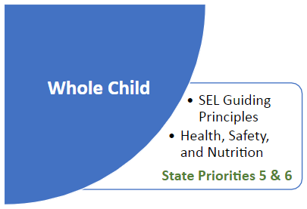

#### Whole Child

Literacy achievement is directly linked to a student’s social-emotional development, sense of safety and belonging, and physical health. Academic achievement greatly improves when schools endeavor to support the whole child. To effectively address the needs of the whole child, schools should collaborate with families, caretakers, and community agencies to deliver integrated services that promote improved access to health and learning supports, high expectations, and a positive school climate – all of which are necessary for students to thrive in the 21st century.

Systems that support the whole child support LCFF State Priority 5,[51] which addresses student engagement, and LCFF State Priority 6,[52] which addresses school climate. The LCFF Priorities/Whole Child Resource Map[53] provides LCFF priorities and whole child resources and supports to help LEAs, schools, and families serve the needs of the whole child.

##### Social-Emotional Learning

Social and Emotional Learning (SEL) reflects the critical role of positive relationships and emotional connections in the learning process and helps students develop a range of skills they need for school and life. SEL skills include the ability to:

* Set and achieve positive goals
* Feel and show empathy for others
* Establish and maintain positive relationships
* Make responsible decisions
* Understand and manage emotions

All of these skills are necessary—both for educators and students—to function well in the classroom, in the community, and in college and careers.

While many teachers instinctively know that social and emotional learning is important, historically schools have been primarily focused on teaching academic content such as reading, math, science, and history, and less intentional about supporting the social and emotional skills that are important to learning and life success. There is a growing body of research proving that SEL is fundamental to academic success, and must be woven into the work of every teacher in every classroom and every after school and summer learning program, if we truly want to prepare all students for college and careers.

California has adopted Social and Emotional Learning Guiding Principles[54] to inform and support strong SEL practice across the state. Explained in detail in the document, the principles call on education agencies and organizations to:

1. Adopt whole child development as the goal of education
2. Commit to equity
3. Build capacity
4. Partner with families and communities
5. Learn and improve

Schools, districts, and youth-serving organizations are encouraged to use the guiding principles as a resource for processes such as the development of LCAP goals; implementing MTSS; setting school or district priorities; designing professional learning, instructional approaches, and curricula adoption; determining assessment methodologies and tools; and building coalitions of families and community stakeholders.

This is of particular importance for students with identified needs for social and emotional supports. State law has called for positive practices as other means of correction in these circumstances, in contrast to punitive approaches.[55] The same applies to students with mental health and other health challenges and those who have experienced trauma. Literature that includes social emotional challenges and development among its key themes is proven to have strong power to engage and support at-risk/at-promise students. All students need opportunities to see people resembling themselves in the texts they read.

As part of the Comprehensive and Integrated Literacy Model, SEL practices and learning are essential for the development of literacy skills.

##### Health and Safety

Coordinated School Health (CSH) is an approach to school health that is a powerful way to reinforce healthy behaviors and empower students with the knowledge, skills, and judgment to help them make smart choices in life. Children that are healthy are more likely to perform better in school academically, and specifically in terms of literacy, than children that are not healthy. Schools with a CSH approach create a school/community environment that allows youth to reach their greatest potential by establishing strong partnerships among youth, families, schools, local government, faith-based organizations, businesses, local health agencies, and others.

Coordinated school health addresses eight different aspects of health: health education, physical education, health services, nutrition services, psychological and counseling services, healthy school environment, health promotion for staff, and parent and community involvement.

While all schools in California implement the coordinated school health program to varying degrees, districts that successfully implement the model designate a staff member as the school health coordinator to provide leadership and institute a school health council with a broad base of school, community, and parental involvement. The Coordinated School Health web page[56] provides more information, including the important connection between student health and academic achievement and links to additional resources.

The correlation between academic achievement and learning environments in which students feel safe, secure, and connected, is clear. In addition to supporting quality academic programs to support literacy, the required Comprehensive School Safety Plan[57] can help to ensure learning environments provide a sense of safety and security for all students.

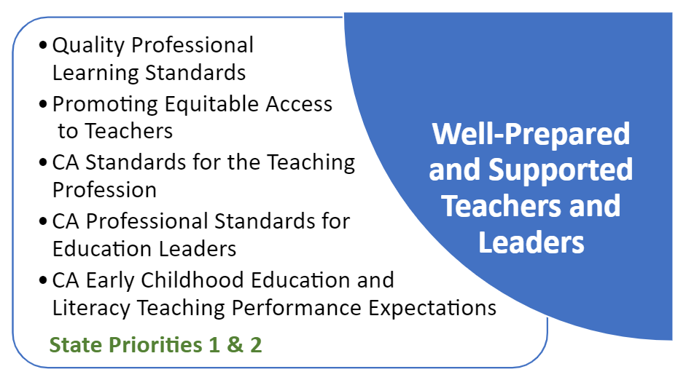

#### Well-Prepared and Supported Teachers and Leaders

The Comprehensive and Integrated Literacy Model relies on well-prepared and supported teachers and leaders to deliver best first instruction. The importance of this is also highlighted in LCFF State Priority 1,[58] which calls for teachers to be appropriately assigned and fully credentialed in the subject areas and for the students they are teaching, and State Priority 2,[59] regarding the implementation of academic content standards for all students. The following standards and guidance ensure preparation, professional learning, and support for literacy instruction is aligned, coherent, and research-based.

##### Professional Standards

The *California Standards for the Teaching Profession* (CSTP)[60] are intended to provide a common language and a vision of the scope and complexity of the profession by which all teachers can define and develop their practice. The standards seek to serve and support professional educators in fulfilling their professional roles and responsibilities from pre-service teacher to experienced practitioner. They are used as the foundation for teacher induction programs. The standards are not set forth as regulations to control the specific actions of teachers, but rather to guide teachers as they develop, refine, and extend their practice. The CSTP have been used for a variety of purposes, including the following:

* To prompt reflection about student learning and teaching practice;
* To formulate professional goals to improve teaching practice in support of student learning; and
* To guide, monitor, and assess the progress of a teacher’s practice toward professional goals.

The *California Early Childhood Education Teaching and Administrator Performance Expectations* are aligned to the CSTP but are specifically adapted to apply to the work of those serving in the job role of assisting, teaching, and master teaching/mentoring/coaching in early childhood education programs and to address teaching and learning for California’s youngest learners from birth through age 8.

The *California Professional Standards for Education Leaders[61]* (CPSEL) identify what an administrator must know and be able to do in order to move into sustainable, effective practice. They are a set of broad policy standards that are the foundation for administrator preparation, induction, development, professional learning, and evaluation in California. Taken together, the CPSEL describe critical areas of leadership for administrators and offer a structure for developing and supporting education leaders throughout their careers.

The California Commission on Teacher Credentialing adopted a new set of Literacy Teaching Performance Expectations (TPEs)[62] at its November 2019 meeting that explicitly addresses the knowledge, skills, and abilities necessary for the development of literacy, including the teaching of reading. These 2019 TPEs are aligned with the *ELA/ELD Framework*. Approved preliminary teacher preparation programs must be aligned with these TPEs by the 2021–22 academic year.

These professional standards used in tandem with California content standards and frameworks ensure that California teachers and administrators are well-prepared and supported to meet the literacy learning needs of students.

##### Promoting Equitable Access to Teachers

Access to a fully-prepared and stable teacher workforce is essential to educational opportunity. Research has shown higher levels of teacher preparedness has positive impacts on student achievement.

The Every Student Succeeds Act (ESSA) [Section 1112(b)(2)](https://uscode.house.gov/view.xhtml?req=(title:20%20section:6312%20edition:prelim)%20OR%20(granuleid:USC-prelim-title20-section6312)&f=treesort&edition=prelim&num=0&jumpTo=true) requires each LEA receiving ESSA funds to submit a plan to the state educational agency that describes how it will identify and address any disparities that result in low-income and minority students being taught at higher rates than other students by ineffective, inexperienced, or out-of-field teachers; also referred to as equity gaps.

The CDE has developed the Promoting Equitable Access to Teachers (PEAT) Program[63] to assist LEAs to identify and address local disparities, or equity gaps. A key element of the PEAT Program is a suite of equity tools designed to guide LEAs as they collect and analyze the appropriate data, conduct data analyses to identify potential equity gaps, conduct a root cause analysis and consider various strategies to address disparities, and engage stakeholders in the process. The PEAT program supports positive literacy outcomes by ensuring the equitable distribution of teachers.

##### Professional Learning

Chapter 11 of the *ELA/ELD Framework*[64] is provides extensive information regarding professional learning in support of literacy instruction, including guidance on initial preparation and induction, components of effective professional learning, sources of professional learning, and critical professional learning content in ELA/literacy and ELD.

The state’s Quality Professional Learning Standards[65] (QPLS) identify the characteristics of professional learning that are most likely to support educators in building individual and collective capacity to meet professional, school, and student performance expectations. Efforts to support and improve literacy instruction depend heavily upon a high-quality professional learning system, and the QPLS is a resource schools and districts may use to align their professional learning systems to   
research-based practices. Quality literacy programs provide sustainable professional learning systems focused on literacy instruction, including literacy coaching models.

As noted in the QPLS, quality professional learning is:

* Rooted in student and educator needs demonstrated through **data**
* Focused on **content and pedagogy**
* Designed to ensure **equitable** outcomes
* Designed and structured to be **ongoing, intensive, and embedded** in practice
* **Collaborative** with an emphasis on **shared accountability**
* Supported by **adequate resources**
* **Coherent and aligned** with other standards, policies, and programs

Instructional coaching has shown positive outcomes for literacy achievement. In its literature review *Instructional Coaching for English Language Arts: Practices and Outcomes*,[66] the Regional Educational Laboratory Northeast and Islands defines instructional coaches as on-site professional development providers whose main professional responsibility is to bring evidence-based practices and instructional methods into the classroom through collaborative partnerships with teachers and other school leaders. Their research identifies the following common features and components of coaching interventions that are more likely to report positive outcomes:

* Coaching and mentoring are provided in addition to more general professional development such as trainings, workshops, or online modules.
* Higher amounts of coaching sessions, longer durations, and sustainability over time contribute to positive outcomes.
* Regular, immediate, and specific feedback is provided to participating teachers.
* Positive outcomes of instructional coaching for teachers of young learners targets specific literacy-related skills for development rather than broad literacy supports.

Providers and systems should utilize adult learning principles and an inquiry approach to determine the needs for professional development and coaching, with continuous feedback provided to teachers and professional development providers through a feedback loop, inquiry cycle, or professional learning community. Data on teacher and student growth, including regular measurement and monitoring to determine teacher and student growth, should drive professional development and coaching. These supports should be narrow in focus; tied to local initiatives, goals, objectives, and vision; and be based on state guidance documents.

The professional development model should build capacity and nurture a team of literacy experts at schools (including teachers), districts, and county offices of education to be support providers. Teacher-led professional learning holds great promise as well as school and district leadership learning alongside teachers. All members of the system, including families and all staff (specialists, early childhood education providers, teachers, coaches, administrators, and paraprofessionals) should receive professional development and, in most cases, coaching within an aligned model to ensure messaging about the continuous improvement of instructional practices and student support is consistent and strong.

##### State Partners for Professional Learning

While professional learning decisions are made at the local level, the CDE and its partners provide several professional learning opportunities aligned to state guidance and policies. The California Collaborative for Educational Excellence,[67] in collaboration with the CDE and SBE, coordinates the Statewide System of Support, which brings together California’s improvement networks and resources to assist LEAs in meeting the state priorities. The California County Superintendents Educational Services Association[68] supports a network of 58 county offices of education (COEs) to provide guidance and services to local districts, including professional learning opportunities. The California Subject Matter Project[69] is a network of nine discipline-based statewide projects housed at institutions of higher education that provide content-specific professional development and regional professional learning supporting teacher professional learning communities and maintaining the critical link between higher education and TK–12.

Professional learning opportunities provided by the CDE, COEs, institutions of higher education, and nonprofit organizations can be found in the CDE Professional Learning Opportunities Database.[70]

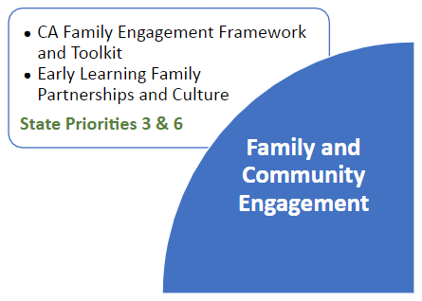

#### Family and Community Engagement

*Parents and families are essential partners in promoting literacy and language development for their children. Parents’ desire for the best for their children should be consistently nurtured and regularly celebrated by the schools and districts. Enlisting parent and family understanding and support of the CA CCSS for ELA/Literacy, the CA ELD Standards, and this* ELA/ELD Framework *are key. California’s vision for its students can only be realized when it is shared by students’ parents and families.* (*ELA/ELD Framework*, p. 1002)

Parents and families are each child’s first teachers and their best supporters and resources. Involving parents and families in the literacy development of their children and in the literacy life of the school can take many forms. Parents and families are the natural partners and allies for the teachers and specialists who teach their children on a day-to-day basis. Frequent and effective communication in person, at school, or through home visits is the best means for learning about students and supporting their parents or other key caring adults in their lives to support them. Communication via email, text, phone, newsletter, personal note, and school web site is also important. Communicating in the family’s primary language is essential, as is valuing the cultural resources and assets that the family brings. Chapter 11 of the *ELA/ELD Framework*[71] provides considerations and tools for engaging parents and families.

Additionally, the *Family Engagement Framework: A Tool for California School Districts*[72] is a tool for leaders in school districts and county offices of education to use as they work with schools, families, and communities to plan, implement, and evaluate family engagement practices that directly impact improved student achievement. The *Family Engagement Toolkit: Continuous Improvement Through an Equity Lens*[73] provides practical planning and evaluation tools that support efforts to engage all families, particularly those of underrepresented and underserved students. The *Family Partnerships and Culture*[74]publication promotes understanding of children’s cultural or multicultural experiences at home and helps teachers use those experiences as building blocks for teaching and learning in early education settings.

As noted in the *ELA/ELD Framework*, the larger community of cultural, ethnic, and social community groups; local businesses; local government; and service groups can be effective school partners. Soliciting funds should not be the only interaction the school has with these groups. These groups are often good sources of professional learning (e.g., cultural awareness, art and music), volunteers, field trips, publicity, and advocacy. Just as parents and families need to be valued and feel welcome in the school, so too do community agencies and businesses.

Local colleges and universities, professional organizations, technical assistance agencies, and public agencies can be good sources of expertise and professional learning for the school. Mentoring, tutoring, student teacher placement, and other specific opportunities to collaborate may be available. Strategic identification of services available from these groups and other partnership opportunities increase the support for the literacy goals of the school.

The *CA EL Roadmap* establishes in Principle One that educators value and build strong family, community, and school partnerships, and California’s Social and Emotional Learning Guiding Principle Four calls for systems to maximize the resources of the entire school community, including expanded learning opportunities, early learning and care programs, and family and community partnerships, to advance SEL and student well-being. LCFF also calls for family and community engagement through State Priority 3,[75] which addresses parent input in decision-making and participation in programs, and State Priority 6,[76] which addresses school climate.

Building relationships and a shared vision for students’ literacy goals with a broad range of individuals and organizations inside the school and school district and within the community and larger professional milieu may bring positive support to the school and its students.

#### California’s Statewide System of Support

The CDE supports implementation and compliance with state and federal laws, facilitates the development of LEA guidance, and, in collaboration with the State Board of Education and the California Collaborative for Educational Excellence,[77] coordinates the Statewide System of Support, which brings together California’s improvement networks and resources to assist LEAs in meeting the state priorities. All improvement networks may utilize the Comprehensive and Integrated Literacy Model to make connections among state guidance and focus supports to meet the specific needs of LEAs.

## SLP Continuous Improvement Process

With the implementation of the Local Control and Funding Formula (LCFF), the Local Control and Accountability Plan (LCAP), the California School Dashboard, and the Statewide System of Support, California has established an education system based on the principle of continuous improvement. The California Department of Education (CDE), in collaboration with its statewide partners for literacy and stakeholders, is using the continuous improvement process to improve literacy outcomes for students.

Figure 3 Continuous Improvement Model

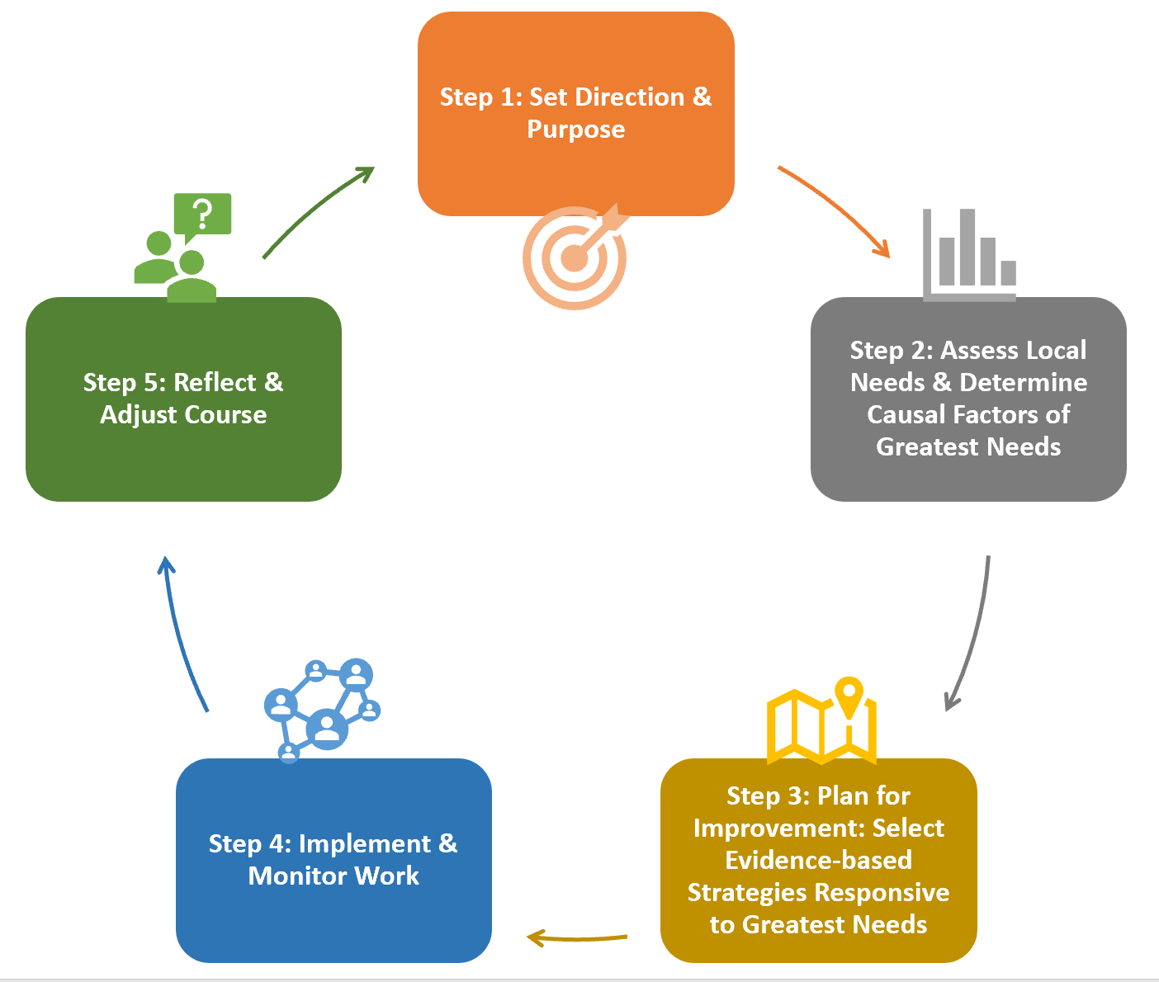

In this section of the Comprehensive State Literacy Plan (SLP), each step of the continuous improvement process at the state level is detailed, illustrating how the CDE and its partners assessed statewide literacy needs and developed plans to leverage the Comprehensive Literacy State Development (CLSD) Grant funds to address those needs.

At the local level, local educational agencies (LEAs) are encouraged to examine local literacy programs and supports through the continuous improvement process. This section can support LEAs by illustrating this process and providing the resources and tools that can be leveraged at the local level to improve literacy outcomes. Additional literacy program resources, including templates, protocols, and examples, are in development as an outcome of this plan (See Step 4: Implement & Monitor Work below). General resources and tools to assist LEAs as they plan and implement their continuous improvement efforts through their LCAP and school planning process are available on the CDE Continuous Improvement Resources web page.[78]

### Bullseye iconStep 1: Set Direction and Purpose

The Comprehensive and Integrated Literacy Model described in the previous section sets the direction for literacy programs statewide by aligning and integrating state literacy initiatives to ensure **high-quality literacy instruction occurs within the context of inclusive and equitable systems of schooling featuring high levels of engagement, a focus on continuous improvement, and application of the California Multi-Tiered System of Support (MTSS) Framework.**

State content standards and state curriculum frameworks define age/grade level goals for student achievement and instruction. The goal of the SLP is to support all students to meet age/grade level literacy foundations and content standards and all LEAs to implement state literacy guidance with fidelity by the conclusion of the CLSD Grant. These goals are further detailed below.

At the local level, LEAs can set the direction and purpose of local literacy programs by defining a mission and/or vision, setting goals and performance measures, and developing a statement of purpose that addresses the local context. LEAs are not required to adopt the state direction and purpose but are encouraged to consider it as a model informed by extensive research and stakeholder input.

#### Birth to Age Five Literacy Goals

*Language development naturally occurs through ongoing interactions with adults. Babies have an inborn capacity to learn language that emerges by experiencing language input from adults. Experiences with language allow infants and toddlers to acquire mastery of sounds, grammar, and rules that guide communication and to share meaning with others. By intentionally including language in responsive interactions with infants and toddlers, and by planning experiences that actively engage children in communication, teachers can enrich the complex and amazing process of language development.* (*California Infant/Toddler Curriculum Framework*, p. 84)

*Language is one of the most crucial tools that children acquire, one that is essential for cognitive development, reading achievement, and overall school performance, as well as for social relations. It allows people to share a society’s achievements and history and the deepest emotions. Language includes conventional sounds, gestures, and visual symbols, such as writing, that are used separately and jointly for purposes of communication. The human brain is “hard-wired” to learn language, a process quite similar in all children. Yet children differ a good deal as to when they use their first words, start to combine words into sentences, and use complex sentence forms to communicate meaning. Though children begin to develop language and literacy at birth, with nonverbal cues such as eye gaze and gestures, they arrive at preschool ready to communicate with symbols: words, signs, and pictures.* (*California Preschool Curriculum Framework*, p. 98)

Many early childhood experts consider language development to be one of the greatest accomplishments in the first three years of life. The rate of children’s early language growth and later language outcomes is directly related to the verbal input that children receive when communicating with adults and other children. Children develop concepts about print through seeing print in the environment and observing people using print for various purposes. Knowing the letters of the alphabet at preschool age is related to both short- and long-term reading proficiency. Preschoolers’ development of narrative thinking goes through a series of stages that ultimately lead to their making sense of stories and the world around them. Interest in books and a positive regard for reading are important developmental accomplishments for preschool-age children. Children from a very young age notice writing in their surroundings. They begin to understand that signs in the environment represent words for ideas or concepts. By age three they begin to differentiate between writing and other kinds of visual representation, such as drawing.

The family is at the center of a young child’s learning and development. In light of the family’s central role in a child’s early experience and development, programs need to partner with family members in all aspects of curriculum planning. Strong partnerships with families grow from respecting and valuing diverse views, expectations, goals, and understandings families have for their children. Programs demonstrate respect for families by exchanging information about their children’s learning and development and sharing ideas about how to support learning at home and in the early childhood education program.

The statewide literacy goal for this age band is that all children meet or exceed the developmental milestones described in the Language Development Domain of the *Infant/Toddler Foundations* document and the Language and Literacy Domain of the *Preschool Foundations* document. Guidance provided in the related Curriculum Frameworks and Learning and Development Program Guidelines linked to below is implemented with fidelity.

| **Age Span** | **Foundations** | **Curriculum Framework** | **Program Guidelines** |
| --- | --- | --- | --- |
| Infant/Toddler | Language Development Domain  <https://www.cde.ca.gov/sp/cd/re/itf09langdev.asp> | <https://www.cde.ca.gov/sp/cd/re/documents/itcurriculumframework.pdf> | <https://www.cde.ca.gov/sp/cd/re/documents/itguidelines2019.pdf> |
| Preschool | Volume 1 (Foundations in Language and Literacy, p. 47)  <https://www.cde.ca.gov/sp/cd/re/documents/preschoollf.pdf> | Volume 1 (Chapter 4: Language and Literacy, p. 97)  <https://www.cde.ca.gov/sp/cd/re/documents/psframeworkkvol1.pdf> | <https://www.cde.ca.gov/sp/cd/re/documents/preschoolproggdlns2015.pdf> |

#### Transitional Kindergarten to Grade Five Literacy Goals

*In transitional kindergarten through grade one, children acquire the skills, knowledge, and dispositions that establish the foundation for a lifetime of learning. They develop new understandings about how the world works, and they begin to build autonomy in their own learning. Children experience and thoughtfully engage with a range of high quality literary and informational texts. They comprehend and use increasingly varied vocabulary, grammatical structures, and discourse practices as they share with one another their understandings and ideas about texts and other learning experiences. They learn about the English written system and acquire the foundational skills that enable them to interact independently with print as readers and writers in the years ahead.* (*ELA/ELD Framework*, p. 132)

*The grades two to three span is a pivotal time for children as they build more sophisticated comprehension and decoding skills and develop the fluency necessary to propel them into more advanced reading, including independently reading chapter books.* (*ELA/ELD Framework*, p. 285)

*Students in grades four and five learn to employ and further develop their literacy and language skills to comprehend, use, and produce increasingly sophisticated and complex texts as well as communicate effectively with others about a range of texts and topics. Importantly, they read widely and they read a great deal. They read to pursue knowledge (as when they engage in research) and they read for pleasure.* (*ELA/ELD Framework*, p. 393)

The first years of schooling are a profoundly important time on the pathway to literacy, and the quality of the curricula and instruction offered to children in transitional kindergarten through grade five has long-lasting implications. In transitional kindergarten through grade one, students acquire the skills, knowledge, and dispositions that establish the foundation for a lifetime of learning. In grades two and three, students become increasingly fluent with written language and they engage with progressively more complex high-quality literary and informational text, expand their knowledge in the content areas, and continue to develop as effective communicators. By grade five, students learn to consolidate their skills and apply them across content areas, in different settings, and for different purposes.

The statewide literacy goal for this grade band is that all students achieve the CCSS ELA/Literacy for their grade level and guidance provided in the *ELA/ELD Framework* is implemented with fidelity, with particular attention to grade span chapters below.

| ***ELA/ELD Framework* Chapter** | **Web Link** |
| --- | --- |
| Chapter 3: Content and Pedagogy: Transitional Kindergarten Through Grade One | <https://www.cde.ca.gov/ci/rl/cf/documents/elaeldfwchapter3.pdf> |
| Chapter 4: Content and Pedagogy: Grades Two and Three | <https://www.cde.ca.gov/ci/rl/cf/documents/elaeldfwchapter4.pdf> |
| Chapter 5: Content and Pedagogy: Grades Four and Five | <https://www.cde.ca.gov/ci/rl/cf/documents/elaeldfwchapter5.pdf> |

#### Grade Six to Grade Twelve Literacy Goals

*The CA CCSS for ELA/Literacy for grades six through eight represent a big leap for students as they move from the elementary grades to the middle grades. Moving beyond details and examples, students now are expected to cite textual evidence to support their analysis of what the text states explicitly and they infer from it. Argument is introduced in grade six, and students are expected to go beyond stating reasons and evidence by tracking and evaluating arguments and claims in texts and writing their own arguments, rather than opinions, to support claims with clear reasons and relevant evidence.* (*ELA/ELD Framework*, p. 506)

*By the end of grade twelve the intent is for every student to have established his or her own* literate identify *drawing on the knowledge, skills, and confidence developed over thirteen to fourteen years of prior schooling to have attended the second goal—the* ***capacities of literate individuals*** *(demonstrating independence; building strong content knowledge; responding to varying demands of audience, task, purpose, and discipline; comprehending as well as critiquing; valuing evidence; using technology and digital media strategically and capably; and coming to understand other perspectives and cultures).* (*ELA/ELD Framework*, p. 664)

The grade 6–8 chapter of the *ELA/ELD Framework* highlights the young adolescents’ quest for autonomy, relevance, meaning, and competence that begins in earnest during these years. This multifaceted quest relies on motivation and engagement, two critical factors in students’ school success. Successful educators recognize that students crave social affiliation while still wanting adult guidance and approval. They capture students’ interests and help students pay attention by remaining responsive. Moreover, “successful educators use their enthusiasm to challenge young adolescents’ increasing capacity to learn new information, perceive new connections and perspectives, and experience the pleasure of creating new knowledge.”

As students mature, the grade 9–12 chapter notes how students’ progress through the high school years sees many cognitive, physical, emotional, and social changes as these emerging adults contemplate their future and their place in the world around them. High school students are also motivated by peer groups and signals of their increasing degrees of independence. Graduating seniors who attain the goals of the *ELA/ELD Framework* are well-positioned to meet the rigors of postsecondary education and future jobs and to pursue a path of lifelong fulfillment and informed citizenship.

In grades 6–12, the CA CCSS for ELA/Literacy recognize the role that complex skills in literacy and language analysis and applications play across the curricula. The inclusion of the reading and writing standards for history/social studies, science, and technical subjects in grades 6–12 underscores this relationship.

Students enter high school with a range of abilities, skills, knowledge, attitudes, and educational experiences. Some are well positioned to find high school a successful and satisfying time in their school careers, and others enter quite unprepared for the academic demands they face during these four years. The *ELA/ELD Framework* provides guidance for supporting grade 6–12 students who are experiencing difficulty in literacy. In this grade band, time is of the essence: assistance should be provided swiftly, be fast paced to accelerate learning, and address what is needed.

The statewide literacy goal for this grade band is that all students achieve the CCSS ELA/Literacy for their grade level and guidance provided in the *ELA/ELD Framework* is implemented with fidelity, with particular attention to the grade span chapters below.

| ***ELA/ELD Framework* Chapter** | **Web Link** |
| --- | --- |
| Chapter 6: Content and Pedagogy: Grades Six through Eight | <https://www.cde.ca.gov/ci/rl/cf/documents/elaeldfwchapter6.pdf> |
| Chapter 7: Content and Pedagogy: Grades Nine through Twelve | <https://www.cde.ca.gov/ci/rl/cf/documents/elaeldfwchapter7.pdf> |

### Bar chart iconStep 2: Assess Local Needs and Determine Causal Factors

The CDE conducted the Comprehensive Statewide Literacy Needs Assessment and brought together groups of stakeholders to review the results. Stakeholders also reviewed current student achievement data to inform consideration of statewide priorities to support the improvement of literacy outcomes. Below you will find information and analysis of current student achievement data and the results of the needs assessment.

At the local level, LEAs can use the needs assessment process in collaboration with local stakeholders to focus on specific problems rather than symptoms, prioritize causes most likely to have a significant impact on the problem, and focus on actionable causes of the problem. Needs assessments are used to identify strengths and weaknesses within the context and constraints of the LEA and to dig deeper into root causes. They go beyond student data to include data on the effectiveness of current practices to evaluate what is and is not working. LEAs can utilize the Comprehensive Statewide Literacy Needs Assessment[79] to review local literacy programs. Additional tools and resources for LEA use are in development as an outcome of the state plan development process.

#### Current Statewide Literacy Data

##### Desired Results Developmental Profile

The *Desired Results Developmental Profile (2015) [DRDP (2015)]: A Developmental Continuum from Early Infancy to Kindergarten Entry[80]* is a formative assessment instrument developed by the CDE for young children and their families to be used to inform instruction and program development.

The Language and Literacy Development (LLD) domain of the Desired Results Developmental Profile (DRDP) assesses the progress of children in developing the following foundational language and literacy skills:

* Understanding Language
* Responding to Language
* Communication and Use of Language
* Reciprocal Communication and Conversation
* Interest in Literacy
* Comprehension of Age-Appropriate Text
* Concepts about Print
* Phonological Awareness
* Letter and Word Knowledge
* Emergent Writing

These skills can be demonstrated in any language and in any mode of communication. Language and literacy skills in a child’s first language form the foundation for learning English. Therefore, dual language learners may demonstrate knowledge and skills in their home language, in English, or in both languages. LLD measures should be completed for all infants, toddlers, and preschool-age children, including those who are dual language learners.

The following levels can be observed on the DRDP:

* Responding (Earlier, Later): Knowledge, skills, or behaviors that develop from basic responses (through using senses and through actions) to differentiated responses. Children generally engage in back-and-forth interactions with familiar adults and communicate through nonverbal messages.
* Exploring (Earlier, Middle, Later): Knowledge, skills, or behaviors that include active exploration including purposeful movement, purposeful exploration and manipulation of objects, purposeful communication, and the beginnings of cooperation with adults and peers. Children generally begin this period by using nonverbal means to communicate and, over time, grow in their ability to communicate verbally or use other conventional forms of language.
* Building (Earlier, Middle, Later): Knowledge, skills, or behaviors that demonstrate growing understanding of how people and objects relate to one another, how to investigate ideas, and how things work. Children use language to express thoughts and feelings, to learn specific early literacy and numeracy skills, and to increasingly participate in small group interactions and cooperative activities with others.
* Integrating (Earlier): Knowledge, skills, or behaviors that demonstrate the ability to connect and combine strategies in order to express complex thoughts and feelings, solve multi-step problems, and participate in a wide range of activities that involve social-emotional, self-regulatory, cognitive, linguistic, and physical skills. Children begin to engage in mutually supportive relationships and interactions.

In 2019, DRDP LLD results were submitted for 86,598 four year olds in publicly-funded preschools. Most four year olds (84.5 percent) were observed at the Building and Integrating developmental levels. The following chart displays the percent of four year olds that were observed at the Responding and Exploring LLD developmental levels.

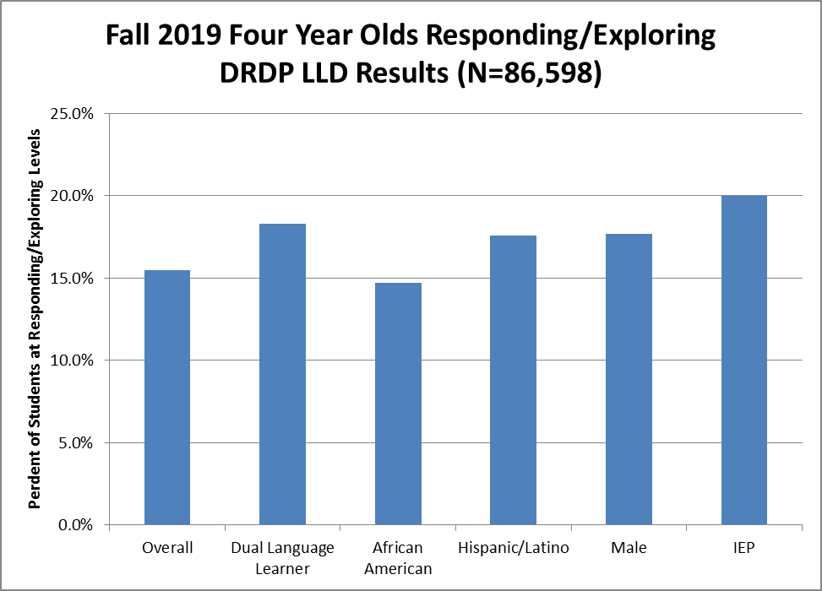

This data shows that more four year olds who are dual language learners, Hispanic/Latino, male, or have individualized education programs (IEPs) were observed at the Responding and Exploring developmental levels than the overall percent of four year olds. Complete data for these results are provided in Appendix B.

More information is available on the DRDP Online Resources[81] web page.

##### California Assessment of Student Performance and Progress

The Smarter Balanced English language arts (ELA) assessment overall reporting achievement level descriptors consists of four achievement levels: Standard Exceeded (Level 4), Standard Met (Level 3), Standard Nearly Met (Level 2), and Standard Not Met (Level 1).

In the Smarter Balanced system, there are two kinds of claims: an “overall claim,” corresponding to performance on the entire assessment of English language arts/literacy or mathematics, and four domain-specific claims corresponding to performance in different areas in each of the assessments. The Smarter Balanced Overall Claim for ELA states, “*Students can demonstrate progress toward college and career readiness in English Language arts and Literacy*.”

The four domain-specific claims for ELA focus on what students are expected to be able to do at each grade level. These claims are broad statements that outline the outcomes related to mastery of the standards within the domain. The four claims for ELA are:

* Reading: “*Students can read closely and analytically to comprehend a range of increasingly complex literary and informational texts.”*
* Writing: *“Students can produce effective writing for a range of purposes and audiences.”*
* Listening: *“Students can employ effective speaking and listening skills for a range of purposes and audiences.”*
* Research*: “Students can engage in research/inquiry to investigate topics, and to analyze, integrate, and present information.”*

Three claim descriptor categories were identified by using the distance a student's performance on the questions related to that claim is from the Level 3 "Standard Met" achievement level criterion. The claim achievement category indicates that the student’s score on a claim is one of the following:

* "Above Standard," if the scale score of a claim is above the "Standard Met" achievement level on the total content-area test.
* "Near Standard," if the scale score of a claim is at or near the "Standard Met" achievement level on the total content-area test.
* "Below Standard," if the scale score of a claim is below the "Standard Met" achievement level on the total content-area test.

Additionally, assessment targets provide a bridge between the content standards and the evidence that supports the claims.

Below are the 2018–19 CAASPP ELA/Literacy Results. Trend and cohort data are available in Appendix C.

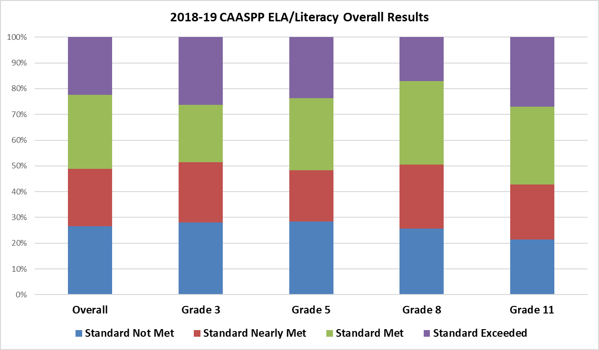

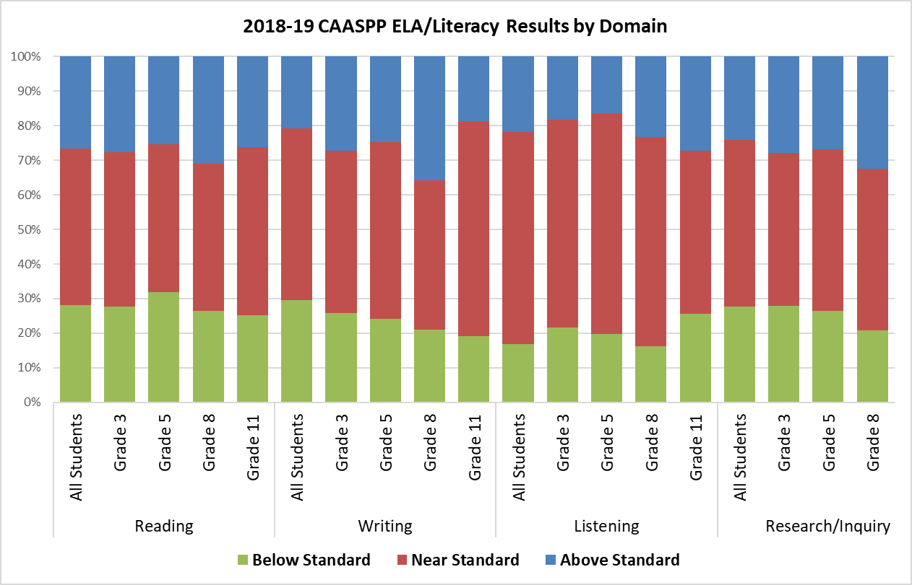

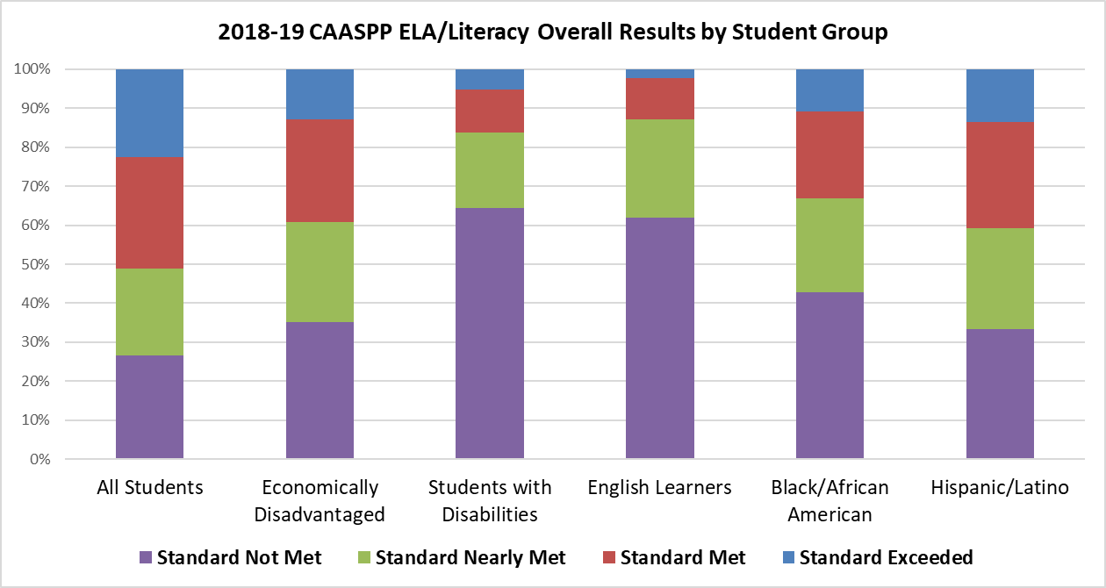

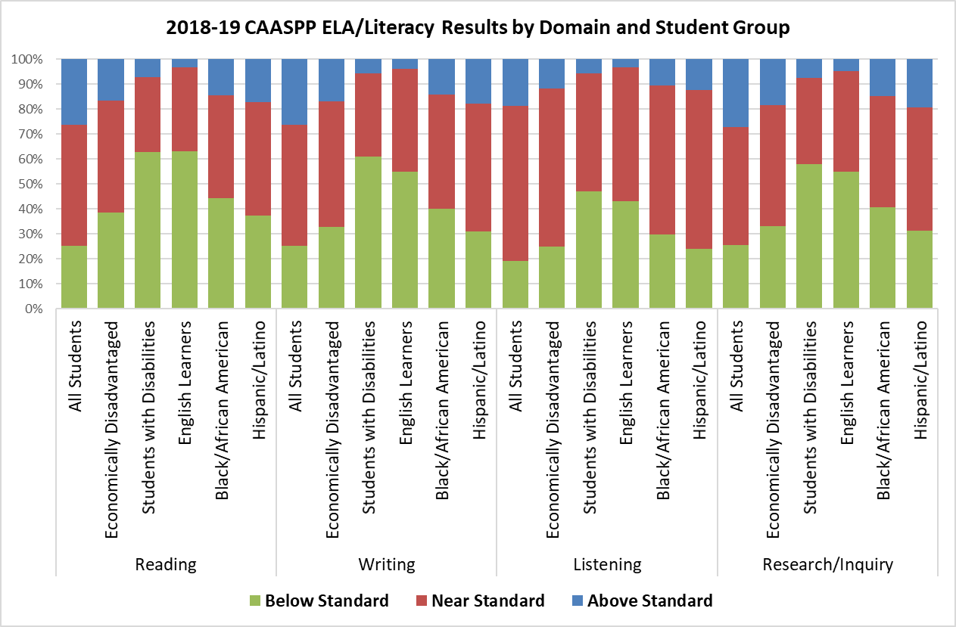

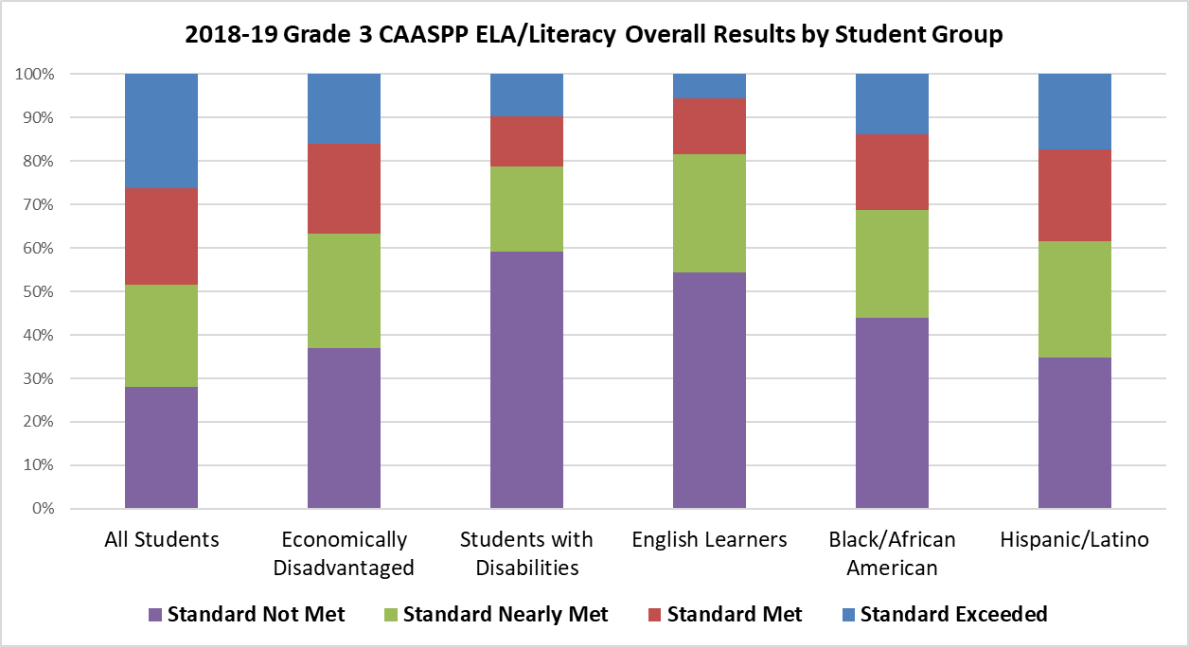

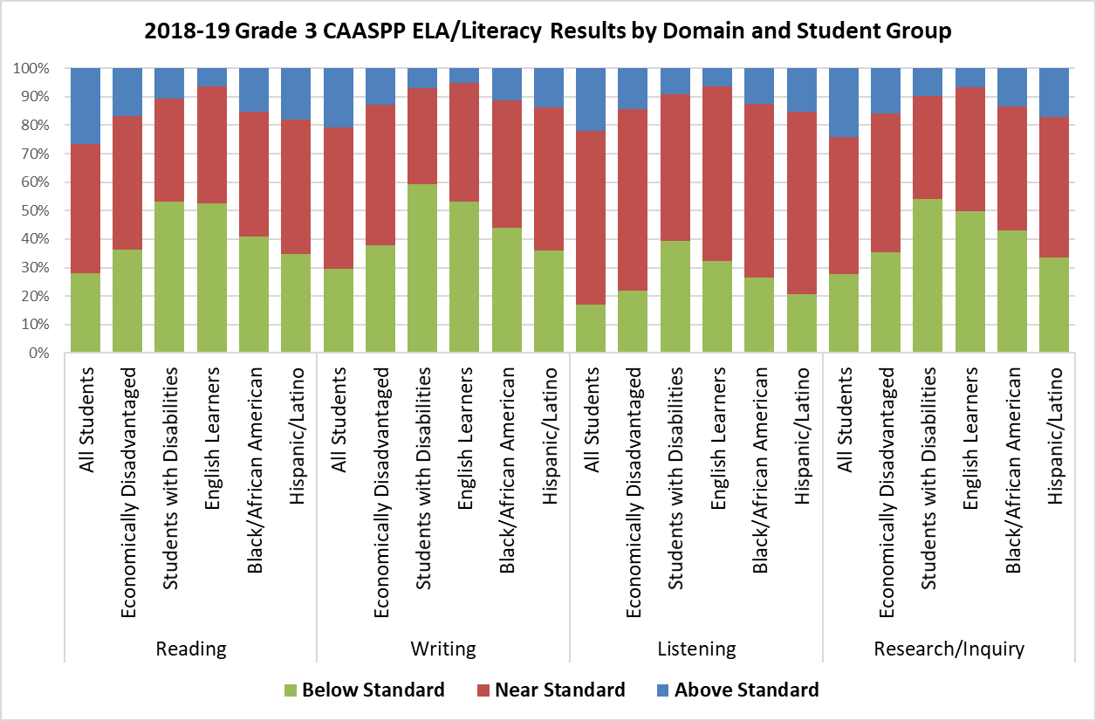

CAASPP ELA/Literacy results for Grade 3 show that 28.04 percent of students did not meet the grade level standard, not including the Standard Nearly Met (Level 2) achievement level. Writing and Reading domains show the highest percentages of students below standard. Across the domains, the student groups with the highest percentages of students not meeting the grade level standard are students with disabilities, English learners, and Black/African American students.

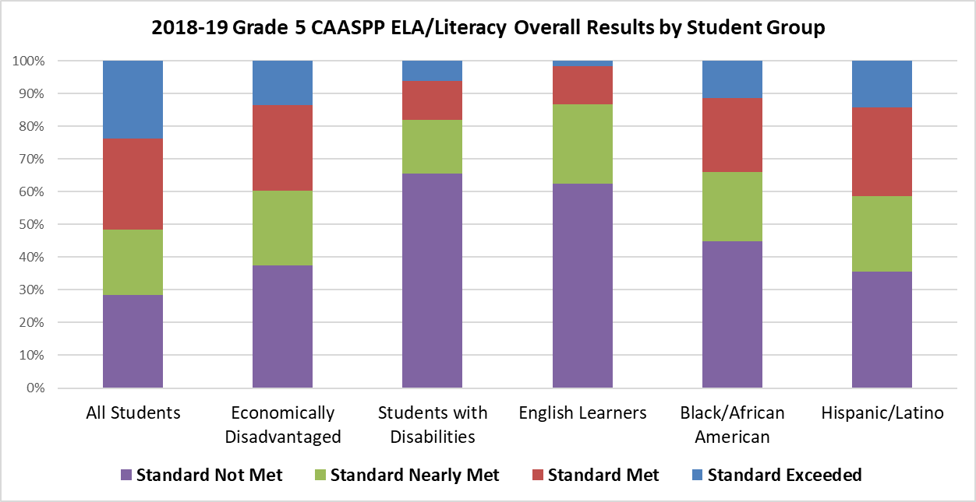

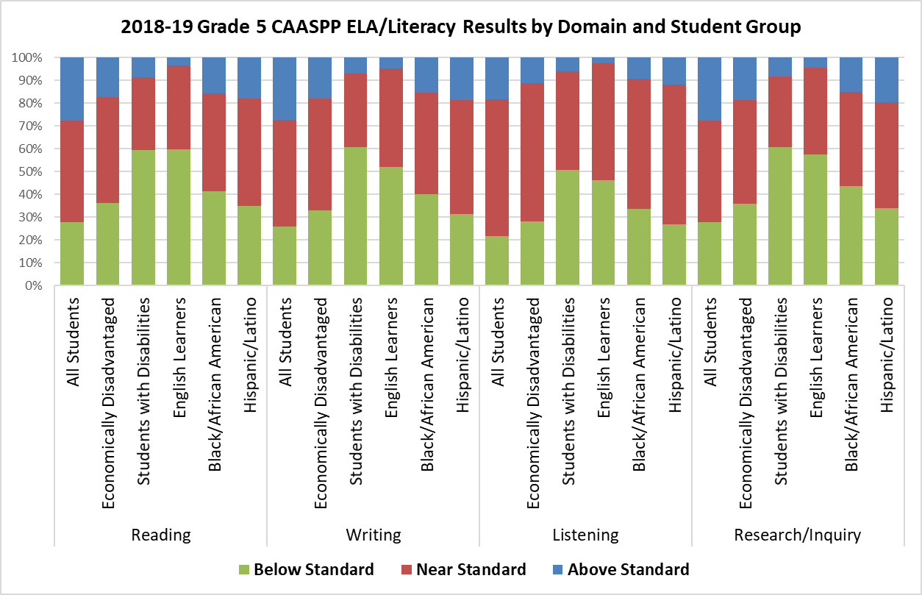

CAASPP ELA/Literacy results for Grade 5 show that 28.44 percent of students did not meet the grade level standard, not including the Standard Nearly Met (Level 2) achievement level. Research and Reading domains show the highest percentages of students below standard. Across the domains, the student groups with the highest percentages of students not meeting the grade level standard are students with disabilities, English learners, and Black/African American students.

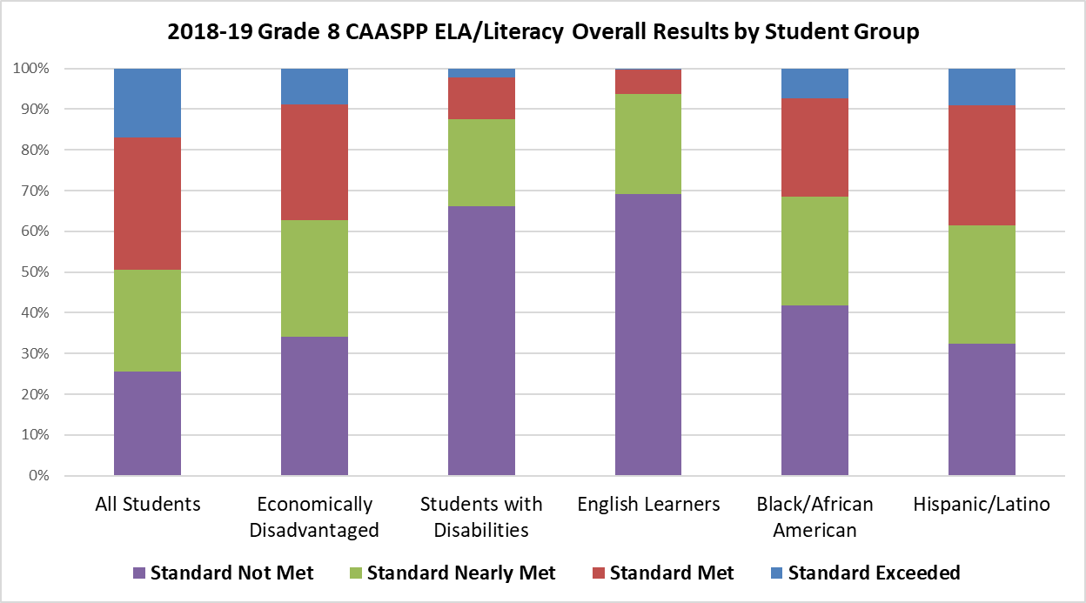

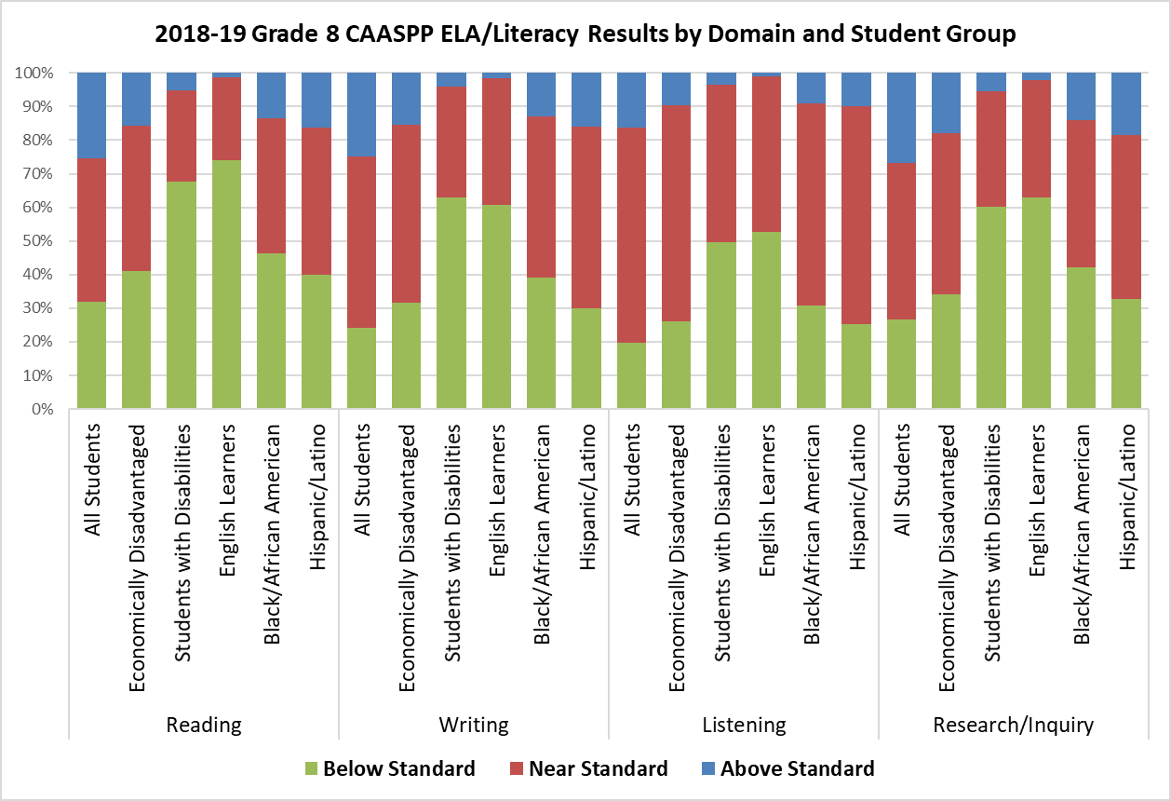

CAASPP ELA/Literacy results for Grade 8 show that 25.66 percent of students did not meet the grade level standard, not including the Standard Nearly Met (Level 2) achievement level. Reading and Research domains have the highest percentages of students below standard. Across the domains, the student groups with the highest percentages of students not meeting the grade level standard are English learners, students with disabilities, and Black/African American students.

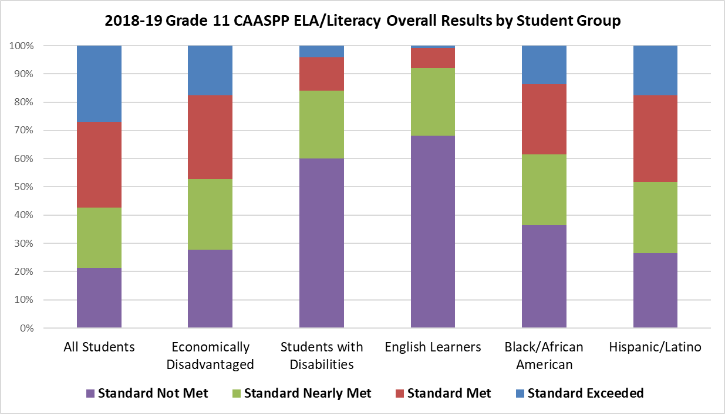

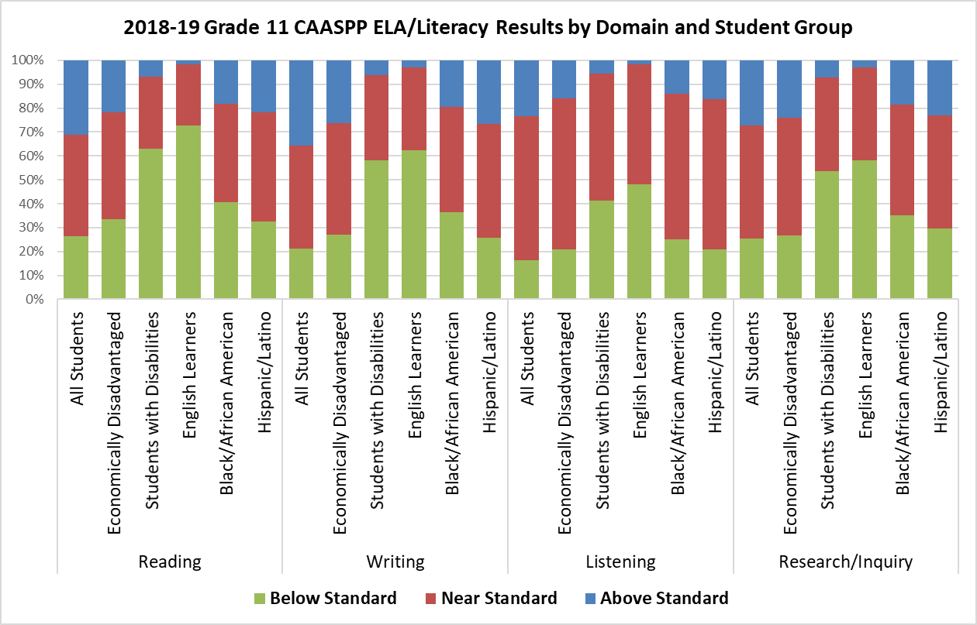

CAASPP ELA/Literacy results for Grade 11 show that 21.35 percent of students did not meet the grade level standard, not including the Standard Nearly Met (Level 2) achievement level. Reading and Writing domains show the highest percentages of students below standard. Across the domains, the student groups with the highest percentages of students not meeting the grade level standard are English learners, students with disabilities, and Black/African American students.

##### Assessment Cycles

Yearly assessments, such as the CAASPP assessments, are long-cycle assessments. They assess students’ mastery of standards at the end of the grade and provide student achievement results at several levels, including individual, school, district, and state. Long-cycle assessment results are appropriately used for system monitoring and accountability, adjustments to programs, curricula and instruction, and identifying professional learning needs, among other uses.

At the local level, LEAs utilize the full range of assessment cycles (short, medium, long) in a continuous improvement process to provide ongoing information to teachers throughout the year. Please see Chapter 8 of the *ELA/ELD Framework* for more information regarding assessment cycles.[82] In a Multi-Tiered System of Support, Tier 1 instruction should result in no less than 80 percent of students achieving grade-level expectations. If less than 80 percent succeed in Tier 1 instruction, schools should engage in close examination of the curriculum and teaching practices and make appropriate adjustments.

##### Additional Relevant Data

Not all relevant data could be displayed in this plan. Educators should also review the data available in the California School Dashboard.[83] California’s accountability system is based on multiple measures that assess how LEAs and schools are meeting the needs of their students. In a Comprehensive and Integrated Literacy Model, multiple factors influence a student’s literacy outcomes. The multiple measures reported in the Dashboard help to assess factors beyond academics that contribute to literacy outcomes, such as English language proficiency growth, chronic absenteeism (student engagement), and suspensions (school climate).

At the local level, LEAs should also consider relevant data that is not reported in the Dashboard, such as data related to early childhood education programs, expanded learning programs, biliteracy achievement, school surveys (such as the California School Climate, Health, and Learning Survey[84]) school libraries, teacher librarians, specialists, counselors, school nurses, and community resources.

#### Stakeholder Engagement

##### Comprehensive Statewide Literacy Needs Assessment

To prepare for the development of the Comprehensive State Literacy Plan, the CDE conducted a comprehensive statewide literacy needs assessment available to all California LEAs, including county offices of education, districts, and schools (including private and charter). The CDE collected 167 responses from across the state. A summary of the results is provided below. The CDE and the SLT used these results to inform statewide literacy priorities defined in the age/grade band sections.

The implementation levels for the key topics of the needs assessment are defined as follows:

* Emerging: Establishing Consensus
* Developing: Building Infrastructure
* Operationalizing: Gaining Consistency
* Optimizing: Innovating and Sustaining

###### Key Topic A: Engaged Leadership and Supporting Teachers to Improve Instruction

Key Topic A gathered data on how the LEA and school leaders collaborate to implement high-quality literacy programs, which includes analyzing assessment data, utilizing evidence-based instructional practices, building literacy-focused teams, and promoting teacher learning and leadership. Key Topic A mainly addresses the “Well-Prepared and Supported Teachers and Leaders” element of the Comprehensive and Integrated Literacy Model.

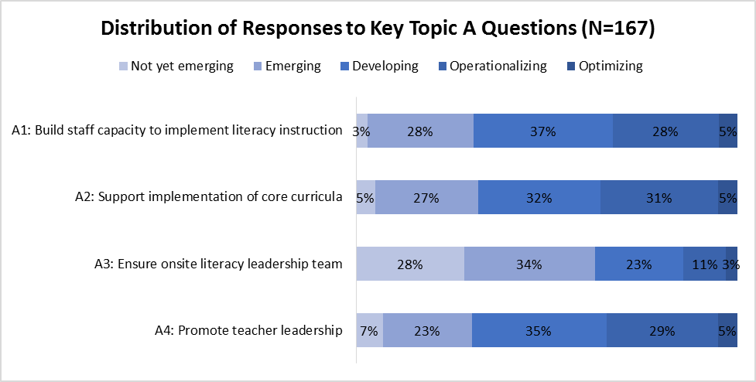

Of all the key topics, Key Topic A had the fewest respondents in the Optimizing level across the topic questions. Most respondents consider implementation of this key topic to be in the Emerging and Developing levels. The greatest area of need in this topic appears to be the need to establish onsite literacy leadership teams, with 28 percent of respondents reporting that this area is Not Yet Emerging. Respondents noted several challenges to this key topic in their open-ended responses, including the lack of resources, instructional leadership, professional learning on literacy instruction, ongoing support such as coaching, and systemic implementation.

###### Key Topic B: Assessment Practices and Intervention Supports

Key Topic B gathered data on assessment policies, procedures, and practices that are developed, implemented, and documented, and literacy interventions are provided as needed. Key Topic B mainly addresses the “Assessment System” of “Best First Instruction” of the Comprehensive and Integrated Literacy Model.

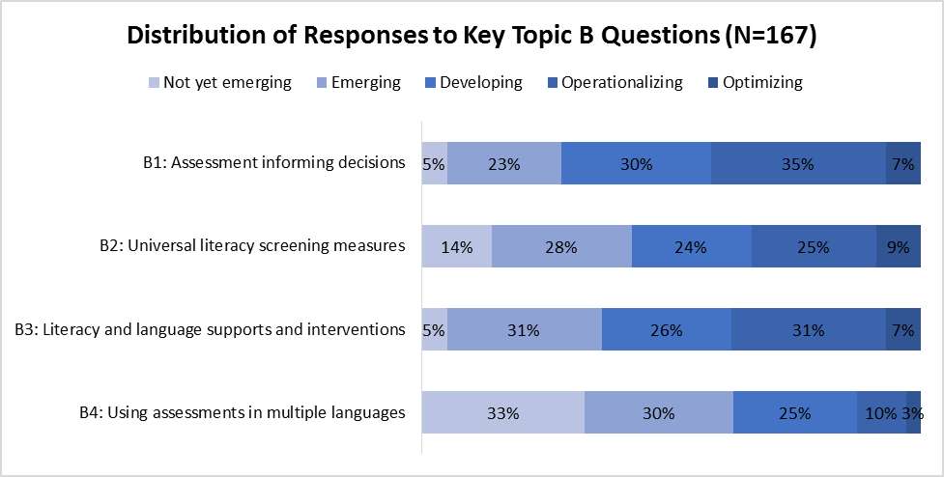

Fewer respondents reported being in the Operationalizing and Optimizing levels with the use of universal screening measures to appropriately place and provide interventions to students and using assessments in multiple languages than the other areas of this topic, with 33 percent of respondents reporting this area as Not Yet Emerging. Implementation challenges noted by respondents for this area include lack of professional learning around using formative and interim assessment data to inform instruction, lack of substitutes to provide release time for teachers to collaborate around data, lack of supports for English learners and students with disabilities, and lack and inconsistent use of universal screeners in early learning programs.

###### Key Topic C: Policy, Structure, and Cultural Alignment

Key Topic C gathered data on the implementation of California’s policies, procedures, and guidance documents relating to standards-based literacy instruction as well as implementation of culturally relevant pedagogy in all transitional kindergarten through grade twelve classrooms. Key Topic C mainly addresses “Best First Instruction” and “Celebration of Diversity and Asset-Based Approach” of the Comprehensive and Integrated Literacy Model.

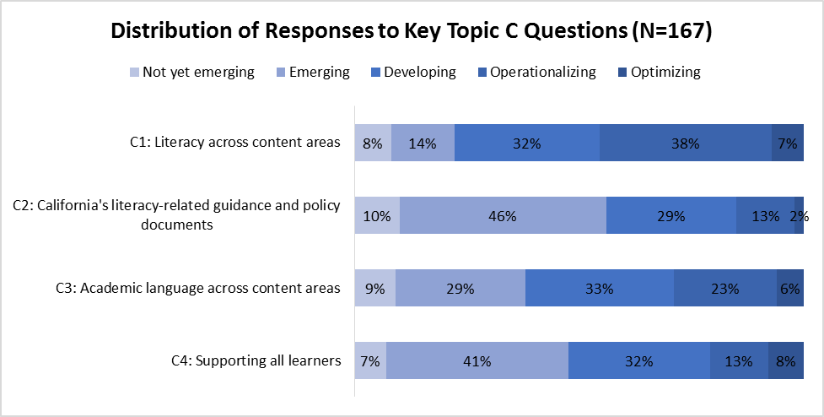

Most respondents report being at the Emerging or Not Yet Emerging levels of implementing California’s literacy-related guidance and policy documents and supporting all learners. While implementation of literacy across the content areas appears to be mostly at the Developing and Operationalizing levels, implementation of academic language across content areas shows more respondents at the Emerging level. Respondents reiterated their concerns about the lack of sustained quality professional learning to support English learners and students with disabilities. They noted that current curriculum does not address ELD or align with the *California Dyslexia Guidelines* and that LEAs need more professional learning on this document and the *ELA/ELD Framework* to support the implementation of designated and integrated ELD. Respondents also stated that more professional learning is needed to implement culturally responsive pedagogy and social-emotional learning.

###### Key Topic D: Family, Community, and Partner Supports

Key Topic D gathered data on how LEAs exist and work within the context of their communities and how they collaborate with parents, families, community members, and outside organizations to create the structures necessary for effective literacy instruction and learning. Key Topic D mainly addresses “Family and Community Engagement” element of the Comprehensive and Integrated Literacy Model.

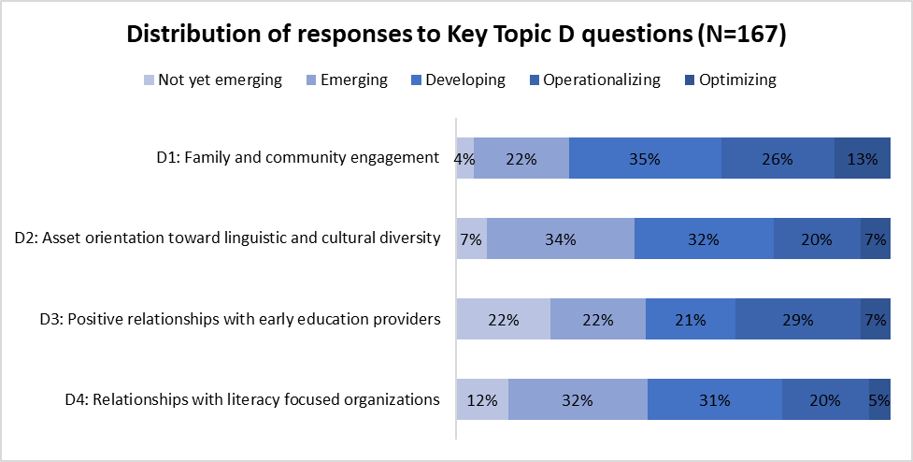

A large majority of respondents report being at the Developing level and below in this key topic. Regarding relationships with early education providers, 22 percent of respondents report being at the Not Yet Emerging level. Almost half of the respondents (44 percent) report being at the Not Yet Emerging and Emerging level in implementing relationships with literacy focused organizations. Respondents reported challenges in increasing parent engagement, providing culturally diverse books and multilingual resources, sharing information with and supporting early education providers, and prioritizing community partnerships.

##### State Literacy Team

One of the objectives of the CLSD grant proposal was for the CDE to convene a state literacy team to provide input and recommendations on the Comprehensive State Literacy Plan. The State Literacy Team (SLT)[85] is comprised of a diverse group of stakeholders with experience in literacy education. This team convened for two two-day virtual meetings to provide feedback on the Comprehensive State Literacy Plan and was facilitated by staff from the Region 15 Comprehensive Center at WestEd. The CDE sought the SLT’s feedback to address the following questions:

* What are the literacy needs of California’s children?
* What are the implementation considerations for each evidence-based strategy prioritized by the SLT?
* What resources should LEAs consider using when implementing these evidence-based strategies?

A key goal of the convenings was to prioritize a list of evidence-based literacy strategies based on facilitated analysis of student needs as well as the experience and expertise of the SLT members.

### Map with pin iconStep 3: Plan for Improvement

The State Literacy Team helped the CDE select and prioritize strategies to address statewide literacy needs. These priorities are outlined for each age/grade band below with key state guidance and resources highlighted to inform state-level activities, which are also described in this step of the process.

At the local level, LEAs can plan for improvement by selecting evidence-based strategies that align with local needs and context, setting milestones, outlining actions, determining outputs, and developing a timeline.

#### Birth to Age Five Statewide Literacy Priorities

After reviewing the Statewide Literacy Needs Assessment and results from the DRDP, the State Literacy Team identified the following statewide priorities for supporting literacy development from a child’s birth through age five:

* Support early childhood education (ECE) programs to create literacy-rich environments and experiences and support the quality of ECE programs and their capacity to support early language and literacy skills.
* Increase parenting support by increasing parental knowledge, skills, and confidence through parenting curriculum and literacy activities with special attention to access and equity for all.

##### Key State Guidance and Resources

Guidance and resources provided in the Comprehensive and Integrated Literacy Model section support quality literacy programs across grade levels. The following state guidance and resources will be leveraged to address statewide literacy priorities. Additional resources, including professional development and other early learning publications are available on the CDE Child Development Resources web page.[86]

###### Literacy-Rich Environments and Experiences

Learning activities should focus on the essential components of literacy, including   
print-based activities (e.g., learning and writing letters, learning the alphabetic principle). Practitioners can gain an understanding of what high-quality early literacy looks and sounds like when grounded in the following guidance documents.

Infant/Toddler Resources

*Efforts to foster communication and language development also promote emergent literacy in infants and toddlers. As children learn language, they are building a foundation for later literacy. The connection between language experiences and emergent literacy should be made strong in the infant/toddler curriculum. It is essential to provide a learning environment that offers easily accessible and age-appropriate books. The books should reflect the experiences of the children and allow for exploration of new images and ideas.* (*California Infant/Toddler Curriculum Framework*, p. 87–88)

The *California Infant/Toddler Learning & Development Foundations[87]* are at the center of California's infant/toddler learning and development system. The foundations describe how children develop and what they learn and are designed to illuminate the competencies that infants and toddlers need for later success.

In California, priority has been placed on aligning the infant/toddler learning and development foundations with the preschool learning foundations in four major domains:

* Social-emotional development
* Language development
* Cognitive development
* Perceptual and motor development

The language development foundations cover the following competencies:

* **Receptive Language:** The child’s developing ability to understand words and increasingly complex utterances
* **Expressive Language:** The child’s developing ability to produce the sounds of language, and speak with an increasingly expansive vocabulary and use increasingly complex utterances
* **Communication Skills and Knowledge:** The child’s developing ability to communicate nonverbally and verbally
* **Interest in Print:** The child’s developing interest in engaging with print in books and in the environment

There are many specific milestones and dimensions of language development, such as phonology and syntax. As to practice, the four foundations provide a level of detail that is accessible to families and infant care teachers seeking to enhance children’s early language development and communication.

The *California Infant/Toddler Curriculum Framework[88]* supports early childhood educators working in programs serving children birth to three years of age in implementing high-quality curriculum practices that lead to acquisition of the knowledge and skills described in the *Infant/Toddler Learning and Development Foundations.*

The *Infant/Toddler Learning and Development Program Guidelines, Second Edition[89]* publication presents information about how to provide high-quality early and care, including recommendations for program policies and day-to-day practices that will improve program services to all infants and toddlers.

Preschool Resources

*Interesting materials, organized attractively to create specific areas in the indoor and outdoor learning environments, prompt children to talk, explore, build, draw, paint, move, inquire, and enact roles in pretend play. Literacy materials and props, embedded throughout the learning environment, make using language and engaging in reading and writing a routine part of each preschool day.* (*Preschool Curriculum Framework*, p. 103)

The *California Preschool Learning Foundations*[90] outline key knowledge and skills that most children can achieve when provided with the kinds of interactions, instruction, and environments that research has shown to promote early learning and development. The foundations can provide early childhood educators, parents, and the public with a clear understanding of the wide range of knowledge and skills that preschool children typically attain when given the benefits of a high-quality preschool program.

The language and literacy foundations address a wide range of specific competencies that preschool children will need support to learn. These foundations focus on the following three strands:

1. Listening and Speaking: use and conventions, vocabulary, and grammar.
2. Reading: concepts about print, phonological awareness, alphabetics and word/print recognition, comprehension and analysis of age-appropriate text, and literacy interest and response.
3. Writing: writing strategies.

Created as companion volumes to the *California Preschool Learning Foundations*, the *California Preschool Curriculum Frameworks*[91] present strategies for early childhood educators that enrich learning and development opportunities for all of California’s preschool children.

The *California Preschool Program Guidelines[92]* provides the detailed guidance needed by administrators and teachers to offer high-quality preschool programs that prepare children to arrive in kindergarten with the foundational skills necessary for school success.

Access and Equity

During the infant/toddler years, all children depend on responsive, secure relationships to develop and learn. As stated in the CDE’s *Infant/Toddler Learning and Development Program Guidelines* (2007), high-quality programs offer infants and toddlers primary relationships in small groups. Such programs provide personalized care that reflects consideration for individual differences among children. These foundations support infant/toddler programs in the effort to foster the learning and development of all young children in California, including children with disabilities or other special needs. In some cases, infants and toddlers with disabilities or other special needs will reveal their developmental progress in alternative ways. It is important to provide opportunities for children to follow different pathways to learning. Therefore, the infant/toddler learning and development foundations incorporate universal design for learning.

In today’s diverse infant/toddler programs, making the environment, play materials, activities, and experiences accessible to all children is critical to successful learning. Universal design is not a single approach that will accommodate everyone; rather, it refers to providing multiple approaches to learning in order to meet the needs of diverse learners. Universal design provides for multiple means of representation, multiple means of engagement, and multiple means of expression.[93] “Multiple means of representation” refers to providing information in a variety of ways so the learning needs of all children are met. “Multiple means of expression” refers to allowing children to use alternative ways to communicate or demonstrate what they know or what they are feeling. “Multiple means of engagement” refers to providing choices within the setting or program that facilitate learning by building on children’s interests.

When reading each foundation, an infant care teacher needs to consider the means by which a child with a disability or other special need might best acquire information and act competently. To best meet a child’s needs, a parent and an early intervention specialist or related service provider are vitally important resources.

In terms of preschool, children of comparable ages enter school with various linguistic, social, and cognitive skills. Some children may exhibit competencies that go beyond the level described in a particular foundation, while others may need more time to reach that level. The amount and kind of support they need varies from child to child. The application of these foundations requires the teacher’s attention to the individual characteristics of the child. Children with disabilities or other special needs may require adaptations and various means of engagement and expression of knowledge suited to their disability.

Teachers should read each foundation and the accompanying examples, then consider the means by which a child with a disability might best acquire information and demonstrate competence in these areas. A child’s special education teacher, parents, or related service provider may be contacted for consultation and suggestions.

Dual Language Learners

Children in California are diverse in terms of the languages they speak, and many are dual language learners. They develop content knowledge and skills while acquiring English. The science foundations, for example, emphasize the role of language and often rely on children’s verbal abilities to describe their observations, make comparisons, record information, and share findings and explanations. However, children may also communicate their knowledge and skills nonverbally—through gestures, facial expressions, and actions.

California’s *Best Practices for Young Dual Language Learners: Research Overview Papers*[94] provides early childhood educators with valuable information on current research in the development of young dual language learners. It spans the disciplines of neuroscience, cognitive science, developmental psychology, assessment, education research, family engagement, and special needs. It provides insight into how young dual language learners learn two languages, and also how they learn and develop in other domains. At the same time, the research summaries provide guidance to early childhood educators on how to support the learning and development of young dual language learners in preschool programs.

The resource guide, *Preschool English Learners: Principles and Practices to Promote Language, Literacy, and Learning (Second Edition)*,[95] provides teachers with the knowledge and tools they seek to educate preschool dual language learners most effectively. It was developed by a group of experts who collectively brought strong practical, academic, and research backgrounds to the topic of educating young dual language learners.

The *CA EL Roadmap[96]* was designed to provide guidance to educators from preschool through grade twelve. Both the EL Roadmap Policy and the associated guidance document were developed by a committee of educators that included experts in the field of early childhood education. This document can assist early childhood educators to embrace the dual language learners they serve and to prepare them to enter the transitional kindergarten through grade twelve educational system. This document emphasizes the importance of embracing the home language and culture students bring as an asset; ensuring that they receive intellectually rich and developmentally appropriate learning experiences throughout their educational career; and creating an articulated pathway for them to develop literacy, including biliteracy or multiliteracy, beginning in early childhood and continuing through grade twelve. The recently released *Improving Education for Multilingual and English Learner Students* addresses early learning and care for multilingual and dual language learners zero to five in Chapter 4. [97]

The DRDP ELD Domain assesses the progress of children who are dual language learners in learning to communicate in English. The developmental progression described in the four ELD measures is related to the child’s experiences with English, not the child’s age. Children acquire English in different ways and at different rates. Factors that affect English acquisition include degree of exposure to English, level of support provided in their home/first language, and individual differences such as age of exposure to English or the structure of the child’s home/first language. The ELD measures should be completed only for preschool-age children whose home language is other than English. The DRDP addresses cultural and linguistic responsiveness in two primary ways:

1. Teachers and service providers observe and document children’s behavior in both the home language and English to obtain a more accurate profile of the children’s knowledge and skills across developmental domains.
2. Teachers and service providers rate children’s progress on two language development domains. The Language and Literacy Development (LLD) domain assesses all children’s progress in developing foundational language and literacy skills where ratings should be based on skills in all languages. The   
   English-Language Development (ELD) domain assesses current knowledge and skills and progress in learning to communicate in English.

Young dual language learners may demonstrate knowledge and skills in their home language, in English, or in both languages. They may also code-switch, which is using more than one language within a conversation. Therefore, communication in all languages the child uses should be considered when collecting documentation and completing the measures in all domains. The adult who is conducting observations and collecting documentation should speak the child’s home language. If not, the adult must receive assistance from another adult, who does speak the child’s home language. This may be an assistant teacher, director, parent, or other adult who knows the child.

Children with Special Needs

The *Inclusion Works! Creating Child Care Programs That Promote Belonging for Children with Special Needs[98]* handbook gives guidance and resources for providers of child care programs on specific ways to include young children who have disabilities or special needs. Suggestions for ways to adapt the environment are provided, along with examples of inclusive strategies. A glossary and appendixes make this handbook a practical tool for care providers.

*Indicators of dyslexia are apparent at an early age; research indicates that students exhibit difficulty with literacy skills as early as preschool. At this age, a child is actively developing phonological awareness through the language activities to which she is exposed. It is important to understand typical developmental benchmarks in the area of literacy. Children often meet some of these benchmarks and not others, especially depending on their exposure to books and literacy development activities. Preschool, frequent reading, and activities like songs and rhymes all play a part in a child’s early literacy development.* (*California Dyslexia Guidelines*, p. 15)

The *California Dyslexia Guidelines*[99] note that indicators of dyslexia for preschool age children include difficulties with early literacy skills such as learning nursery rhymes and rhyming patterns, learning letter names, delayed language and vocabulary development, difficulty retelling a story in sequence, and struggling to segment and blend sounds in words. It is important for teachers and other service providers to be alert to the early warning signs for dyslexia and to provide instructional environments that are rich in oral language and early print activities that support development in these areas.

###### Increase Parenting Supports

Families are invaluable partners in early childhood programs’ efforts to enhance early learning and prepare children for school. Supporting parents and families is an ongoing process. Early childhood programs increase parenting support by increasing parental knowledge, skills, and confidence through parenting curriculum and literacy activities, with special attention to equity and access for all. Parent resources should be available in multiple languages and through multiple formats, and providers should strive for equitable access by communicating with parents in various mediums, including texts, emails, workshops, and home visits. Content of resources should work toward increasing parents’ knowledge of their child’s foundational literacy skills and supporting ways for parents to increase their own literacy skills.

Because the family’s approach to guiding early development is inﬂuenced by adult family members’ culture or cultures, a key aspect of developing partnerships with families is to be responsive to their cultures. The *Family Partnerships and Culture*publication[100] promotes understanding of children’s cultural or multicultural experiences at home and helps teachers use those experiences as building blocks for teaching and learning in early education settings. It complements the resources of the CDE’s Early Learning and Development System, particularly the *California Infant/Toddler Curriculum Framework* and the *California Preschool Curriculum Framework*, Volumes One, Two, and Three.

*Family Partnerships and Culture* draws upon both current research and evidence-based practice. This publication offers a comprehensive view of how to include family and culture in curriculum planning. Developing effective partnerships with families involves building on family and cultural strengths and being supportive of families as they try to manage stress in their daily lives. The vision of family members, teachers, and program directors working together to enhance young children’s learning holds great promise. Partnerships that recognize family strengths and create a context for supporting families will augment other best practices in early education programs. The result is high-quality early learning experiences that contribute to children’s well-being and successful development.

Parent resources for early learning are also available from First 5 California,[101] also known as the California Children and Families Commission. First 5 California is dedicated to improving the lives of California’s young children and their families through a comprehensive system of education, health services, childcare, and other crucial programs. First 5 California partners with the 58 First 5 county commissions to serve California's diverse populations. A wealth of information is available on the First 5 California Parents web site,[102] including guidance for parents for supporting the healthy development of early reading, speech, language, and literacy skills of their child.

#### Transitional Kindergarten to Grade Five Statewide Literacy Priorities

After reviewing the Statewide Literacy Needs Assessment and CAASPP results, the State Literacy Team identified the following statewide priorities for supporting literacy development for students in transitional kindergarten through grade five:

* Build teacher capacity for Tier 1 foundational skills and reading comprehension, including best first reading and writing instruction.
* Build school capacity for effective literacy and comprehensive English language development for English learners, including opportunities to develop biliteracy and primary language instruction whenever possible.
* Build school capacity to support students struggling with reading, including, but not limited to, students with disabilities and students with dyslexia.
* Increase sustainable high-quality professional learning systems, including literacy coaching models.

##### Key State Guidance and Resources

Guidance and resources provided in the Comprehensive and Integrated Literacy Model section support quality literacy programs across grade levels. The following state guidance and resources will be leveraged to address statewide literacy priorities.

###### Tier 1 Instruction in Foundational Skills, Reading, and Writing

Quality literacy programs focus on evidence-based, best first instruction for all students. In a Multi-Tiered System of Support, Tier 1 instruction should result in no less than 80 percent of students achieving grade-level expectations. If less than 80 percent succeed in Tier 1 instruction, schools should engage in close examination of the curriculum and teaching practices and make appropriate adjustments. In this grade band, it is critical to improve explicit and systematic instruction in phonological awareness, phonics, fluency, vocabulary, comprehension, writing, and coherently building content knowledge.

Regarding foundational skills (print concepts, phonological awareness, phonics and word recognition, and fluency), educators should view these skills as a continuum whereby students continuously develop skills even beyond their grade level. Achievement of the foundational skills is given high priority in the early years and sufficient priority in later years to meet, as appropriate, the needs of older children and adolescents. Students of any grade who struggle with foundational skills should be provided additional, sometimes different, instruction while also having access to and participating in the other components of literacy programs and subject matter curricula.

Attention to each of the *ELA/ELD Framework* key themes, including Meaning Making, Language Development, Effective Expression, and Content Knowledge, is essential at every grade level, and the Foundational Skills are critical contributors to their development. In other words, development of the foundational skills is a necessary, but not sufficient, condition for students to appreciate and use the written system—to make meaning with it, continue to acquire rich language from interactions with it, express themselves effectively in writing, and gain knowledge from text sources. Activities to address this statewide priority must ensure a focus on foundational skills is achieved within a robust and comprehensive instructional program that attends to all *ELA/ELD Framework* key themes.

The *ELA/ELD Framework* provides a great depth of information and research on the importance of high-quality, systematic instruction in the following areas. See the sections below for key excerpts, and references from the *ELA/ELD Framework.* For more detailed information on how this instruction plays out across the grade band, refer to the chapters and pages cited.

**Phonological Awareness**

(*ELA/ELD Framework* Ch. 3, pp. 151–5, 214–5, 247–8)

It is essential that children develop phonological awareness early in the elementary school years, with the goal of attaining phonemic awareness, the most difficult and important level, by the end of grade one, if not well before. The reason phonemic awareness development is crucial is that English is predominantly an alphabetic orthography, one in which written symbols represent phonemes. Children are best positioned to understand the logic of and gain independence with the English written system when they are aware that spoken language consists of phonemes. Phonemic awareness is essential for developing an understanding of the alphabetic principle, which is that individual sounds in spoken words can be represented by letters or groups of letters in print. The relationship between phonemic awareness and success in reading acquisition is well documented.

**Phonics**

(*ELA/ELD Framework* Ch. 3, pp.150–2, 156–61, 215–27, 249–54; Ch. 4, pp. 310–13, 327–9, 361–3, Ch. 5, 417–8)

A major goal of early reading instruction is to teach children the skills that allow them to independently engage with print. One of these skills is decoding printed words. Mastering this skill begins the process of automatically recognizing words, which frees readers to think about what they read. Instruction is systematic and explicit, and new learning is applied to words in isolation and in text.

By sounding out or decoding a new word, the learner connects the letters or letter combinations with the sounds they represent and blends those sounds into a recognizable spoken word with its attendant meaning. (The spoken word should already be in the beginning reader’s vocabulary, and the learner should understand that the point of decoding is to access meaning.) After a word is decoded several times, this sound-symbol-meaning package becomes established. In subsequent encounters with the word in print, the learner recognizes and understands the word at a glance. It is now a sight word.

**Fluency**

(*ELA/ELD Framework* Ch. 3, pp. 161,184, 218, 254–5; Ch. 4, pp. 313, 329–30, 364-5; Ch. 5, pp. 418–9, 439–40, 473–4)

Fluency is the ability to read with accuracy, appropriate rate (which requires automaticity), and prosody (that is, expression, which includes rhythm, phrasing, and intonation). Children need sufficient instruction in phonics and word recognition to develop their ability to quickly access printed words. They also need excellent models of fluent reading, such as when the teacher reads aloud. And, most important, they need many opportunities to engage in activities such as choral reading, partner reading, repeated reading, and, especially, independent reading of a wide range of grade-level texts. Children who are fluent, automatic decoders have the mental energy to attend to meaning making. In the upper elementary grades, students continue to develop fluency, which is robustly related to silent reading comprehension (Rasinski, Rikli and Johnston 2009).

**Vocabulary**

(*ELA/ELD Framework* Ch. 2. pp. 81–2, Ch. 3, 241–2; Ch. 4, 296–7, Ch. 5, p. 403–5)

Children are provided thoughtful and deliberate vocabulary instruction that involves providing extensive experiences with language, creating a word conscious environment, teaching specific words, and teaching word-learning strategies. Selected words from literary and informational texts and content area instruction (e.g., history–social science, science, mathematics, and the arts) are defined and discussed at different points in the instructional cycle.

A review of research on vocabulary instruction (National Reading Technical Assistance Center [NRTA] 2010) concluded the following:

* Higher frequency of exposure to targeted vocabulary words will increase the likelihood that young children will understand and remember the meanings of new words and use them frequently (NRTA 2010, 4).
* Explicit instruction of words and their meanings increases the likelihood that young children will understand and remember the meanings of new words (NRTA 2010, 4). Contextual approaches have been found to produce greater gains than lessons that emphasize word definitions (Nash and Snowling 2006).
* Questioning strategies that highlight vocabulary and language engagement enhance students’ word knowledge (NRTA, 5)

**Comprehension**

(*ELA/ELD Framework* Ch. 2, pp. 69–70, Ch. 3, pp. 137–141, 202-4, 240; Ch. 4, p. 289–292, 320, 352–3; Ch. 5, 398–402, 423–7)

Many factors influence comprehension of text, including proficiency with language (especially academic language, that is, complex sentence and discourse structures and vocabulary), content knowledge, and knowledge of and skill with the alphabetic code.

A panel of experts in its Improving Reading Comprehension in Kindergarten Through 3rd Grade Practice Guide[103] makes clear the importance of meaning making as children engage with text: “Students who read with understanding at an early age gain access to a broader range of texts, knowledge, and educational opportunities, *making early reading comprehension instruction particularly critical*” (italics added). In other words, young children should learn *from the start* that the purposes of written language include conveying information, sharing ideas, provoking questions, igniting curiosity, persuading, and entertaining, and they should be provided instruction that facilitates thoughtful interactions with text. Such thoughtful interactions include critical thinking, a crucial 21st century skill. To delay instruction that targets meaning making until after children have acquired foundational skills is to serve children poorly.

As students advance through the grade levels, ample experiences with complex text that are successful and satisfying contribute to children’s progress in achieving the skills and knowledge required for college, the workforce, responsible citizenship, and the demands of the 21st century. Teachers play a crucial role in ensuring that all students engage meaningfully with and learn from challenging text. They provide   
strategically-designed instruction with appropriate levels of scaffolding, based on students’ needs and as appropriate to the text and task, while always helping children work toward achieving independence.

**Writing**

(*ELA/ELD Framework* Ch. 3, pp. 145–6, 174, 207–10, 242–4; Ch. 4, p. 299–301, 321–3, 354–8, Ch. 5, pp. 406–9, 429–33, 467–9)

Children’s writing (as dictated or independently produced) is *about something*: the expression of opinions, sharing of information, and telling of stories. Furthermore, children share their writing with others and respond to their questions and suggestions to more effectively communicate their thinking in written language. In other words, writing is not simply copying text. It is using the understanding that print is purposeful, in concert with the skills that are being acquired, to create and communicate, to express ideas and information—for oneself or for others.

In all grades, writing is taught, not merely assigned and graded. During the early years of schooling, students begin to use the alphabetic code as their own tool for their own purposes. Children are taught and observe that writing is about conveying meaning. Written language is the communicative mode by which they can learn much about their world through reading and can express their thoughts and, if they wish, to make them available for others to read through writing. Young children find satisfaction in their increasing abilities to express themselves in print.

**Content Knowledge**

(*ELA/ELD Framework* Ch. 2, pp. 87–9, Ch. 3, pp. 148–50, 177, 212, 246–7; Ch. 4, p. 306–10, 326, 361; Ch. 5, p. 413–17, 438, 472–3)

Decades of research indicate that knowledge contributes significantly to reading and writing achievement. There is a powerful relationship between content knowledge and literacy and language development. The more one knows about a topic, the more success one is likely to have engaging meaningfully with text and others about the topic. Furthermore, knowledge of subject matter is accompanied by, and indeed cannot be separated from, language development. Words, sentence structures, and discourse structures differ across subject matter (Shanahan and Shanahan 2012), and so content learning contributes to the development of language, especially academic language. In short, content knowledge facilitates literacy and language development.

###### Literacy and English Language Development for English Learners

ELA/ELD Framework

California’s English learner (EL) students shall be provided comprehensive ELD, which includes both integrated and designated ELD instruction. ELs enter school at different ages and with a range of cultural and linguistic backgrounds, socioeconomic conditions, experiences with formal schooling, proficiencies in their primary language(s) and in English, as well as other experiences in the home, school, and community. Many were born in the U.S., and others come from nations all over the world. In short, they are a heterogeneous group of individuals. All of California’s ELs are learning English as an additional language while simultaneously engaging in intellectually challenging and content-rich instruction. It is incumbent upon every educator to understand California's model of comprehensive ELD instruction.

Integrated ELD instruction occurs throughout the school day in every subject area by every teacher who has an EL student in the classroom. The CA ELD Standards are used in tandem with the CA CCSS for ELA/Literacy and other content standards to ensure students strengthen their abilities to use academic English as they learn content through English.

Designated ELD is provided to ELs during a protected time in the regular school day. Teachers use the CA ELD Standards as the focal standards in ways that build into and from content instruction to develop critical language ELs need for content learning in English. Ideally, students are grouped for designated ELD by English language proficiency levels (Emerging, Expanding, Bridging), although schools need to consider their particular student population (e.g., number of ELs at each proficiency level) and make appropriate decisions about grouping.

English language development instruction ensures that ELs use English purposefully; interact in meaningful ways with peers, content, and texts; and learn about how English works.

In the *ELA/ELD Framework*, pairs of vignettes in each grade level (for transitional kindergarten through grade 8) and grade span (grades 9–10 and 11–12) illustrate (1) integrated ELD instruction in the context of a content area and (2) designated ELD instruction that builds into and from the content. Many shorter snapshots of practice in the framework describe effective practices in ELD instruction.

Promoting Bilingualism and Biliteracy

(*ELA/ELD Framework*, Chapter 2, p. 61)

In the global 21st century world, bilingualism and biliteracy are particularly valuable. Supporting ELs in developing the home language to high levels of proficiency along with English not only helps them build their literacy in English, it also provides them with an important resource: the ability to communicate in multiple languages. Research indicates that bilingual programs, in which literacy is the goal and bilingual instruction is sustained, promote literacy in English, as well as the primary language (August and Shanahan 2006; Genesee, Lindholm-Leary, Saunders and Christian 2006; Goldenberg 2008). Bilingualism also has other metacognitive benefits, including better working memory, abstract reasoning skills, attention control, and problem-solving skills (Adesope, Lavin, Thompson, and Ungerleider 2010) and has been shown to delay   
age-related cognitive decline (Bialystok, Craik, and Freedman 2007). Not only does bilingualism have metacognitive benefits, it also helps students connect with their family and culture and supports healthy self-image and pride in their heritage and community.

Primary Language Support

(*ELA/ELD Framework*, Chapter 2, p. 102)

ELs come to California schools with the valuable asset of the primary or home language. Literacy skills like phonological awareness, decoding, writing, and comprehension can be transferred from the home language to English (August and Shanahan 2006; Genesee and others 2006). Teachers can facilitate the transfer of these skills by using primary language resources. This can include giving English learners who read in their home language the opportunity to read texts in that language as well as providing oral or written translations and pointing out cognates to help ELs transfer skills across both languages. School libraries can support this work by providing library collections that reflect the languages spoken by students and those taught in biliteracy programs. Other primary language support resources include the Common Core en Español, [104] which provides Spanish translations and linguistically augmented versions of the CA CCSS to support equitable assessment and curriculum development, and the Spanish Language Development Standards[105], which are the Spanish translation of the California English Language Development Standards with linguistic augmentations.

English Learner Roadmap

The California State Board of Education unanimously approved the California English Learner Roadmap State Board of Education Policy: Educational Programs and Services for English Learners (EL Roadmap Policy) on July 12, 2017. This policy is intended to provide guidance to LEAs on welcoming, understanding, and educating the diverse population of students who are ELs attending California public schools. The *California English Learner Roadmap: Strengthening Comprehensive Educational Policies, Programs, and Practices for English Learners* (*CA EL Roadmap*)[106] builds on the EL Roadmap Policy and provides further guidance on educating ELs. The *CA EL Roadmap* supports LEAs as they implement the EL Roadmap Policy.

The principles of the *CA EL Roadmap[107]* are intended to guide all levels of the system towards a coherent and aligned set of practices, services, relationships, and approaches to teaching and learning that add up to a powerful, effective, twenty-first century education for all ELs. Underlying this systemic application of the CA EL Roadmap principles is the foundational understanding that ELs are the shared responsibility of all educators and that all levels of the educational system have a role to play in ensuring the access and achievement of the over 1.3 million ELs who attend California schools.

**Principle One: Assets-Oriented and Needs-Responsive Schools**  
Pre-schools and schools are responsive to different EL strengths, needs, and identities and support the socio-emotional health and development of English learners. Programs value and build upon the cultural and linguistic assets students bring to their education in safe and affirming school climates. Educators value and build strong family, community, and school partnerships.

**Principle Two: Intellectual Quality of Instruction and Meaningful Access**  
ELs engage in intellectually rich, developmentally appropriate learning experiences that foster high levels of English proficiency. These experiences integrate language development, literacy, and content learning as well as provide access for comprehension and participation through native language instruction and scaffolding. ELs have meaningful access to a full standards-based and relevant curriculum and the opportunity to develop proficiency in English and other languages.

**Principle Three: System Conditions that Support Effectiveness**  
Each level of the school system (state, county, district, school, pre-school) has leaders and educators who are knowledgeable of and responsive to the strengths and needs of ELs and their communities and who utilize valid assessment and other data systems that inform instruction and continuous improvement. Each level of the system provides resources and tiered support to ensure strong programs and build the capacity of teachers and staff to leverage the strengths and meet the needs of ELs.

**Principle Four: Alignment and Articulation Within and Across Systems**  
ELs experience a coherent, articulated, and aligned set of practices and pathways across grade levels and educational segments, beginning with a strong foundation in early childhood and appropriate identification of strengths and needs, and continuing through to reclassification, graduation, higher education, and career opportunities. These pathways foster the skills, language(s), literacy, and knowledge students need for college- and career-readiness and participation in a global, diverse, multilingual, 21st century world.

In addressing the literacy needs of ELs at the state level, several EL Roadmap resources can be leveraged:

* Illustrative Case Examples from the field that illustrate the EL Roadmap Principles and Elements in action.
* Three-Way Crosswalk between the California EL Roadmap Policy Principles, Special Education Annual Performance Report Indicators, and the eight Local Control Funding Formula priority areas can help facilitate alignment of local goals and policies with the mission, vision, and principles of the EL Roadmap Policy.
* Self-Reflection Rubric that can be used by all educators.
* Partner resources, including teacher toolkits, videos, and early learning resources.

The recently released *Improving Education for Multilingual and English Learner Students* supports implementation of the EL Roadmap and also specifically addresses content instruction with integrated and designated English language development in the elementary grades in Chapter 5.[108]

###### Supporting Students Struggling with Reading, Students with Disabilities, and Students with Dyslexia

Universal Screening

Districts should build school capacity in the use of diagnostic tools and screening. Early universal screening and intervention are vital supports for struggling readers, whether the source of their difficulties is neurobiological, as in dyslexia, or due to other factors. It is a critical first step in identifying students who may be at risk of experiencing difficulty with reading and who may need more instruction. Universal screening consists of brief assessments focused on target skills that are highly predictive of future outcomes (Jenkins 2003). According to researchers at the National Institutes of Child Health and Human Development, for 90 to 95 percent of poor readers, prevention and early intervention programs that combine instruction in phonemic awareness, phonics, fluency development, and reading comprehension strategies—provided by well-trained, linguistically informed teachers—can increase reading skills to average reading levels or above (Lyon 1997).

A variety of screeners, diagnostic tools, and assessments should be used with children, beginning with screeners used by pediatricians, to determine the instructional needs of students. Diagnostic tools and screeners should be vetted and have research backing.

When assessing ELs, it is important to distinguish between a language need and a disability. A reading specialist should be consulted and screeners should be trained in assessing English learners effectively. The *California Practitioners’ Guide for Educating English Learners with Disabilities[109]* provides guidance on effective assessment practices.

Students Struggling with Reading

Educators should use a comprehensive assessment system to identify the root cause of early reading challenges. The assessment data from this system should guide teachers in providing targeted instruction based on specific student needs and be monitored to support regrouping of students within interventions.

Extended or extra instructional time should focus on small-group, early literacy instruction targeting student needs. Small-group instruction should employ evidence-based practices. This focused instruction should be integrated with classroom instruction (with a “push in” model preferred) and in collaboration among classroom, special education, and resource specialist teachers to ensure accommodations are appropriate. It should also be noted that reading interventions should not replace   
high-quality first, or Tier 1, instruction in phonological awareness, phonics, fluency, vocabulary, and comprehension.

In order for schools and districts to address the needs of students, teachers should be provided with high-quality professional development that covers topics such as managing effective small group instruction, reading foundations, language and literacy development, and increasing teacher awareness and understanding of state guidance documents such as the *California Dyslexia Guidelines* and the *ELA/ELD Framework*. Additionally, scheduled time for professional learning communities should be used to discuss differentiated instructional strategies with access to materials and resources to support differentiation.

Supporting Students Strategically

Chapter 2 of the *ELA/ELD Framework* provides information regarding the following considerations for supporting students strategically:

* Guiding Principles: UDL, MTSS, and Sharing Responsibility
* Using Assessment to Inform Instruction
* Planning
* Grouping
* Scaffolding
* Primary Language Support
* Structuring the Instructional Day

The grade band chapters of the *ELA/ELD Framework* provide additional guidance for supporting students strategically, including research findings for supporting students experiencing difficulties or those with learning disabilities.

Students with Disabilities

While specific learning disabilities vary widely, difficulty reading is the most common type of specific learning disability. A student’s membership in a particular disability category only represents a label for a qualifying condition. The range of severity of disability and the educational needs within each disability category are widely variable. Thus, services provided are based on individual need and not a label. All students with disabilities require knowledgeable teachers who work closely with education specialists and families to determine how best to provide equitable access to the curriculum.

Depending upon the learner and the identified needs, specially design instruction is provided to students with disabilities. The education specialist and general education teacher share responsibility for developing and implementing individualized education programs (IEPs). Together, they ensure that students with disabilities are provided with the supports needed to achieve their highest potential, and they communicate and collaborate with families in culturally and linguistically appropriate ways.

Most students who are eligible for special education services are able to achieve the CCSS for ELA/Literacy when the following three conditions are met:

1. Standards are implemented within the foundational principles of Universal Design for Learning.
2. Evidence-based instructional strategies are implemented, and instructional materials and curricula reflect the interests, preferences, and readiness of each student to maximize learning potential.
3. Appropriate accommodations are provided to help students access grade-level content.

More information regarding supporting literacy achievement for students with disabilities is included in Chapter 9: Access and Equity of the *ELA/ELD Framework*, including guidance on supporting students with specific disabilities.[110]

Additional state guidance has been released by the CDE to support ELs with disabilities.

*Identifying, assessing, and differentiating instruction for English learners with disabilities require educators first to understand the complex interrelationships of language, culture, home, and school factors that affect learning and behavior and then to consider these factors when making decisions about students’ unique characteristics and needs so that they may thrive at school.* (*California Practitioner’s Guide for Educating English Learners with Disabilities*, p. 1)

The *2019 California Practitioner's Guide for Educating English Learners with Disabilities*[111] is a comprehensive resource that provides evidence-based information on how to identify, assess, support, and reclassify English learners with disabilities. The multi-tier system of support and interventions that are in this comprehensive document will assist the LEA to determine effective literacy interventions.

Students with Dyslexia

To identify students with dyslexia, and other struggling readers, the *California Dyslexia Guidelines*recommend universal screening, within a MTSS framework. Universal screening should target areas such as phonemic awareness; letter naming; sound-symbol correspondence; and single word decoding for real and pseudowords.

A variety of screeners, diagnostic tools, and assessments should be used with children, beginning with screeners used by pediatricians, to determine the instructional needs of students. Diagnostic tools and screeners should be vetted and have research backing.

Although the problems experienced by students with dyslexia may originate with neurobiological differences, the most effective treatment for these students and for those who struggle with related reading and language problems is skilled teaching.

California *Education Code* Section 56335(a) defines educational services for students with dyslexia as follows: “‘educational services’ means an evidence-based, multisensory, direct, explicit, structured, and sequential approach to instructing pupils who have dyslexia.” In addition, effective intervention for students with dyslexia should include instruction in phonemic awareness, phonics, vocabulary development, fluency, and comprehension. This type of instruction is called “Structured Literacy.”

For more detailed information on dyslexia screening, assessment, and instruction please see the *California Dyslexia Guidelines*.

###### High-Quality Professional Learning Systems

Please see the Professional Learning section within the Comprehensive and Integrated Literacy Model, which refers to the *ELA/ELD Framework* and the state’s Quality Professional Learning Standards for specific state guidance on high-quality professional learning systems. It is important to highlight, however, that professional learning systems provide opportunities for collaboration between early childhood educators and TK–12 educators to strengthen the continuum of coherent literacy instruction.

#### Grades Six to Grade Twelve Statewide Literacy Priorities

After reviewing the Statewide Literacy Needs Assessment and CAASPP results, the State Literacy Team identified the following priorities for supporting literacy development for students in grades six through twelve:

* Build teacher capacity across disciplines for literacy instruction.
* Increase asset-based teaching in schools, including culturally and linguistically responsive and sustaining pedagogies.
* Build school capacity for effective literacy and comprehensive English language development for English learners, including opportunities to develop biliteracy and primary language instruction whenever possible.
* Build school capacity for effective literacy instruction for students with disabilities.

##### Key State Guidance and Resources

Guidance and resources provided in the Comprehensive and Integrated Literacy Model section support quality literacy programs across grade levels. The following state guidance and resources will be leveraged to address statewide literacy priorities.

###### Disciplinary Literacy

The *ELA/ELD Framework*speaks to the CA CCSS for ELA/Literacy and the CA ELD Standards recognize the role that complex skills in literacy and language analysis and applications play across the curricula. This integrated and interdisciplinary approach holds special promise for students in the middle and secondary grades, as literacy expectations are found throughout all of California’s subject matter content standards.

As noted in Chapter 6 of the *ELA/ELD Framework*, disciplinary literacy refers to the particular ways in which content areas or disciplines (history/social studies, mathematics, science and engineering, arts, physical education, health, and world languages) use language and literacy (reading, writing, speaking, and listening) to engage with the content and communicate as members of discourse communities (e.g., scientists, historians, artists). Fang, Schleppegrell, and Moore (2013,1) argue that “learning in the content areas is best conceived of as learning specialized ways of making meaning within the disciplines…Each discipline has its own culture and ways of reading, writing, speaking, thinking, and reasoning.”

From this perspective, speakers and writers make deliberate choices about how they use particular language resources and how they organize their spoken, written, aural, or visual texts. These choices depend on the discipline in which they are being produced, among other things. Proficient users of language in particular disciplines make language choices (sometimes unconsciously) about precise vocabulary, about how they shape sentences and paragraphs, and about how they connect ideas throughout an entire text so that it is cohesive in ways that meet the expectations of their audience. An argumentative text in history or the arts shares some common features with arguments in literature or science, but there are many things that are different about arguments in each of these disciplines. A major task for teachers is to support all students to understand how to shift registers and make informed language choices that meet the expectations of different disciplinary contexts.

Chapter 1 of the *ELA/ELD Framework* notes that the CCSS set expectations not only for ELA but also for literacy in history/social studies, science, and technical subjects. Just as students learn to read, write, speak, listen, and use language effectively in ELA, so too do they learn the literacy skills and understandings required for college and career readiness in multiple disciplines. Literacy standards for grade six and above are predicated on teachers of ELA, history/social studies, science, and technical subjects using their content area expertise to help students meet the particular challenges of reading, writing, speaking, listening, and language in their respective fields.

There is a need for professional learning for all teachers, not just ELA teachers, in literacy instruction. Teachers, specialists, administrators, and others should create structures for collaboration in which all school professionals have opportunities to work together to learn about standards and instructional approaches, share successful practices, plan curriculum and instruction, develop formative and other assessments, analyze student work, and modify schedules and instruction as needed. In these settings teachers need to identify and address the points of shared responsibility—specific literacy tasks and assignments and groups of students, such as ELs and others—for which joint planning and monitoring are necessary. Other examples of collaborations include the following:

* Design of cross-discipline units (e.g., a project-based unit on an issue that can be understood and analyzed from different disciplinary perspectives, a service learning project related to multiple fields)
* Consultation on individual or group needs for student improvement (e.g., building vocabulary across content areas, or engaging in the writing process for multiple and varied purposes)
* Collaborating to compile a list of reading and writing assignments across content classes to ensure students read and produce an appropriate variety of text types and lengths across all content area courses
* Creation of criteria and tools for providing feedback to students on writing and collaborative discussions across disciplines

The overlapping nature of the CA CCSS for ELA/Literacy, the CA CCSS for Mathematics (CA CCSSM), and the California Next Generation Science Standards (CA NGSS) illustrates the interconnected nature of the thinking and communication processes central to each set of standards. The Standards for Mathematical Practice, the Science and Engineering Practices, and the Capacities of Literate Individuals in ELA/Literacy all communicate core practices that students need to employ to be successful in each discipline. Described as “important ‘processes and proficiencies’… in mathematics education” (CDE 2013, 6) and “the practices of inquiry and the discourses by which [scientific and engineering] ideas are developed and refined” (NRC, 2012, 218), both of these statements highlight literacy and language.

The *History-Social Science Framework* also includes guidance for incorporating literacy instruction in secondary history-social science curricula. The framework emphasizes the importance of utilizing the CA CCSS for ELA/Literacy and the CA ELD Standards to create expectations for reading, writing, listening, speaking, and language in   
history-social science. The framework notes that literacy skills—specifically reading, writing, speaking, and listening—are critical components of history-social science instruction. For more information on literacy instruction in grades 6–8, refer to Chapter 9 the *History-Social Science Framework*. Chapter 13 of the *History-Social Science Framework* includes information on literacy instruction in grades 9–12.

Chapters 11, 12, and 13 of the *Science Framework[112]* include instructional guidance for teachers to effectively incorporate literacy skills and instructional methods as part of their science curriculum.

Teacher librarians have a key responsibility for building library collections that support instruction in all content areas and build students’ technological and critical competencies across the content areas.

###### Culturally Relevant and Sustaining Teaching

In reviewing CAASPP ELA/Literacy results, achievement gaps between English learners and students of color and their English only and white peers are at their widest in grade 11. To address these disparities, asset-based pedagogies show particular promise for students in grade 6 through 12.

As noted in the *ELA/ELD Framework*, culturally and linguistically responsive teaching and equity-focused approaches emphasize validating and valuing students’ cultural and linguistic heritage—and all other aspects of students’ identities—while also ensuring their full development of academic English and their ability to engage meaningfully in a range of academic contexts across the disciplines. As awareness and appreciation of language and cultural diversity increase, misunderstanding and miscommunication in classrooms and schools decrease. Teachers should adopt an asset-based stance toward the culture and language of their students and an additive approach to their students’ language development. More information is available in Chapter 9: Access and Equity of the *ELA/ELD Framework*.[113]

The *English Learner Roadmap* echoes these recommendations in Principle One:

*Pre-schools and schools are responsive to different English learner (EL) strengths, needs, and identities and support the socio-emotional health and development of English learners. Programs value and build upon the cultural and linguistic assets students bring to their education in safe and affirming school climates. Educators value and build strong family, community, and school partnerships*.

One step toward enacting this principle is to see students’ languages and cultures as assets to be valued and built upon in culturally responsive curriculum and instruction and in programs that support, wherever possible, the development of proficiency in multiple languages. [114] More discussion regarding multilingualism is provided in the next statewide priority section.

More information is provided in the Asset-Based Pedagogies section within the Comprehensive and Integrated Literacy Model.

###### Academic Content and English Language Development for English Learners

As EL adolescents leave their elementary years and progress through middle school and high school, the content they encounter and the language they are expected to understand and produce in school become increasingly complex. For ELs’ development of content knowledge and academic English, it is critical for teachers to create the intellectually rich, interactive, and inclusive types of learning environments called for in the CA CCSS for ELA/Literacy and the CA ELD Standards. The needs of individual EL adolescent students vary widely and depend on a multitude of factors, including age on arrival to the U.S., immigrant status, prior schooling, primary language and literacy experiences, English language proficiencies, content knowledge, and many other things. Therefore, districts, schools, and teachers should learn as much about their EL students as they can in order to provide them with the educational approaches that best support them to develop English and become college and career ready in an accelerated time frame.

Adolescent ELs look to their teachers as guides and mentors in their continuing apprenticeship in academic subjects and preparation for adult life. Like all adolescents, EL students are more deeply engaged with school learning when their teachers are respectful of who they are as individuals and of their communities and families and when they are confident that their teachers believe they can succeed at challenging academic tasks, care about their success, and provide high levels of support. Teachers’ respectful attitudes and positive dispositions toward their EL students are critical for academic success and healthy socio-emotional development.

The *ELA/ELD Framework* promotes the implementation of carefully designed and comprehensive systems that support all ELs to develop advanced levels of English in all content areas. This comprehensive approach to ELD includes both integrated and designated ELD. Integrated ELD refers to ELD throughout the day and across the disciplines for all ELs. In integrated ELD, the CA ELD Standards are used in all disciplines in tandem with the CA CCSS foe ELA/Literacy and other content standards to support ELs’ linguistic and academic progress. Designated ELD is a protected time during the regular school day when teachers use the CA ELD Standards as the focal standards in ways that build into and from content instruction so that ELs develop critical English language skills, knowledge, and abilities needed for rigorous academic content learning in English.

Regardless of the structure schools opt to use in order to provide designated ELD to their EL students, this coursework should not prevent any EL from participating in comprehensive curricula that includes full access to all core disciplines and electives, such as performing and visual arts, world languages, and other classes all students need in order to be college- and career-ready. The Grades Six to Eight and Grades Nine to Twelve chapters of the *ELA/ELD Framework* provide examples of integrated and designated ELD in brief snapshots and lengthier vignettes.

During the secondary grades, providing students with the opportunity to continue to develop literacy in two or more languages can help prepare students to participate in California’s global society and can facilitate cross-cultural understanding and pride. ELs come to school with the asset of the home language. Schools can continue to provide ELs and reclassified students with opportunities to develop the home language to high levels of proficiency along with English, culminating in the award of the California State Seal of Biliteracy[115] upon high school graduation. The State Seal of Biliteracy is a recognition provided to graduating high school seniors who have demonstrated strong literacy skills in one or more languages in addition to English. Primary language support resources include the Common Core en Español[116], which provides Spanish translations and linguistically augmented versions of the CA CCSS to support equitable assessment and curriculum development, and the Spanish Language Development Standards[117], which are the Spanish translation of the California English Language Development Standards with linguistic augmentations.

The *CA EL Roadmap* provides further guidance on educating ELs. The principles of the *CA EL Roadmap* guide all levels of the system towards a coherent and aligned set of practices, services, relationships, and approaches to teaching and learning that add up to a powerful, effective, 21st century education for all ELs. Underlying this systemic application of the *CA EL Roadmap* principles is the foundational understanding that ELs are the shared responsibility of all educators and that all levels of the educational system have a role to play in ensuring their access and achievement. The recently released *Improving Education for Multilingual and English Learner Students* supports implementation of the EL Roadmap and also specifically addresses content and language instruction in middle and high school in Chapter 6.[118]

###### Supporting Students with Disabilities

While specific learning disabilities vary widely, difficulty reading is the most common type of specific learning disability. A student’s membership in a particular disability category only represents a label for a qualifying condition. The range of severity of disability and the educational needs within each disability category are widely variable. Thus, services provided are based on individual need and not a label. All students with disabilities require knowledgeable teachers who work closely with education specialists and families to determine how best to provide equitable access to the curriculum.

Depending upon the learner and the identified needs, specially designed instruction is provided to students with disabilities. The education specialist and general education teacher share responsibility for developing and implementing individualized education programs (IEPs). Together, they ensure that students with disabilities are provided with the supports needed to achieve their highest potential, and they communicate and collaborate with families in culturally and linguistically appropriate ways.

Most students who are eligible for special education services are able to achieve the CCSS for ELA/Literacy when the following three conditions are met:

1. Standards are implemented within the foundational principles of Universal Design for Learning.
2. Evidence-based instructional strategies are implemented, and instructional materials and curricula reflect the interests, preferences, and readiness of each student to maximize learning potential.
3. Appropriate accommodations are provided to help students access grade-level content.

More information regarding supporting literacy achievement for students with disabilities is included in Chapter 9: Access and Equity of the *ELA/ELD Framework*, including guidance on supporting students with specific disabilities.[119]

In the upper grades reading demands increase dramatically as the school system transitions from teaching students how to read to using reading as a tool for students to learn new information. Reading instruction tends to focus on comprehension strategies, fluency, and gaining new vocabulary. Writing demands also increase significantly, and students are expected to compose multi-paragraph essays. As students move into middle school, in-class reading diminishes, and independence in reading activities is the basis of most assignments. Students with dyslexia who previously managed to struggle through reading demands often become overwhelmed by the amount of independent reading, the increase in complex vocabulary, and the speed at which reading takes place.

It is imperative that interventions aligned with the principles of Structured Literacy are still available for older students with dyslexia who are not reading on grade level. In addition, assistive technology and accommodations play powerful roles to ensure that these students can access grade-level content and experience academic success in the upper grades. For example, text-to-speech and speech-to-text technology enable students with dyslexia to engage with the complex content and construct the sophisticated written responses that are required at these grade levels. For more detailed information on dyslexia and older students, please see the *California Dyslexia Guidelines*.

As noted in the *CA Practitioners’ Guide for Educating English Learners with Disabilities*, adolescent ELs with disabilities face a limited time frame in which to develop English language and literacy skills, master academic content, and satisfy course requirements for graduation. Fitting in course work that supports their English language development and acquisition of appropriately rigorous academic content can pose challenges. Schools can help ensure that ELs with disabilities are on a diploma track and have access to college by affording opportunities for credit recovery, allowing flexible scheduling, or providing extended instructional time. At the secondary level, in particular, participation in designated ELD courses and special education services should not prevent ELs with disabilities access to the full range of electives.

#### State-Level Activities

Local Literacy Lead Agencies will be selected to implement evidence-based strategies to address statewide literacy priorities. Additionally, the CDE and its literacy partners will provide professional learning opportunities statewide to support the development of local literacy plans and local implementation of evidence-based strategies to address local needs. The CDE and its literacy partners will also develop a Literacy Resources Repository to collect and organize high-quality literacy resources. The CDE will monitor this work.

The CDE and its partners will facilitate the development of resources and activities below. To be notified when these resources and activities are available, please join the Comprehensive Literacy State Development (CLSD) listserv by sending a blank email to: [join-california-literacy-state-development-program@mlist.cde.ca.gov](mailto:join-california-literacy-state-development-program@mlist.cde.ca.gov).

##### Local Literacy Lead Agencies

The statewide literacy priorities above will be implemented and studied by Local Literacy Lead Agencies. To establish these agencies, the CDE will announce a Request for Applications (RFA) in 2021 to award a competitive grant to seven county offices of education (COE), or consortia of COEs. COE grantees will be required to build expertise in strategies that address the statewide literacy priorities and implement strategies through a three-year small scale pilot with one or more local districts.

Regardless of the statewide priority focus of subgrants, grantees will be required to implement programs aligned to the Comprehensive and Integrated Literacy Model, including integration of all key themes of the ELA/ELD Framework, all strands of the CCSS for ELA/Literacy, culturally relevant and sustaining pedagogies, and evidence-based family literacy strategies. Implementation of programs will focus on the needs of underserved students (as evidenced by outcome data), including children living in poverty, English learners, children with disabilities, and children of color. Grantees will also be required to support local LEAs to develop and implement local literacy plans aligned to the Comprehensive and Integrated Literacy Model and the continuous improvement process.

Grantees will follow the continuous improvement process throughout the life of the grant. This involves defining, measuring, and reporting relevant metrics, including improvement in literacy assessment results, addressing disparities in literacy programs and achievement, and an increase in quality professional learning opportunities. If interim benchmarks are not being met, grantees will be required to reflect on possible challenges and make appropriate course adjustments. Major deliverables of the grants will be to report on implementation learning, share practical resources and tools, and make recommendations for sustaining and scaling up of strategies to address literacy priorities statewide.

##### Professional Learning Opportunities

In collaboration with statewide literacy partners, the CDE will provide a Literacy Professional Learning Webinar Series over the next several years to support LEAs to develop local literacy plans with special sessions that will address the statewide literacy priorities outlined above.

##### Literacy Resources Repository

There are numerous high-quality, evidence-based, and practical resources available to support comprehensive and integrated literacy programs, which could not all be referenced in this plan. The CDE will provide a central online resource repository devoted to literacy resources to support LEAs in developing local literacy plans and address the statewide literacy priorities outlined above.

### Connections iconStep 4: Implement and Monitor Work

The CDE will implement the activities above through the life of the Comprehensive State Literacy Development Grant, regularly examining progress of the Local Literacy Lead Agencies Grant, professional learning opportunities, and the Literacy Resources Repository, with attention to the following outputs:

* Number of webinar participants
* Number of positive evaluations for webinars from participants
* Number of LEAs receiving technical assistance
* Number of grant applications
* Number of LEAs participating in grant activities
* Number of local literacy plans aligned to the state literacy plan
* Relevant, measurable outcomes for students served by the Local Literacy Lead Agencies Grant (specific outcomes to be determined through the application process)

The CDE will meet regularly internally and with its partners to discuss progress, celebrate successes, and identify challenges and possible solutions. Updates will be provided to the public through the CDE CLSD web page and listserv.[120]

At the local level, LEAs are encouraged to examine the progress of literacy improvement actions, outputs, and strategy-aligned milestones. LEAs may establish local literacy teams responsible for implementation and monitoring that meet regularly to discuss progress and report to leadership teams for support. Important members of the literacy team may include district and site administrators, teachers, specialists, teacher librarians, and other appropriate staff.

### Questions iconStep 5: Reflect and Adjust Course

The Comprehensive State Literacy Plan will be revisited regularly over the course of the CLSD grant to reflect on the implementation and progress of literacy support strategies, determine any essential course adjustments, and consider the sustainability and expansion of successful models.

At the local level, LEAs are encouraged to revisit literacy improvement plans regularly to report results, determine if activities are positively impacting progress, and determining adjustments in collaboration with stakeholders. Because the continuous improvement cycle is ongoing, activities may need to be adjusted or added as milestones are reached or not reached as determined by data. LEAs return to Step 1 of the process to continue progress on literacy achievement and possibly scale up and sustain successful activities.

## Works Cited

Adesope, Olusola, Tracy Lavin, Terri Thompson, and Charles Ungerleider. 2010. “A Systematic Review and Meta-Analysis of the Cognitive Correlates of Bilingualism.” *Review of Educational Research* 80 (2): 207–245.

August, Diane, and Timothy Shanahan, ed. 2006. *Developing Literacy in Second-Language Learners: Report of the National Literacy Panel on Language-Minority Children and Youth*. Mahwah, NJ: Lawrence Erlbaum.

Bialystok, Ellen, Fergus I. M. Craik, and Morris Freedman. 2007. “Bilingualism as a Protection Against the Onset of Symptoms of Dementia.” *Neuropsychologia* 45: 459–464.

California Department of Education (CDE). 2013. *California Common Core State Standards for Mathematics*. 2010/2013. Sacramento: California Department of Education.

Genesee, Fred, Kathryn Lindholm-Leary, Bill Saunders, and Donna Christian. 2006. *Educating English Language Learners: A Synthesis of Research Evidence*. New York: Cambridge University Press.

Goldenberg, Claude. 2008. “Teaching English Language Learners: What the Research Does—and Does Not—Say.” *American Educator* 32 (2): 8–23, 42–44.

Fang, Zhihui, Mary J. Schleppegrell, and Jason Moore. 2013. “The Linguistic Challenges of Learning Across Disciplines.” In *Handbook of Langauge and Literacy: Development and Disorders*. 2nd ed., edited by C. Addison Stone, Elaine R. Silliman, Barbara J. Ehren, and Geraldine P. Wallach. New York: Guilford Press.

Jenkins, Joseph R. 2003. *Candidate Measures for Screening At-Risk Students*. Paper presented at the National Research Center on Learning Disabilities Responsiveness-to-Intervention Symposium, Kansas City, MO.

Lyon, G. R. 1997. “Hearing on Literacy: Why Kids Can’t Read.” Testimony given to the Committee on Education and the Workforce in the United States House of Representatives, Washington, DC, July 10, 1997.

Nash, Hannah, and Margaret Snowling. 2006. “Teaching New Words to Children with Poor Existing Vocabulary Knowledge; A Controlled Evaluation of the Definition and Context Methods.” *International Journal of Language and Communication Disorders*. 41: 335–354.

National Reading Technical Assistance Center. 2010. *A Review of the Current Research on Vocabulary Instruction: A Research Synthesis.* Washington, DC: U.S. Department of Education.

National Research Council. 2012. *A Framework for K–12 Science Education: Practices, Crosscutting Concepts, and Core Ideas.* Committee on a Conceptual Framework for New K–12 Science Education Standards. Board on Science Education, Division of Behavioral and Social Sciences and Education. Washington, DC: the National Academies Press.

National Research Council. 2012. *Education for Life and Work: Developing Transferable Knowledge and Skills in the 21st Century*, edited by James W. Pellegrino and Margaret L. Hilton. Committee onDefining Deeper Learning and 21st Century Skills, Board on Testing and Assessment and Boardon Science Education, Division of Behavioral and Social Sciences and Education. Washington, DC:The National Academies Press.

Rasinkski, Timothy, Andrew Rikli, and Susan Johnston. 2009. “Reading Fluency: More than Automaticity? More than a Concern for the Primary Grades?” *Literacy Research and Instruction*, 48 (4): 350–361.

Shanahan, Timothy, and Cynthia Shanahan. 2012. “What is Disciplinary Literacy and Why Does it Matter? *Topics in Language Disorders* 31: 7–18.

## Appendix A: Glossary

| **Term/Abbreviation** | **Definition** |
| --- | --- |
| Asset-based pedagogies | Pedagogies that focus on the strengths that diverse students bring to the classroom.  <https://www.cde.ca.gov/pd/ee/assetbasedpedagogies.asp> |
| Biliteracy/bilingualism, Multiliteracy/multilingualism | Biliteracy is the ability to read and write proficiently in two languages. Multiliteracy is the ability read and write in multiple languages. Bilingualism is the ability to speak proficiently in two languages. Multilingualism is the ability speak proficiently in multiple languages. |
| California Assessment of Student Performance and Progress (CAASPP) | California’s statewide student assessment system that assists teachers, administrators, students, and parents by promoting high-quality teaching and learning through the use of a variety of assessment approaches and item types.  <https://www.cde.ca.gov/ta/tg/ca/> |
| California Common Core State Standards for English Language Arts and Literacy in History/Social Studies, Science, and Technical Subjects (CA CCSS for ELA/Literacy) | Define what students should know and be able to do at each grade level in English language arts and literacy in history/social studies, science, and technical subjects.  <https://www.cde.ca.gov/re/cc/> |
| California Department of Education (CDE) | The CDE and the State Superintendent of Public Instruction are responsible for enforcing education law and regulations; and for continuing to reform and improve public elementary school programs, secondary school programs, adult education, some preschool programs, and child care programs.  <https://www.cde.ca.gov/> |
| Comprehensive Literacy State Development (CLSD) Grant | A competitive grant for state educational agencies that advances literacy skills through the use of evidence-based practices, activities, and interventions, including pre-literacy skills, reading, and writing. The grant serves children from birth through grade 12, with an emphasis on disadvantaged children, including children living in poverty, English learners, and children with disabilities. The grant also sets two priorities for state grantees: (1) projects that include evidence-based family literacy strategies, and (2) projects that increase educational options for groups of students who have traditionally been underserved.  <https://www.cde.ca.gov/pd/ps/clsd.asp> |
| Comprehensive and Integrated Literacy Model | The Comprehensive and Integrated Literacy Model presented in the SLP sets the direction for literacy programs statewide by aligning and integrating state literacy initiatives. It also sets the direction for activities outlined in the State Literacy Plan Continuous Improvement Process section. A comprehensive and integrated literacy model ensures high-quality literacy instruction occurs within the context of inclusive and equitable systems of schooling featuring high levels of engagement, a focus on continuous improvement, and application of the California Multi-Tiered System of Support Framework. |
| Continuous Improvement | A process of:   * Identifying what is working and what needs to change * Developing a sound plan (e.g., LCAP, school plan) and including more effective, or evidence-based practices in the plan * Implementing the plan * Using data to monitor outcomes and make timely adjustments to improve those outcomes   <https://www.cde.ca.gov/sp/sw/t1/continuousimprovement.asp> |
| Disciplinary literacy | The use of reading, reasoning, investigating, speaking, and writing required to learn and form complex content knowledge appropriate to a particular discipline. (McConachie & Petrosky, 2010) |
| Desired Results Developmental Profile (DRDP) | The DRDP (2015) is a formative assessment instrument developed by the California Department of Education for young children and their families to be used to inform instruction and program development.  <https://www.cde.ca.gov/sp/cd/ci/desiredresults.asp> |
| Dual Language Learners | The Office of Head Start defines dual language learners as children who “acquire two or more languages simultaneously, and learn a second language while continuing to develop their first language.  <https://www.desiredresults.us/dll/dual.html> |
| Best first instruction – Tier 1 | Tier 1 core or universal instruction, also known as first teaching or first instruction, is differentiated instruction delivered to all students in general education. The goal is for all students to receive high-quality, standards-aligned instruction, using culturally and linguistically responsive teaching that meets the full range of student needs.  <https://www.cde.ca.gov/ci/rl/cf/documents/elaeldfwchapter9.pdf> (see page 913) |
| English Language Arts (ELA) | Subjects taught for the improvement of reading, writing, speaking and listening, and language. |
| *English Language Arts/English Language Development Framework* (*ELA/ELD Framework*) | Provides guidance for implementing the CA CCSS for ELA/Literacy and the CA ELD Standards.  <https://www.cde.ca.gov/ci/rl/cf/elaeldfrmwrksbeadopted.asp> |
| English Language Development (ELD) | Instruction designed specifically for English learners to develop their reading, writing, speaking and listening, and language skills in English. |
| English learners (ELs) | Students who are gaining proficiency in reading, writing, speaking and listening, and language skills in English. |
| *California English Learner Roadmap: Strengthening Comprehensive Educational Policies, Programs, and Practices for English Learners* (*CA EL Roadmap*) | Builds upon the California English Learner Roadmap State Board of Education Policy: Educational Programs and Services for English Learners to provide guidance to local educational agencies on welcoming, understanding, and educating the diverse population of students who are English learners attending California public schools. |
| Evidence-based interventions | Practices or programs that have evidenceto show that they are effective at producing results and improving outcomes when implemented.  <https://www.cde.ca.gov/re/es/evidence.asp> |
| Literacy | Literacy is traditionally known as the ability to read and write. The Internet and other forms of information and communication technologies are redefining literacy, expanding its applicability beyond printed text. For a full discussion, please see the section Defining Literacy in the 21st Century. |
| Local Control Funding Formula (LCFF) | Hallmark legislation that defines how all local educational agencies in the state are funded, how they are measured for results, and the services and supports they receive to allow all students to succeed to their greatest potential.  <https://www.cde.ca.gov/fg/aa/lc/index.asp> |
| Local Control and Accountability Plan (LCAP) | A three-year plan that describes the goals, actions, services, and expenditures to support positive student outcomes that address state and local priorities.  <https://www.cde.ca.gov/re/lc/> |
| Local educational agency (LEA) | In the context of the State Literacy Plan, a school, school district, or county office of education. |
| Multi-Tiered System of Support (MTSS) | An integrated, comprehensive framework that focuses on CCSS, core instruction, differentiated learning, student-centered learning, individualized student needs, and the alignment of systems necessary for all students’ academic, behavioral, and social success.  <https://www.cde.ca.gov/ci/cr/ri/mtsscomprti2.asp> |
| State Board of Education (SBE) | The 11-member policy-making body for California’s TK–12 academic standards, curriculum, instructional materials, assessments, and accountability.  <https://www.cde.ca.gov/be/> |
| State Literacy Plan (SLP) | Aligns and integrates state literacy initiatives, content standards, and state guidance documents to support teachers of students, birth through grade 12, and is the foundational element to achieving the objectives of the Comprehensive Literacy State Development Grant.  <https://www.cde.ca.gov/pd/ps/clsd.asp> |
| State Literacy Team (SLT) | Comprised of a diverse group of stakeholders with experience in literacy education that provides input and recommendations on the Comprehensive State Literacy Plan.  <https://www.cde.ca.gov/pd/ps/clsdteam.asp> |
| Universal Design for Learning (UDL) | A research-based framework for guiding educational practice that focuses on addressing the varied needs of students in the planning instruction stages. UDL allows educators to acknowledge the needs of all learners at the point of planning and first teaching, thereby reducing the amount of follow-up and alternative instruction necessary.  [http://www.cast.org](http://www.cast.org/) |
| Social and Emotional Learning (SEL) | Reflects the critical role of positive relationships and emotional connections in the learning process and helps students develop a range of skills they need for school and life.  <https://www.cde.ca.gov/ci/se/index.asp> |

## Appendix B: Long Descriptions and Data Tables

### Figure 1 Multi-Tiered System of Support

Diagram illustrating the Multi-Tiered System of Support, which is a tiered triangle. The top tier is labeled “Tier 3: Intensive.” The middle tier is labeled “Tier 2: Supplemental.” The bottom tier is labeled “Tier 1: Universal” and includes the following bullet points:

* All students
* High-quality first instruction
* Challenging coursework
* Inclusive and equitable

Next to Tier 1 is a box with the following text:

Tier 1 resources include:

* All Content Standards
* Model School Library Standards
* Early Learning Foundations
* All Curriculum Frameworks
* Instructional Resources
* Assessments
* Improving Education for Multilingual and English Learner Students
* Dyslexia Guidelines
* Practitioners Guide for Educating ELs with Disabilities

More information about the tiers and the resources is provided in the Best First Instruction section.

### Figure 2 Comprehensive and Integrated Literacy Long Description

Diagram illustrating the Comprehensive and Integrated Literacy Model. A grey triangle appears in the middle of the diagram labeled “MTSS & Best First Instruction” with “State Priorities 4, 7, & 8” appearing below. Surrounding the triangle is a blue circle separated into quadrants. Each quadrant is labeled with an element of the model and attached to the quadrant is a list of state guidance and resources. The element names and resources are displayed clockwise from the top as follows:

* Element: Celebration of Diversity and Asset-Based Approach
* Resources:
  + EL Roadmap
  + Asset-Based Pedagogies
  + CA Education for a Global Economy Initiative
  + State Seal of Biliteracy
  + State Priority 7
* Element: Whole Child
  + Resources
    - SEL Guiding Principles
    - Health, Safety, and Nutrition
    - State Priorities 5 & 6
* Element: Well-Prepared and Supported Teachers and Leaders
  + Resources
    - Quality Professional Learning Standards
    - Promoting Equitable Access to Teachers
    - CA Standards for the Teaching Profession
    - CA Professional Standards for Education Leaders
    - CA Early Childhood Education and Literacy Teaching Performance Expectations
    - State Priorities 1 & 2
* Element: Family and Community Engagement
  + Resources
    - CA Family Engagement Framework and Toolkit
    - Early Learning Family Partnerships and Culture
    - State Priorities 3 & 6

These elements and resources are explained in greater detail in the Comprehensive and Integrated Literacy Model section.

### Fall 2019 DRDP LLD Four Year Old Results

#### Number of Four Year Olds

| **Demographic** | **Responding Earlier** | **Responding Later** | **Exploring Earlier** | **Exploring Middle** | **Exploring Later** | **Building Earlier** | **Building Middle** | **Building Later** | **Integrating Earlier** |
| --- | --- | --- | --- | --- | --- | --- | --- | --- | --- |
| Overall | 201 | 470 | 2406 | 2347 | 7998 | 28768 | 29218 | 13172 | 2018 |
| Monolingual English | 73 | 170 | 1000 | 1010 | 3477 | 14101 | 15806 | 7705 | 1224 |
| Dual Language Learner | 128 | 300 | 1406 | 1337 | 4521 | 14667 | 13412 | 5467 | 794 |
| White | 103 | 234 | 1218 | 1175 | 4080 | 15272 | 15621 | 6906 | 933 |
| African American | 7 | 24 | 131 | 137 | 496 | 1677 | 1841 | 929 | 173 |
| Asian | 25 | 41 | 196 | 166 | 604 | 2256 | 2617 | 1559 | 354 |
| Hispanic/Latino | 50 | 157 | 736 | 735 | 2443 | 8232 | 7646 | 2989 | 400 |
| Other Ethnicities | 16 | 14 | 125 | 134 | 375 | 1331 | 1493 | 789 | 158 |
| Female | 83 | 189 | 997 | 975 | 3441 | 13501 | 15140 | 7417 | 1205 |
| Male | 118 | 281 | 1409 | 1372 | 4555 | 15266 | 14078 | 5755 | 813 |
| No IEP | 146 | 384 | 1948 | 1922 | 6711 | 24923 | 25553 | 11626 | 1824 |
| IEP | 55 | 86 | 458 | 425 | 1287 | 3845 | 3665 | 1546 | 194 |

#### Percent of Four Year Olds

| **Demographic** | **Responding Earlier** | **Responding Later** | **Exploring Earlier** | **Exploring Middle** | **Exploring Later** | **Building Earlier** | **Building Middle** | **Building Later** | **Integrating Earlier** |
| --- | --- | --- | --- | --- | --- | --- | --- | --- | --- |
| Overall | 0.2% | 0.5% | 2.8% | 2.7% | 9.2% | 33.2% | 33.7% | 15.2% | 2.3% |
| Monolingual English | 0.2% | 0.4% | 2.2% | 2.3% | 7.8% | 31.6% | 35.5% | 17.3% | 2.7% |
| Dual Language Learner | 0.3% | 0.7% | 3.3% | 3.2% | 10.8% | 34.9% | 31.9% | 13.0% | 1.9% |
| White | 0.2% | 0.5% | 2.7% | 2.6% | 9.0% | 33.5% | 34.3% | 15.2% | 2.0% |
| African American | 0.1% | 0.4% | 2.4% | 2.5% | 9.2% | 31.0% | 34.0% | 17.2% | 3.2% |
| Asian | 0.3% | 0.5% | 2.5% | 2.1% | 7.7% | 28.9% | 33.5% | 19.9% | 4.5% |
| Hispanic/Latino | 0.2% | 0.7% | 3.1% | 3.1% | 10.4% | 35.2% | 32.7% | 12.8% | 1.7% |
| Other Ethnicities | 0.4% | 0.3% | 2.8% | 3.0% | 8.5% | 30.0% | 33.7% | 17.8% | 3.6% |
| Female | 0.2% | 0.4% | 2.3% | 2.3% | 8.0% | 31.4% | 35.3% | 17.3% | 2.8% |
| Male | 0.3% | 0.6% | 3.2% | 3.1% | 10.4% | 35.0% | 32.3% | 13.2% | 1.9% |
| No IEP | 0.2% | 0.5% | 2.6% | 2.6% | 8.9% | 33.2% | 34.1% | 15.5% | 2.4% |
| IEP | 0.5% | 0.7% | 4.0% | 3.7% | 11.1% | 33.3% | 31.7% | 13.4% | 1.7% |

### 2018–19 CAASPP ELA/Literacy Results

#### 2018–19 CAASPP ELA/Literacy Overall Results

| **Grade Level** | **Standard Exceeded** | **Standard Met** | **Standard Nearly Met** | **Standard Not Met** |
| --- | --- | --- | --- | --- |
| Overall | 22.48% | 28.62% | 22.28% | 26.63% |
| Grade 3 | 26.35% | 22.19% | 23.42% | 28.04% |
| Grade 5 | 23.66% | 28.02% | 19.88% | 28.44% |
| Grade 8 | 17.04% | 32.37% | 24.93% | 25.66% |
| Grade 11 | 27.10% | 30.17% | 21.38% | 21.35% |

#### 2018–19 CAASPP ELA/Literacy Results by Domain

| **Domain** | **Grade Level** | **Above Standard** | **Near Standard** | **Below Standard** |
| --- | --- | --- | --- | --- |
| Reading | All Students | 26.17% | 48.59% | 25.23% |
| Reading | Grade 3 | 26.64% | 45.35% | 28.01% |
| Reading | Grade 5 | 27.61% | 44.61% | 27.78% |
| Reading | Grade 8 | 25.35% | 42.84% | 31.81% |
| Reading | Grade 11 | 31.00% | 42.47% | 26.53% |
| Writing | All Students | 26.17% | 48.59% | 25.23% |
| Writing | Grade 3 | 20.83% | 49.66% | 29.50% |
| Writing | Grade 5 | 27.30% | 46.93% | 25.78% |
| Writing | Grade 8 | 24.80% | 51.04% | 24.15% |
| Writing | Grade 11 | 35.84% | 43.13% | 21.03% |
| Listening | All Students | 18.69% | 62.25% | 19.06% |
| Listening | Grade 3 | 21.89% | 61.25% | 16.86% |
| Listening | Grade 5 | 18.31% | 60.11% | 21.59% |
| Listening | Grade 8 | 16.38% | 63.80% | 19.82% |
| Listening | Grade 11 | 23.36% | 60.44% | 16.21% |
| Research/Inquiry | All Students | 27.23% | 47.22% | 25.55% |
| Research/Inquiry | Grade 3 | 24.14% | 48.16% | 27.70% |
| Research/Inquiry | Grade 5 | 27.83% | 44.36% | 27.81% |
| Research/Inquiry | Grade 8 | 26.90% | 46.58% | 26.52% |
| Research/Inquiry | Grade 11 | 32.37% | 46.72% | 20.90% |

#### 2018–19 CAASPP ELA/Literacy Overall Results by Student Group

| **Student Group** | **Standard Exceeded** | **Standard Met** | **Standard Nearly Met** | **Standard Not Met** |
| --- | --- | --- | --- | --- |
| All Students | 22.48% | 28.62% | 22.28% | 26.63% |
| Economically Disadvantaged | 13.00% | 26.19% | 25.63% | 35.17% |
| Students with Disabilities | 5.21% | 11.14% | 19.29% | 64.35% |
| English Learners | 2.38% | 10.43% | 25.18% | 62.01% |
| Black/African American | 10.81% | 22.38% | 24.10% | 42.71% |
| Hispanic/Latino | 13.66% | 27.15% | 25.85% | 33.35% |

#### 2018–19 CAASPP ELA/Literacy Results by Domain and Student Group

| **Domain** | **Student Group** | **Above Standard** | **Near Standard** | **Below Standard** |
| --- | --- | --- | --- | --- |
| Reading | All Students | 26.17% | 48.59% | 25.23% |
| Reading | Economically Disadvantaged | 16.52% | 44.80% | 38.68% |
| Reading | Students with Disabilities | 7.16% | 30.15% | 62.69% |
| Reading | English Learners | 3.32% | 33.43% | 63.25% |
| Reading | Black/African American | 14.52% | 41.17% | 44.31% |
| Reading | Hispanic/Latino | 17.19% | 45.45% | 37.35% |
| Writing | All Students | 26.17% | 48.59% | 25.23% |
| Writing | Economically Disadvantaged | 17.00% | 50.30% | 32.70% |
| Writing | Students with Disabilities | 5.74% | 33.16% | 61.09% |
| Writing | English Learners | 3.90% | 41.31% | 54.79% |
| Writing | Black/African American | 14.17% | 45.79% | 40.04% |
| Writing | Hispanic/Latino | 17.77% | 51.27% | 30.96% |
| Listening | All Students | 18.69% | 62.25% | 19.06% |
| Listening | Economically Disadvantaged | 11.81% | 63.20% | 24.99% |
| Listening | Students with Disabilities | 5.57% | 47.40% | 47.02% |
| Listening | English Learners | 3.22% | 53.66% | 43.12% |
| Listening | Black/African American | 10.34% | 59.92% | 29.73% |
| Listening | Hispanic/Latino | 12.38% | 63.75% | 23.87% |
| Research/Inquiry | All Students | 27.23% | 47.22% | 25.55% |
| Research/Inquiry | Economically Disadvantaged | 18.51% | 48.43% | 33.07% |
| Research/Inquiry | Students with Disabilities | 7.45% | 34.63% | 57.93% |
| Research/Inquiry | English Learners | 4.57% | 40.53% | 54.91% |
| Research/Inquiry | Black/African American | 14.82% | 44.49% | 40.69% |
| Research/Inquiry | Hispanic/Latino | 19.40% | 49.24% | 31.35% |

#### 2018–19 Grade 3 CAASPP ELA/Literacy Overall Results by Student Group

| **Student Group** | **Standard Exceeded** | **Standard Met** | **Standard Nearly Met** | **Standard Not Met** |
| --- | --- | --- | --- | --- |
| All Students | 26.35% | 22.19% | 23.42% | 28.04% |
| Economically Disadvantaged | 16.07% | 20.54% | 26.53% | 36.86% |
| Students with Disabilities | 9.63% | 11.70% | 19.50% | 59.18% |
| English Learners | 5.54% | 12.89% | 27.17% | 54.40% |
| Black/African American | 13.93% | 17.37% | 24.84% | 43.85% |
| Hispanic/Latino | 17.30% | 21.19% | 26.66% | 34.85% |

#### 2018–19 Grade 3 CAASPP ELA/Literacy Results by Domain and Student Group

| **Domain** | **Student Group** | **Above Standard** | **Near Standard** | **Below Standard** |
| --- | --- | --- | --- | --- |
| Reading | All Students | 26.64% | 45.35% | 28.01% |
| Reading | Economically Disadvantaged | 16.78% | 46.94% | 36.28% |
| Reading | Students with Disabilities | 10.56% | 36.31% | 53.14% |
| Reading | English Learners | 6.27% | 41.20% | 52.52% |
| Reading | Black/African American | 15.20% | 43.98% | 40.82% |
| Reading | Hispanic/Latino | 17.91% | 47.26% | 34.83% |
| Writing | All Students | 20.83% | 49.66% | 29.50% |
| Writing | Economically Disadvantaged | 12.96% | 49.19% | 37.85% |
| Writing | Students with Disabilities | 7.17% | 33.57% | 59.26% |
| Writing | English Learners | 5.31% | 41.50% | 53.19% |
| Writing | Black/African American | 11.29% | 44.80% | 43.91% |
| Writing | Hispanic/Latino | 13.81% | 50.07% | 36.12% |
| Listening | All Students | 21.89% | 61.25% | 16.86% |
| Listening | Economically Disadvantaged | 14.36% | 63.68% | 21.96% |
| Listening | Students with Disabilities | 9.16% | 51.56% | 39.28% |
| Listening | English Learners | 6.37% | 61.33% | 32.30% |
| Listening | Black/African American | 12.45% | 60.94% | 26.62% |
| Listening | Hispanic/Latino | 15.37% | 63.81% | 20.82% |
| Research/Inquiry | All Students | 24.14% | 48.16% | 27.70% |
| Research/Inquiry | Economically Disadvantaged | 15.92% | 48.62% | 35.46% |
| Research/Inquiry | Students with Disabilities | 9.77% | 36.23% | 54.00% |
| Research/Inquiry | English Learners | 6.79% | 43.51% | 49.70% |
| Research/Inquiry | Black/African American | 13.47% | 43.59% | 42.95% |
| Research/Inquiry | Hispanic/Latino | 17.02% | 49.46% | 33.52% |

#### 2018–19 Grade 5 CAASPP ELA/Literacy Overall Results by Student Group

| **Student Group** | **Standard Exceeded** | **Standard Met** | **Standard Nearly Met** | **Standard Not Met** |
| --- | --- | --- | --- | --- |
| All Students | 23.66% | 28.02% | 19.88% | 28.44% |
| Economically Disadvantaged | 13.55% | 26.05% | 23.00% | 37.40% |
| Students with Disabilities | 6.08% | 11.91% | 16.45% | 65.57% |
| English Learners | 1.66% | 11.64% | 24.23% | 62.48% |
| Black/African American | 11.30% | 22.74% | 21.22% | 44.74% |
| Hispanic/Latino | 14.36% | 26.91% | 23.22% | 35.51% |

#### 2018–19 Grade 5 CAASPP ELA/Literacy Results by Domain and Student Group

| **Domain** | **Student Group** | **Above Standard** | **Near Standard** | **Below Standard** |
| --- | --- | --- | --- | --- |
| Reading | All Students | 27.61% | 44.61% | 27.78% |
| Reading | Economically Disadvantaged | 17.43% | 46.31% | 36.26% |
| Reading | Students with Disabilities | 8.60% | 32.00% | 59.40% |
| Reading | English Learners | 3.38% | 37.01% | 59.61% |
| Reading | Black/African American | 15.83% | 42.69% | 41.48% |
| Reading | Hispanic/Latino | 18.14% | 46.96% | 34.90% |
| Writing | All Students | 27.30% | 46.93% | 25.78% |
| Writing | Economically Disadvantaged | 17.94% | 49.05% | 33.01% |
| Writing | Students with Disabilities | 7.04% | 32.29% | 60.68% |
| Writing | English Learners | 4.91% | 42.95% | 52.14% |
| Writing | Black/African American | 15.26% | 44.74% | 39.99% |
| Writing | Hispanic/Latino | 18.72% | 50.05% | 31.23% |
| Listening | All Students | 18.31% | 60.11% | 21.59% |
| Listening | Economically Disadvantaged | 11.13% | 60.74% | 28.13% |
| Listening | Students with Disabilities | 6.10% | 43.33% | 50.58% |
| Listening | English Learners | 2.37% | 51.39% | 46.24% |
| Listening | Black/African American | 9.44% | 56.94% | 33.62% |
| Listening | Hispanic/Latino | 11.71% | 61.53% | 26.77% |
| Research/Inquiry | All Students | 27.83% | 44.36% | 27.81% |
| Research/Inquiry | Economically Disadvantaged | 18.64% | 45.36% | 36.00% |
| Research/Inquiry | Students with Disabilities | 8.40% | 30.80% | 60.80% |
| Research/Inquiry | English Learners | 4.40% | 38.16% | 57.44% |
| Research/Inquiry | Black/African American | 15.00% | 41.51% | 43.49% |
| Research/Inquiry | Hispanic/Latino | 19.72% | 46.18% | 34.10% |

#### 2018–19 Grade 8 CAASPP ELA/Literacy Overall Results by Student Group

| **Student Group** | **Standard Exceeded** | **Standard Met** | **Standard Nearly Met** | **Standard Not Met** |
| --- | --- | --- | --- | --- |
| All Students | 17.04% | 32.37% | 24.93% | 25.66% |
| Economically Disadvantaged | 8.76% | 28.40% | 28.73% | 34.11% |
| Students with Disabilities | 2.24% | 10.20% | 21.44% | 66.13% |
| English Learners | 0.33% | 5.85% | 24.76% | 69.05% |
| Black/African American | 7.37% | 24.05% | 26.69% | 41.90% |
| Hispanic/Latino | 9.04% | 29.40% | 29.07% | 32.49% |

#### 2018–19 Grade 8 CAASPP ELA/Literacy Results by Domain and Student Group

| **Domain** | **Student Group** | **Above Standard** | **Near Standard** | **Below Standard** |
| --- | --- | --- | --- | --- |
| Reading | All Students | 25.35% | 42.84% | 31.81% |
| Reading | Economically Disadvantaged | 15.67% | 43.31% | 41.02% |
| Reading | Students with Disabilities | 5.05% | 27.32% | 67.63% |
| Reading | English Learners | 1.31% | 24.58% | 74.11% |
| Reading | Black/African American | 13.46% | 40.19% | 46.35% |
| Reading | Hispanic/Latino | 16.14% | 43.94% | 39.92% |
| Writing | All Students | 24.80% | 51.04% | 24.15% |
| Writing | Economically Disadvantaged | 15.41% | 52.96% | 31.63% |
| Writing | Students with Disabilities | 4.00% | 32.93% | 63.07% |
| Writing | English Learners | 1.71% | 37.59% | 60.70% |
| Writing | Black/African American | 13.05% | 47.91% | 39.05% |
| Writing | Hispanic/Latino | 16.03% | 53.90% | 30.08% |
| Listening | All Students | 16.38% | 63.80% | 19.82% |
| Listening | Economically Disadvantaged | 9.56% | 64.23% | 26.21% |
| Listening | Students with Disabilities | 3.41% | 46.84% | 49.75% |
| Listening | English Learners | 0.90% | 46.32% | 52.77% |
| Listening | Black/African American | 9.02% | 60.28% | 30.71% |
| Listening | Hispanic/Latino | 9.93% | 64.95% | 25.13% |
| Research/Inquiry | All Students | 26.90% | 46.58% | 26.52% |
| Research/Inquiry | Economically Disadvantaged | 18.00% | 47.77% | 34.23% |
| Research/Inquiry | Students with Disabilities | 5.45% | 34.28% | 60.27% |
| Research/Inquiry | English Learners | 2.23% | 34.82% | 62.95% |
| Research/Inquiry | Black/African American | 13.98% | 43.80% | 42.22% |
| Research/Inquiry | Hispanic/Latino | 18.56% | 48.69% | 32.74% |

#### 2018–19 Grade 11 CAASPP ELA/Literacy Overall Results by Student Group

| **Student Group** | **Standard Exceeded** | **Standard Met** | **Standard Nearly Met** | **Standard Not Met** |
| --- | --- | --- | --- | --- |
| All Students | 27.10% | 30.17% | 21.38% | 21.35% |
| Economically Disadvantaged | 17.51% | 29.70% | 25.09% | 27.69% |
| Students with Disabilities | 4.12% | 11.74% | 24.02% | 60.11% |
| English Learners | 0.76% | 7.07% | 24.07% | 68.11% |
| Black/African American | 13.66% | 24.77% | 25.06% | 36.51% |
| Hispanic/Latino | 17.65% | 30.62% | 25.27% | 26.46% |

#### 2018–19 Grade 11 CAASPP ELA/Literacy Results by Domain and Student Group

| **Domain** | **Student Group** | **Above Standard** | **Near Standard** | **Below Standard** |
| --- | --- | --- | --- | --- |
| Reading | All Students | 31.00% | 42.47% | 26.53% |
| Reading | Economically Disadvantaged | 21.60% | 44.80% | 33.60% |
| Reading | Students with Disabilities | 6.82% | 30.28% | 62.90% |
| Reading | English Learners | 1.60% | 25.80% | 72.60% |
| Reading | Black/African American | 18.31% | 41.18% | 40.51% |
| Reading | Hispanic/Latino | 21.85% | 45.48% | 32.67% |
| Writing | All Students | 35.84% | 43.13% | 21.03% |
| Writing | Economically Disadvantaged | 26.37% | 46.65% | 26.98% |
| Writing | Students with Disabilities | 6.16% | 35.74% | 58.10% |
| Writing | English Learners | 2.88% | 34.83% | 62.29% |
| Writing | Black/African American | 19.62% | 43.91% | 36.47% |
| Writing | Hispanic/Latino | 26.65% | 47.68% | 25.67% |
| Listening | All Students | 23.36% | 60.44% | 16.21% |
| Listening | Economically Disadvantaged | 16.03% | 63.16% | 20.81% |
| Listening | Students with Disabilities | 5.54% | 53.17% | 41.28% |
| Listening | English Learners | 1.58% | 50.33% | 48.09% |
| Listening | Black/African American | 13.89% | 61.05% | 25.06% |
| Listening | Hispanic/Latino | 16.31% | 63.60% | 20.90% |
| Research/Inquiry | All Students | 27.23% | 47.22% | 25.55% |
| Research/Inquiry | Economically Disadvantaged | 24.13% | 49.33% | 26.54% |
| Research/Inquiry | Students with Disabilities | 7.05% | 39.27% | 53.68% |
| Research/Inquiry | English Learners | 3.08% | 38.67% | 58.25% |
| Research/Inquiry | Black/African American | 18.37% | 46.56% | 35.08% |
| Research/Inquiry | Hispanic/Latino | 24.42% | 50.13% | 31.35% |

### Comprehensive Statewide Literacy Needs Assessment

#### Key Topic A: Engaged Leadership and Supporting Teachers to Improve Instruction

| **Subtopic** | **Not yet emerging** | **Emerging** | **Developing** | **Operationalizing** | **Optimizing** |
| --- | --- | --- | --- | --- | --- |
| A4: Promote teacher leadership | 7% | 23% | 35% | 29% | 5% |
| A3: Ensure onsite literacy leadership team | 28% | 34% | 23% | 11% | 3% |
| A2: Support implementation of core curricula | 5% | 27% | 32% | 31% | 5% |
| A1: Build staff capacity to implement literacy instruction | 3% | 28% | 37% | 28% | 5% |

#### Key Topic B: Assessment Practices and Intervention Supports

| **Subtopic** | **Not yet emerging** | **Emerging** | **Developing** | **Operationalizing** | **Optimizing** |
| --- | --- | --- | --- | --- | --- |
| B4: Using assessments in multiple languages | 33% | 30% | 25% | 10% | 3% |
| B3: Literacy and language supports and interventions | 5% | 31% | 26% | 31% | 7% |
| B2: Universal literacy screening measures | 14% | 28% | 24% | 25% | 9% |
| B1: Assessment informing decisions | 5% | 23% | 30% | 35% | 7% |

#### Key Topic C: Policy, Structure, and Cultural Alignment

| **Subtopic** | **Not yet emerging** | **Emerging** | **Developing** | **Operationalizing** | **Optimizing** |
| --- | --- | --- | --- | --- | --- |
| C4: Supporting all learners | 7% | 41% | 32% | 13% | 8% |
| C3: Academic language across content areas | 9% | 29% | 33% | 23% | 6% |
| C2: California's literacy-related guidance and policy documents | 10% | 46% | 29% | 13% | 2% |
| C1: Literacy across content areas | 8% | 14% | 32% | 38% | 7% |

#### Key Topic D: Family, Community, and Partner Supports

| **Subtopic** | **Not yet emerging** | **Emerging** | **Developing** | **Operationalizing** | **Optimizing** |
| --- | --- | --- | --- | --- | --- |
| D4: Relationships with literacy focused organizations | 12% | 32% | 31% | 20% | 5% |
| D3: positive relationships with early education providers | 22% | 22% | 21% | 29% | 7% |
| D2: Asset orientation toward linguistic and cultural diversity | 7% | 34% | 32% | 20% | 7% |
| D1: Family and community engagement | 4% | 22% | 35% | 26% | 13% |

## Appendix C: CAASPP Trend and Cohort Results

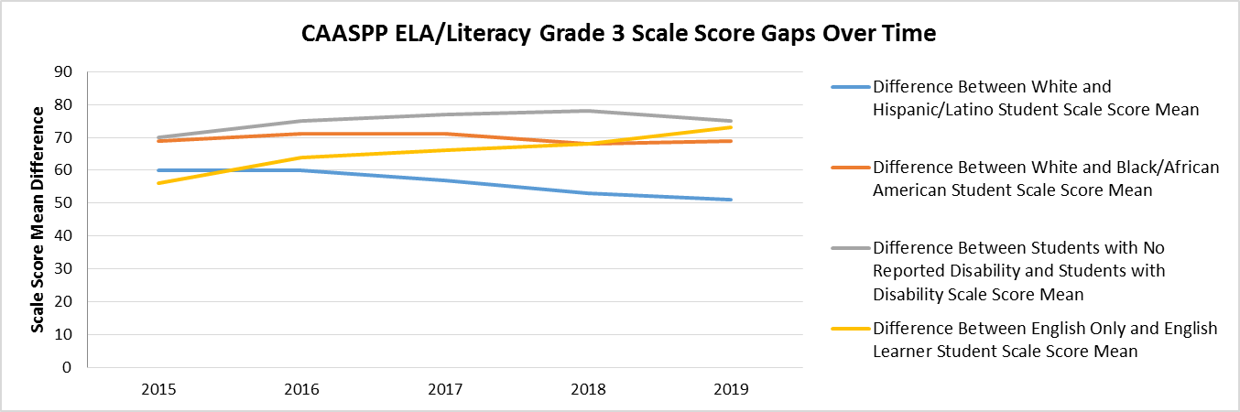

### CAASPP ELA/Literacy Grade 3 Scale Score Gaps Over Time

| **Comparison** | **2015** | **2016** | **2017** | **2018** | **2019** |
| --- | --- | --- | --- | --- | --- |
| Difference Between White and Hispanic/Latino Student Scale Score Mean | 60 | 60 | 57 | 53 | 51 |
| Difference Between White and Black/African American Student Scale Score Mean | 69 | 71 | 71 | 68 | 69 |
| Difference Between Students with No Reported Disability and Students with Disability Scale Score Mean | 70 | 75 | 77 | 78 | 75 |
| Difference Between English Only and English Learner Student Scale Score Mean | 56 | 64 | 66 | 68 | 73 |

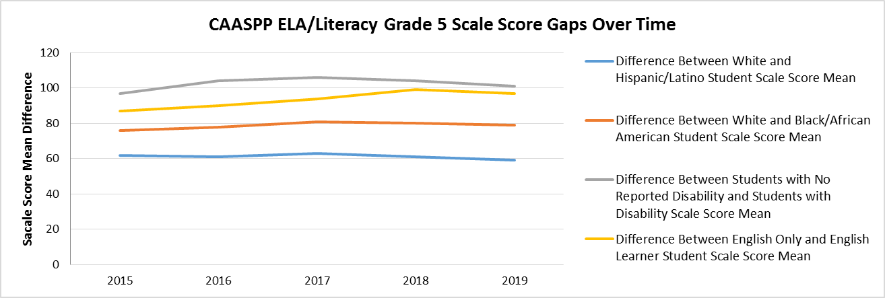

### CAASPP ELA/Literacy Grade 5 Scale Score Gaps Over Time

| **Comparison** | **2015** | **2016** | **2017** | **2018** | **2019** |
| --- | --- | --- | --- | --- | --- |
| Difference Between White and Hispanic/Latino Student Scale Score Mean | 62 | 61 | 63 | 61 | 59 |
| Difference Between White and Black/African American Student Scale Score Mean | 76 | 78 | 81 | 80 | 79 |
| Difference Between Students with No Reported Disability and Students with Disability Scale Score Mean | 97 | 104 | 106 | 104 | 101 |
| Difference Between English Only and English Learner Student Scale Score Mean | 87 | 90 | 94 | 99 | 97 |

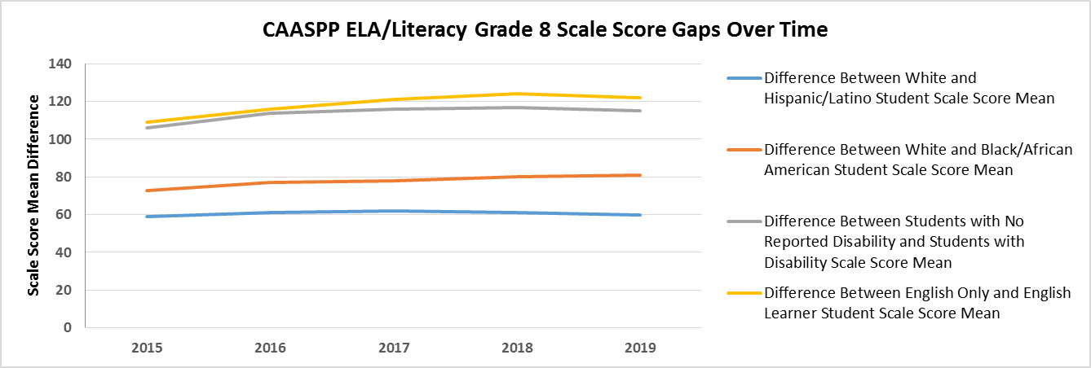

### CAASPP ELA/Literacy Grade 8 Scale Score Gaps Over Time

| **Comparison** | **2015** | **2016** | **2017** | **2018** | **2019** |
| --- | --- | --- | --- | --- | --- |
| Difference Between White and Hispanic/Latino Student Scale Score Mean | 59 | 61 | 62 | 61 | 60 |
| Difference Between White and Black/African American Student Scale Score Mean | 73 | 77 | 78 | 80 | 81 |
| Difference Between Students with No Reported Disability and Students with Disability Scale Score Mean | 106 | 114 | 116 | 117 | 115 |
| Difference Between English Only and English Learner Student Scale Score Mean | 109 | 116 | 121 | 124 | 122 |

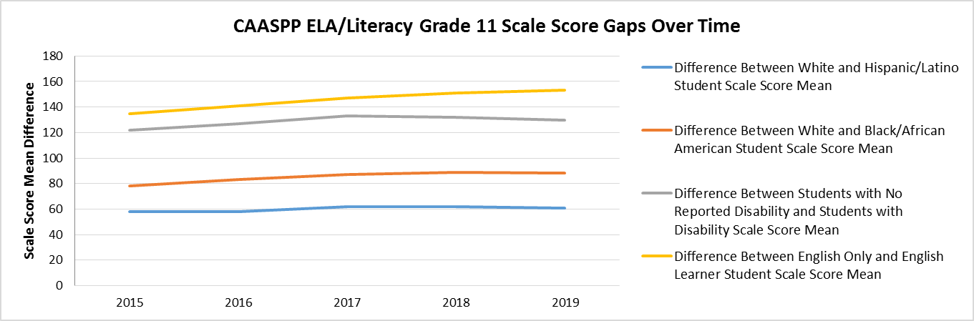

### CAASPP ELA/Literacy Grade 11 Scale Score Gaps Over Time

| **Comparison** | **2015** | **2016** | **2017** | **2018** | **2019** |
| --- | --- | --- | --- | --- | --- |
| Difference Between White and Hispanic/Latino Student Scale Score Mean | 58 | 58 | 62 | 62 | 61 |
| Difference Between White and Black/African American Student Scale Score Mean | 78 | 83 | 87 | 89 | 88 |
| Difference Between Students with No Reported Disability and Students with Disability Scale Score Mean | 122 | 127 | 133 | 132 | 130 |
| Difference Between English Only and English Learner Student Scale Score Mean | 135 | 141 | 147 | 151 | 153 |

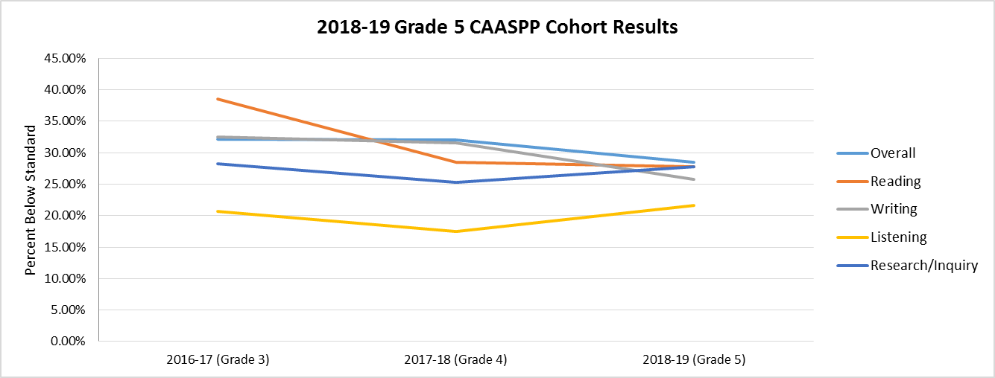

### 2018–19 Grade 5 CAASPP Cohort Results

| **Strand** | **2016–17 (Grade 3)** | **2017–18 (Grade 4)** | **2018–19 (Grade 5)** |
| --- | --- | --- | --- |
| Overall | 32.10% | 32.08% | 28.44% |
| Reading | 38.58% | 28.46% | 27.78% |
| Writing | 32.46% | 31.61% | 25.78% |
| Listening | 20.73% | 17.48% | 21.59% |
| Research/Inquiry | 28.25% | 25.31% | 27.81% |

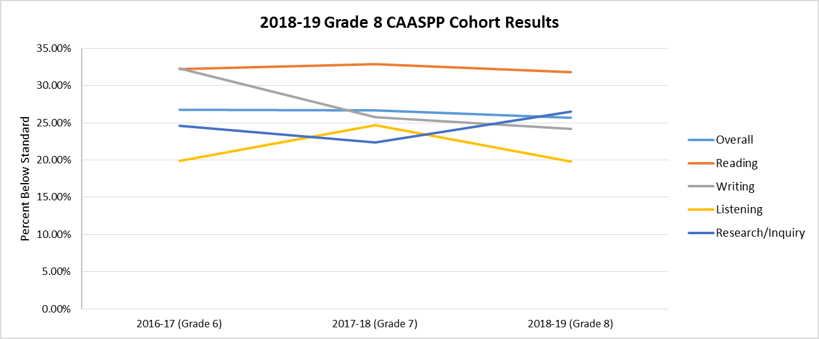

### 2018–19 Grade 8 CAASPP Cohort Results

| **Strands** | **2016–17 (Grade 6)** | **2017–18 (Grade 7)** | **2018–19 (Grade 8)** |
| --- | --- | --- | --- |
| Overall | 26.76% | 26.70% | 25.66% |
| Reading | 32.23% | 32.91% | 31.81% |
| Writing | 32.29% | 25.73% | 24.15% |
| Listening | 19.89% | 24.64% | 19.82% |
| Research/Inquiry | 24.59% | 22.35% | 26.52% |

1. Information accurate as of 2018.
2. <https://www.cde.ca.gov/be/ag/ag/yr19/documents/jul19item10.docx>
3. <https://www.cde.ca.gov/fg/aa/lc/index.asp>
4. <https://www.cde.ca.gov/re/lc/>
5. <https://www.cde.ca.gov/ci/cr/ri/>
6. Chapter 9: Access and Equity, *ELA/ELD Framework*, p. 913, at <https://www.cde.ca.gov/ci/rl/cf/documents/elaeldfwchapter9.pdf>.
7. <https://www.cde.ca.gov/be/st/ss/documents/finalelaccssstandards.pdf>
8. All California content standards may be found on the CDE web page at <https://www.cde.ca.gov/be/st/ss/>.
9. <https://commoncore-espanol.sdcoe.net/Home>
10. <https://www.cde.ca.gov/sp/el/er/documents/eldstndspublication14.pdf>
11. <https://www.cde.ca.gov/sp/el/er/sldstandards.asp>
12. <https://www.cde.ca.gov/ci/rl/cf/elaeldfrmwrksbeadopted.asp>
13. <https://www.cde.ca.gov/ci/cr/cf/allfwks.asp>
14. <https://www.cde.ca.gov/ci/rl/cf/elaeldfrmwrksbeadopted.asp>
15. Chapter 6, p. 531, <https://www.cde.ca.gov/ci/rl/cf/documents/elaeldfwchapter6.pdf>
16. <https://www.cde.ca.gov/ci/sc/cf/cascienceframework2016.asp>
17. <https://www.habitsofmindinstitute.org/what-are-habits-of-mind/>
18. <https://www.cde.ca.gov/ci/rl/cf/documents/elaeldfwchapter10.pdf>
19. <https://www.cde.ca.gov/sp/cd/re/documents/preschoollf.pdf>
20. <https://www.cde.ca.gov/sp/cd/re/itf09aavcontents.asp>
21. <https://www.cde.ca.gov/sp/cd/re/documents/psenglearnersed2.pdf>
22. <https://www.cde.ca.gov/ci/gs/em/documents/tkguide.pdf>
23. <https://www.cde.ca.gov/ci/rl/cf/documents/elaeldfwchapter3.pdf>
24. <https://www.cde.ca.gov/eo/in/lcff-pri7-practices.asp>
25. <https://www.cde.ca.gov/ci/rl/cf/documents/elaeldfwchapter9.pdf>
26. See [http://www.cast.org](http://www.cast.org/)
27. <https://www.cde.ca.gov/sp/el/er/improvingmleleducation.asp>
28. <https://www.cde.ca.gov/sp/se/ac/documents/cadyslexiaguidelines.pdf>
29. <https://www.cde.ca.gov/sp/el/er/pracguide.asp>
30. <https://www.cde.ca.gov/eo/in/lcff-pri4-practices.asp>
31. [https://www.desiredresults.us/sites/default/files/docs/forms/  
    DRDP2015PSC_090116.pdf](https://www.desiredresults.us/sites/default/files/docs/forms/%0bDRDP2015PSC_090116.pdf)
32. <https://www.cde.ca.gov/ta/tg/ca/>
33. <https://www.cde.ca.gov/ta/tg/ca/sbteacherguides.asp>
34. <https://www.cde.ca.gov/ta/tg/sa/sbacinterimassess.asp>
35. <https://www.cde.ca.gov/ta/tg/sa/tools-for-teachers.asp>
36. <https://www.cde.ca.gov/ta/tg/ep/>
37. <https://www.cde.ca.gov/ta/tg/ca/csa.asp>
38. <https://www.cde.ca.gov/eo/in/lcff-pri8-practices.asp>
39. <https://www.cde.ca.gov/eo/in/lcff-pri7-practices.asp>
40. <https://www.cde.ca.gov/sp/el/rm/>
41. <https://www.cde.ca.gov/sp/el/rm/roadmaptolcap.asp>
42. <https://www.cde.ca.gov/sp/el/t3/documents/lcapelaprcrosswalk.docx>
43. <https://www.cde.ca.gov/sp/el/er/improvingmleleducation.asp>
44. <https://www.cde.ca.gov/sp/el/er/caedge.asp>
45. <https://www.cde.ca.gov/sp/el/er/edgefaq.asp>
46. <https://www.cde.ca.gov/sp/el/er/sealofbiliteracy.asp>
47. <https://www.cde.ca.gov/pd/ee/assetbasedpedagogies.asp>
48. <https://www.cde.ca.gov/pd/ee/culturallysustainingped.asp>
49. <https://www.cde.ca.gov/pd/ee/responsiveteaching.asp>
50. <https://www.cde.ca.gov/pd/ee/culturalrelevantpedagogy.asp>
51. <https://www.cde.ca.gov/eo/in/lcff-pri5-practices.asp>
52. <https://www.cde.ca.gov/eo/in/lcff-pri6-practices.asp>
53. <https://www.cde.ca.gov/eo/in/lcff1sys-resources.asp>
54. <https://www.cde.ca.gov/eo/in/documents/selguidingprincipleswb.pdf>
55. California *Education Code* Section 48900(w)(1) <http://leginfo.legislature.ca.gov/faces/codes_displaySection.xhtml?sectionNum=48900&lawCode=EDC> ; California *Education Code* Section 48900.5 <http://leginfo.legislature.ca.gov/faces/codes_displaySection.xhtml?sectionNum=48900.5&lawCode=EDC>
56. <https://www.cde.ca.gov/ls/he/cs/>
57. <https://www.cde.ca.gov/ls/ss/vp/safeschlplanning.asp>
58. <https://www.cde.ca.gov/eo/in/lcff-pri1-practices.asp>
59. <https://www.cde.ca.gov/eo/in/lcff-pri2-practices.asp>
60. <http://www.ctc.ca.gov/educator-prep/standards/CSTP-2009.pdf>
61. <http://www.ctc.ca.gov/educator-prep/standards/CPSEL-booklet-2014.pdf>
62. <https://www.ctc.ca.gov/docs/default-source/educator-prep/standards/literacy-tpes.pdf?sfvrsn=9e802cb1_2>
63. <https://www.cde.ca.gov/pd/ee/peat.asp>
64. <https://www.cde.ca.gov/ci/rl/cf/documents/elaeldfwchapter11.pdf>
65. <https://www.cde.ca.gov/pd/ps/qpls.asp>
66. [https://ies.ed.gov/ncee/edlabs/infographics/pdf/REL_NEI_Instructional_Coaching_  
    for_ELA.pdf](https://ies.ed.gov/ncee/edlabs/infographics/pdf/REL_NEI_Instructional_Coaching_%0bfor_ELA.pdf)
67. <https://ccee-ca.org/>
68. <https://ccsesa.org/about/>
69. <https://csmp.ucop.edu/>
70. <https://www.cde.ca.gov/pd/te/ce/prodev07intro.asp>
71. <https://www.cde.ca.gov/ci/rl/cf/documents/elaeldfwchapter11.pdf>
72. <https://www.cde.ca.gov/ls/pf/pf/documents/famengageframeenglish.pdf>
73. <https://www.cde.ca.gov/fg/aa/lc/documents/family-engagement.pdf>
74. <https://www.cde.ca.gov/sp/cd/re/documents/familypartnerships.pdf>
75. <https://www.cde.ca.gov/eo/in/lcff-pri3-practices.asp>
76. <https://www.cde.ca.gov/eo/in/lcff-pri6-practices.asp>
77. <https://ccee-ca.org/>
78. <https://www.cde.ca.gov/sp/sw/t1/continuousimprovement.asp>
79. <https://www.cde.ca.gov/pd/ps/documents/needsassessment-afterclose.docx>
80. [https://www.desiredresults.us/sites/default/files/docs/forms/  
    DRDP2015PSC_090116.pdf](https://www.desiredresults.us/sites/default/files/docs/forms/DRDP2015PSC_090116.pdf)
81. <https://www.desiredresults.us/drdp-online-resources>
82. <https://www.cde.ca.gov/ci/rl/cf/documents/elaeldfwchapter8.pdf>
83. <https://www.cde.ca.gov/ta/ac/cm/>
84. <https://calschls.org/>
85. <https://www.cde.ca.gov/pd/ps/clsdteam.asp>
86. <https://www.cde.ca.gov/sp/cd/re/>
87. <https://www.cde.ca.gov/sp/cd/re/itfoundations.asp>
88. <https://www.cde.ca.gov/sp/cd/re/itframework.asp>
89. <https://www.cde.ca.gov/sp/cd/re/documents/itguidelines2019.pdf>
90. <https://www.cde.ca.gov/sp/cd/re/documents/preschoollf.pdf>
91. <https://www.cde.ca.gov/sp/cd/re/psframework.asp>
92. <https://www.cde.ca.gov/sp/cd/re/documents/preschoolproggdlns2015.pdf>
93. <http://www.cast.org/>
94. <https://www.cde.ca.gov/sp/cd/ce/documents/dllresearchpapers.pdf>
95. <https://www.cde.ca.gov/sp/cd/re/documents/psenglearnersed2.pdf>
96. <https://www.cde.ca.gov/sp/el/rm/index.asp>
97. <https://www.cde.ca.gov/sp/el/er/documents/mleleducationch4.pdf>
98. <https://www.cde.ca.gov/sp/cd/re/documents/inclusionworks.pdf>
99. <http://www.cde.ca.gov/sp/se/ac/dyslexia.asp>
100. <https://www.cde.ca.gov/sp/cd/re/documents/familypartnerships.pdf>
101. <http://www.ccfc.ca.gov/index.html>
102. <https://www.first5california.com/en-us/>
103. <https://ies.ed.gov/ncee/wwc/PracticeGuide/14>
104. <https://commoncore-espanol.sdcoe.net/Home>
105. <https://www.cde.ca.gov/sp/el/er/sldstandards.asp>
106. <https://www.cde.ca.gov/sp/el/rm/>
107. <https://www.cde.ca.gov/sp/el/rm/principles.asp>
108. <https://www.cde.ca.gov/sp/el/er/documents/mleleducationch5.pdf>
109. <https://www.cde.ca.gov/sp/el/er/pracguide.asp>
110. <https://www.cde.ca.gov/ci/rl/cf/documents/elaeldfwchapter9.pdf>
111. <https://www.cde.ca.gov/sp/el/er/pracguide.asp>
112. <https://www.cde.ca.gov/ci/sc/cf/cascienceframework2016.asp>
113. <https://www.cde.ca.gov/ci/rl/cf/documents/elaeldfwchapter9.pdf>
114. <https://www.cde.ca.gov/sp/el/rm/principleone.asp>
115. <https://www.cde.ca.gov/sp/el/er/sealofbiliteracy.asp>
116. <https://commoncore-espanol.sdcoe.net/Home>
117. <https://www.cde.ca.gov/sp/el/er/sldstandards.asp>
118. <https://www.cde.ca.gov/sp/el/er/documents/mleleducationch6.pdf>
119. <https://www.cde.ca.gov/ci/rl/cf/documents/elaeldfwchapter9.pdf>
120. <https://www.cde.ca.gov/pd/ps/clsd.asp>