State of Disproportionality

Understanding Policies and Procedures across Organizations

Shannon Coulter

November 21, 2021

## State of Disproportionality

### Survey Overview

We administered the State of Disproportionality Survey to special education directors across California to gather information about disproportionality and the work districts engage in to reduce it. The South County SELPA, one of four SELPA Content Leads for the State of California, designed this survey as part of a state grant to address disproportionality. We designed the survey to capture the “state” of disproportionality in each of California’s 144 SELPA regions by asking questions about experiences regarding special education data, culture, general education processes and policies, training, system of support, resources, and others. We sent the survey to approximately 940 school districts and received 320 responses for a response rate of 34%. Several factors affected the lower response rate. First, many districts do not receive disproportionality results because of the size of the school district and student populations. These districts elected not to take the survey. Second, some districts do not have disproportionality findings according to the state improvement plan because there are no differences in proportions of students in special education, such is the case in districts where the population is largely homogeneous. This is another reason why some districts elected not to take the survey. Third, because disproportionality is a shifting metric each year (i.e., a district may not have a finding one year and have one the next) determining the population to survey is challenging. Therefore, our response rate may be lower simply because we sent the survey to a greater number of districts who would have actually completed it. We share the results using contingency tables where rows are the survey items and columns are organizations supporting districts with disproportionality work. Below we arrayed the participants by the organizations supporting them with disproportionality work. Most participants worked with the System Improvement Leads (sils), followed by SELPA content leads, SPP-TAP, WestEd, System Improvement Leads, Orange County, ED&D, Cal-TAC, and CDE’s Seeds of Partnership. About 23 participants completing the survey worked with ED&D.

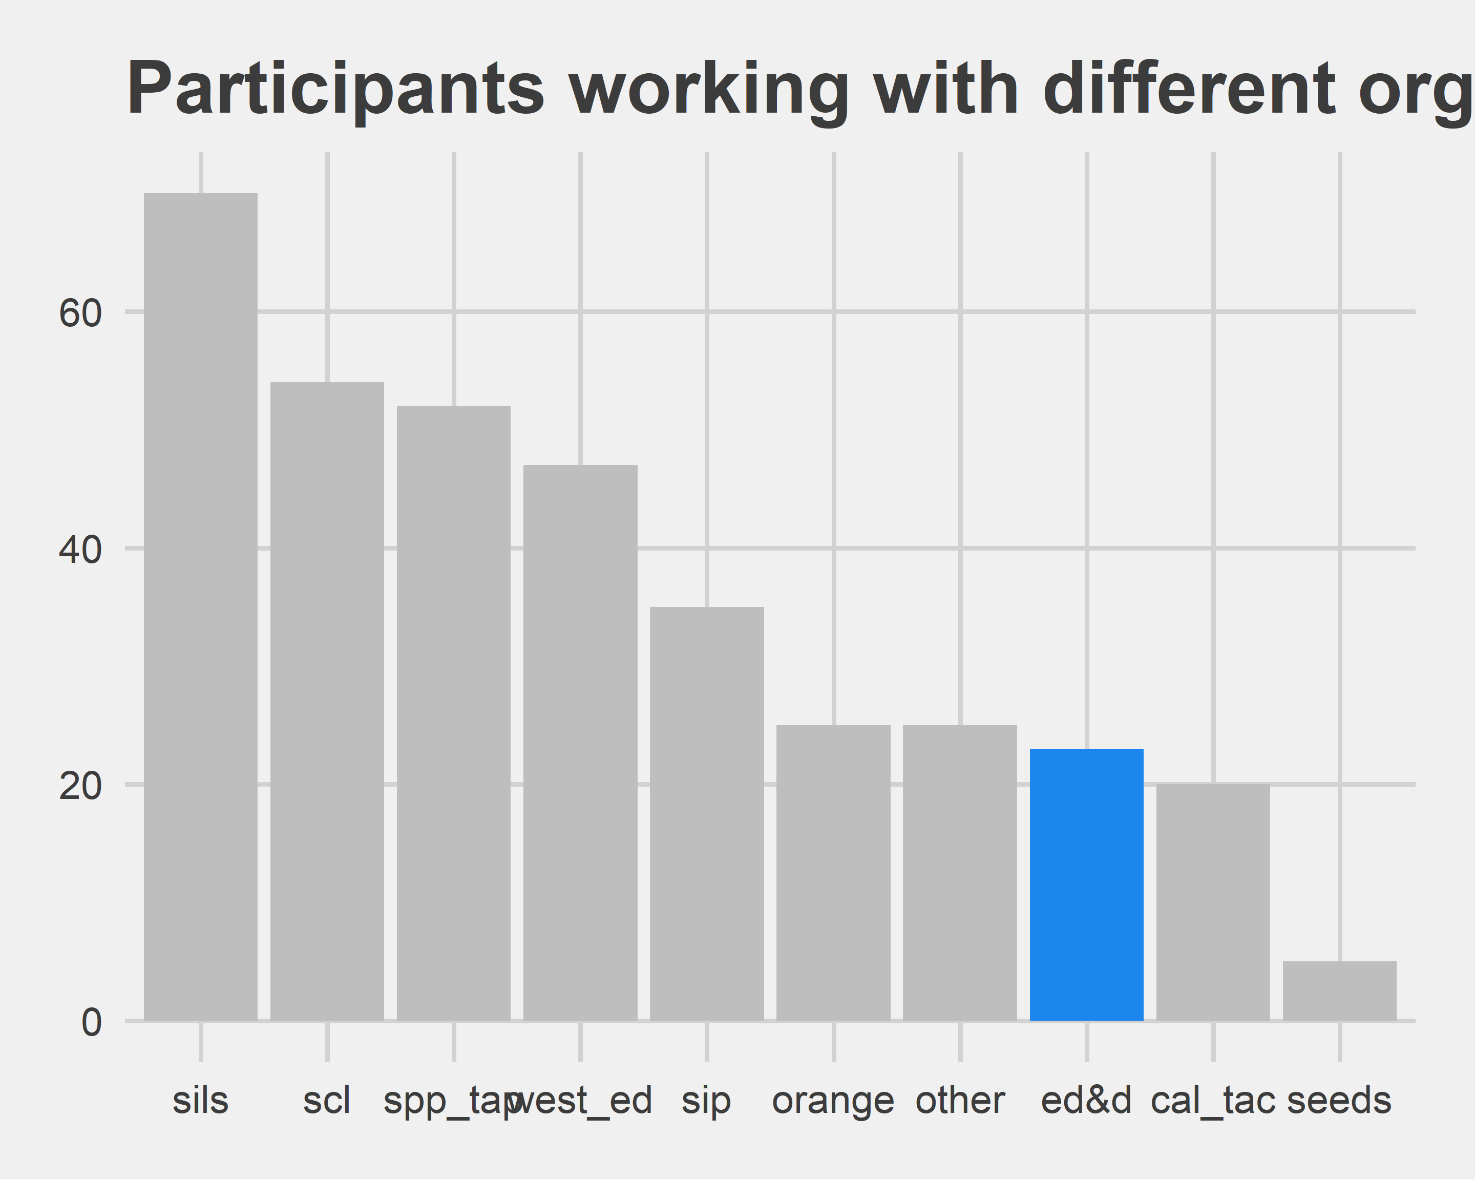

### Disproportionality Knowledge

We divided the survey into four sections. This section focuses on disproportionality knowledge. Participants were asked a series of questions to gauge their knowledge level on disproportionality. We arrayed the results in contingency tables depicting the statement/responses and the organization for which the survey participants received support. We displayed the number of participants completing the survey under each organization’s abbreviated name along with the frequency of responses for each category of the survey item.

### General Education Practices

This section highlights general education processes and procedures leading to a special education referral. These questions ask participants the degree to which these processes are in place in their district and the extent to which the district implements these processes well. We arrayed the results by statement and organization and the number of participants completing the survey.

### Mutli-tiered System of Supports

The following section highlights MTSS processes and procedures present in the school district. These questions ask whether the district has these processes and procedures in place and the extent to which the district implements these processes and procedures well. We arrayed the results by statement and organization with the number of participants completing the survey.

### Disproportionality Practices, Resources, and Supports

The following section of the survey highlights the section on disproportionality practices, resources, processes and procedures, and supports. This section asks respondents to respond to twenty-eight questions related to their districts organizational capacity, resources, practices, and policies regarding disproportionality. Similar to previous sections, we arrayed the results by statement and organization with the number of participants completing the survey listed under the organization’s name.

### Findings and Conclusions

We administered a survey on the state of disproportionality to special education administrator’s across California. We recieved 320 reponses and arrayed these responses by the organizations supporting districts with disproportionality-related services. These organizations included ED&D, System Improvement Leads (SILS), Supporting Inclusive Practices (SIP), and SPP-TAP. **The System Improvement Leads registered the highest percentages of favorable responses.** In 21 of the 48 survey items (or 44% of the survey), participants supported by the System Improvement Leads rated items qualitatively better than participants supported by other organizations. For example, when asked: “Does your district gather data on the ethnic and racial breakdowns of children being referred to special education?”, 78% of respondents supported by the SILS indicated “Yes” to that question, which is a preferred or recommended behavior for a district addressing disproportionality. It is important to note that differences between responses aggregated to an organizational level are often quite small, sometimes only a percentage point difference. Another important consideration is that we do not know if the systems supported by the SILS would have rated these items higher prior to working with the SILS. The survey represents a “snapshot” of how well equipped districts are to address disproportionality (arrayed by the organizations supporting them). It appears based on survey responses that districts supported by SILS are best situated to reduce disproportionality in the future. **The support ED&D and SPP-TAP provide have a similar percentage of favorable responses.** Participants supported by ED&D rated 11 items qualitatively better (23%) than respondents reporting on behalf of other organizations, which is the same rate as respondents reporting on behalf of SPP-TAP. Participants from these two organizations appear equally well equipped to reduce disporportionality in the future.

*ED&D Strengths and Weaknesses*

In terms of the major sections of the survey: Disproportionality Knowledge, General Education Practices, MTSS, and Disproportionality Practices, Resources, and Supports, ED&D performs best in the last section around disproportionality practices, resources, and supports. **ED&D outperforms all other support organizations in disproportionality practices, resources, and supports.** For example, ED&D respondents indicated they believed their district’s risk ratio scores would decline in the coming year, their districts are better equipped to tackle disproportionality, their districts have enacted policies to prevent disproportionality, and their districts have specific goals to address disproportionality. ED&D received the highest percentage of preferred/favorable responses to the questions related to disproportionality practices, resources, and supports. SPP-TAP performed similarly to ED&D in this section of the survey, being edged out by a few questions. SPP-TAP received the highest percentage of preferred/favorable responses to 38% of the survey items in this section. **ED&D must consider how its current services align and integrate with other drivers of disproportionate outcomes.** Many systems influence and affect special education outcomes. Support organizations (such as ED&D), regardless of their core services, must be mindful of the impact each system has on disproportionality. If a car doesn’t start and a mechanic focuses all of his/her energy repairing the electrical system, the car is no more functional if its transmission does not adjust the gearing in the car. Therefore, ED&D must consider how its services align and integrate with other drivers of disproportionate outcomes. For example, districts supported by ED&D indicated lower percentages of preferred/favorable responses compared to other support organizations in relation to convening SSTs and implementing a process to review evidence prior to making a special education referral. Both items are part of the general education practices section and are critical elements to ensuring an effective process for making referrals to special education. Having ineffective general education practices might create a bottleneck in the system where students are made eligible for special education who otherwise would not be. ED&D respondents also indicated lower favorable responses with regard to having data routines and implementing routines well as part of their multi-tiered system of support. An effective system of support ensures students’ needs are aligned to the right tiers of instruction. Failure to implement an effective tiered instructional system leads to faulty decisions about how students respond to instruction. Finally, ED&D participants indicated lower preferred ratings for gathering data on ethnic and racial breakdowns of children being referred to special education and/or suspension or expulsion. These questions emerge from the disproportionality section of the survey. Knowledge about student demographics is an important aspectin the decision-making process for special education eligibility and should be better understood by the districts ED&D supports. Therefore, these organizations supported by ED&D might benefit from additional resources to improve these weaker areas so they are more situated to reduce disproportionality in the future.