Ada:
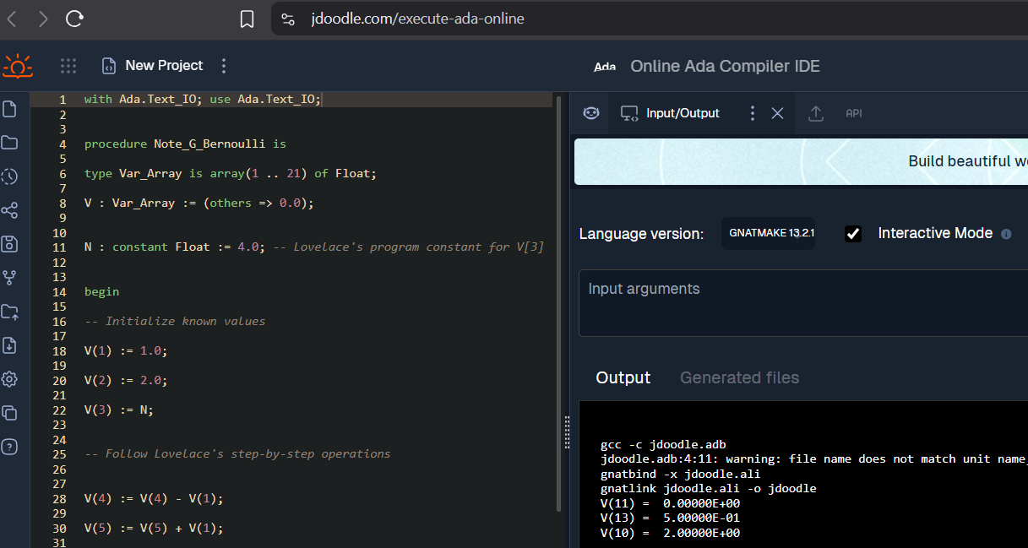

How are variables assigned in Ada?​
The variable is given, followed by a colon and then the variable type. Afterwards, assignment uses the walrus operator (:=) before the value is written. All lines end in a semicolon to delineate the end of a sentence.
The example is shown under:
N: constant Float := 4.0;

How are arrays declared? ​
Arrays are declared first as an array type with the number of array elements and the type of those elements. Then a variable is assigned to the array so that the array can be indexed. The example is shown below, with an array of 20 floating point elements, initialized to 0.0 :
type Var_Array is array(1 .. 21) of Float;
V : Var_Array := (others => 0.0);

Where are they declared? Is this good or bad? Why?
The array is declared in the top of the script before the “begin” statement. This can be a good thing if you are working with lots of arrays and can’t remember each array’s name and size limit. Think of this like attributing macros or type defines in C prior to writing the main function. The programmer would automatically know where to look if they need to change their functionality without having to alter their pre-existing code. That could also be considered bad if changing the definition leads to the program breaking. All in all, it’s a useful organizational tool.

Fortran:

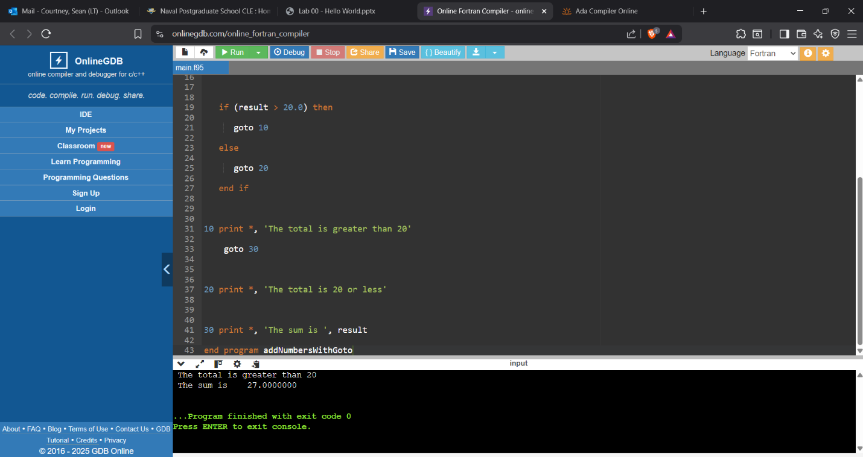Why are goto statements awesome? Why are they not?​
Goto statements have the advantage of redirecting program flow to another part of your script such that you never have to re-write functionality more than once. The disadvantage to this is that the program flow doesn’t travel from the top down, and in some cases, it can confuse the reader if those redirects are overused.

Discuss the benefit of restrictions on the programmer?
Goto statements are powerful if used in moderation. If a programmer is restricted on file size and absolutely has to use goto statements to reduce the number of lines in their code – then that would be the only use case where excessive goto’s seem necessary. In short, restrictions force the programmer to come up with smarter (perhaps more concise) solutions to a complex problem.

Algol 68:
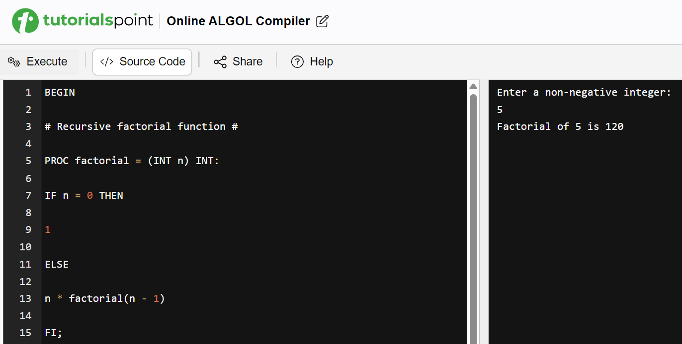
In ALGOL (especially ALGOL 68), semicolons are used as statement separators, not as terminators. This means semicolons separate adjacent statements within a sequence, but there is no semicolon after the last statement in the sequence. Discuss the benefits of this approach.
In this approach, it would be easy to find the start and end of a statement by finding the semicolon of the previous statement and the semicolon of the statement you’re viewing. This can lead to efficient debugging practice.
Having no semicolon in the last statement makes sense because there are no other statements after it to be parsed, meaning that the compiler has to do one less check in order to compile the program. Although, nothing can be written after the END declaration since the entire script still has to be evaluated by the parser – meaning that syntax issues after this point will still trigger an error output.

Cobol:
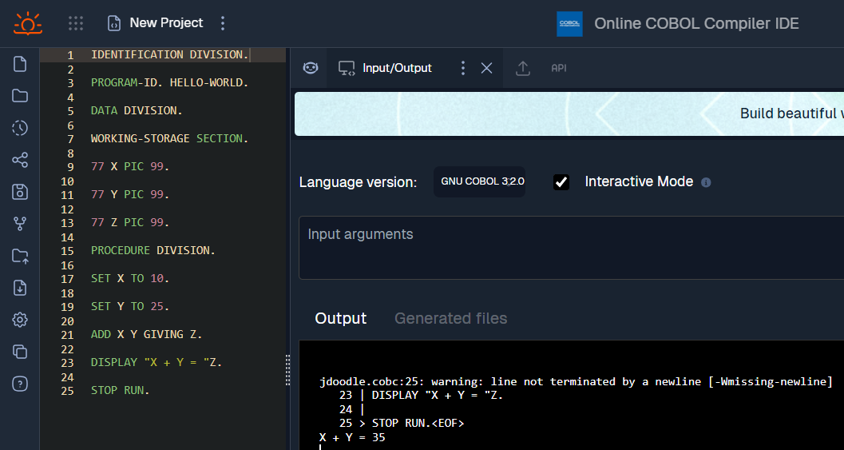
There is a semantic error in this code. What is it?​
In line 21, when adding X and Y, most operations of having two variables next to each other indicate multiplication. Here, the semantics of cobol say this is okay, because the operand is located before the two variables used.

How is string concatenation done? Do you like this?
It appears that string concatenation is performed simply by terminating the string and including the variable afterwards. If you want another string directly after the variable, simply add another grouping of quotation marks.
Personally, being used to how python’s string concatenation works, this methodology feels off. However, in practicality, it makes writing the concatenation slightly faster.

Pascal:
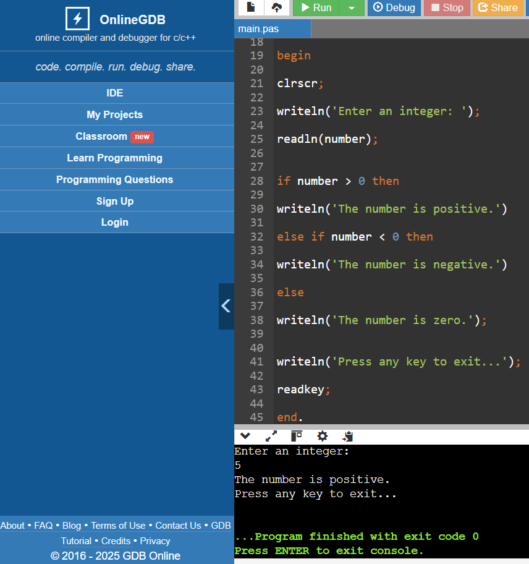
If you could design a language, how would you do comments?
It was fun to see comments in pascal using curly braces and parenthesis-star combinations. But that’s no different from how we interpret the difference between comments and docstrings in either python or C.
Python uses # for comments and surrounding groups of 3 quotation marks for docstrings
C uses two forward slashes for //comments and /*comments*/ for docstrings
I would prefer comments written like python’s hashtag, but instead of docstrings using triple quotation marks, I’d like for it to be ### 3 or more hashtags in sequence ### since programmers do this already to emphasize importance.

Batch:
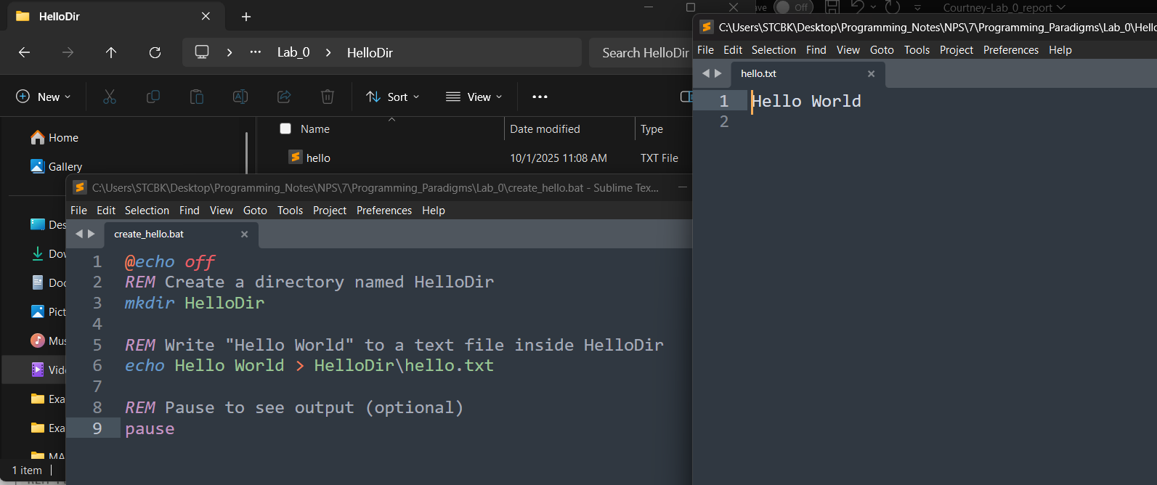
What is the difference between > and >> when writing to a file in these scripts?
The singular > is an output redirect. The echo is meant to write to the output terminal, but the output is redirected to the sub-directory and written into hello.txt
The double >> is also an output redirect, but instead of overwriting the file and outputting fresh text, the text is now appended to the end of the file. Once the hello.txt file exists with text inside it, “Hello World” will be shown on a new line.

Go:
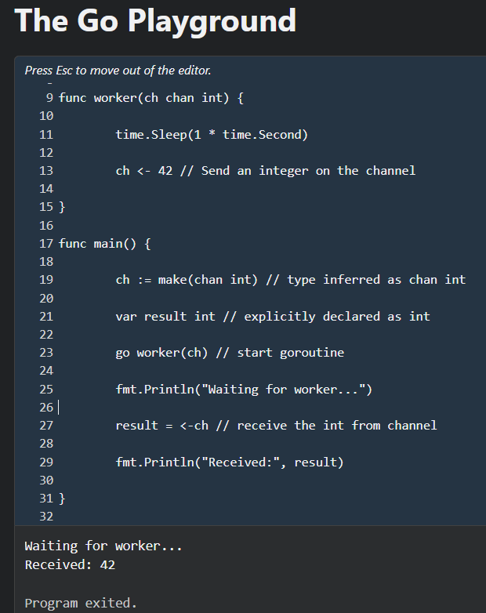
There are two types, ch and result. One is inferred that it will be an int, the other is explicitly declared. What are the benefits to allowing implicit typing?​
In the case of go, letting the channel decide on what its type will be allows for the channel to be multi-purpose. This lets our use of the worker thread to not only be limited to integer values.

Is the function worker ever executed in the main thread?
No it is not. When go worker(ch) is executed, it spawns a new thread performing the worker function. The result then waits for that thread’s output, applying the output to the result variable.

Visual Basic:
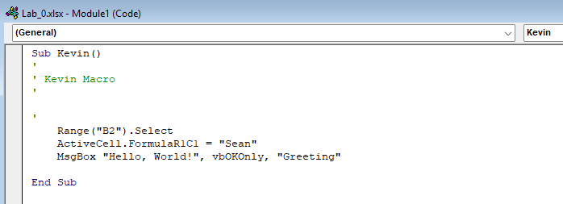
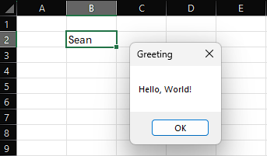
Why have statement terminators like semi-colons?
Those terminators tell the compiler where to stop processing without needing to look for a new-line character. For example, loops in C require multiple statements separated by semi-colons all in the same line. The parser needs to tell the compiler where to evaluate those statements cleanly. In other programming languages shown above, blocks of code are separated by them.

Prolog:
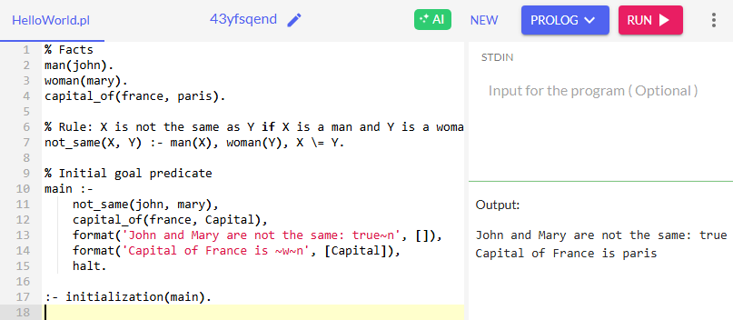
What would happen to the execution if you place the Rule’s section above the Facts section?
Nothing changed!
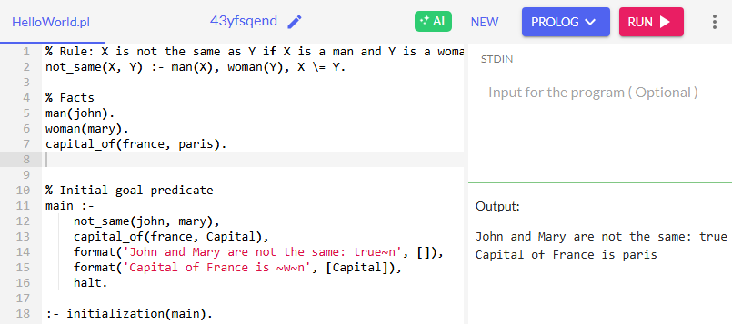
It appears that all declarations get put together prior to their use in the main function. Upon searching how this is done, apparently prolog’s backend looks for those variable declarations, sort of like backtracking in order to satisfy evaluating conclusions.

Haskell:
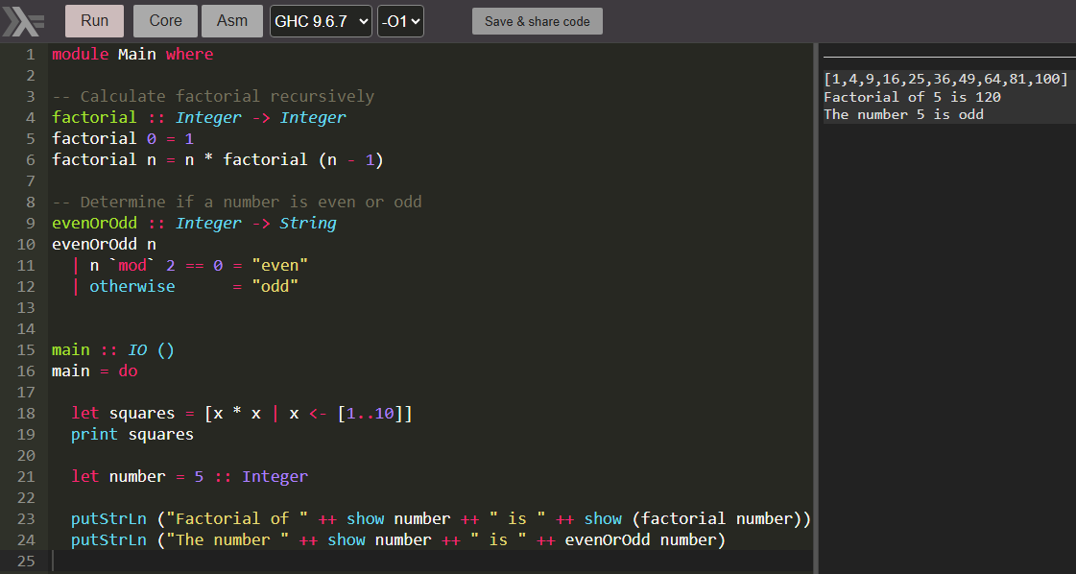
Explain the function header:
evenOrOdd :: Integer -> String
What is meant by evenOrOdd, Integer, and String?
evenOrOdd is the function name
The “: : Integer” piece is declaring the input type to that function
And then “- > String” is declaring the output type of that function
At least, that’s what visually makes sense.

