URL: https://scout-collab.github.io/FSR-dojo13GRP6/blog.html
Annual Water Budget for the Leadville Series
By Taylor B. on Oct. 25th
Figure 1. Leadville monthly precipitation and PET. Adapted from the Thoma workbook using data from EOSDIS Earthdata.
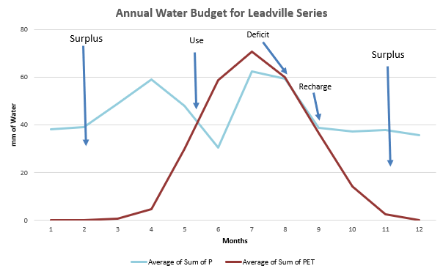
“Consider the scenario of your soil being impacted by a drought. What would you, a land manager, do to mitigate the impacts of increased ET and/or decreased P?”
If the Leadville series were impacted by a drought, and I was acting as a land manager, I would try to limit water loss first. From the graph, the drought would probably occur in months 5 through 8. According to Lake County's Climate Action Plan (2026), the region is already experiencing hotter summers, reduced snowpack, and longer, more intense wildfire seasons. Because the soil is very rocky and dominated by lodgepole pine, plant-available water is already low (California Soil Resource Lab). I would put a moratorium on logging activity and try to preserve as much shade as possible along with maintaining the integrity of the surface horizons in an effort to slow down evaporation. Since Leadville soils are mostly found around steep mountain slopes, maintaining vegetation would also help prevent erosion during precipitation events. Overall, I think protecting the forest floor and minimizing soil disturbance would be the most practical way to conserve moisture and help the Leadville soil recover from drought conditions.
Lake County Government. (2026). Climate action plan. https://www.lakecountyco.gov/724/Climate-Action-Plan
U.S. Department of Agriculture, Natural Resources Conservation Service. (2007). Official series description: Leadville series. https://soilseries.sc.egov.usda.gov/OSD_Docs/L/LEADVILLE.html
California Soil Resource Lab. (n.d.). Soil Data Explorer – Leadville. University of California, Davis. Retrieved September 18, 2026, from https://soilmap2-1.lawr.ucdavis.edu/sde/?series=leadville

