SYSTEM REQUIREMENTS SPECIFICATION
(SRS / Functional Specification Document)
Secure Home Router for Non-Technical Users
Version 1.0 · 20 July 2026 · Prepared by: Systems Analysis · Status: Draft for review

Contents

1. Introduction

1.1 Purpose
This document specifies the functional behavior of the Secure Home Router system: what each function does, its inputs/outputs, preconditions, behavior, and error handling, together with process flow diagrams and data descriptions. It is the bridge between the product backlog (router-security-app-backlog.xlsx — the 'what and why') and engineering design (the 'how'). Story IDs are cross-referenced throughout so every requirement is traceable to the backlog.

1.2 Scope & releases
Functions are tagged MVP, v1.1, or v1.2 per the approved release plan. ISP centralized management is out of scope (see the separate future-consideration document). Design constraints inherited by every function: (C1) outbound-only connectivity — the router never accepts inbound internet connections; (C2) full local operation with WAN down; (C3) local admin identity and cloud identity are independent; (C4) no networking jargon in Basic-mode UI.

1.3 Definitions
Term | Meaning
Daemon | The on-router service exposing the Local API and mediating all access to OpenWrt internals (ubus/UCI)
Profile | A named group (usually a child) of one or more devices sharing content/time rules
Basic / Advanced mode | Default simplified UI vs. opt-in power-user UI; Advanced never replaces Basic
TOTP | Time-based one-time password (Google Authenticator-compatible); verified locally on the router
Slot A/B | Dual firmware partitions (RAUC); update installs to inactive slot with auto-rollback
Relay | Cloud rendezvous for v1.1 remote access; router connects to it outbound via WireGuard

2. System Overview
The system comprises four subsystems: (1) the router firmware — a custom OpenWrt image plus the Daemon; (2) client applications — mobile app and web dashboard sharing one API client; (3) cloud services — identity/MFA, router registry, OTA, push; (4) from v1.1, the remote-access relay. All client functionality flows through the Daemon's Local API; clients never touch OpenWrt internals directly.
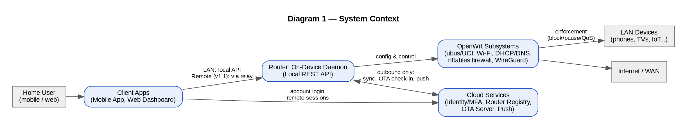

3. Functional Specification

3.1 Onboarding & Identity

FR-01 — First-Run Guided Setup [MVP · US1.1–1.3, US14.1–14.2, US14.5]
Takes a new router from power-on to a secured, named, locally-managed state in under 5 minutes, with no internet or account required.
Aspect | Specification
Inputs | Unique per-unit default password (device label/QR); user-chosen admin password, Wi-Fi name/password, router name
Outputs | Secured router config; device registry seeded by LAN auto-scan; setup-complete state
Preconditions | Factory-fresh or factory-reset device; client on LAN/BT proximity
Behavior | Wizard sequence per Diagram 2. Credential change and Wi-Fi change are non-skippable. Router name required (needed later for multi-router). Auto-detected devices get best-guess friendly names, user may rename or skip.
Error / edge handling | Abandoned mid-setup → wizard resumes at last completed step; power loss during setup must not brick (config committed atomically per step); wrong default password → point user to the device label, rate-limit attempts.
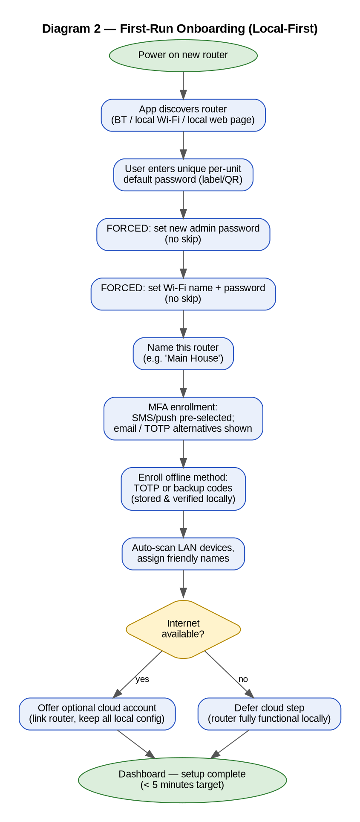

FR-02 — MFA Enrollment & Verification [MVP · US1.2, US3.1–3.3, US13.1–13.2]
Protects admin access with a second factor, guaranteeing at least one method that works with no internet.
Aspect | Specification
Inputs | Phone number / email / TOTP secret exchange (QR); user-entered codes
Outputs | Enrolled factors; one-time backup codes (displayed once); verified session
Preconditions | Admin credentials set (FR-01)
Behavior | SMS/push pre-selected default; email and TOTP visible alternatives. Onboarding also enrolls an offline-capable factor (TOTP or backup codes). TOTP and backup codes verified entirely on-router; SMS/push/email verified via cloud. Login flow per Diagram 3: with WAN down, online methods are shown disabled with a plain-language reason and the offline alternative offered on the same screen.
Error / edge handling | Code delivery failure → offer fallback method; repeated wrong codes → exponential backoff/lockout window; all backup codes consumed → prompt regeneration at next successful login; total factor loss → physical recovery (FR-13).
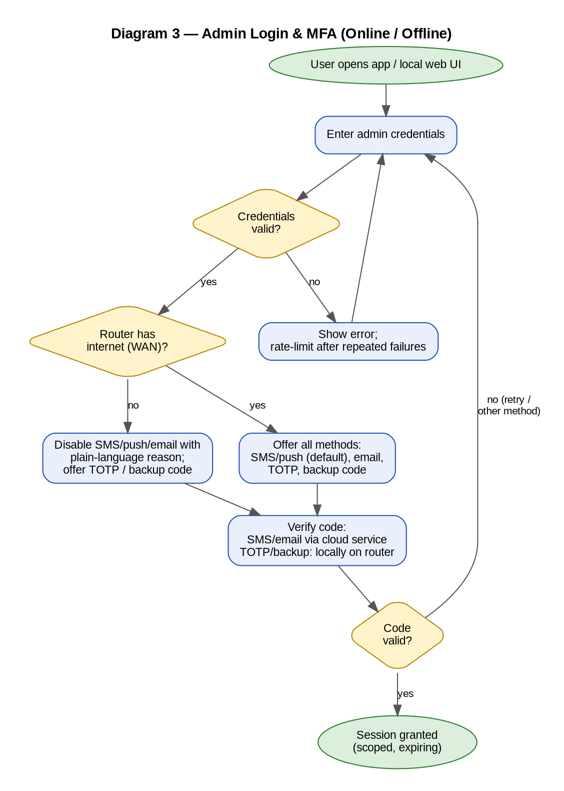

FR-03 — Cloud Account Link & Multi-Router [MVP (link) / v1.1 (multi) · US14.3–14.4, US14.6]
Optionally links the router to a cloud account for remote features; supports several named routers under one account.
Aspect | Specification
Inputs | Account credentials + MFA; router-name
Outputs | Router↔account binding; config synced up; (v1.1) router list with per-router status
Preconditions | Local setup complete; WAN available for the link step
Behavior | Linking preserves all local configuration — sync is upward, never a reset. 'Start fresh' exists only as a separate, explicitly confirmed action. v1.1: account home lists routers by name; switching reuses the session; data fully isolated per router.
Error / edge handling | Link interrupted mid-sync → retry idempotently, local config remains source of truth; account deleted → router continues fully functional locally (constraint C3).

3.2 Dashboard & Device Management

FR-04 — Security Status Dashboard [MVP · US2.1–2.3]
Single plain-language answer to 'is my network safe?', with one-tap remediation.
Aspect | Specification
Inputs | Daemon-computed status inputs: credential state, update recency, WPA mode, unknown-device flags, block-service health
Outputs | Green/Yellow/Red status + one-line reason; fix actions; summary chips (device count, update date)
Preconditions | Authenticated session
Behavior | Status recomputed on change and on app open. Each contributing issue maps to exactly one 'Fix' action executing without menu navigation; status updates in real time after a fix. No jargon in Basic mode (C4).
Error / edge handling | Conflicting signals → worst state wins; stale data (daemon unreachable) → explicit 'can't reach your router' state, never a false green.

FR-05 — Device Registry & Control [MVP · US4.1–4.3]
Friendly, real-time view of everything on the network, with instant per-device pause/block and new-device alerts.
Aspect | Specification
Inputs | DHCP leases, ARP/association events, fingerprinting hints (hostname, OUI); user renames; pause/block commands
Outputs | Device list (icon, friendly name, last-seen); nftables rules for paused/blocked devices; push alert on unknown join
Preconditions | Authenticated session
Behavior | List defaults to friendly names — MAC/IP only in Advanced device detail (v1.2). Pause/block apply within seconds and persist across reboot. New/unknown devices flagged visually and via push with a direct Block action.
Error / edge handling | MAC randomization may fragment identity → merge heuristics + easy manual merge/rename; 20+ devices must not lag (NFR); blocking the admin's own device warns before applying.

3.3 Blocking & Parental Controls

FR-06 — Site & Category Blocking [MVP · US5.1, US5.3]
Blocks specific sites or whole content categories network-wide or per profile, enforced at the network layer so it cannot be bypassed by removing an app on the child's device.
Aspect | Specification
Inputs | Category selections; explicit domains; profile/device scope; category database (licensed/maintained)
Outputs | DNS/SNI enforcement rules; block events to the log
Preconditions | Blocking service enabled
Behavior | Enforcement per Diagram 4 at dnsmasq/nftables. Admin unblock ≤ 2 taps, effective within seconds. Per-profile scope overrides network scope.
Error / edge handling | Category DB unreachable/stale → last-known list continues (fail-closed for enabled categories); DoH/DoT bypass on client devices → force LAN DNS / block known DoH endpoints (documented residual risk); admin lockout risk → admin devices exempt from self-blocking own management access.

FR-07 — Block Page [MVP · US5.2, US5.7]
Replaces silent failures with a friendly explanation — without a self-serve unblock path.
Aspect | Specification
Inputs | Blocked HTTP request (redirect) / blocked HTTPS attempt (strategy per US5.7)
Outputs | Local block page (HTTP); non-alarming failure + in-app visibility (HTTPS)
Preconditions | FR-06 active
Behavior | Page states the block is by the network's Family settings and directs the person to ask the admin — no request-access button (confirmed product decision). HTTPS: chosen strategy must avoid browser certificate warnings; blocked HTTPS attempts remain visible to the admin in-app even when no page can render.
Error / edge handling | Captive-portal-style interception must not break OS connectivity checks; page served locally so it works with WAN down.
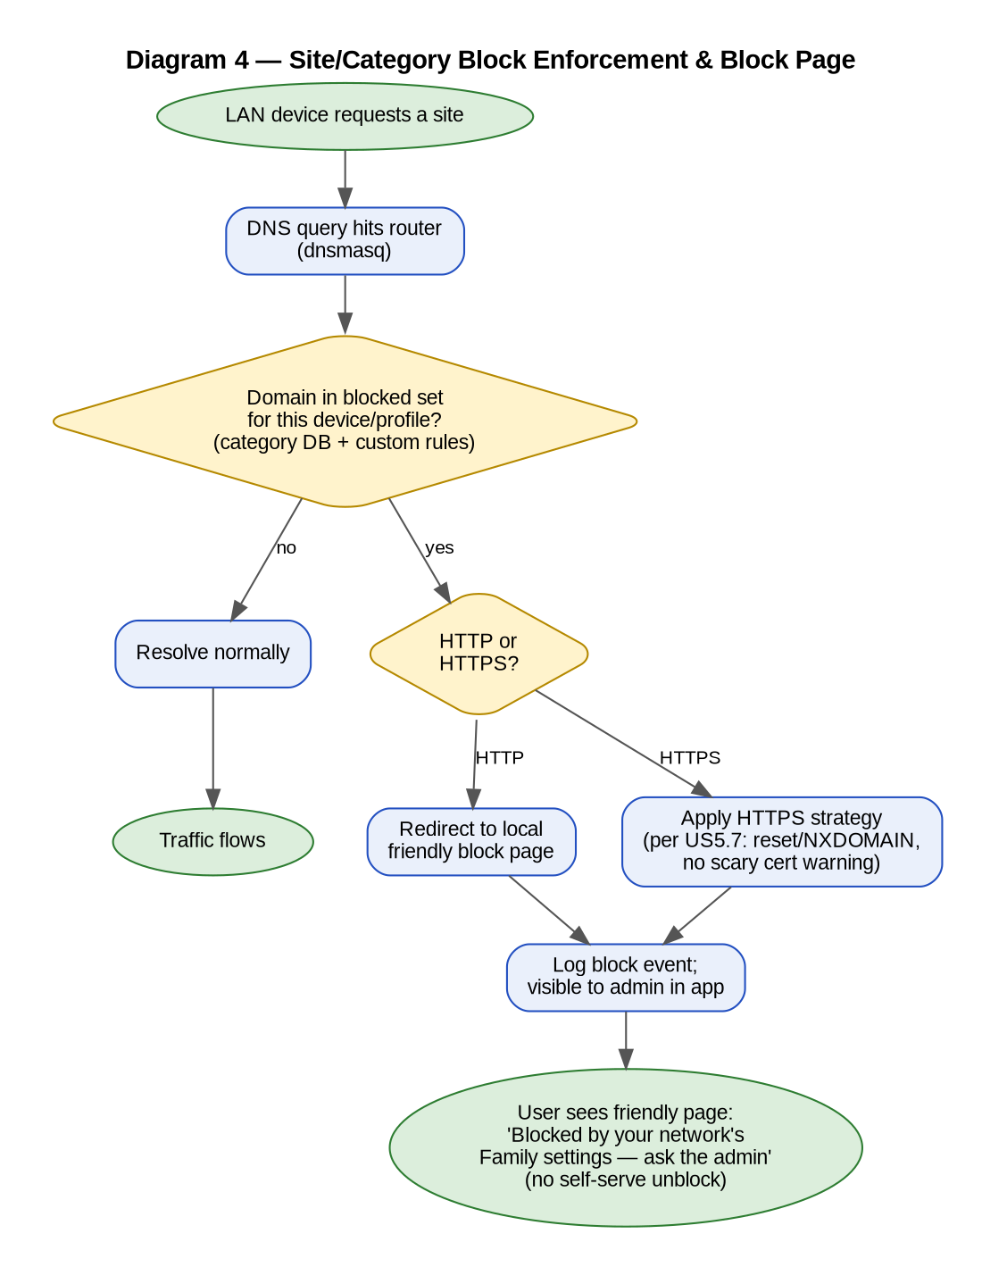

FR-08 — Parental Profiles, Time Limits & Pause [MVP · US8.1–8.4]
Per-child profiles bundling devices with content rules, daily limits, bedtime schedules, and an instant pause.
Aspect | Specification
Inputs | Profile name; member devices; category toggles; schedule (visual sliders); pause/resume taps
Outputs | Persistent per-device rule sets; countdown notices; paused state on profile card
Preconditions | Devices identified (FR-05)
Behavior | Kid/Teen templates offered as starting points; profile creation ≤ 5 taps. Scheduler runs on-router (works offline, survives reboot). Child devices receive a friendly pre-cutoff warning. Pause applies to all member devices within seconds; one-tap resume. Enforcement per Diagram 5.
Error / edge handling | Device in two profiles → disallow (single-profile membership enforced at assignment); clock loss on reboot without WAN → RTC/last-known-time fallback, fail toward the child-safe state during ambiguity; safe-search enforced whenever content filtering is on.
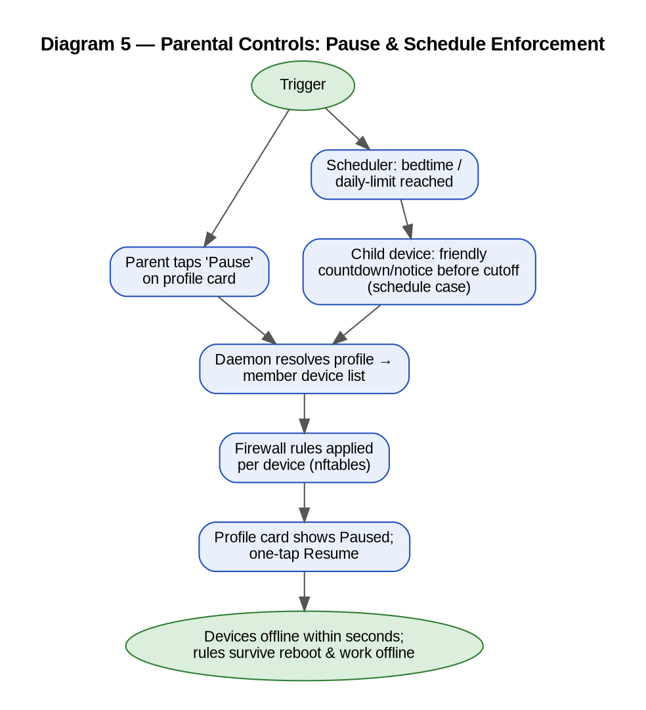

FR-09 — Per-App Blocking [v1.1 (scope from MVP spike) · US5.5–5.6]
Blocks specific mobile apps where the MVP feasibility spike classified them reliably blockable; best-effort apps are labeled as such in the UI.
Aspect | Specification
Inputs | Spike-approved app/category signatures; traffic fingerprints
Outputs | App-level rules; labeled reliability tier in UI
Preconditions | US5.5 spike report accepted (gating)
Behavior | Only spike-verified 'reliable' categories are promised; 'best-effort' shown with an explicit label; infeasible apps not offered.
Error / edge handling | CDN-shared infrastructure, cert pinning, encrypted SNI/ECH limit detection — the spike defines the boundary; marketing copy must not exceed it.

FR-10 — Ad Blocking [v1.1 · US6.1]
Single network-wide toggle blocking ad/tracker domains via DNS lists for all devices.
Aspect | Specification
Inputs | On/off toggle; curated filter lists
Outputs | DNS-level blocking; dashboard status
Preconditions | User opt-in (off by default)
Behavior | One toggle in Basic mode; list management deferred to Advanced (v1.2, US6.2). Changes apply without router restart.
Error / edge handling | Site breakage complaints → per-site allow exception surfaced in Basic mode as 'this site isn't working? allow it'.

3.4 Resilience, Updates & Recovery

FR-11 — Offline Operation [MVP · US13.3, US15.3]
Everything local keeps working when the internet is down — management, blocking, schedules, MFA (offline factors).
Aspect | Specification
Inputs | WAN state detection
Outputs | Full LAN dashboard; cloud-dependent features flagged unavailable (never silent timeouts)
Preconditions | None — this is default behavior, not a mode
Behavior | Daemon detects WAN loss, marks cloud endpoints unavailable with plain-language labels, continues serving all LAN functions; resumes sync automatically on reconnect without restart.
Error / edge handling | Flapping WAN → debounce state changes to avoid alert spam.

FR-12 — Firmware Update (OTA) [MVP · US11.1, US16.1–16.3]
Automatic, signed, atomic A/B updates with auto-rollback, distributed via staged rollout.
Aspect | Specification
Inputs | Signed RAUC bundle from OTA server; cohort assignment; low-usage window
Outputs | Updated active slot; version report; dashboard 'last updated'
Preconditions | ~2× rootfs flash (hardware selection criterion, US19.1)
Behavior | Flow per Diagram 6. Outbound check-in only (C1). Rollout percentage server-controlled; fleet failure-rate monitoring can halt a rollout. Emergency security patches use the same pipeline under the patch SLA (US20.3).
Error / edge handling | Signature invalid → reject + report; boot health-check fail → automatic rollback to previous slot + report; download interrupted → resume/retry; power loss mid-install → inactive-slot writes cannot affect the running system.
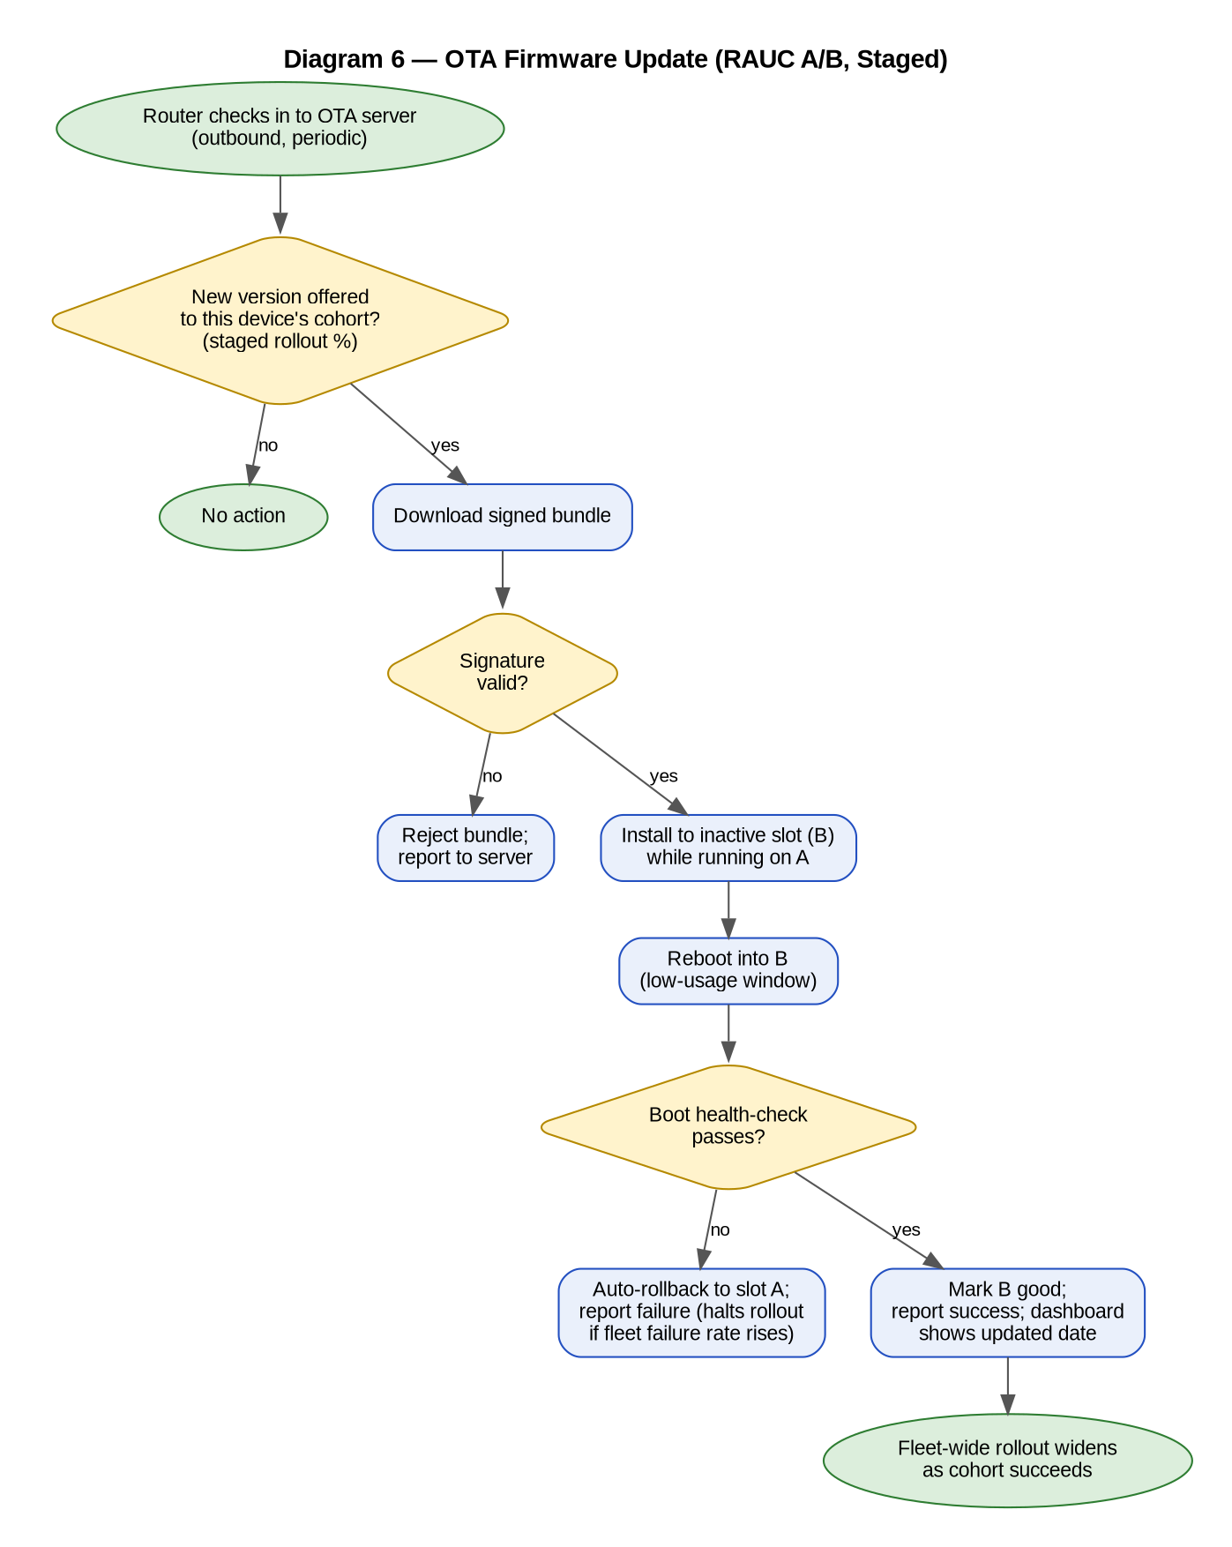

FR-13 — Physical Recovery [MVP · US13.4, US19.3]
Last-resort local recovery when every MFA factor is lost — requiring physical presence.
Aspect | Specification
Inputs | Defined button hold + setup-time recovery code (shown once at onboarding)
Outputs | Admin credentials reset (scope per open decision: credentials-only vs. factory reset)
Preconditions | Physical access to the unit
Behavior | Behavior consequences explained at setup, before ever needed. Hold durations specced jointly with hardware (US19.3) and frozen before pilot tooling.
Error / edge handling | Button semantics must not be triggerable accidentally (duration + confirmation pattern); recovery events logged.

3.5 Remote Access (v1.1)

FR-14 — Remote Session (Visibility + Control) [v1.1 · US7.1–7.4, US7.6, US17.1–17.3]
Full dashboard — live status and control — from anywhere, over an outbound-only tunnel, with two coexisting scopes.
Aspect | Specification
Inputs | Cloud login + MFA (always); relay rendezvous; scope setting
Outputs | Remote session; same core actions as local (pause/block/profiles) applying within seconds; login push alert; revocable session list
Preconditions | Router linked to account; tunnel established (router-initiated WireGuard)
Behavior | Per Diagram 7. Default scope routes only to the daemon API (management-only). Full-LAN is a separate Advanced opt-in (v1.2 US7.5) that never replaces the default. Remote and local experiences expose the same core feature set — never a reduced remote subset (confirmed decision).
Error / edge handling | Tunnel drop → automatic reconnect; relay unreachable → clear 'router offline' state; scope change effective without user re-pairing; inactivity timeout enforced.
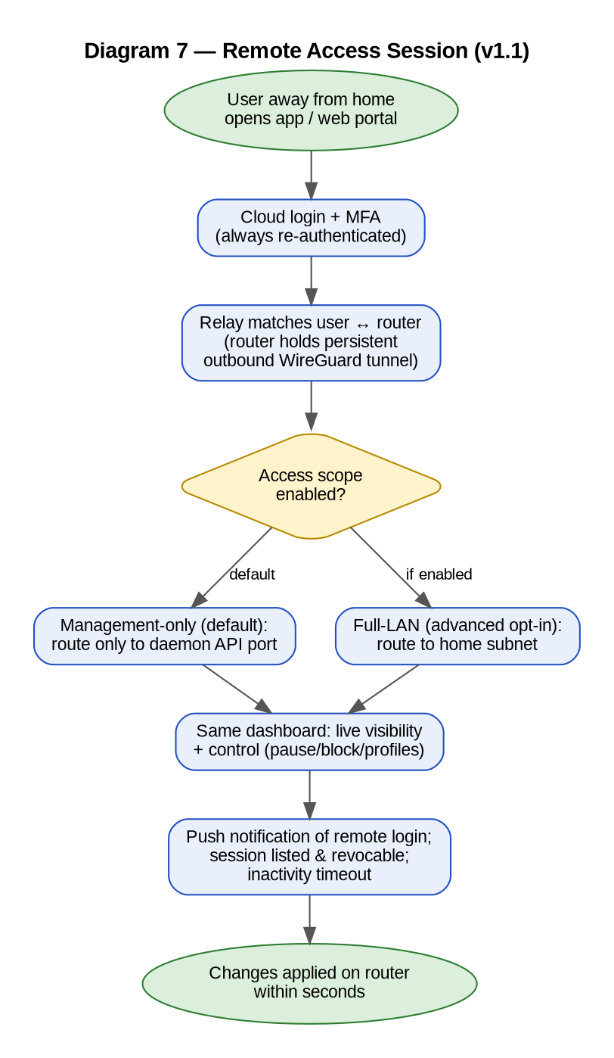

3.6 Supporting Functions

FR-15 — Alerts & Notifications [MVP · US10.1]
Proactive plain-language push for events that matter: new device joined, threat blocked, failed logins, update applied.
Aspect | Specification
Inputs | Daemon events; push tokens
Outputs | Push notifications with direct actions (e.g., Block)
Preconditions | Cloud link for push transport (local in-app alert list works regardless)
Behavior | Default-on for security events; per-category preferences arrive in v1.1 (US10.2).
Error / edge handling | No WAN → events queue to the in-app alert feed; no technical codes in any notification text.

FR-16 — Guest Network [v1.1 · US9.1–9.2]
One-tap isolated guest Wi-Fi with optional auto-expiry.
Aspect | Specification
Inputs | Toggle; optional duration
Outputs | Isolated SSID (no LAN visibility); auto-generated editable credentials
Preconditions | —
Behavior | Isolation from the main LAN by default; expiry disables the SSID automatically.
Error / edge handling | Expiry while guests active → disconnect gracefully; guest SSID never bridges to LAN even if misconfigured (fail-isolated).

FR-17 — Support & Self-Help [MVP (self-help) / v1.1 (remote diag) · US21.1–21.3]
Guided troubleshooting for top scenarios; later, consent-based scoped remote diagnostics for support agents.
Aspect | Specification
Inputs | User-selected symptom; (v1.1) per-session consent
Outputs | Guided fixes; escalation path; (v1.1) read-only diagnostic session, logged and user-visible
Preconditions | —
Behavior | Self-help flows work offline (per FR-11). Support access is diagnostics-scoped — never full admin control; every session logged and shown to the user afterwards.
Error / edge handling | Diagnostic export (US21.3) strips all secrets/passwords.

4. Data Description
Level-0 data stores and flows. Secrets (admin hash, TOTP seeds, backup-code hashes) are encrypted at rest and only ever verified, never read out through the API. Children's activity data is stored on-router by default; any cloud copy is explicit, minimal, consented (US20.2). WAN configuration (*) is modeled as its own namespace to remain cleanly separable for the future ISP project.
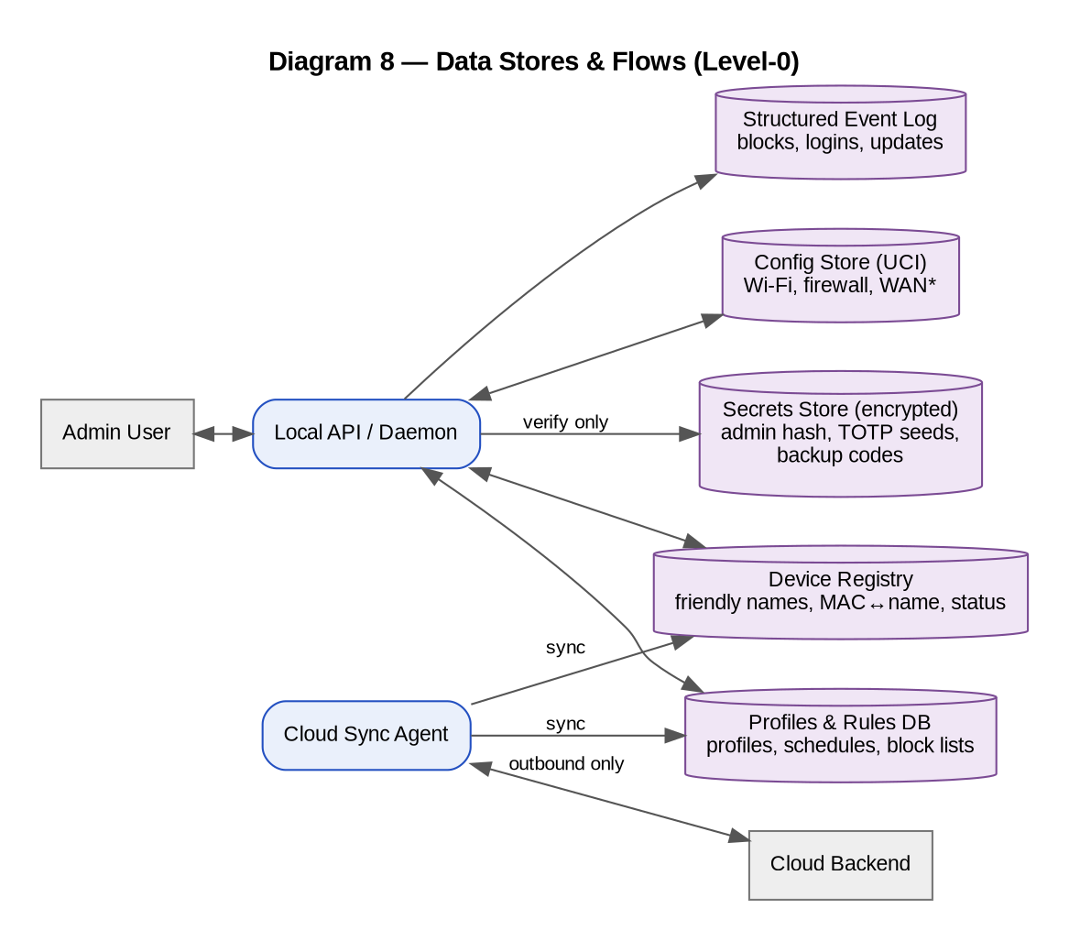
Store | Contents | Notes
Config Store (UCI) | Wi-Fi, firewall, DHCP/DNS, WAN settings | WAN isolated namespace; versioned schema
Profiles & Rules | Profiles, device membership, categories, schedules, custom blocks | Source of truth on-router; syncs to cloud when linked
Device Registry | MAC↔friendly name, type icon, first/last seen, pause/block state | Merge heuristics for MAC randomization
Secrets Store | Admin credential hash, TOTP seeds, backup-code hashes, recovery code | Encrypted at rest; verify-only interface
Event Log | Blocks, logins, remote sessions, updates, support sessions | Structured (machine-readable); feeds alerts, status, v1.2 audit log

5. External Interfaces
Interface | Specification summary
Local API (Daemon) | REST/JSON over LAN, TLS; versioned contract; sole gateway to ubus/UCI; serves mobile, web, and (v1.1) remote sessions identically
Cloud API | Account/MFA, router registry, config sync, push registration; all router-side connections outbound (C1)
OTA Interface | Periodic outbound check-in; signed RAUC bundles; cohort/rollout controlled server-side
Relay Interface (v1.1) | Router-initiated WireGuard; ACLs enforce management-only vs. full-LAN scope at the network layer (US17.3)
User Interfaces | Mobile app (iOS/Android, one codebase), web dashboard (local + cloud-served); Basic mode default, jargon-free; Advanced opt-in (v1.2)

6. Non-Functional Requirements (Summary)
Full set in the backlog's NFR sheet; the ones every function above must honor:
- Usability: common actions ≤ 30 seconds; setup ≤ 5 minutes; no jargon in Basic mode; WCAG 2.1 AA.
- Performance: dashboard status ≤ 2 s; device list smooth at 30+ devices; pause/block effective within seconds.
- Security: MFA on every remote session; secrets encrypted at rest; TLS everywhere; unique per-unit defaults; outbound-only; external audit launch-blocking.
- Reliability: full local function with WAN down; at least one locally-verifiable MFA factor always enrolled; A/B rollback covers failed updates; no flow forces a factory reset as a side effect.
- Architecture: daemon is the sole gateway to OpenWrt internals; update mechanism unchanged when ISP management is added later.

7. Traceability & Related Documents
Every FR cites its backlog story IDs; the backlog's Release column governs delivery order. Related artifacts: router-security-app-backlog.xlsx (epics/stories/tasks/NFRs/release plan) · router-project-plan.docx (phases, milestones, risks, governance) · router-architecture-recommendation.md (technical stack) · home-network-security-research.md (market evidence) · future-consideration-isp-centralized-management.md (deferred scope).

