MVP progress submission • November 2–8, 2026
Group Name: Ace Attorney Course / Section: BSI/T – 3E (Web Systems and Technologies 1)
Members: Allen Jodel Labay, Aldwin Nieva Montiano, Braelyn Ashlee Jao Lacsina, Micheal Vincent Ballerda, Robert Tristan, Ashley Nicole Mandac Onte
Date: November 6, 2026 (updated for MVP v7) GitHub link: https://github.com/scoutlabaymp4-alt/MHG---Moriones-Heritage-Guide
1. PROJECT TITLE & SECTOR
Project title: MHG – Moriones Heritage Guide: An Interactive Web-Based Learning and Visitor Companion for the Marinduque Moriones Festival
Primary sector/domain: Tourism & Cultural Innovation
2. IDENTIFIED PROBLEM
Local context. The Moriones (locally the “Moryonan”) is a Lenten tradition of Marinduque in which participants wear masks and costumes of Roman soldiers as penance, thanksgiving or a vow. A scholarly study of its preservation reports that the tradition’s historical value is declining, that it is becoming increasingly detached from the local community, and that little has been done to ensure the continuity of the mask-making craft, with ageing artisans calling for heirs [1]. The 2003 UNESCO Convention defines intangible cultural heritage as the practices, representations, expressions, knowledge and skills that communities recognize as part of their cultural heritage [2], which is the category this tradition belongs to.
Affected stakeholders. (a) Senior high school and college students in Marinduque and their teachers, who need a trustworthy classroom resource; (b) visitors and returning Marinduqueños who attend during Lent and need context and etiquette guidance; (c) cultural and tourism offices that could maintain or reuse the content. Tourism figures for the province are reported by the Philippine News Agency [3], and the Inquirer describes the Moriones as Marinduque’s top tourist draw [4].
Documented gap. Local reports quote the Church and officials saying that the tradition is “not really a show” [4], that the name “Moryonan” is preferred over “festival”, and that touristic attention has shifted “from Jesus to the Roman soldiers”; Mogpog Resolution No. 29-2017 penalizes “indiscriminate display” of the masks and costumes [5]. Together with the findings in [1], this shows a need for accurate, respectful interpretive material. In the literature reviewed so far, heritage gamification and digital storytelling are studied mostly through AR/VR and mobile applications [6], [7], [8], [9], [10]. A preliminary search in Week 2 did not find a lightweight, web-based interactive guide on the Moriones or on Philippine intangible heritage among the results reviewed; this search was not exhaustive, so the gap is provisional.
Working hypothesis (not yet validated). Young Marinduqueños and visitors have few accessible, engaging digital resources that explain the meaning, story and etiquette of the tradition. The group still has to test this through a review of existing online materials and non-sensitive student feedback (planned for Week 3).
3. PROPOSED SOLUTION
What the application does. MHG is a frontend-only, bilingual (English/Filipino) web guide designed for laptop and desktop screens. Users (1) read interactive heritage modules: the legend of Longinus, a Holy Week timeline, and an “anatomy of a Morion” section with an original 3D mask and a clickable SVG costume glossary; (2) search and filter a directory of rites and heritage sites by municipality and category; and (3) take a short quiz with progress and badges saved in the browser, and complete a respectful-visitor etiquette checklist. Two extensions add a visit planner (choose a day and town, save items, copy or download the plan as text) and the 3D mask. Every fact in the content carries a source tag; where sources disagree (for example on the origin date), the guide shows both.
Design rationale. The quiz applies retrieval practice, which improved long-term retention more than restudying in a controlled study [11]. Badges are a gamification element, defined as the use of game design elements in non-game contexts [12]; a literature review of empirical studies found that the effects of gamification depend on context and on the users [13]. The group has not measured learning or engagement gains and will not claim them unless it collects data.
General objective. To develop a frontend-only, bilingual (English/Filipino) web guide that gives students, visitors and tourism offices accurate, source-tagged and respectful information about the Moryonan of Marinduque, and to check how well it meets its requirements.
Specific objectives.
O1: Deliver at least three working interactive features (heritage modules, searchable directory, quiz with etiquette checklist). (Status: Met; two extensions added (Plan a visit, 3D mask).)
O2: Attach at least one source id to every factual content item and label unsourced guidance as “pending”. (Status: Met (checked by the validator).)
O3: Provide every interface string and content item in both English and Filipino, with the Filipino reviewed by a native speaker before final submission. (Status: Drafted; review pending.)
O4: Meet the automated WCAG 2.x A/AA checks on all views in light and dark themes and make every interaction keyboard-operable. (Status: Met for automated checks; manual checks pending.)
O5: Collect no personal data and require no server or database; keep all state in the browser. (Status: Met by design.)
O6: Pilot the guide with at least five students or visitors using the usability kit (five tasks and the SUS questionnaire) and report completion rate and SUS score. (Status: Planned (Week 3).)
O7: Have the content reviewed by at least one local reviewer (cultural bearer, tourism office or Diocese) and record the review in content.json. (Status: Planned; 0 items reviewed so far.)
Who benefits. Students and teachers (classroom resource), visitors (context and etiquette), and tourism/cultural offices (reusable, source-tagged content in JSON).
Scope and exclusions. Included: static pages, JSON content, SVG and 3D interactions, browser storage, EN/FIL toggle. Excluded: server, database, accounts or logins, payments or bookings, maps and live event data, user-generated content, AR/VR headsets (future work), and any collection of personal data. The group is not an official tourism or Church body, and the tradition is presented as a religious practice, not entertainment.
4. CORE FUNCTIONAL FEATURES — MVP (MINIMUM THREE)
Feature | User action / expected behavior | Implementation status | Evidence / file
Feature 1  Interactive heritage modules | Open Learn → read the legend (with a note that sources differ on the origin), step through the 8-item Holy Week timeline, and in Anatomy turn an original 3D mask or select any of 6 costume parts (click or keyboard) to read its description, source tags and mark it explored. EN/FIL toggle switches all text. | Implemented | index.html; js/app.js (renderLearn, anatomyHTML, selectPart); js/mask3d.js; data/content.json (legend, rites, glossary). Sources: [14], [15], [5]. Tested: docs/TESTING.md #2, #3, #8, #32, #33.
Feature 2  Searchable, filterable directory | Type a keyword (English or Filipino, case- and accent-insensitive) and/or pick a municipality and category; the list and the result count update at once; “no match” suggestions and a reset button when needed. Each of the 12 entries shows when/where, a “verify each year” label for schedule-based items, and source links. | Implemented (12 entries; more to be added after verification) | js/app.js (filterDirectory, drawDirectory); data/content.json (directory, filters). Entries drawn from [14], [4], [16]. Tested: docs/TESTING.md #4, #16–#18.
Feature 3  Quiz, badges and etiquette checklist | Answer 8 multiple-choice questions with immediate feedback, explanation and source; see the score, best score and attempts; earn 5 badges; tick a 6-item etiquette checklist (each item labelled “Sourced” or “Pending review”). Progress, badges, checklist and language are saved in this browser only, with a reset button. | Implemented | js/app.js (drawQuiz, drawChecklist, localStorage key mhg.v1); data/content.json (quiz, etiquette). Tested: docs/TESTING.md #5, #6, #7.
Extension 1  Plan a visit | Choose a Holy Week day and a town; see the rites and sites the sources report; save items to “My plan”; copy the plan as text, download it as .txt, or print it. | Implemented | js/app.js (planView, planText, copyText); data/content.json (days, directory). Tested: docs/TESTING.md #19–#21, #31.
Requirements and design evidence. The table below maps each functional requirement to a feature, to the place it is implemented and to its test evidence (full objectives, non-functional requirements and the 3D mask requirement are in docs/REQUIREMENTS.md). F1–F3 are the three core features; E1 is the Plan a visit extension and E2 the 3D mask. Figures 1–4 give the preliminary architecture and interface design: sitemap, component diagram, user flow and screens of the implemented desktop interface.
Requirement (ID: description) | Feature | Implemented in | Evidence / status
FR1: The user can switch the whole interface and content between English and Filipino. | All | js/app.js (state.lang, ui()); content.json | TESTING #8, #34; Implemented
FR2: The system shows the legend with source tags and states where sources disagree on the origin date. | F1 Heritage modules | legendHTML(); content.json legend | TESTING #2; Implemented
FR3: The system shows the Holy Week rites as an ordered timeline. | F1 Heritage modules | ritesHTML(); content.json rites (8) | TESTING #2; Implemented
FR4: The user can select any of six costume parts by pointer or keyboard and read its description, sources and review status; progress is counted. | F1 Heritage modules | figureSVG(), selectPart(); glossary (6) | TESTING #3; Implemented
FR5: The user can turn and zoom an original 3D mask, show or hide the helmet and optional flowers, and highlight the mask or crest; if 3D is unavailable the illustration is shown. | E2 3D mask | src3d/mask3d.js → js/mask3d.js; bindFigure() | TESTING #32, #33; Implemented
FR6: The user can search the directory by keyword in English or Filipino, ignoring case and accents. | F2 Directory | filterDirectory(); directory (12) | TESTING #4; Implemented
FR7: The user can filter by municipality and category, see the result count, get suggestions when nothing matches, and share the filter state in the address. | F2 Directory | drawDirectory(), setHash() | TESTING #4, #16–#18; Implemented
FR8: The user can pick a day and town, see what the sources report, and save or remove items in a personal plan that persists. | E1 Plan a visit | planView(), togglePlan(); days (8) | TESTING #19, #20; Implemented
FR9: The user can copy the plan as text, download it as .txt or print it; a link is offered only when the site is served over http(s). | E1 Plan a visit | planText(), copyText(), downloadText() | TESTING #31; Implemented
FR10: The user can take an 8-question quiz with immediate feedback, explanation and source, and see score, best score and attempts. | F3 Quiz and etiquette | drawQuiz(); quiz (8) | TESTING #5; Implemented
FR11: The system awards five badges for defined achievements and shows which are earned. | F3 Quiz and etiquette | award(), drawStats() | TESTING #5; Implemented
FR12: The user can tick a six-item etiquette checklist whose items are labelled “Sourced” or “Pending review”, and print it. | F3 Quiz and etiquette | drawChecklist(); etiquette (6) | TESTING #6, #7; Implemented
FR13: The system lists all sources, shows each item's review status, and counts items reviewed by a local reviewer. | Cross-cutting | sourcesHTML(), reviewChip() | TESTING #23; Implemented
FR14: The user can reset saved progress. | F3 Quiz and etiquette | bindQuizView() | TESTING #7; Implemented

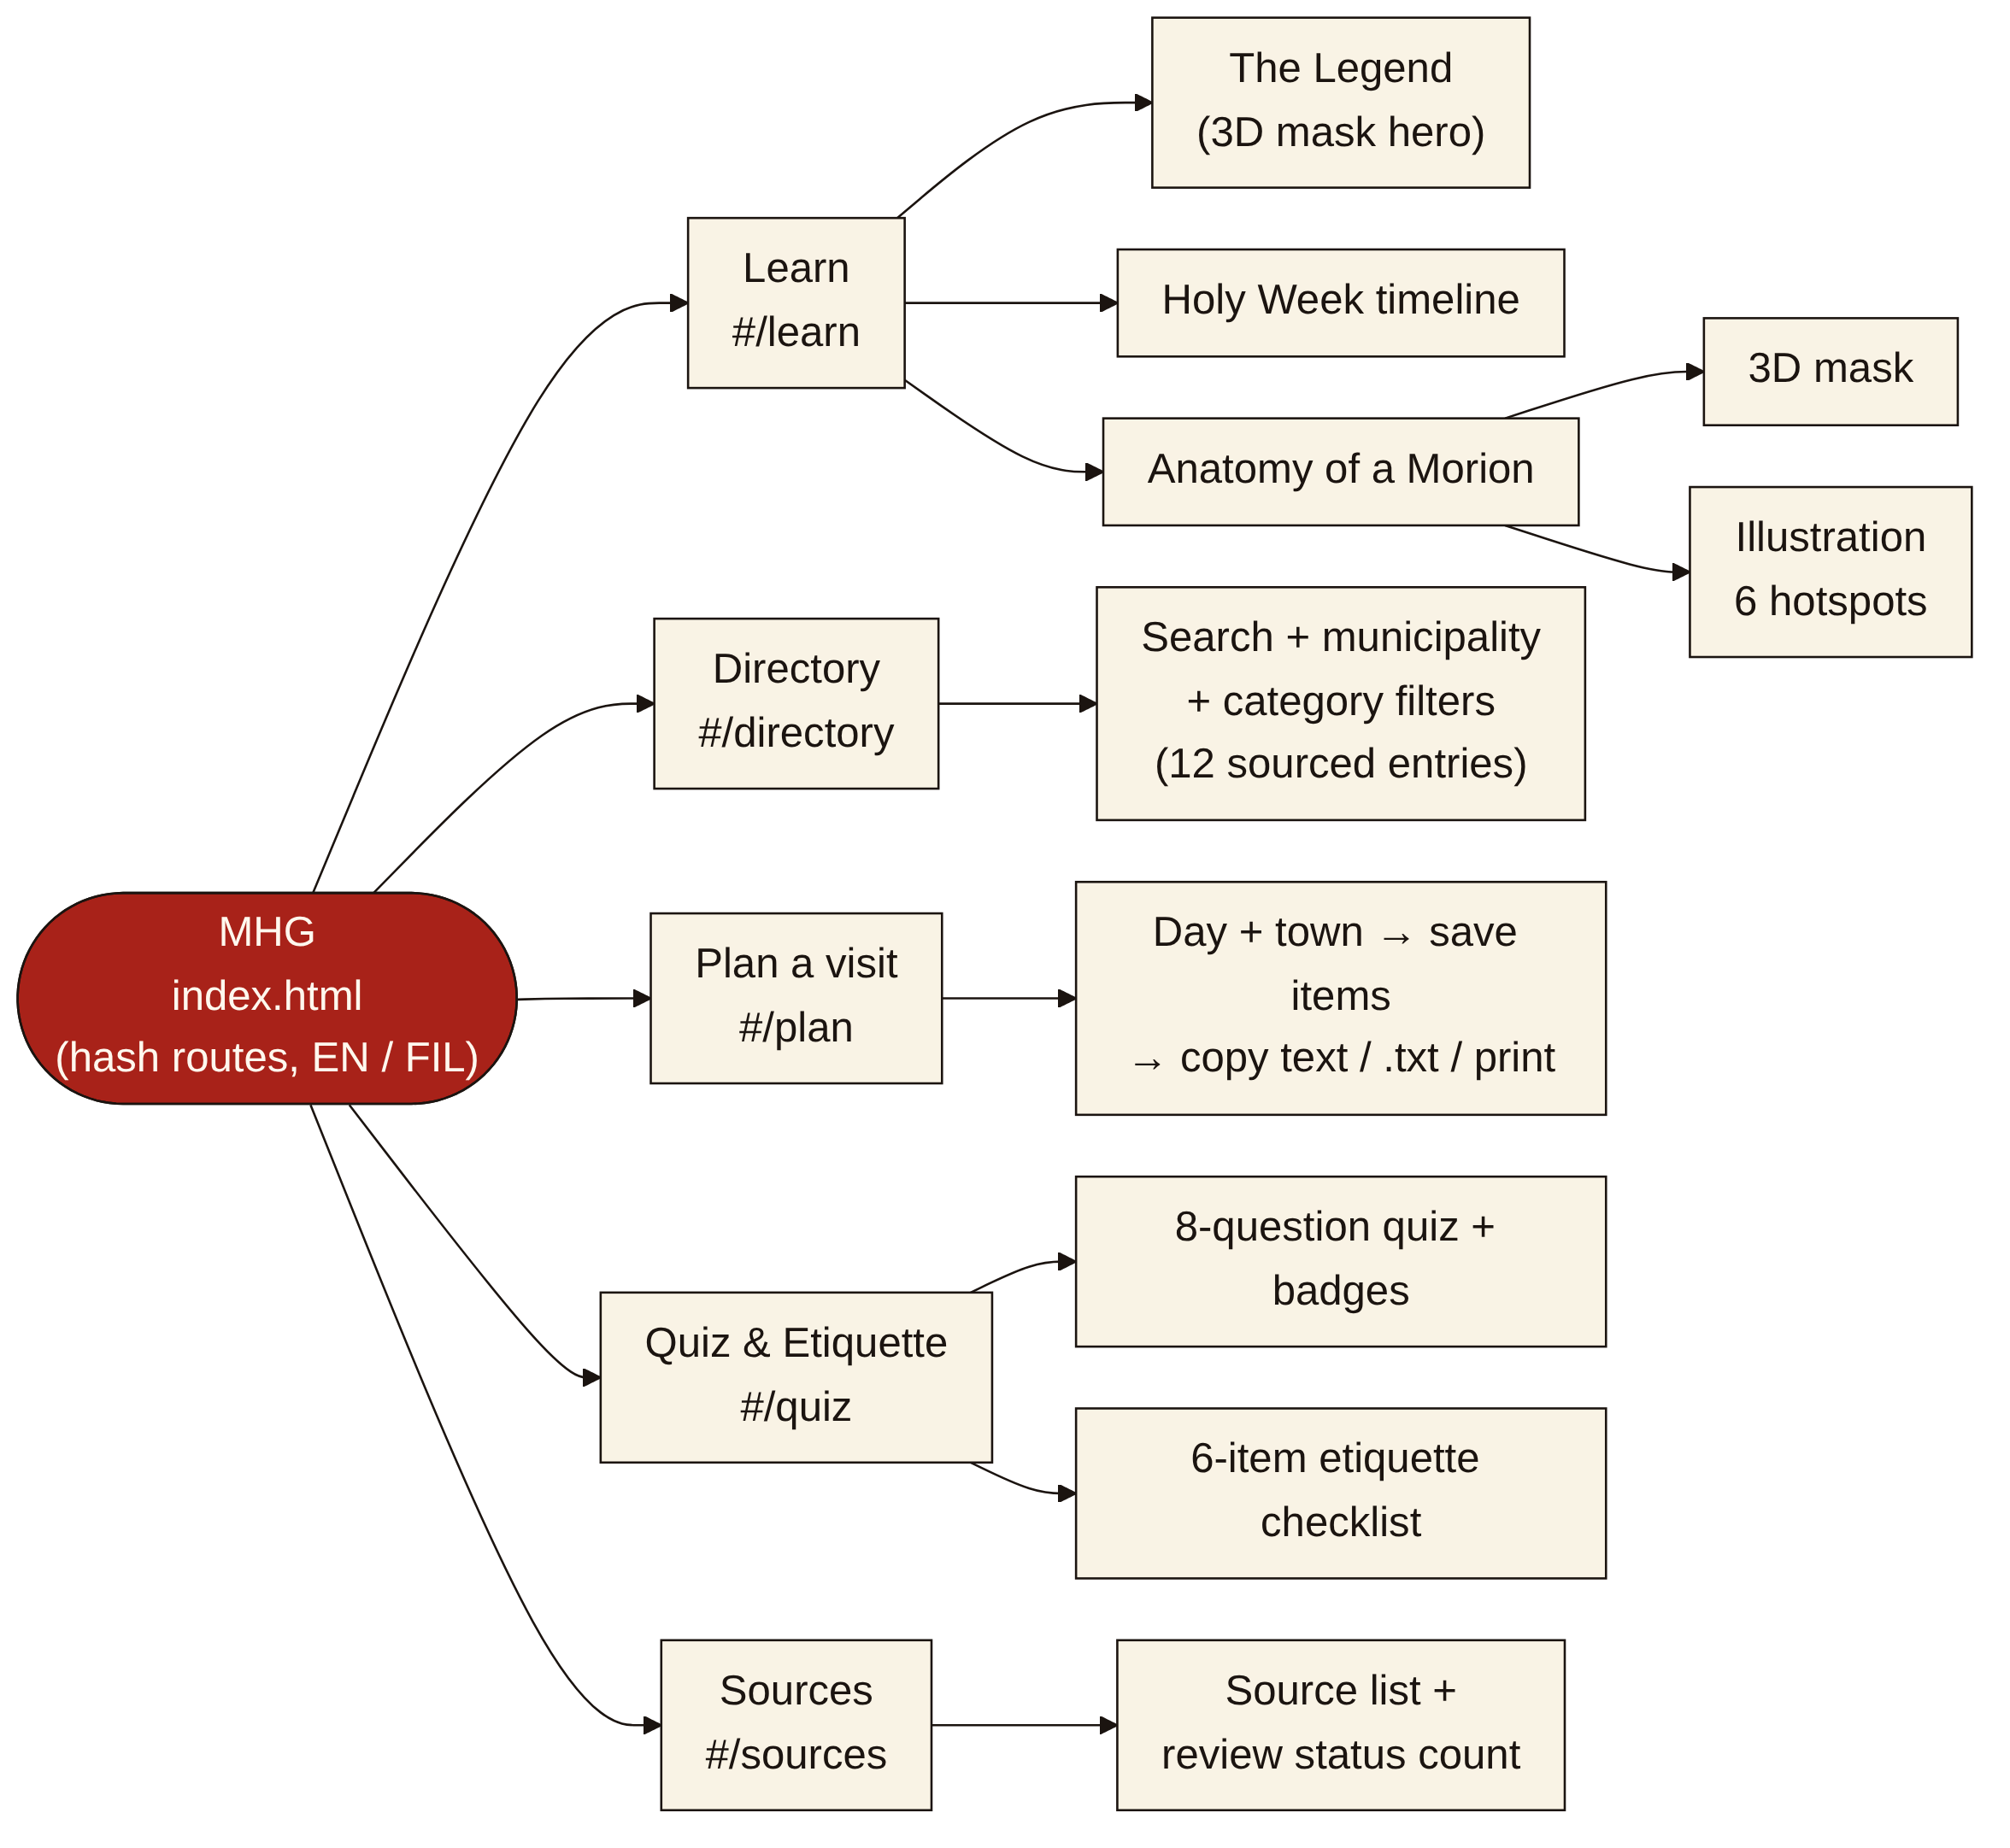
Figure 1. Sitemap of MHG (hash routes in a single index.html).
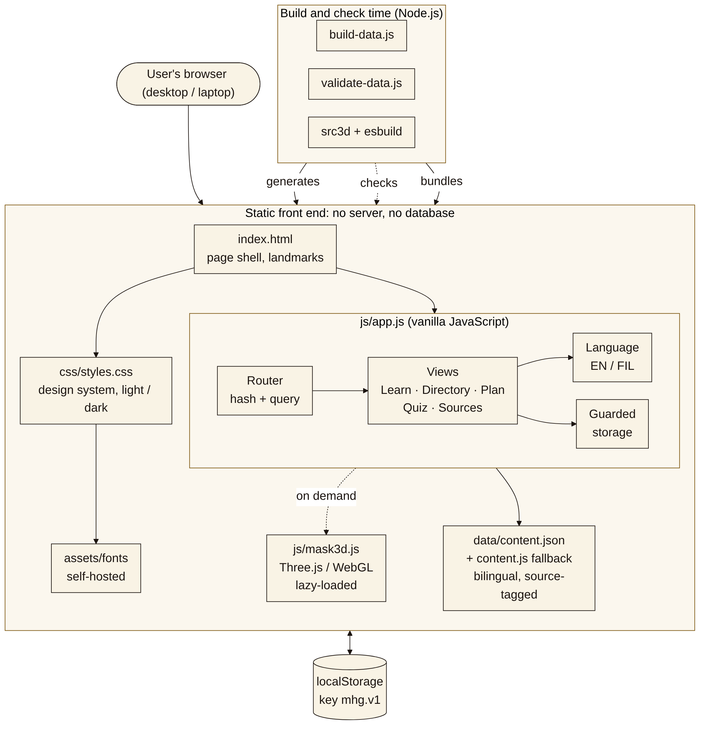
Figure 2. Component diagram: static front end, lazy-loaded 3D module, browser storage and build-time tools.
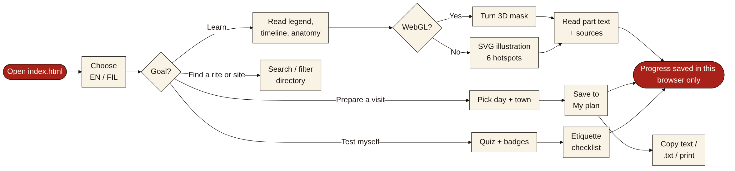
Figure 3. User flow for a visitor or student.
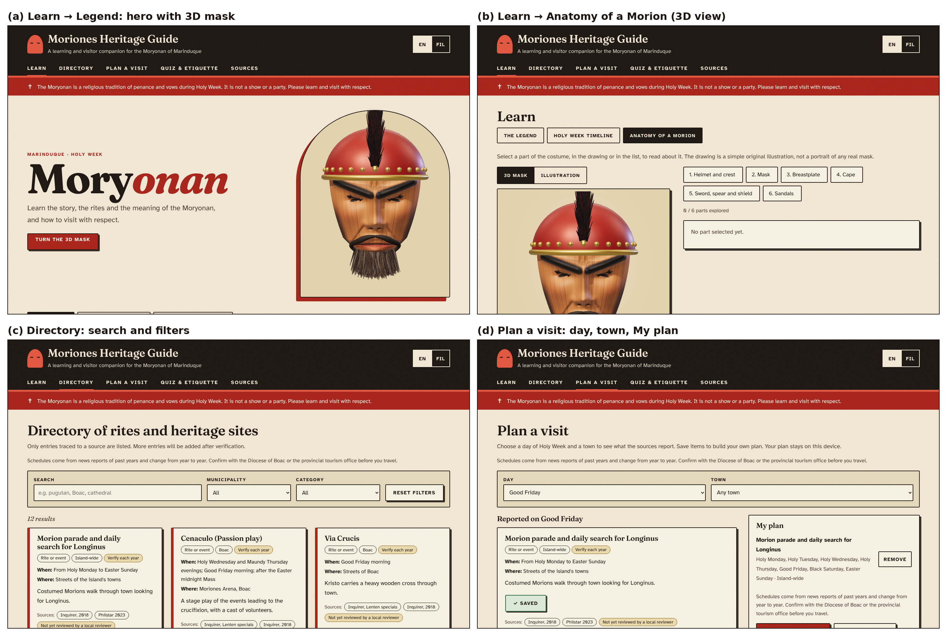
Figure 4. Interface design as implemented (v7, 1440 × 900): (a) Legend with 3D hero, (b) Anatomy 3D view, (c) Directory, (d) Plan a visit.

5. TECHNOLOGY PLAN AND JUSTIFICATION
Selected technology | What it enables | Reason for selection | Literature / docs
Semantic HTML5 with WAI-ARIA roles | Page structure that keyboard and assistive-technology users can navigate (landmarks, tabs, role=button on SVG hotspots, a text label on the 3D view). | Needed for an educational/public resource; native elements give keyboard behavior without extra code. | WCAG 2.2 [17]; WAI-ARIA 1.2 [18]. Automated scan: docs/TESTING.md #10, #34.
CSS3 (desktop-first, light/dark) | A wide layout for laptop and desktop screens (content width up to 78 rem, larger type, multi-column lists); readable contrast; reduced-motion support; one-column fallback on narrow screens. | The group decided on 5 November that the guide targets PC and laptop users first, so the earlier mobile-first and offline-app (PWA) work was removed. No CSS framework needed at this scale. | WCAG 2.2 (contrast, reflow) [17]. Tested: docs/TESTING.md #30, #34.
Vanilla JavaScript (no framework, no build step to run the site) | Routing, directory filter, quiz scoring, visit planner, language toggle and storage, all in the browser. | The interactions are small and client-side, so no server or framework tooling is needed and the repository can be served as static files (e.g., GitHub Pages). Not a claim that a framework is worse: a comparison of Angular, React and Vue for single-page front ends [19] favored React among those three, but it does not include vanilla JavaScript. Revisit Vue/React if the views become reusable components. | Ilievska & Gramatikov [19]; code in js/app.js (about 870 lines).
Three.js (WebGL), prebuilt with esbuild | An original 3D Morion mask that the user can turn and zoom, loaded only when needed; the SVG illustration is the fallback. | Writing WebGL by hand is slow and error-prone; Three.js is MIT-licensed and widely used. The bundle is about 0.5 MB (0.13 MB gzipped) and is prebuilt, so running the site still needs no build. The model is generated in code, so no image or model licence is involved. | THIRD_PARTY.md; src3d/; docs/TESTING.md #32, #33.
Inline SVG with hotspots | Clickable, focusable costume diagram that scales without losing quality and needs no image files. | Original drawing avoids image-licensing risk; keyboard operation and text alternatives are possible with SVG. | WCAG 2.2 [17]; WAI-ARIA 1.2 [18].
JSON content files (data/content.json) with a generated copy (data/content.js) | Bilingual text, directory, quiz and source tags separate from code, so the content can be reviewed or edited by non-programmers. The copy lets the page open straight from disk. | Supports the source-traceability rule: each item lists its source ids. No database needed for a read-only guide. Browsers block fetch() of a JSON file on file:// pages, which caused a “not found” error for the group in VS Code/Edge, so the app falls back to content.js (tools/build-data.js regenerates it; tools/validate-data.js checks it). | README.md; docs/TESTING.md #11, #25.
Self-hosted fonts (Fraunces, Atkinson Hyperlegible) | Consistent typography with no request to a font service. | Keeps the “nothing leaves the device” privacy promise. Atkinson Hyperlegible was designed for legibility. Both are SIL Open Font License; license files are in assets/fonts/. | Font license files in assets/fonts/.
Browser storage (localStorage) | Saves language, quiz results, badges, checklist and visit plan on the user’s device only; nothing is sent to a server. | Keeps the app serverless and avoids collecting personal data. Storage can be unavailable or cleared, so every read/write is guarded and the app still works without it. | Web Storage (Second Edition) [20].

6. DEMONSTRATION & LIMITATIONS
Current working features: All three MVP features run in the browser from the group’s files: (1) heritage modules (legend, 8-item timeline, 3D mask and 6-part SVG glossary), (2) directory with 12 sourced entries and live search/filters, (3) 8-question quiz with 5 badges, saved progress and a 6-item etiquette checklist; plus the Plan a visit extension, the EN/FIL toggle and light/dark themes. To run: double-click index.html, or press F5 in VS Code and choose “MHG in Edge (no server needed)”; steps are in README.md.
Tested behavior: Automated checks in Chromium (see docs/TESTING.md #1–#34): no console errors; the SVG hotspots work by keyboard; directory counts for sample searches and filters were as expected; a full quiz run awarded the expected badges; checklist, best score, badges and plan persisted after reload; the language toggle sets <html lang>; the plan copies as text, downloads as .txt and falls back to a text box when the clipboard is blocked; the 3D mask loads on the home page and in Anatomy, its controls work, and the illustration appears when WebGL is unavailable; no horizontal scroll at 1440 and 1920 px wide; an axe-core scan (WCAG 2.x A/AA) of 7 views in light and dark themes, including the 3D views, reported 0 violations in v7 (earlier runs found contrast and label problems that were fixed). The page also opens from disk (file://). This is development testing by the AI-assisted build, using a software 3D renderer: no students or visitors have tried it yet, real graphics-card speed, Firefox, Safari and screen readers were not tested, and no learning or engagement results exist.
Known defects / incomplete features: (1) The Filipino text is AI-drafted and has not been reviewed by a native speaker. (2) No content has been reviewed yet by local cultural bearers or the tourism office, and no mask carver has reviewed the 3D mask, which is an original generic design, not a copy of any museum object (the Mask Museum page suggested as a reference could not be verified for reuse, so it was not used). (3) Schedules come from news reports of past years (one dated 2018, others undated) and may be outdated; entries are labelled “Verify each year”. (4) Sources disagree on the origin date (1870s [1] vs 1880s [14]); the guide shows both. (5) Only 12 directory entries. (6) Online deployment (GitHub Pages) is not confirmed; “Copy link” works only when the site is online. (7) The costume drawing is a simple illustration and not a depiction of a specific mask. (8) The hypothesis in Section 2 is unvalidated. (9) Testing was done by the AI-assisted build in Chromium on Linux; the group has not yet confirmed the F5/Edge launch, the 3D speed or the copy button on its own Windows computers. (10) The members’ own fixes made with GPT and Copilot are only partly logged in AI_DISCLOSURE.md (exact prompts still to be filled in).
Next-week priorities: Deploy to GitHub Pages; get the Filipino text reviewed; send the content to a local cultural bearer or the provincial tourism office for review; add verified directory entries (e.g., museum and more heritage sites); run the pilot test with at least five students or visitors (docs/USABILITY_TEST.md) and a screen-reader check; finish the manuscript (Results and Discussion, Conclusion, CRediT statement, final abstract); assign responsible members in AI_DISCLOSURE.md.
7. PARTIAL MANUSCRIPT & REFERENCES
Document drafted: Title, draft Abstract, and the Introduction (A–E: background, problem statement, objectives, proposed solution, scope and limitations) and Methodology (A–F: development approach, requirements and features, architecture and design, technology comparison, implementation, evaluation procedure) in MHG_Manuscript_Draft.docx and docs/MANUSCRIPT_DRAFT.md. Results and Discussion, Conclusion and the CRediT statement are not written yet: they depend on the Week 3 pilot test and on the members’ own contributions.
Draft Abstract (for group revision): The Moriones is a Lenten tradition of Marinduque that a preservation study describes as increasingly detached from its community. This project develops MHG, a frontend-only, bilingual web guide for laptop and desktop screens that combines source-tagged heritage modules with an original 3D mask, a searchable directory of rites and sites, a visit planner, and a quiz with an etiquette checklist, built with semantic HTML, CSS, vanilla JavaScript, SVG, JSON and Three.js. Development testing covered functional behavior, persistence, desktop layout and automated accessibility checks. The effect on learning or visitor behavior has not been measured, and content review by local cultural bearers is pending.
Literature reviewed so far: 20 of minimum 15: 10 scholarly papers [1], [6], [7], [8], [9], [10], [11], [12], [13], [19]; 4 standards and conventions [2], [20], [17], [18]; and 6 news or government reports [3], [5], [4], [14], [15], [16]. Each entry was checked against its publisher, database or standards page for authors, title, venue, year and DOI/URL. Group members should re-open every link before final submission.
References (IEEE, numbered by first citation in this document):
[1] C. S. Chan, “Folklore without a folk: Questions in the preservation of the Marinduque Moriones heritage,” Int. J. Heritage Stud., vol. 23, no. 1, pp. 29–40, 2017, doi: 10.1080/13527258.2016.1232746.
[2] UNESCO, “Convention for the Safeguarding of the Intangible Cultural Heritage,” Paris, France, Oct. 17, 2003. [Online]. Available: https://ich.unesco.org/en/convention
[3] M. Gil, “Marinduque tourism sector posts strong Q1 performance,” Philippine News Agency, May 10, 2024. [Online]. Available: https://alpha.pna.gov.ph/articles/1224509
[4] “Lenten tradition: The many faces of penitence in Marinduque,” Inquirer News, Mar. 27, 2018. [Online]. Available: https://newsinfo.inquirer.net/?p=978339
[5] “Moriones: solemn tradition, not festive occasion,” Inquirer News, n.d. (published c. 2018). [Online]. Available: https://newsinfo.inquirer.net/?p=978072
[6] I. Khan, A. Melro, A. C. Amaro, and L. Oliveira, “Systematic review on gamification and cultural heritage dissemination,” J. Digit. Media Interact., vol. 3, no. 8, pp. 19–41, 2020, doi: 10.34624/jdmi.v3i8.21934.
[7] C. G. Marques, J. P. Pedro, and I. Araújo, “A systematic literature review of gamification in/for cultural heritage: Leveling up, going beyond,” Heritage, vol. 6, no. 8, pp. 5935–5951, 2023, doi: 10.3390/heritage6080312.
[8] H. Wang, Z. Gao, X. Zhang, J. Du, Y. Xu, and Z. Wang, “Gamifying cultural heritage: Exploring the potential of immersive virtual exhibitions,” Telematics Inform. Rep., vol. 15, Art. no. 100150, Sep. 2024, doi: 10.1016/j.teler.2024.100150.
[9] G. Mathioudakis et al., “InCulture: A collaborative platform for intangible cultural heritage narratives,” Heritage, vol. 5, no. 4, pp. 2881–2903, 2022, doi: 10.3390/heritage5040149.
[10] K. Kasemsarn, D. Harrison, and F. Nickpour, “Applying inclusive design and digital storytelling to facilitate cultural tourism: A review and initial framework,” Heritage, vol. 6, no. 2, pp. 1411–1428, 2023, doi: 10.3390/heritage6020077.
[11] H. L. Roediger III and J. D. Karpicke, “Test-enhanced learning: Taking memory tests improves long-term retention,” Psychol. Sci., vol. 17, no. 3, pp. 249–255, 2006, doi: 10.1111/j.1467-9280.2006.01693.x.
[12] S. Deterding, D. Dixon, R. Khaled, and L. Nacke, “From game design elements to gamefulness: Defining ‘gamification’,” in Proc. MindTrek, 2011.
[13] J. Hamari, J. Koivisto, and H. Sarsa, “Does gamification work? A literature review of empirical studies on gamification,” in Proc. 47th Hawaii Int. Conf. Syst. Sci. (HICSS), 2014, pp. 3025–3034, doi: 10.1109/HICSS.2014.377.
[14] “Moriones, other Lenten specials color Marinduque,” Inquirer News, n.d. [Online]. Available: https://newsinfo.inquirer.net/172307/moriones-other-lenten-specials-color-marinduque
[15] D. Dy-Zulueta, “Story of faith: Marinduque’s Moriones Festival takes place this Holy Week,” Philstar.com, Apr. 6, 2023. [Online]. Available: https://www.philstar.com/lifestyle/travel-and-tourism/2023/04/06/2257107/story-faith-marinduques-moriones-festival-takes-place-holy-week
[16] “Boac Cathedral declared as important cultural property,” Manila Bulletin, Feb. 22, 2020. [Online]. Available: https://mb.com.ph/2020/02/22/boac-cathedral-declared-as-important-cultural-property
[17] A. Campbell, C. Adams, R. B. Montgomery, M. Cooper, and A. Kirkpatrick, Eds., “Web Content Accessibility Guidelines (WCAG) 2.2,” W3C Recommendation, Oct. 5, 2023. [Online]. Available: https://www.w3.org/TR/2023/REC-WCAG22-20231005/
[18] J. Diggs, J. Nurthen, M. Cooper, and C. MacLeod, Eds., “Accessible Rich Internet Applications (WAI-ARIA) 1.2,” W3C Recommendation, Jun. 6, 2023. [Online]. Available: https://www.w3.org/TR/WAI-ARIA/
[19] F. Ilievska and S. Gramatikov, “Analysis and comparative evaluation of front-end technologies for web application development,” in ICT Innovations 2022 Web Proc., Sep. 2022, pp. 209–223. [Online]. Available: https://proceedings.ictinnovations.org/2022/paper/575/analysis-and-comparative-evaluation-of-front-end-technologies-for-web-application-development
[20] I. Hickson, “Web Storage (Second Edition),” W3C Recommendation, Apr. 19, 2016. [Online]. Available: https://www.w3.org/TR/2016/REC-webstorage-20160419/
8. AI DISCLOSURE PROGRESS
AI tools: Claude (Anthropic), Sonnet 5.5; GPT (OpenAI, version to be recorded); GitHub Copilot in VS Code (model/version not recorded).
Tasks and files: Claude: this document, the abstract and the manuscript draft; the MVP files (index.html, css/styles.css, js/app.js, data/content.json and content.js, tools/, README.md, docs/); the Filipino text; the SVG drawing; the original 3D mask (src3d/, js/mask3d.js); the plan-copy fix; the objectives, requirements and architecture diagrams; reference checking; paper review; the redesign, the desktop-first change and the fix that lets the page open from disk. GPT and Copilot (used by members): the tab-focus fix in js/app.js, the .vscode files, tools/serve.ps1 and README run instructions; Copilot also wrote AI_DISCLOSURE_PROGRESS.md.
VS Code launch issue (from AI_DISCLOSURE_PROGRESS.md): Launched Edge with bug fixing at localhost:8080, which showed a not-found page, then ERR_CONNECTION_REFUSED. Copilot’s first attempt (a task that starts a local server) failed because no server was running. The working change came from Claude: the page falls back to data/content.js when the browser blocks content.json on file://, and F5 and the task open index.html directly; tools/serve.ps1 is optional. File:// loading was tested in Chromium (docs/TESTING.md); the F5/Edge launch is not yet confirmed by a member on Windows.
Prompts: Logged in AI_DISCLOSURE.md (rows 1–10); prompts to Claude are verbatim. Row 10 (desktop-first change, plan copy, 3D mask) records that the Mask Museum page was not used because its reuse terms could not be verified. Known for Copilot so far: “it says unable browser?”, “still says” (from a screenshot) and the prompt quoted in AI_DISCLOSURE_PROGRESS.md. The GPT prompts and other Copilot prompts must still be pasted in by the members who ran them.
Validation and open items: Code tested in a browser; content facts and references checked against their pages; Claude-written files re-tested after the members’ fixes. Not validated: Filipino text (native speaker needed), cultural accuracy and schedules (local review needed). Responsible members are not yet assigned in AI_DISCLOSURE.md.

