**Nolan Anderson**

**MA238 Final exam work.**

**I took pictures with my phone and uploaded it to a word document. Last exam you told me it was hard to see my work, so I am trying a different method. I hope this works better.**

**Number 1**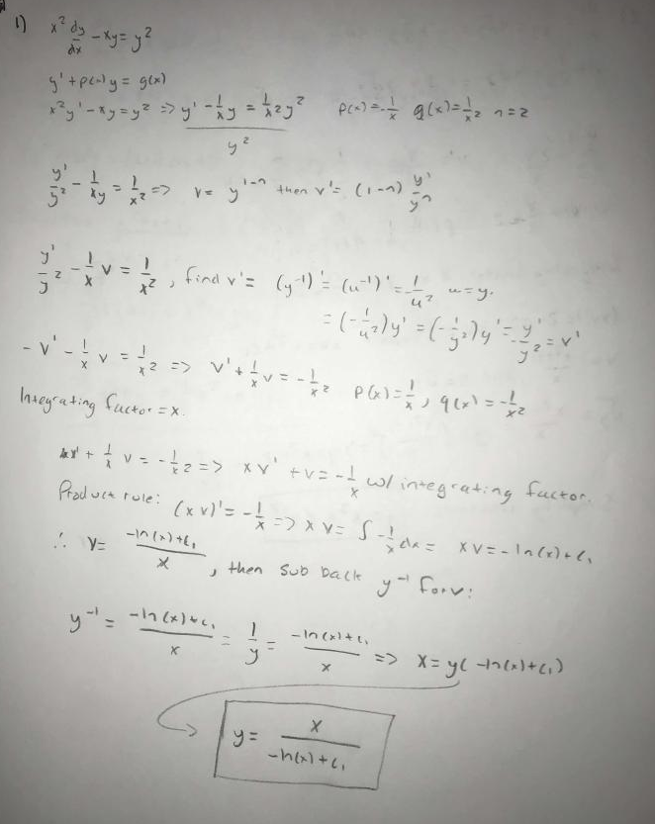

**Number 2**

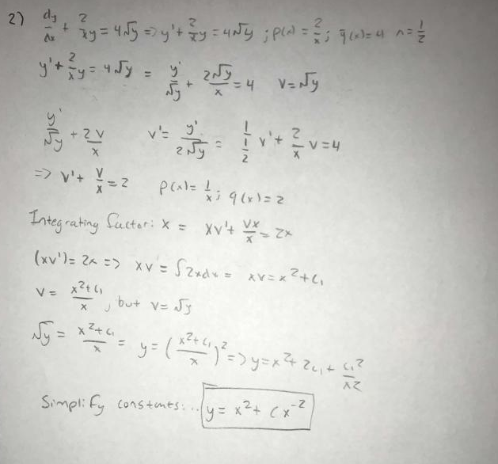

**Number 3**

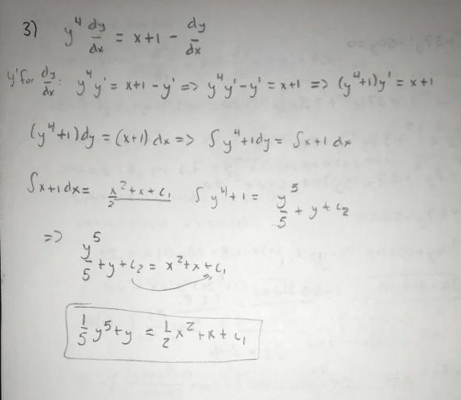

**Number 4**

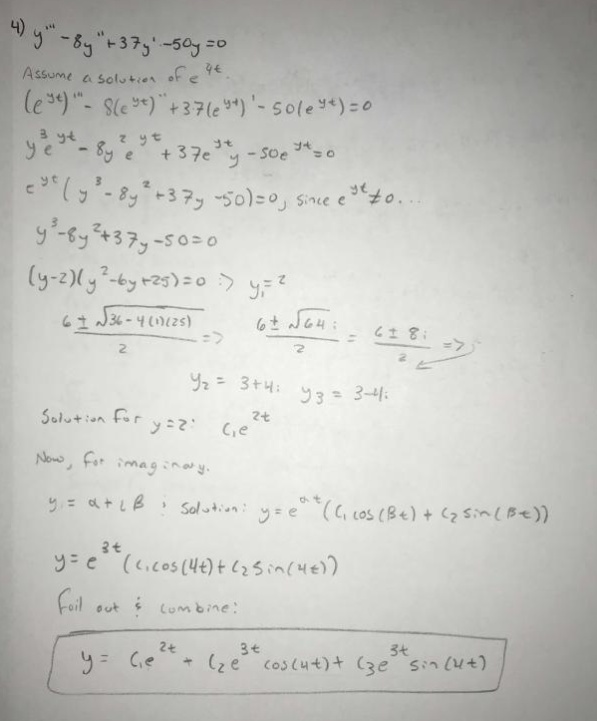

**Number 5**

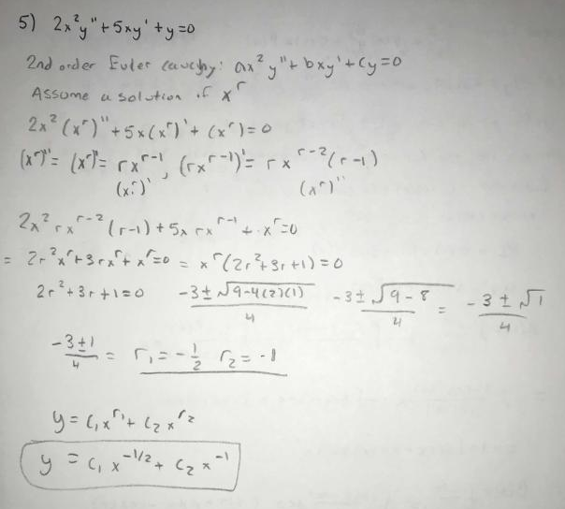

**Number 6**

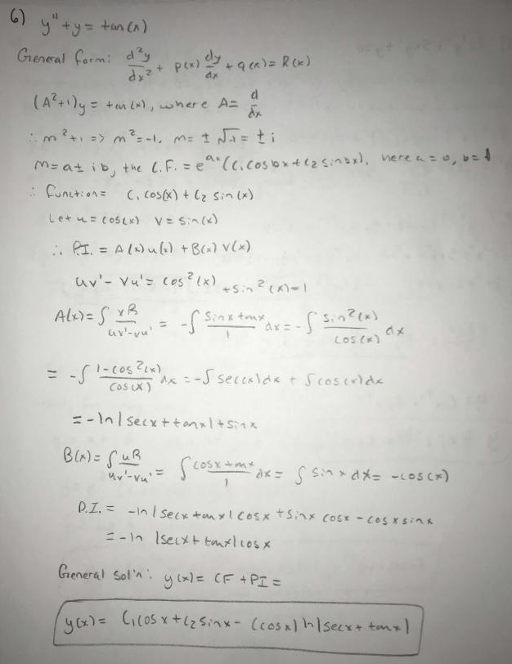

**Number 7**

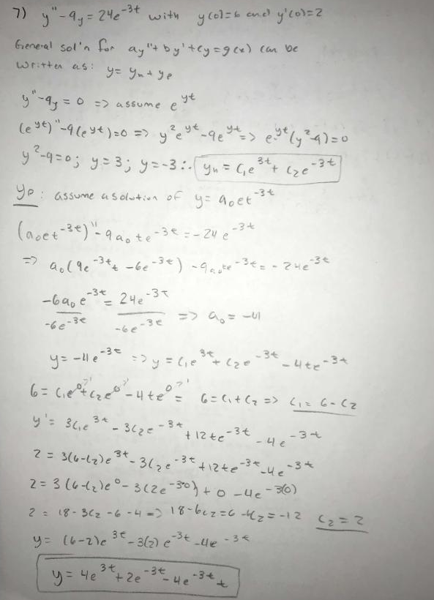

**Number 8**

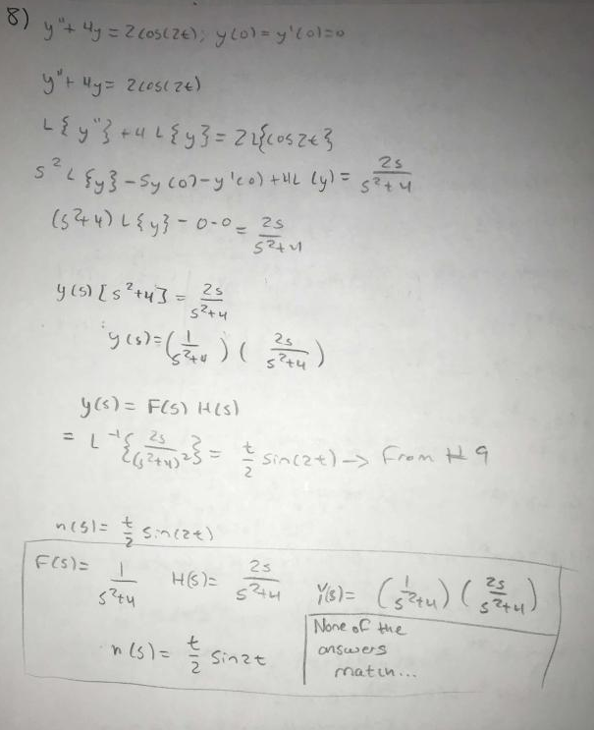

**Number 9**

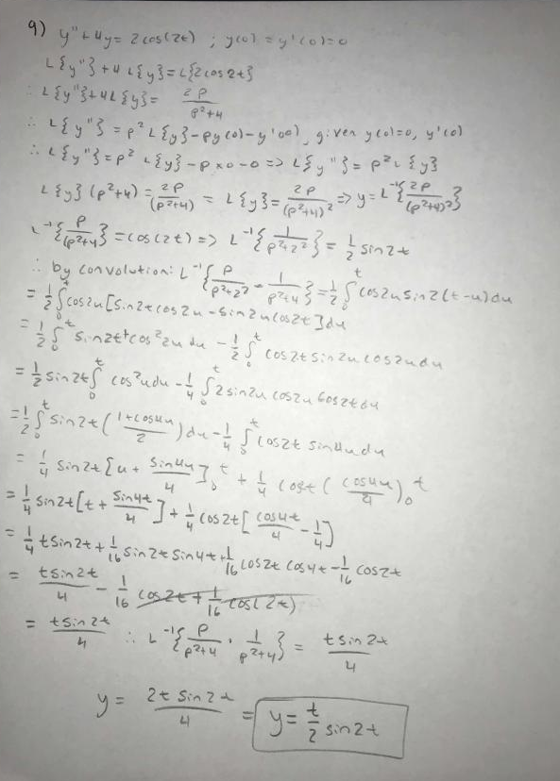

**Number 10**

