Summary
Walk from Sunset Ridge Dr, Bellingen to Adams sawmill, Bonville via Gleniffer and Promised L ands. The total length is 37 km over the three days.
Day 1 :Walk south on Sunset Ridge Dr towards Gleniffer Rd, Turn right onto Gleniffer Rd, Turn right to stay on Gleniffer Rd, Turn right onto Holmes Rd, Turn left onto Cpt 75/3 Trail, Turn right onto Timboon Rd to camp the night in state frost ABOUT 9.7 KM
Day 2:Walk south-west on Timboon Rd towards Little Hydes Creek Rd, Turn right onto Promised Land Rd, Turn right to stay on Promised Land Rd, Walk south-west on Promised Land Rd, Turn left onto Timboon Rd them up to camp ABOUT 16KM
Day 3:Walk west on Gleniffer Rd towards Gordons Rd, Continue straight onto Valery Rd, Continue onto Timboon Rd to we get to Adams sawmill, Bonville .ABOUT 12 KM
The camp is about 2 km from the hall along Timboon rd.

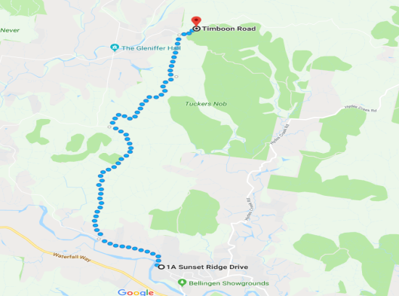DAY 1
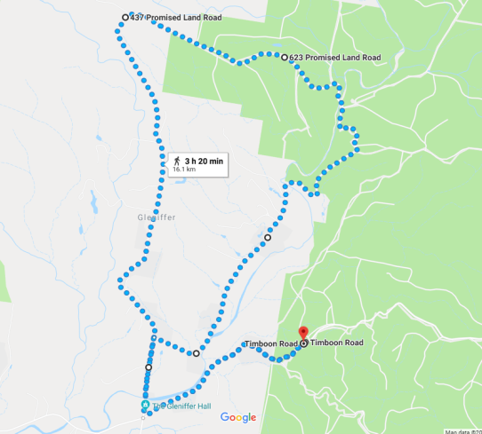DAY 2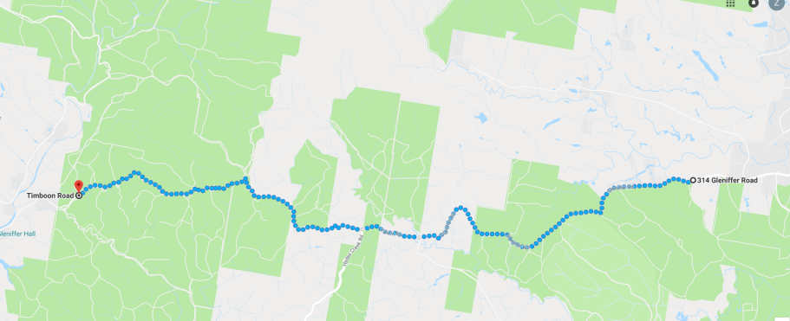DAY 3

Route Plan

Day 1
Walk south on Sunset Ridge Dr towards Gleniffer Rd
14 m
Turn right onto Gleniffer Rd
1.7 km
Turn right to stay on Gleniffer Rd
3.8 km
Turn right onto Holmes Rdreet View
2.4 km
Turn left onto Cpt 75/3 Trail
1.3 km
Turn right onto Timboon Rd

Day 2
Walk south-west on Timboon Rd towards Little Hydes Creek Rd
2.0 km
Turn right onto Promised Land Rd
800 m
Turn right to stay on Promised Land Rd
5.1 km
Walk south-west on Promised Land Rd
4.5 km
Turn left onto Timboon Rd
2.0 km
Day 3
Walk west on Gleniffer Rd towards Gordons Rd
5.6 km
Continue straight onto Valery Rd
1.0 km
Continue onto Timboon Rd

Day one

(Walk south on Sunset Ridge Dr towards Gleniffer Rd, Turn right onto Gleniffer Rd, Turn right to stay on Gleniffer Rd, Turn right onto Holmes Rd, Turn left onto Cpt 75/3 Trail, Turn right onto Timboon Rd to camp the night in state frost ABOUT 9.7 KM)
We started walking at about one a clock and got to never never creek at about 4,30 to have a swim we got to the camp site around 7 o’clock.
Day two
(Walk south-west on Timboon Rd towards Little Hydes Creek Rd, Turn right onto Promised Land Rd, Turn right to stay on Promised Land Rd, Walk south-west on Promised Land Rd, Turn left onto Timboon Rd them up to camp ABOUT 16KM)
We left the camp site at about 9.30.. We made it to never never creek at around 4.30, and picked up water from Leader. Them went for a swim. We got to the camp site by 7 o clock.

Day three
(Walk west on Gleniffer Rd towards Gordons Rd, Continue straight onto Valery Rd, Continue onto Timboon Rd to we get to Adams sawmill, Bonville .ABOUT 12 KM)
We left by 7.30 so we were not in the heat as much. We arriaved at Adams sawmill at 11.30.

