beddit – a betting game for reddit

Scott Walters (srwalte2)

1. **Abstract**
   * **Document Purpose**This document describes the requirements of of bettit, a game designed for live discussion threads on reddit.
   * **Definitions**
     + **Bookie**Describes any person who either was the original poster of the given thread, or a moderator of the subreddit which the given thread was posted in.
     + **User**Anybody who visits a game page. This includes bookies.
     + **Money**A virtual currency, tied to a user’s reddit account. This currency has no real value.
     + **Pot**A property of an event: The sum of all of the bets placed on an event.
   * **Background/Motivation**This application was inspired by my participation in a variety of live discussion threads on reddit, as well as the web app Spelunky Death Roulette.  
     This game will provide a fun way for users to pass the time while watching their favorite show or event, as well as provide a bonding experience to the communities of reddit.
2. **Technical Specifications**
   * **Platform**Web-based
   * **Programming Languages**Node.js, Passport.js, CSS, HTML, SQL.
   * **Coding Standard**Google Javascript Style Guide  
     <http://google-styleguide.googlecode.com/svn/trunk/javascriptguide.xml>
   * **SDK**Node.js stack. Reddit API.
   * **IDE**Eclipse
   * **Interface**Google Chrome for previewing code and displaying web interface
   * **Other Technical Details**Will host a Node.js server with a SQL database. Hosted on either AWS or DigitalCloud.
3. **Function Specifications**
   * **Affordances**
     + Users will be able to sign into bettit with their Reddit account
     + Bookies will be able to enable bettit for their thread.
     + Bookies will be able to open events with any number of outcomes
     + Users will be able to open a thread in bettit and see open and closed events
       1. Users will be able to see the pot for any event, as well as how much money has been placed on each outcome
     + Users will be have a balance of money and be able to see it
       1. A user, upon first log in, will have a positive amount of money placed into their balance.
       2. A user, upon reaching zero/negative balance, will have their balance refilled to the initial balance.
     + Users will be able to place bets on any open event.
       1. Bets will be of a static, positive amount
       2. A User will be able to bet on one outcome per event
     + Bookies will be able to lock events so that no further bets can be made
     + Bookies will be able to close events by selecting the result of the event.
     + Users will receive money based on a closed event based on the size of pot, the outcome the user bet on, and the number of users that bet on the same outcome.
   * **Features**
     + SQL Database will hold all user information, including balances.
     + Use jQuery and Node.js posting so all users have up-to-date information on their balance, new open events, the result of closed events, and other important information.
     + All Users will authenticate their accounts through the reddit API.
   * **Out of Scope**
   * **Mockup**

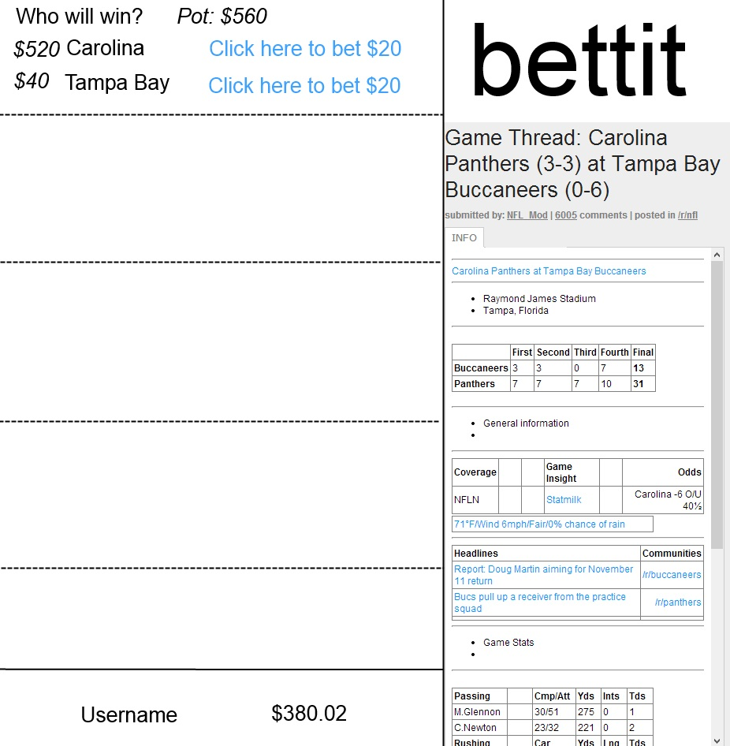

1. **Timeline**
   * **Week 1**
     + Setup server with Node.js and MySQL
     + Write web page template with HTML and CSS, served with Node.js
     + Allow users to sign in through reddit
     + Establish a Database linking users to their balances
   * **Week 2**
     + Recognize Bookies
     + Allow Bookies to create, lock, and close events
   * **Week 3**
     + Allow users to bet on events
     + Allow users to see the created/locked/closed events asynchronously
   * **Week 4**
     + Have users receive the proper payoff one an event has closed
     + Have all information for a given thread update asynchronously
2. **Future Enhancements**
   * Global high scores