Covid new cases trend esimates for some EU countres

## Germany

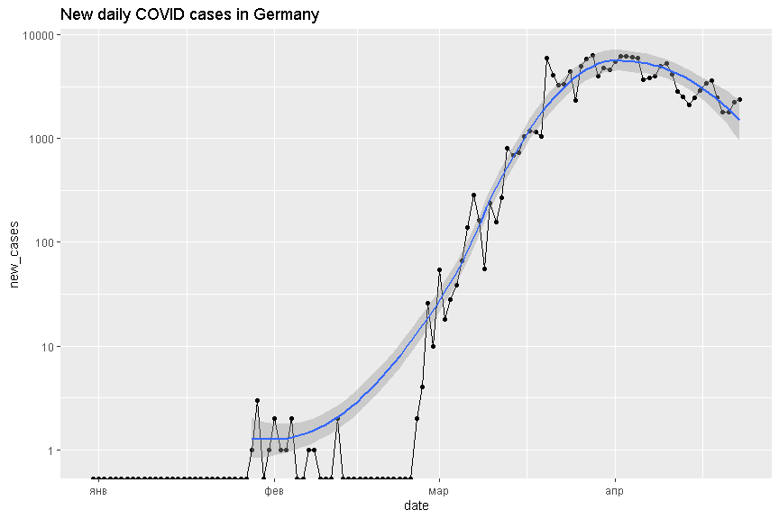

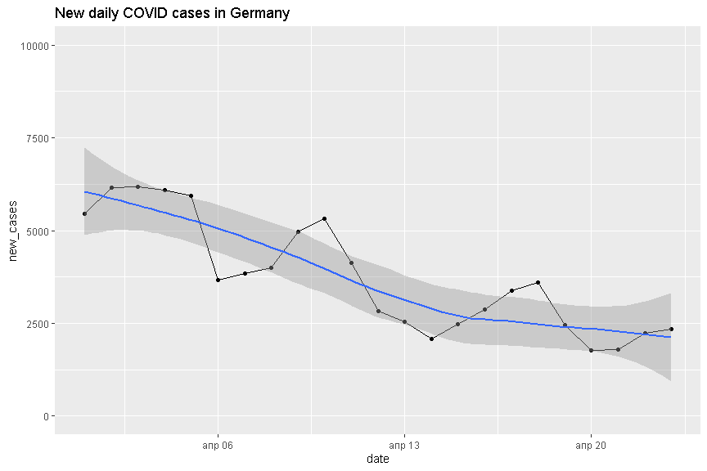

##   
## Call:  
## lm(formula = new_cases ~ I(date - as.Date("2020/04/01")), data = owid_covid_data[location ==   
## "Germany" & date >= as.Date("2020/04/01")])  
##   
## Residuals:  
## Min 1Q Median 3Q Max   
## -1278.78 -596.45 57.56 676.68 1193.95   
##   
## Coefficients:  
## Estimate Std. Error t value Pr(>|t|)   
## (Intercept) 5857.65 317.35 18.458 1.85e-14 ***  
## I(date - as.Date("2020/04/01")) -192.07 24.71 -7.774 1.30e-07 ***  
## ---  
## Signif. codes: 0 '***' 0.001 '**' 0.01 '*' 0.05 '.' 0.1 ' ' 1  
##   
## Residual standard error: 785.9 on 21 degrees of freedom  
## Multiple R-squared: 0.7421, Adjusted R-squared: 0.7299   
## F-statistic: 60.44 on 1 and 21 DF, p-value: 1.299e-07

## [1] "Days left: -8.49793180087667"

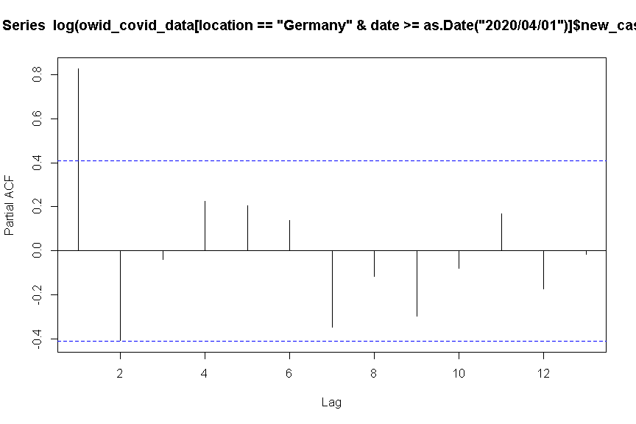

## Spain

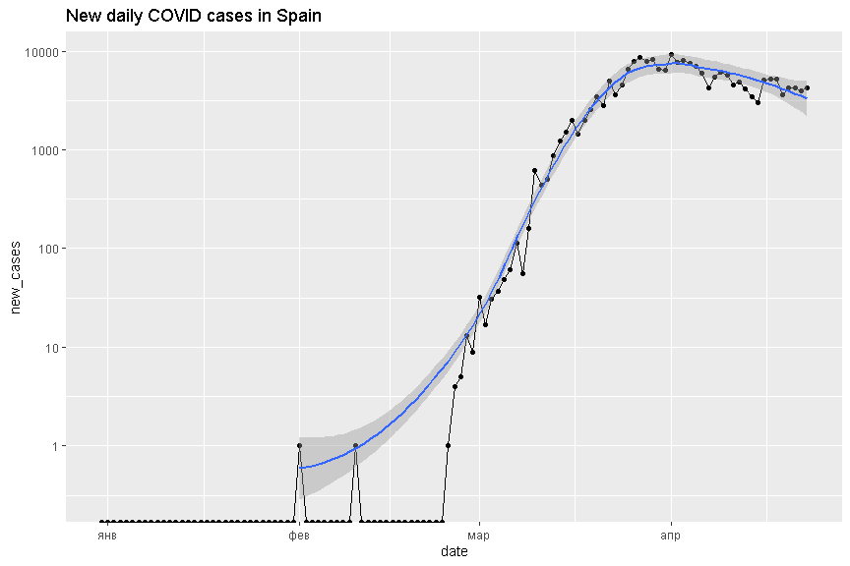

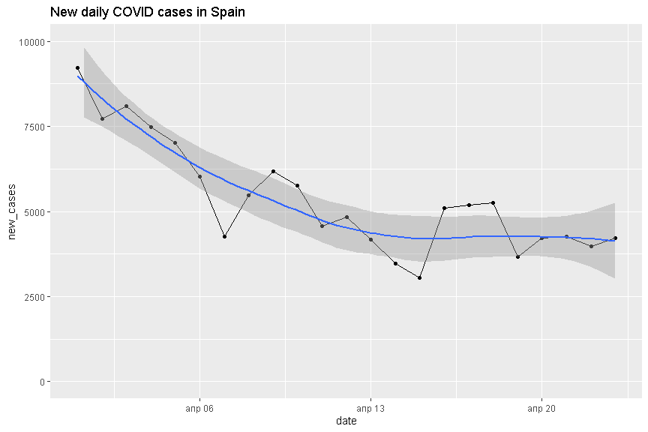

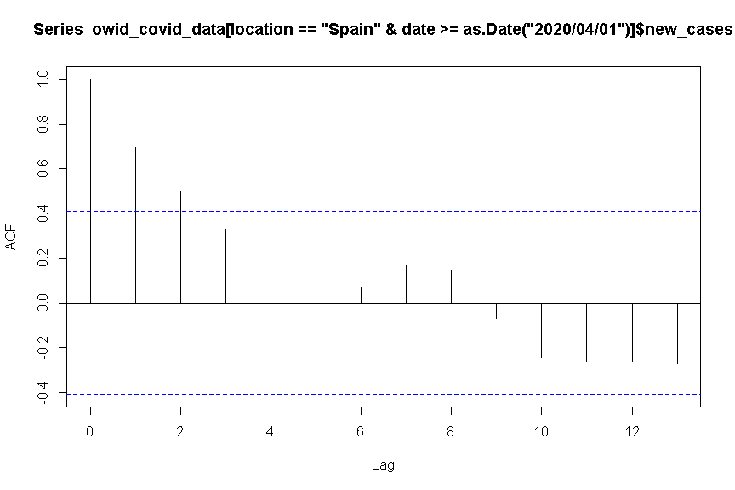

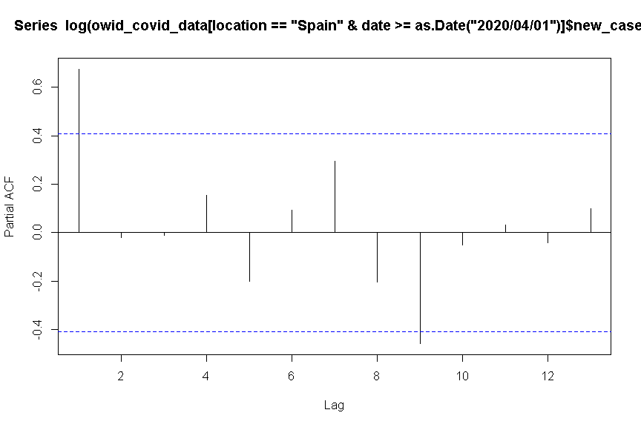

##   
## Call:  
## lm(formula = new_cases ~ I(date - as.Date("2020/04/01")), data = owid_covid_data[location ==   
## "Spain" & date >= as.Date("2020/04/01")])  
##   
## Residuals:  
## Min 1Q Median 3Q Max   
## -2035.6 -583.2 336.4 608.0 1770.6   
##   
## Coefficients:  
## Estimate Std. Error t value Pr(>|t|)   
## (Intercept) 7451.42 403.58 18.463 1.84e-14 ***  
## I(date - as.Date("2020/04/01")) -190.47 31.42 -6.062 5.13e-06 ***  
## ---  
## Signif. codes: 0 '***' 0.001 '**' 0.01 '*' 0.05 '.' 0.1 ' ' 1  
##   
## Residual standard error: 999.5 on 21 degrees of freedom  
## Multiple R-squared: 0.6364, Adjusted R-squared: 0.6191   
## F-statistic: 36.75 on 1 and 21 DF, p-value: 5.135e-06

## [1] "Days left: 17.1213768773832"

# Italy

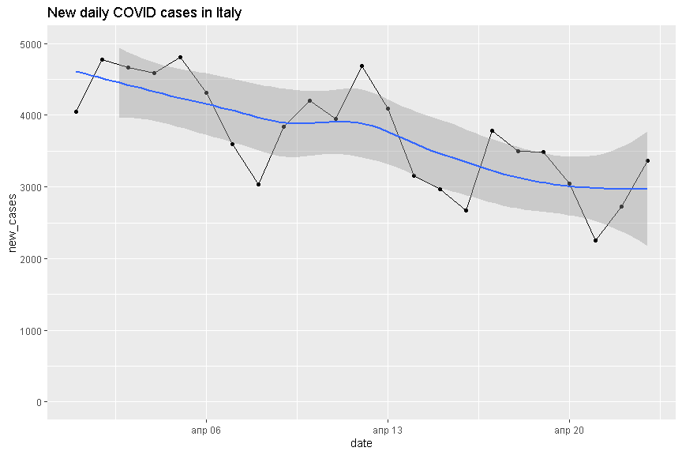

##   
## Call:  
## lm(formula = new_cases ~ I(date - as.Date("2020/04/01")), data = owid_covid_data[location ==   
## "Italy" & date >= as.Date("2020/04/01")])  
##   
## Residuals:  
## Min 1Q Median 3Q Max   
## -1003.5 -457.9 149.4 327.1 972.8   
##   
## Coefficients:  
## Estimate Std. Error t value Pr(>|t|)   
## (Intercept) 4604.88 207.63 22.18 4.70e-16 ***  
## I(date - as.Date("2020/04/01")) -80.33 16.16 -4.97 6.44e-05 ***  
## ---  
## Signif. codes: 0 '***' 0.001 '**' 0.01 '*' 0.05 '.' 0.1 ' ' 1  
##   
## Residual standard error: 514.2 on 21 degrees of freedom  
## Multiple R-squared: 0.5405, Adjusted R-squared: 0.5186   
## F-statistic: 24.7 on 1 and 21 DF, p-value: 6.437e-05

## [1] "Days left: 35.3223981204719"

# Sweden

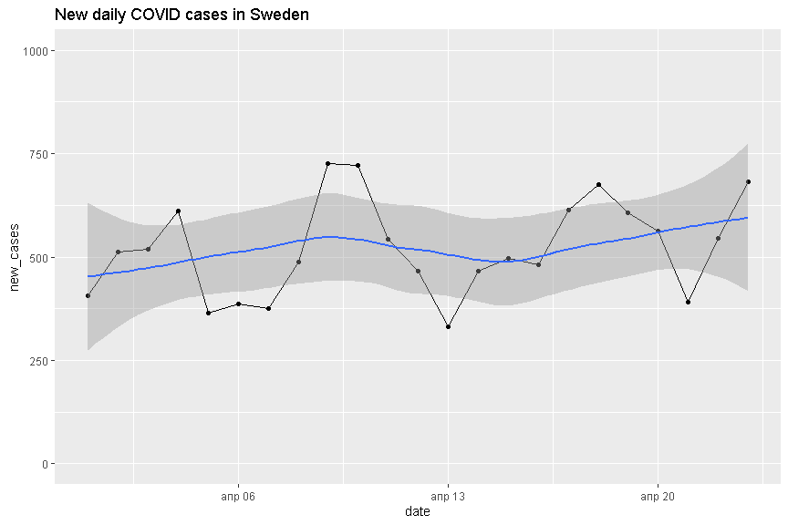

##   
## Call:  
## lm(formula = new_cases ~ I(date - as.Date("2020/04/01")), data = owid_covid_data[location ==   
## "Sweden" & date >= as.Date("2020/04/01")])  
##   
## Residuals:  
## Min 1Q Median 3Q Max   
## -193.63 -62.49 -13.96 59.20 220.11   
##   
## Coefficients:  
## Estimate Std. Error t value Pr(>|t|)   
## (Intercept) 466.424 46.018 10.136 1.53e-09 ***  
## I(date - as.Date("2020/04/01")) 4.934 3.582 1.377 0.183   
## ---  
## Signif. codes: 0 '***' 0.001 '**' 0.01 '*' 0.05 '.' 0.1 ' ' 1  
##   
## Residual standard error: 114 on 21 degrees of freedom  
## Multiple R-squared: 0.08284, Adjusted R-squared: 0.03916   
## F-statistic: 1.897 on 1 and 21 DF, p-value: 0.183

## [1] "Days left: -116.53655117164"