COVID in Мoscow

## [1] "CovidMoscowDB was NOT updated"

## Общий тренд

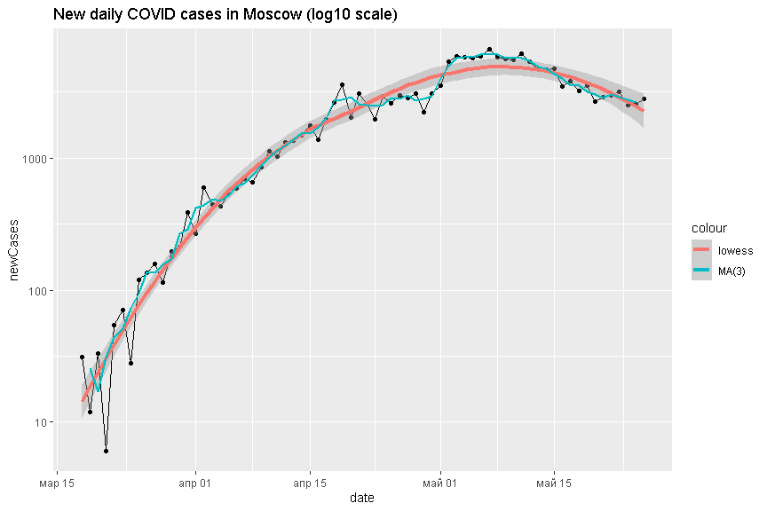

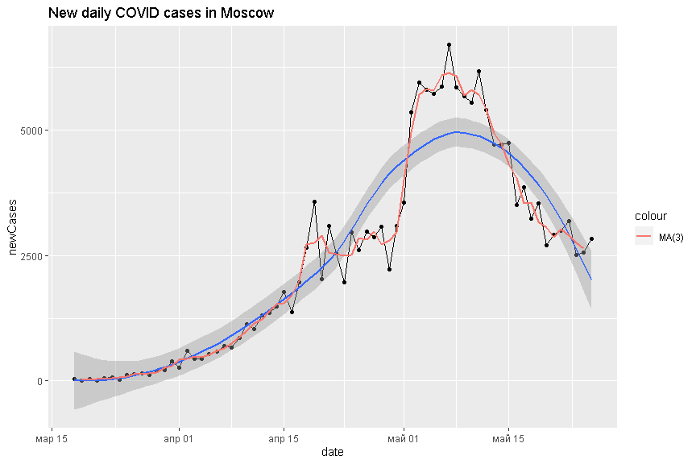

## One line

##   
## Call:  
## lm(formula = log(newCases) ~ days_from_beg, data = CovidMoscow)  
##   
## Residuals:  
## Min 1Q Median 3Q Max   
## -3.0490 -0.5902 0.3801 0.6521 1.3083   
##   
## Coefficients:  
## Estimate Std. Error t value Pr(>|t|)   
## (Intercept) 4.630685 0.211397 21.91 <2e-16 ***  
## days_from_beg 0.070042 0.005287 13.25 <2e-16 ***  
## ---  
## Signif. codes: 0 '***' 0.001 '**' 0.01 '*' 0.05 '.' 0.1 ' ' 1  
##   
## Residual standard error: 0.8938 on 68 degrees of freedom  
## Multiple R-squared: 0.7207, Adjusted R-squared: 0.7166   
## F-statistic: 175.5 on 1 and 68 DF, p-value: < 2.2e-16

## Segmented

##   
## -------------- N. Breaking points = 1 =-------------  
##   
## ***Regression Model with Segmented Relationship(s)***  
##   
## Call:   
## segmented.lm(obj = lm_msk0, psi = start_psi[1:npt])  
##   
## Estimated Break-Point(s):  
## Est. St.Err  
## psi1.days_from_beg 30.541 1.344  
##   
## Meaningful coefficients of the linear terms:  
## Estimate Std. Error t value Pr(>|t|)   
## (Intercept) 3.175955 0.152715 20.80 <2e-16 ***  
## days_from_beg 0.161241 0.008744 18.44 <2e-16 ***  
## U1.days_from_beg -0.156035 0.010717 -14.56 NA   
## ---  
## Signif. codes: 0 '***' 0.001 '**' 0.01 '*' 0.05 '.' 0.1 ' ' 1  
##   
## Residual standard error: 0.4355 on 66 degrees of freedom  
## Multiple R-Squared: 0.9357, Adjusted R-squared: 0.9327   
##   
## Convergence attained in 2 iter. (rel. change 0)  
##   
## -------------- N. Breaking points = 2 =-------------  
##   
## ***Regression Model with Segmented Relationship(s)***  
##   
## Call:   
## segmented.lm(obj = lm_msk0, psi = start_psi[1:npt])  
##   
## Estimated Break-Point(s):  
## Est. St.Err  
## psi1.days_from_beg 15.408 1.237  
## psi2.days_from_beg 49.567 1.489  
##   
## Meaningful coefficients of the linear terms:  
## Estimate Std. Error t value Pr(>|t|)   
## (Intercept) 2.65796 0.15898 16.719 <2e-16 ***  
## days_from_beg 0.23609 0.01806 13.073 <2e-16 ***  
## U1.days_from_beg -0.16261 0.01897 -8.570 NA   
## U2.days_from_beg -0.12586 0.01416 -8.886 NA   
## ---  
## Signif. codes: 0 '***' 0.001 '**' 0.01 '*' 0.05 '.' 0.1 ' ' 1  
##   
## Residual standard error: 0.333 on 64 degrees of freedom  
## Multiple R-Squared: 0.9635, Adjusted R-squared: 0.9607   
##   
## Convergence attained in 2 iter. (rel. change 0)  
##   
## -------------- N. Breaking points = 3 =-------------  
##   
## ***Regression Model with Segmented Relationship(s)***  
##   
## Call:   
## segmented.lm(obj = lm_msk0, psi = start_psi[1:npt])  
##   
## Estimated Break-Point(s):  
## Est. St.Err  
## psi1.days_from_beg 13.000 1.895  
## psi2.days_from_beg 28.027 3.737  
## psi3.days_from_beg 51.162 1.894  
##   
## Meaningful coefficients of the linear terms:  
## Estimate Std. Error t value Pr(>|t|)   
## (Intercept) 2.64530 0.16422 16.108 <2e-16 ***  
## days_from_beg 0.23926 0.02147 11.143 <2e-16 ***  
## U1.days_from_beg -0.12701 0.02891 -4.394 NA   
## U2.days_from_beg -0.05670 0.02187 -2.593 NA   
## U3.days_from_beg -0.10844 0.01789 -6.061 NA   
## ---  
## Signif. codes: 0 '***' 0.001 '**' 0.01 '*' 0.05 '.' 0.1 ' ' 1  
##   
## Residual standard error: 0.3239 on 62 degrees of freedom  
## Multiple R-Squared: 0.9666, Adjusted R-squared: 0.9628   
##   
## Convergence attained in 9 iter. (rel. change 1.123e-06)  
##   
## -------------- N. Breaking points = 4 =-------------  
##   
## ***Regression Model with Segmented Relationship(s)***  
##   
## Call:   
## segmented.lm(obj = lm_msk0, psi = start_psi[1:npt])  
##   
## Estimated Break-Point(s):  
## Est. St.Err  
## psi1.days_from_beg 12.998 1.803  
## psi2.days_from_beg 32.001 2.137  
## psi3.days_from_beg 42.452 1.625  
## psi4.days_from_beg 46.547 1.257  
##   
## Meaningful coefficients of the linear terms:  
## Estimate Std. Error t value Pr(>|t|)   
## (Intercept) 2.64465 0.16486 16.042 < 2e-16 ***  
## days_from_beg 0.23942 0.02331 10.269 7.74e-15 ***  
## U1.days_from_beg -0.12832 0.02678 -4.792 NA   
## U2.days_from_beg -0.10876 0.03276 -3.320 NA   
## U3.days_from_beg 0.23312 0.14382 1.621 NA   
## U4.days_from_beg -0.28109 0.14101 -1.993 NA   
## ---  
## Signif. codes: 0 '***' 0.001 '**' 0.01 '*' 0.05 '.' 0.1 ' ' 1  
##   
## Residual standard error: 0.3145 on 60 degrees of freedom  
## Multiple R-Squared: 0.9695, Adjusted R-squared: 0.9649   
##   
## Convergence attained in 10 iter. (rel. change 2.3597e-06)  
## breakpoint estimate(s): 0.7586737 14.63432 21.01552 23.26827 50.6566   
##   
## -------------- N. Breaking points = 5 =-------------  
##   
## ***Regression Model with Segmented Relationship(s)***  
##   
## Call:   
## segmented.lm(obj = lm_msk0, psi = start_psi[1:npt])  
##   
## Estimated Break-Point(s):  
## Est. St.Err  
## psi1.days_from_beg 13.002 1.749  
## psi2.days_from_beg 31.999 2.190  
## psi3.days_from_beg 42.623 1.537  
## psi4.days_from_beg 45.573 1.723  
## psi5.days_from_beg 52.172 5.133  
##   
## Meaningful coefficients of the linear terms:  
## Estimate Std. Error t value Pr(>|t|)   
## (Intercept) 2.64474 0.16108 16.419 <2e-16 ***  
## days_from_beg 0.23940 0.02106 11.367 <2e-16 ***  
## U1.days_from_beg -0.12832 0.02553 -5.026 NA   
## U2.days_from_beg -0.10853 0.03355 -3.235 NA   
## U3.days_from_beg 0.26638 0.22665 1.175 NA   
## U4.days_from_beg -0.26918 0.23250 -1.158 NA   
## U5.days_from_beg -0.05367 0.06206 -0.865 NA   
## ---  
## Signif. codes: 0 '***' 0.001 '**' 0.01 '*' 0.05 '.' 0.1 ' ' 1  
##   
## Residual standard error: 0.3177 on 58 degrees of freedom  
## Multiple R-Squared: 0.9699, Adjusted R-squared: 0.9642   
##   
## Convergence attained in 16 iter. (rel. change 7.5517e-06)  
##   
## -------------- N. Breaking points = 6 =-------------  
##   
## ***Regression Model with Segmented Relationship(s)***  
##   
## Call:   
## segmented.lm(obj = lm_msk0, psi = start_psi[1:npt])  
##   
## Estimated Break-Point(s):  
## Est. St.Err  
## psi1.days_from_beg 13.057 1.740  
## psi2.days_from_beg 31.982 2.434  
## psi3.days_from_beg 43.416 1.432  
## psi4.days_from_beg 45.261 1.143  
## psi5.days_from_beg 54.008 4.330  
## psi6.days_from_beg 62.967 5.442  
##   
## Meaningful coefficients of the linear terms:  
## Estimate Std. Error t value Pr(>|t|)   
## (Intercept) 2.64559 0.16296 16.235 < 2e-16 ***  
## days_from_beg 0.23920 0.02131 11.227 5.84e-16 ***  
## U1.days_from_beg -0.12882 0.02520 -5.111 NA   
## U2.days_from_beg -0.10344 0.03348 -3.090 NA   
## U3.days_from_beg 0.40214 0.45550 0.883 NA   
## U4.days_from_beg -0.41145 0.45636 -0.902 NA   
## U5.days_from_beg -0.07363 0.06465 -1.139 NA   
## U6.days_from_beg 0.06113 0.07840 0.780 NA   
## ---  
## Signif. codes: 0 '***' 0.001 '**' 0.01 '*' 0.05 '.' 0.1 ' ' 1  
##   
## Residual standard error: 0.3214 on 56 degrees of freedom  
## Multiple R-Squared: 0.9703, Adjusted R-squared: 0.9634   
##   
## Convergence attained in 8 iter. (rel. change 4.7555e-06)

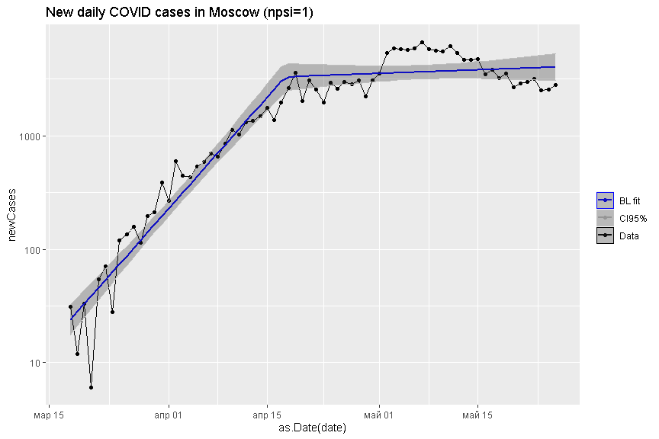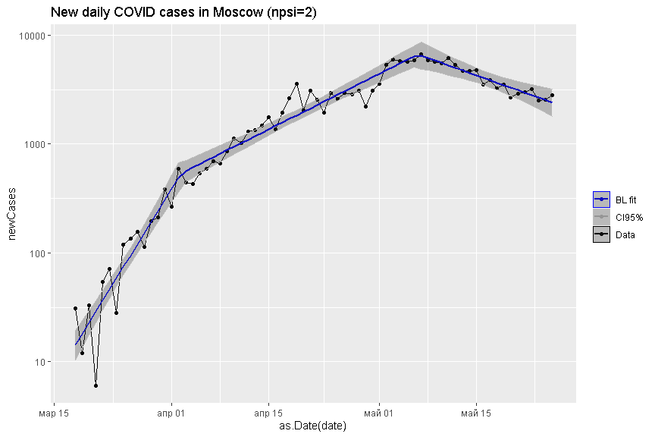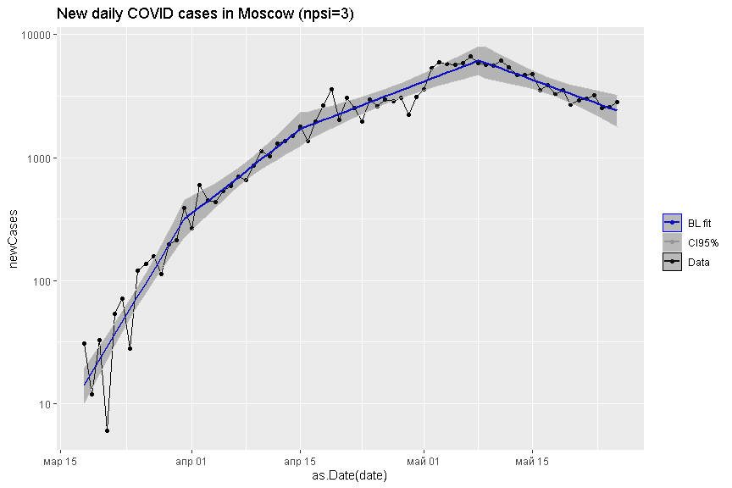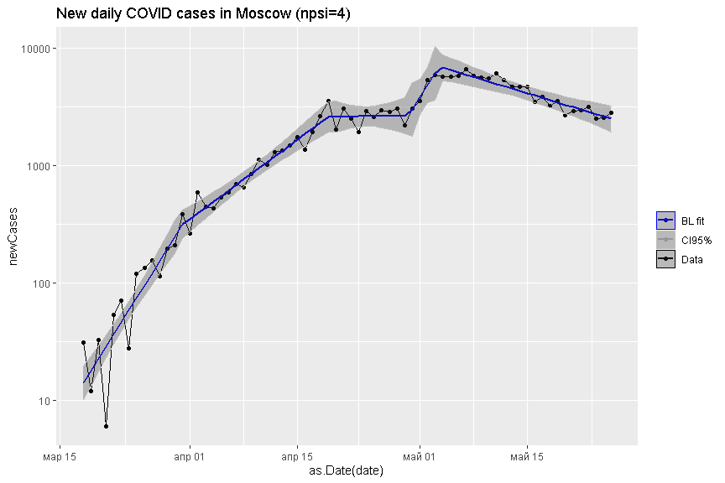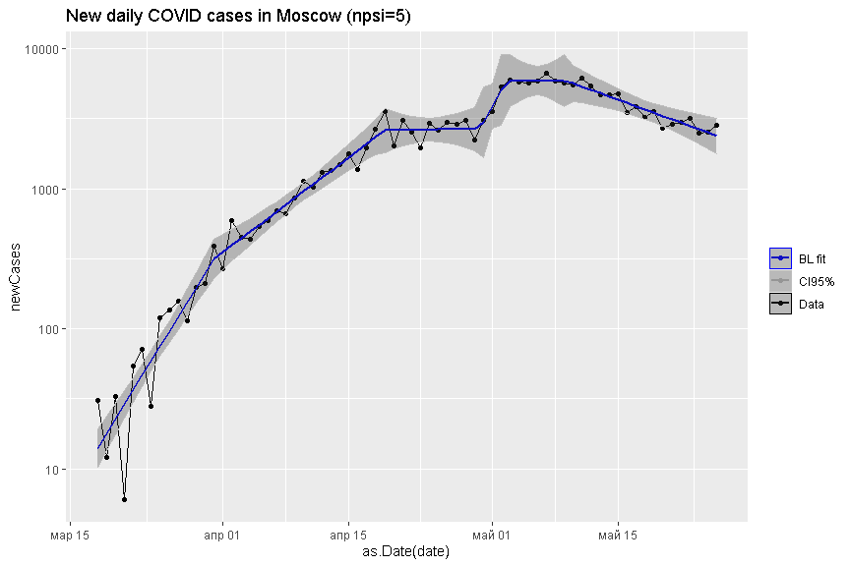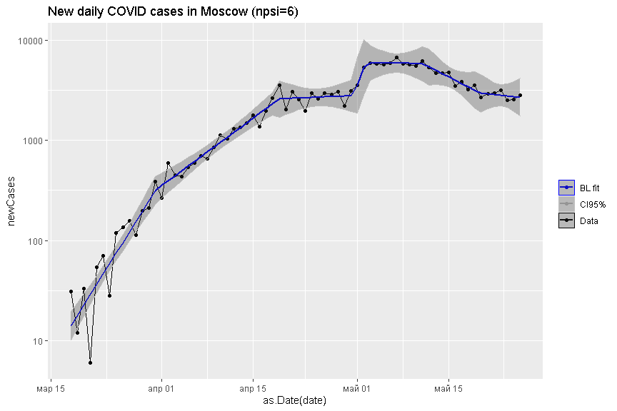

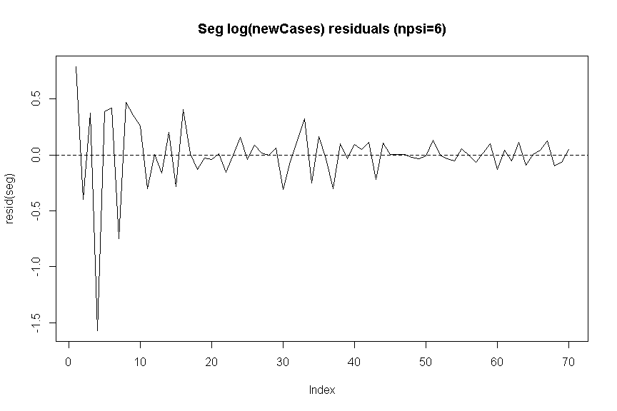

##   
## -------------- N. Breaking points = 1 =-------------  
## Slopes  
## $days_from_beg  
## Est. St.Err. t value CI(95%).l CI(95%).u  
## slope1 0.1612400 0.0087444 18.43900 0.1437800 0.178700  
## slope2 0.0052063 0.0061957 0.84031 -0.0071639 0.017577  
##   
## Doubling of cases:  
## slope1 slope2   
## 4.298854 133.136235   
##   
## -------------- N. Breaking points = 2 =-------------  
## Slopes  
## $days_from_beg  
## Est. St.Err. t value CI(95%).l CI(95%).u  
## slope1 0.236090 0.018059 13.0730 0.200010 0.272160  
## slope2 0.073471 0.005821 12.6220 0.061842 0.085100  
## slope3 -0.052392 0.012913 -4.0573 -0.078189 -0.026595  
##   
## Doubling of cases:  
## slope1 slope2 slope3   
## 2.935945 9.434296 -13.230019   
##   
## -------------- N. Breaking points = 3 =-------------  
## Slopes  
## $days_from_beg  
## Est. St.Err. t value CI(95%).l CI(95%).u  
## slope1 0.239260 0.021471 11.1430 0.196340 0.282180  
## slope2 0.112250 0.019354 5.8000 0.073565 0.150940  
## slope3 0.055555 0.010180 5.4572 0.035205 0.075905  
## slope4 -0.052883 0.014713 -3.5943 -0.082294 -0.023472  
##   
## Doubling of cases:  
## slope1 slope2 slope3 slope4   
## 2.897046 6.175031 12.476774 -13.107183   
##   
## -------------- N. Breaking points = 4 =-------------  
## Slopes  
## $days_from_beg  
## Est. St.Err. t value CI(95%).l CI(95%).u  
## slope1 0.2394200 0.023314 10.269000 0.192790 0.286060  
## slope2 0.1111100 0.013174 8.433800 0.084755 0.137460  
## slope3 0.0023437 0.029990 0.078149 -0.057646 0.062334  
## slope4 0.2354600 0.140660 1.674000 -0.045898 0.516820  
## slope5 -0.0456280 0.009887 -4.615000 -0.065405 -0.025852  
##   
## Doubling of cases:  
## slope1 slope2 slope3 slope4 slope5   
## 2.895110 6.238387 295.749106 2.943800 -15.191268   
##   
## -------------- N. Breaking points = 5 =-------------  
## Slopes  
## $days_from_beg  
## Est. St.Err. t value CI(95%).l CI(95%).u  
## slope1 0.23940000 0.021060 11.367000 0.197240 0.281560  
## slope2 0.11108000 0.014431 7.697100 0.082193 0.139970  
## slope3 0.00254760 0.030287 0.084116 -0.058079 0.063174  
## slope4 0.26893000 0.224620 1.197300 -0.180690 0.718540  
## slope5 -0.00025033 0.060031 -0.004170 -0.120420 0.119910  
## slope6 -0.05392100 0.015726 -3.428700 -0.085400 -0.022441  
##   
## Doubling of cases:  
## slope1 slope2 slope3 slope4 slope5 slope6   
## 2.895352 6.240072 272.078498 2.577426 -2768.933730 -12.854865   
##   
## -------------- N. Breaking points = 6 =-------------  
## Slopes  
## $days_from_beg  
## Est. St.Err. t value CI(95%).l CI(95%).u  
## slope1 0.2392000 0.021306 11.227000 0.196520 0.281880  
## slope2 0.1103800 0.013464 8.198100 0.083408 0.137350  
## slope3 0.0069353 0.030640 0.226350 -0.054444 0.068315  
## slope4 0.4090800 0.454470 0.900130 -0.501330 1.319500  
## slope5 -0.0023684 0.041487 -0.057087 -0.085477 0.080740  
## slope6 -0.0759950 0.049586 -1.532600 -0.175330 0.023338  
## slope7 -0.0148690 0.060731 -0.244840 -0.136530 0.106790  
##   
## Doubling of cases:  
## slope1 slope2 slope3 slope4 slope5 slope6 slope7   
## 2.897772 6.279645 99.944801 1.694405 -292.664744 -9.120958 -46.616933

## Struct change

##   
## Optimal 4-segment partition:   
##   
## Call:  
## breakpoints.formula(formula = log(newCases) ~ days_from_beg,   
## h = 7/CovidMoscow[, .N], data = CovidMoscow)  
##   
## Breakpoints at observation number:  
## 7 33 45   
##   
## Corresponding to breakdates:  
## 0.1 0.4714286 0.6428571

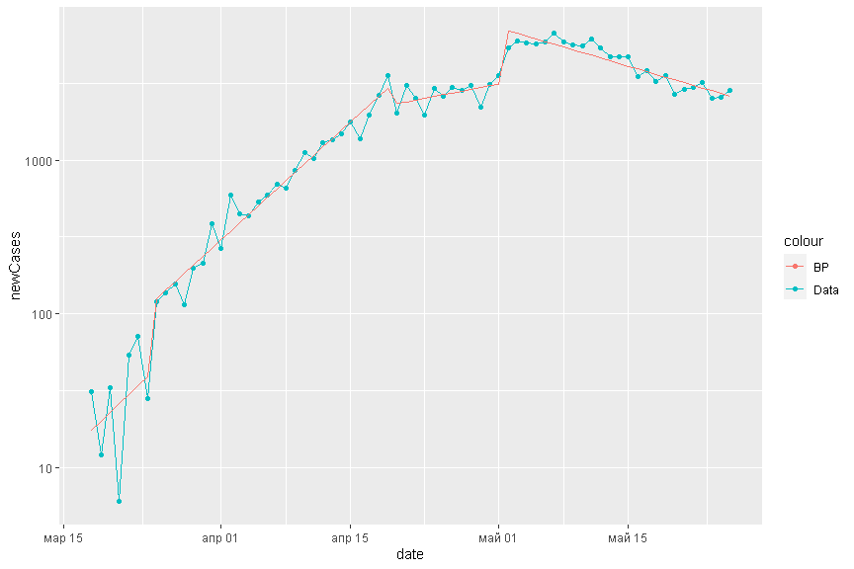

# Дифференциалы

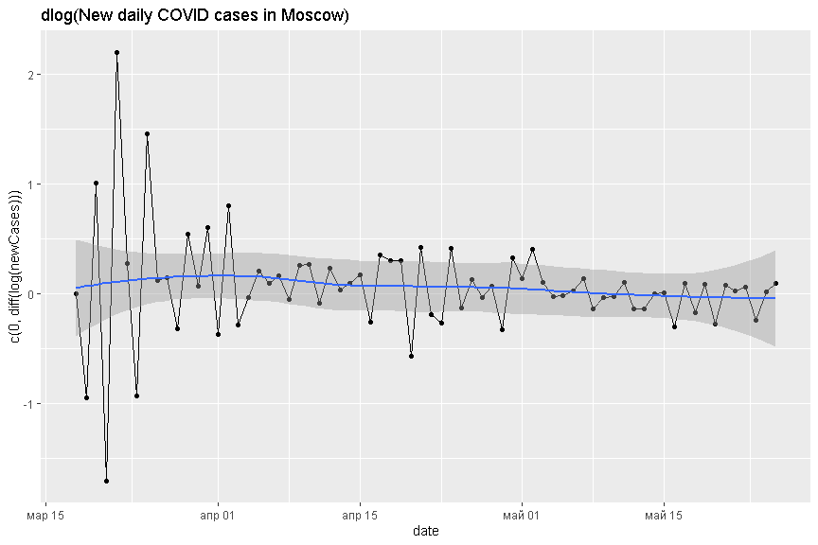

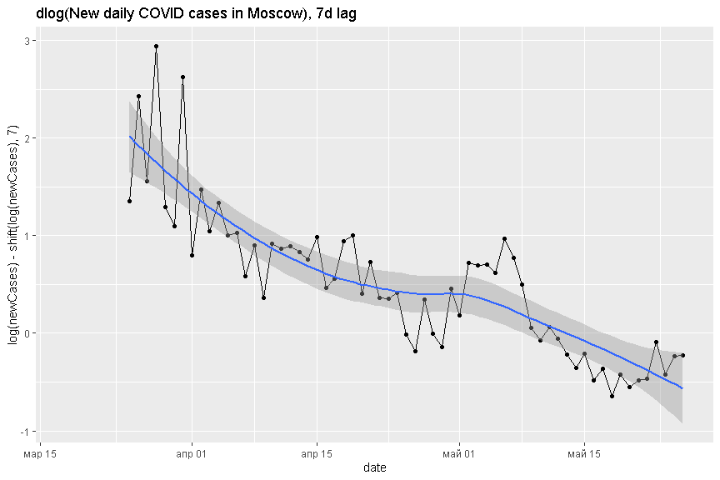

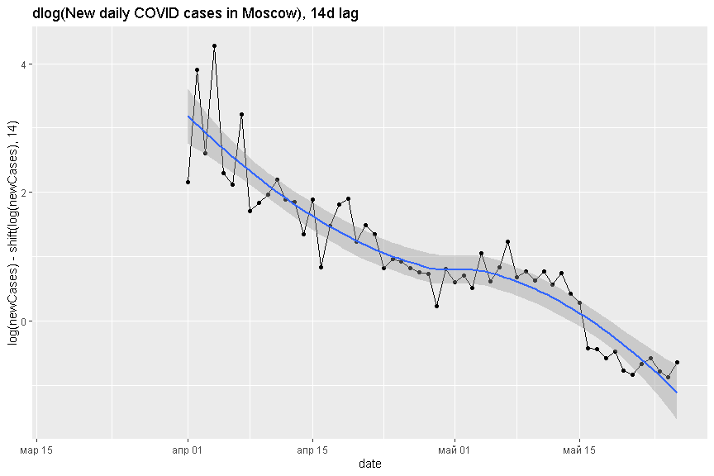

### ARMA errors

## Series: log(d1$newCases)   
## Regression with ARIMA(0,1,0) errors   
##   
## Coefficients:  
## xreg  
## 0.0429  
## s.e. 0.0311  
##   
## sigma^2 estimated as 0.05428: log likelihood=2.59  
## AIC=-1.17 AICc=-0.94 BIC=2.84  
##   
## Training set error measures:  
## ME RMSE MAE MPE MAPE MASE ACF1  
## Training set 8.904142e-05 0.228788 0.1713657 0.03301363 2.268126 0.9640508 -0.3048746

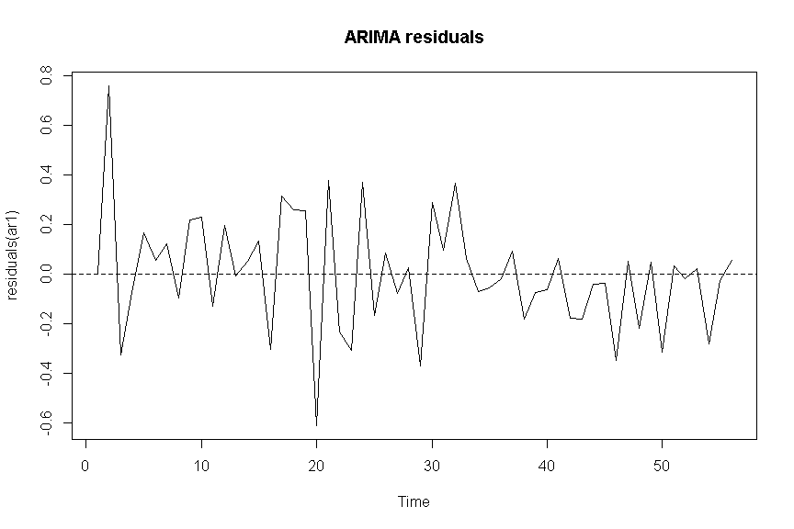

## Apple mobility trends

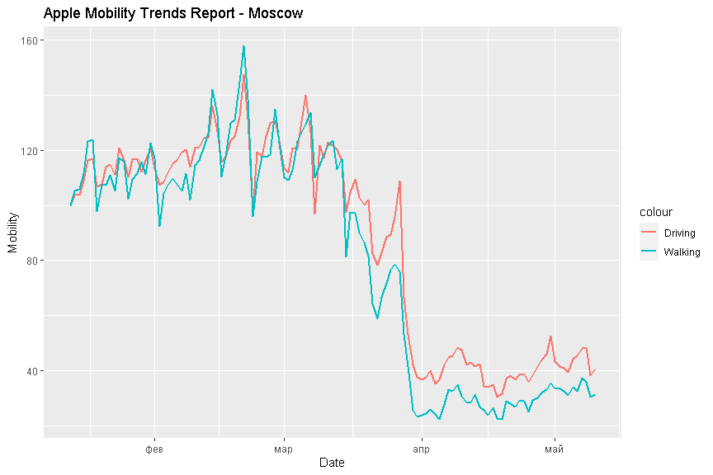

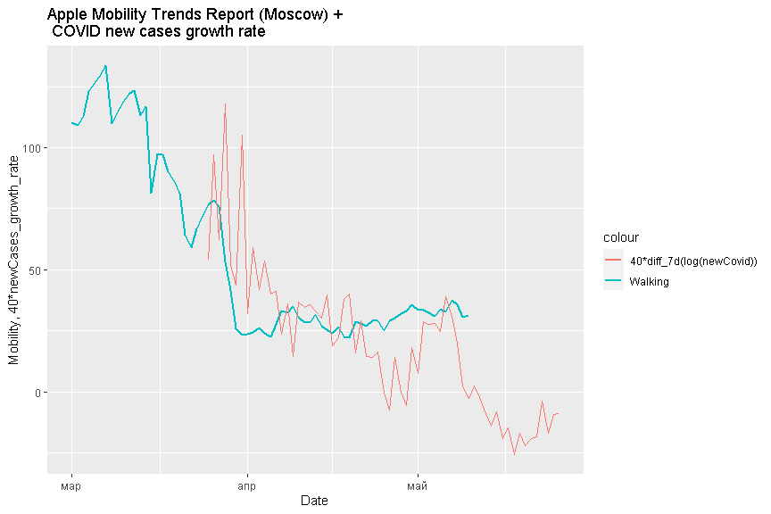

## Rolling sum over 2 weeks (aka active cases)

