Correlations in US Covid daily variables

Q: Каков лаг между кривой выявления новых случаев и кривой смертельных исходов?

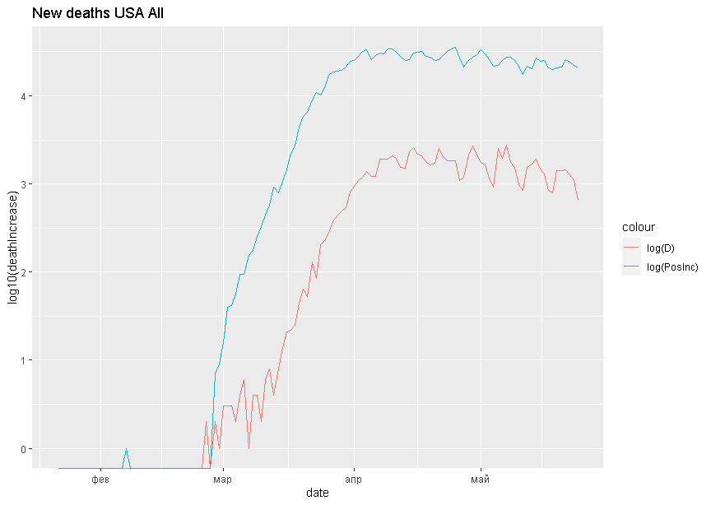

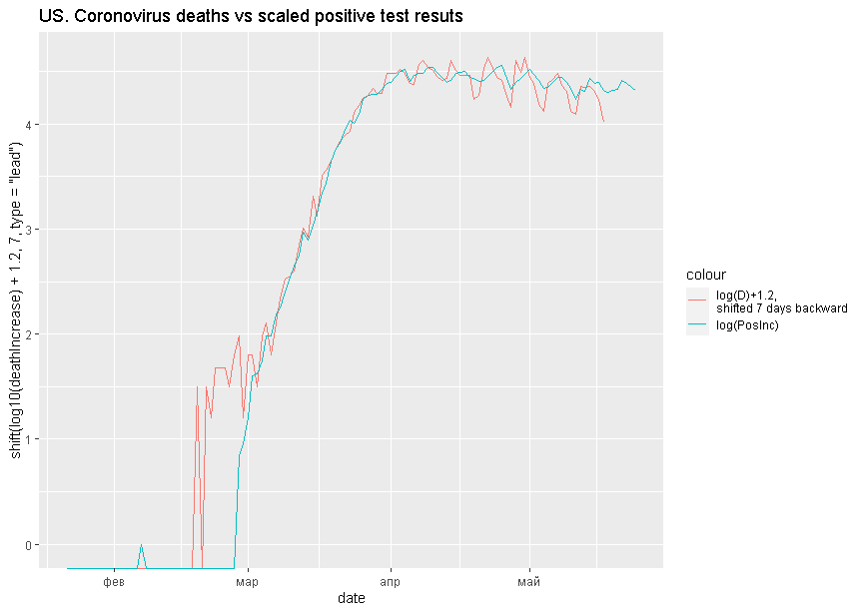

Модель с распределенными лагами и учетом дней недели.

##   
## Call:  
## lm(formula = log(deathIncrease) ~ shift(log(positiveIncrease),   
## 5) + shift(log(positiveIncrease), 7) + shift(log(positiveIncrease),   
## 10) + shift(log(positiveIncrease), 14) + weekday, data = data2)  
##   
## Residuals:  
## Min 1Q Median 3Q Max   
## -0.45891 -0.10596 0.00269 0.09176 0.56159   
##   
## Coefficients:  
## Estimate Std. Error t value Pr(>|t|)   
## (Intercept) -3.17036 0.34069 -9.306 3.03e-13 ***  
## shift(log(positiveIncrease), 5) 0.51126 0.18174 2.813 0.006623 **   
## shift(log(positiveIncrease), 7) 0.59256 0.22456 2.639 0.010586 *   
## shift(log(positiveIncrease), 10) -0.13507 0.18543 -0.728 0.469165   
## shift(log(positiveIncrease), 14) 0.05132 0.08910 0.576 0.566813   
## weekday2 -0.04837 0.08554 -0.566 0.573842   
## weekday3 0.31965 0.09021 3.543 0.000772 ***  
## weekday4 0.21769 0.09969 2.184 0.032915 *   
## weekday5 0.20637 0.11040 1.869 0.066461 .   
## weekday6 0.15389 0.11157 1.379 0.172903   
## weekday7 0.13651 0.09794 1.394 0.168534   
## ---  
## Signif. codes: 0 '***' 0.001 '**' 0.01 '*' 0.05 '.' 0.1 ' ' 1  
##   
## Residual standard error: 0.1904 on 60 degrees of freedom  
## (14 observations deleted due to missingness)  
## Multiple R-squared: 0.9819, Adjusted R-squared: 0.9789   
## F-statistic: 326.2 on 10 and 60 DF, p-value: < 2.2e-16

## Analysis of Variance Table  
##   
## Response: log(deathIncrease)  
## Df Sum Sq Mean Sq F value Pr(>F)   
## shift(log(positiveIncrease), 5) 1 116.253 116.253 3207.9372 < 2.2e-16 ***  
## shift(log(positiveIncrease), 7) 1 0.735 0.735 20.2816 3.141e-05 ***  
## shift(log(positiveIncrease), 10) 1 0.259 0.259 7.1335 0.009723 **   
## shift(log(positiveIncrease), 14) 1 0.232 0.232 6.4009 0.014050 *   
## weekday 6 0.733 0.122 3.3702 0.006264 **   
## Residuals 60 2.174 0.036   
## ---  
## Signif. codes: 0 '***' 0.001 '**' 0.01 '*' 0.05 '.' 0.1 ' ' 1

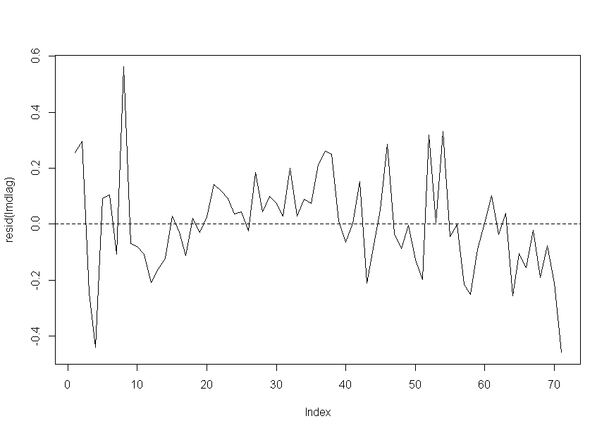

##   
## Call:  
## lm(formula = log(deathIncrease) ~ shift(log(positiveIncrease),   
## 7) + weekday, data = data2)  
##   
## Residuals:  
## Min 1Q Median 3Q Max   
## -0.76502 -0.08908 0.02347 0.09300 1.08042   
##   
## Coefficients:  
## Estimate Std. Error t value Pr(>|t|)   
## (Intercept) -2.30842 0.15244 -15.143 <2e-16 ***  
## shift(log(positiveIncrease), 7) 0.94291 0.01504 62.712 <2e-16 ***  
## weekday2 -0.07563 0.11196 -0.676 0.5016   
## weekday3 0.24232 0.11197 2.164 0.0339 *   
## weekday4 0.25053 0.11202 2.237 0.0285 *   
## weekday5 0.15176 0.11217 1.353 0.1804   
## weekday6 -0.02785 0.11228 -0.248 0.8049   
## weekday7 -0.03265 0.11229 -0.291 0.7721   
## ---  
## Signif. codes: 0 '***' 0.001 '**' 0.01 '*' 0.05 '.' 0.1 ' ' 1  
##   
## Residual standard error: 0.2682 on 70 degrees of freedom  
## (7 observations deleted due to missingness)  
## Multiple R-squared: 0.9828, Adjusted R-squared: 0.9811   
## F-statistic: 571.4 on 7 and 70 DF, p-value: < 2.2e-16

## Analysis of Variance Table  
##   
## Response: log(deathIncrease)  
## Df Sum Sq Mean Sq F value Pr(>F)   
## shift(log(positiveIncrease), 7) 1 286.468 286.468 3982.1829 < 2e-16 ***  
## weekday 6 1.272 0.212 2.9462 0.01272 *   
## Residuals 70 5.036 0.072   
## ---  
## Signif. codes: 0 '***' 0.001 '**' 0.01 '*' 0.05 '.' 0.1 ' ' 1

У остатков есть явная зависимость от времени. 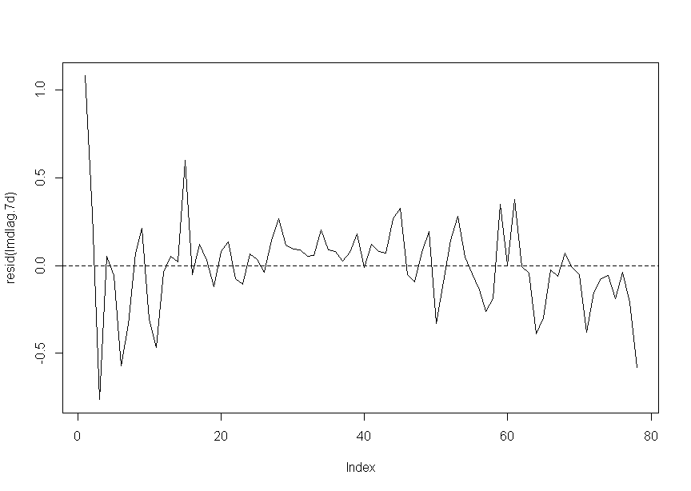 Вывод: DLM предпочитает модель с лагом 5-7 дней, но она описыает взаимное поведение кривых только в нулевом приближении. Со временем зависимость несколько меняется.

Q: Какая доля эффективных тестов (т.е. тестов, выявивших зараженных) от числа проведенных тестов)?

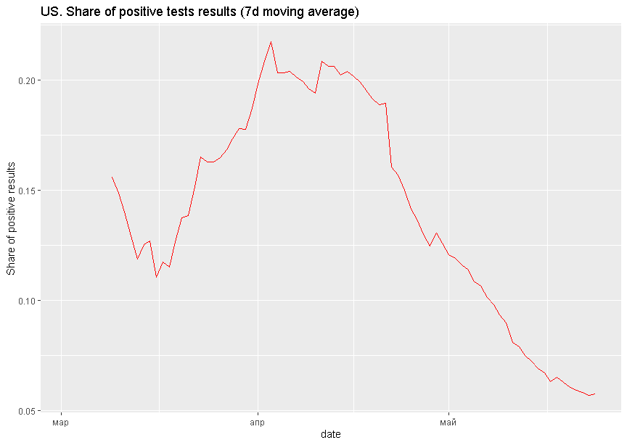

Q: Какая летальность видуса (CFR) в США?

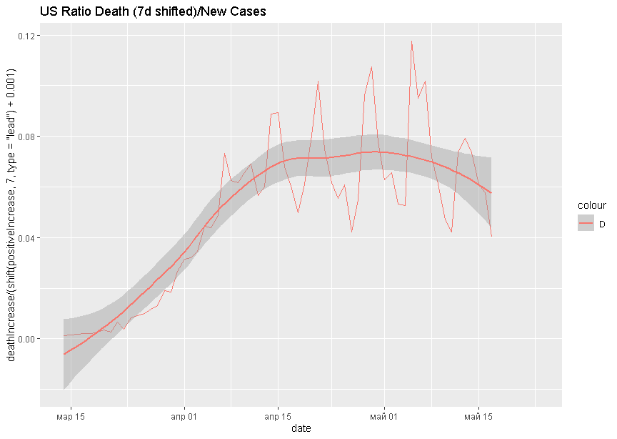 Около 7%.