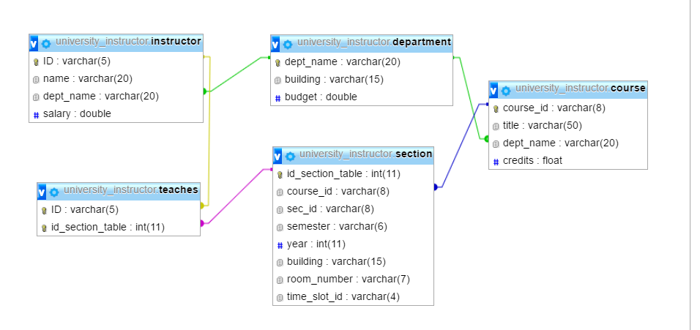

Department course

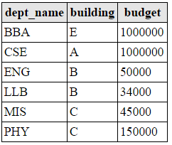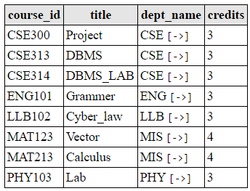

Instructor teaches

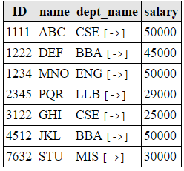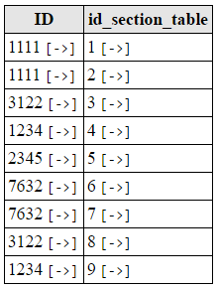

Section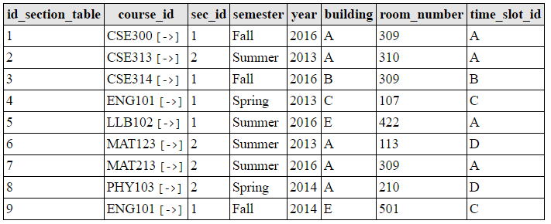

Practice Set 1

* Find out the course ids offered in summer 2016.
* select course_id from section where semester = 'Summer' and year = 2016;
* Find out the departments with budget more than 50000.
* select dept_name from Department where budget > 50000;
* List all the course ids, semester and year taught before spring 2014.
* select course_id,semester,year from section where year < 2014;
* Find out all the courses offered by CSE dept.
* select course_id,title from course where dept_name ='CSE';
* Find the instructor ids, course ids, sections, year and semester of the instructors who teach any course.
* select ID,course_id,sec_id,semester,year from teaches natural join section;
* Find the names of the instructors who teach any course at 2016.
* select name from instructor natural join teaches natural join section where year = 2016;
* List the course ids that are taught by the instructors of MIS dept.
* select course_id from instructor natural join teaches natural join section where dept_name = 'MIS';
* Find out the courses offered by CSE.
* select * from course where dept_name = 'CSE';
* List the departments of A building.
* select dept_name from Department where building = 'A';
* Find the instructors name and id who teaches at room 309.
* select name,ID from instructor natural join teaches natural join section where room_number = 309;
* Find the department names whose courses are held at room 309.
* select dept_name from course natural join section where room_number = 309;
* Find the department names with a “B” in it.
* select dept_name from Department where dept_name like '%B%';
* Find the course ids which has “1” in their 4th character.
* select course_id from Section where course_id like ‘___1%’;
* Order the salaries of the instructors in increasing order.
* select * from instructor order by salary asc ;
* Show the instructor table so that salary is represented as monthly_salary.
* select ID, name, dept_name, salary/12 as montly_salary from instructor;
* If the given salary of the instructors are monthly then show their ‘yearly_salary’.

select ID, name, dept_name, salary*12 as yearly_salary from instructor;

* Find the average budget of the university.
* select avg(budget) from Department;
* Find the maximum salary of all instructors.
* select max(salary) from instructor;
* Show the average salary of all instructors.
* Select avg(salary) from instructor;
* Find the instructors who teaches courses offered by MIS.
* Select ID from instructor natural join teaches natural join course where dept_name=’MIS’;
* Modify the database so that the instructors whose salary is less than 30,000 BDT is increased by 2000 BDT.
* Update instructor set salary= case

When salary<30,000 then salary+2000

Else salary

End;

* Modify the database so that the instructors whose salary is less than 30,000 BDT is increased to 30,000 BDT.
* Update instructor set salary =30,000 where salary<30,000;
* Change all the sections that are for year 2013 to 2014 and 2014 to 2015.
* Update section set year=case

When year=2013 then 2014

When year=2014 then 2015

Else year

End;

* Update the database so that the instructor 7632 does not teach any course.
* Update instructor natural join course
* Insert another 3 credit course with an id BBA213, titled ‘Cost Accounting’ offered by BBA dept.
* Insert into course values(‘BBA-213’,’Cost Accounting’,’BBA’,3);
* The above course is offered for summer 2014 section 1. The classes will be held at E building Room 214 and at time B.
* This course will be taught by instructor 1222.
* Find the names of the departments who offer 3 credit courses.
* Select dept_name from course where credit=3;
* Find the name of the instructor who teaches MAT213 course.
* Select name from instructor natural join course where course_id=’MAT-213’;
* Find the course titles taught by ABC.
* Select course_titlefrom instructor natural join course where name=’ABC’;