Practice Set 3

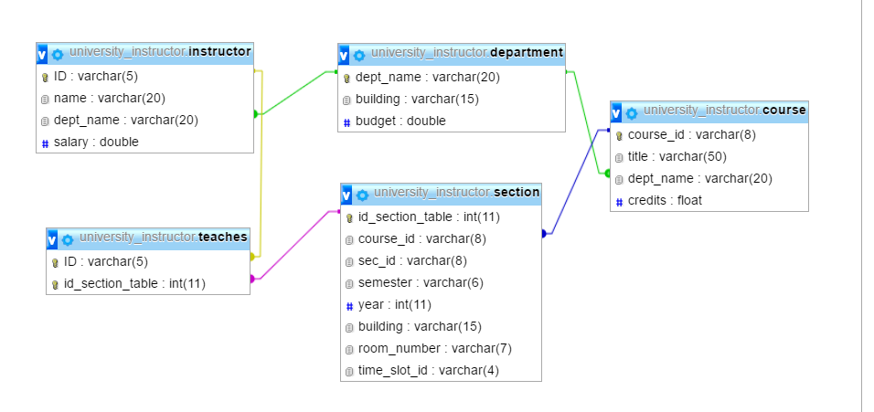

* Modify the database given above like the one given below.

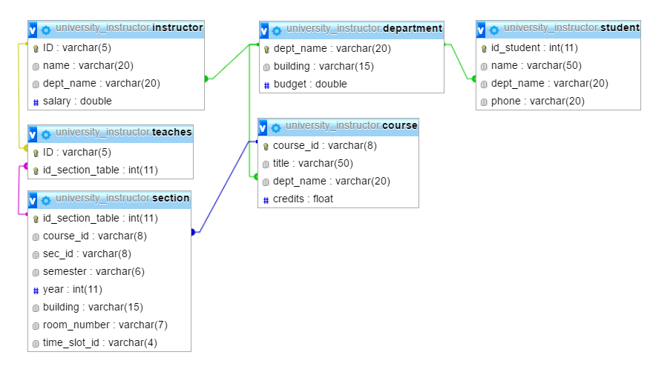

* Insert the data like the table given below.

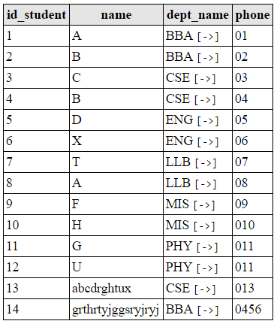

* Modify the previous ++database like the one as below.

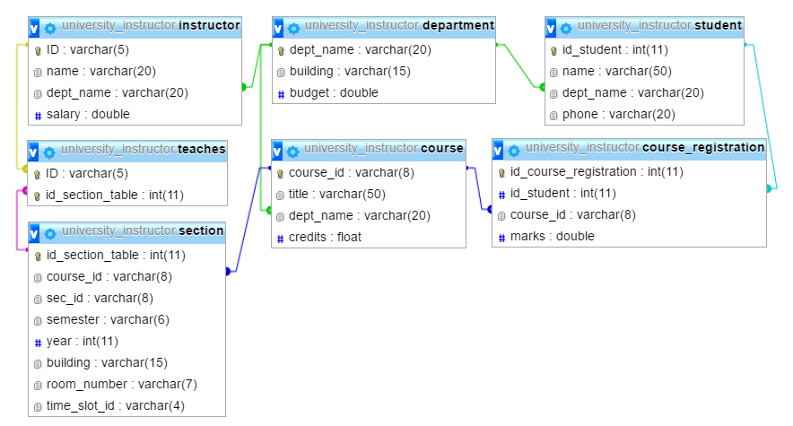

* Insert the data like below

t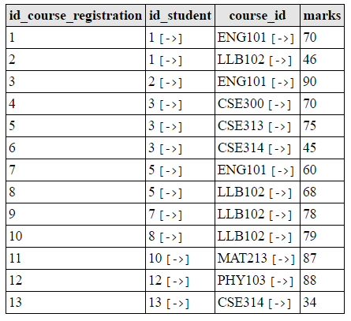

* Find the students who have registered for the courses of CSE department.
  + Select id_student,name from student natural join course_registration

Where course_id like ‘CSE%’;

* Find the courses registered by the students of CSE dept.
  + Select course_id from course natural join course_regisration where dept_name=’CSE’;
* Find the total number of courses registered by each student.
  + Select count(course_id) from course natural join course_registration group by dept_name;
* Find the students who have registered for more than one course.
  + Select * from course_registration natural join student where count(id_course_registration)=1;
* Find the students who haven’t registered yet.
  + Select * from student, course_registration not in (select * from student natural join course_regisration);
* Find the total marks of each student.
  + Select sum(marks) from course_registration group by id_student;
* Find the average marks of each student.
  + Select avg(marks) from course_registration group by id_student;
* Find the average marks of each student of each department.
* Find the student who has obtained the highest average marks.
  + Select max(marks) from course_registration where marks in (select avg(marks) from course_registration);
* Find the student’s name who has registered last.
  + Select * from course_registration where id_course_registration=max( id_course_registration);
* Find the total credits registered by each student.
  + Select sum(credits) from course natural join course_registrtion group by id_student;
* Find the students whose name has more than one letter.
  + Select name from student where not in (select name from student where name like ‘-‘);
* Find the students whose name has a “c” in the 3rd letter.
  + Select name from student where name like ‘—c%’;