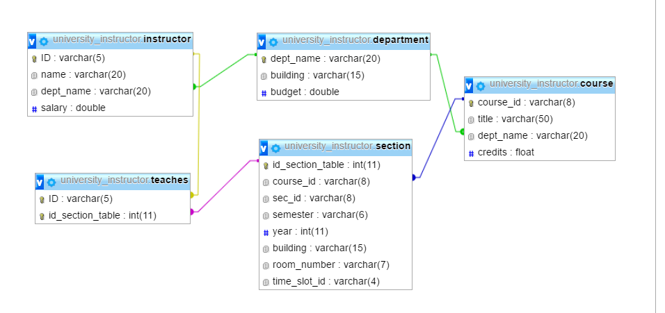

Department course 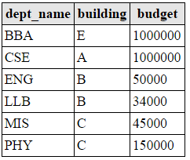 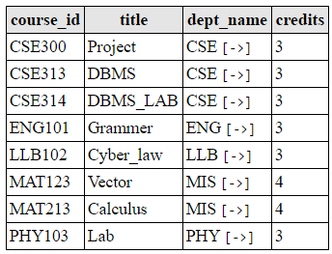

Instructor teaches

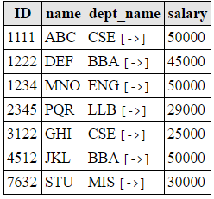 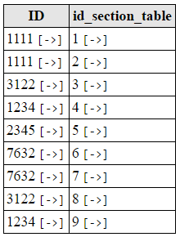

Section 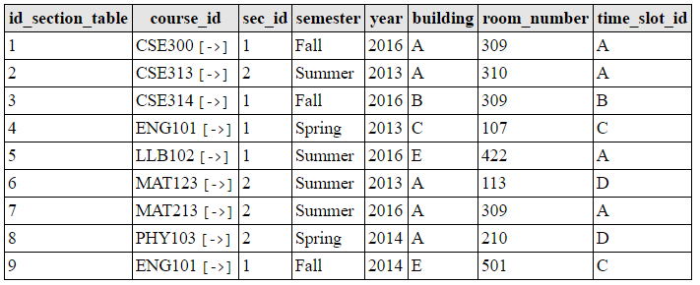

Practice Set 1

* Find out the course ids offered in summer 2016.
* select course_id from section where semester='Summer' and year=2016;
* Find out the departments with budget more than 50000.
* select dept_name,budget from

department where budget>50000;

* List all the course ids, semester and year taught before spring 2014.
* select course_id,semester,year from section where year<2014;
* Find out all the courses offered by CSE dept.
* select course_id from course where dept_name='CSE';
* Find the instructor ids, course ids, sections, year and semester of the instructors who teach any course.
* Select ID,course_id,sec_id,year,semester from (instructor natural join teaches natural join section);
* Find the names of the instructors who teach any course at 2016.
* select name from (instructor natural join teaches natural join
* List the course ids that are taught by the instructors of MIS dept.
* Find out the courses offered by CSE.
* List the departments of A building.
* Find the instructors name and id who teaches at room 309.
* Find the department names whose courses are held at room 309.
* Find the department names with a “B” in it.
* Find the course ids which has “1” in their 4th character.
* Order the salaries of the instructors in increasing order.
* Show the instructor table so that salary is represented as monthly_salary.
* If the given salary of the instructors are monthly then show their ‘yearly_salary’.
* Find the average budget of the university.
* Find the maximum salary of all instructors.
* Show the average salary of all instructors.
* Find the instructors who teaches courses offered by MIS.
* Modify the database so that the instructors whose salary is less than 30,000 BDT is increased by 2000 BDT.
* Modify the database so that the instructors whose salary is less than 30,000 BDT is increased to 30,000 BDT.
* Change all the sections that are for year 2013 to 2014 and 2014 to 2015.
* Update the database so that the instructor 7632 does not teach any course.
* Insert another 3 credit course with an id BBA213, titled ‘Cost Accounting’ offered by BBA dept.
* The above course is offered for summer 2014 section 1. The classes will be held at E building Room 214 and at time B.
* This course will be taught by instructor 1222.
* Find the names of the departments who offer 3 credit courses.
* Find the name of the instructor who teaches MAT213 course.
* Find the course titles taught by ABC.