Depertment Course

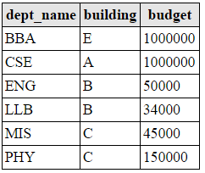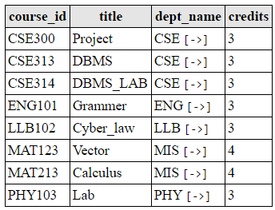

Instructor teaches

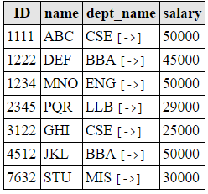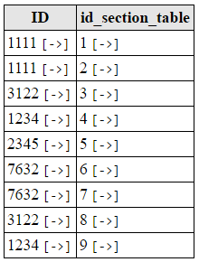

Section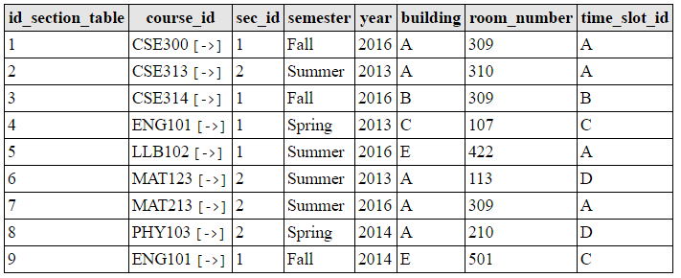

* Find the total number of instructors in the university.
  + select count(ID) from instructor;
* Find the total number of instructors in each department.
  + select count(ID),dept_name from instructor group by dept_name;
* Find the departments which have only one instructor.
  + select dept_name from instructor group by dept_name having count(ID)=1;
* Find the departments which have maximum number of instructors.
  + select dept_name from instructor group by dept_name having count(ID)=(select max(count(ID)) from instructor group by dept_name);
* Find the average salary of all instructors.
  + select avg(salary) from instructor;
* Find the instructors whose salary is more than average salary of all instructors.
  + select * from instructor where salary>(select avg(salary) from instructor);
* Find the average salary of instructors in each department.
  + select avg(salary),dept_name from instructor group by dept_name;
* Find the maximum average salary amongst the average salary of each department.
  + select max(salary) from instructor where salary in(select avg(salary) from instructor group by dept_name);
* Find the minimum average salary amongst the average salary of each department.
  + select min(salary) from instructor where salary in(select avg(salary) from instructor group by dept_name);
* Find the instructors whose salary is greater than the average salary of LLB.
  + select * from instructor where salary>(select avg(salary) from instructor) and dept_name='LLB';
* What is the total credit offered by CSE dept.
  + select sum(credits) from course where dept_name='CSE';
* List the total credits offered by each dept as tot_credit along with the department name.
  + select dept_name,sum(credits) as tot_credit from course group by dept_name;
* List the total number of instructors per department and total salary of those departments.
  + select dept_name,sum(salary),count(ID) from instructor group by dept_name;
* Find the payroll of each department.
  + select sum(salary),dept_name from instructor group by dept_name;
* Find the department that has the maximum payroll.
  + select dept_name from instructor where salary=(select max(salary) from instructor);