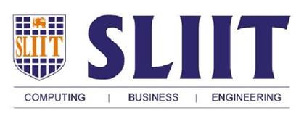

Sri Lanka Institute of Information Technology

**Business case for ESBPII assignment.**

**Chandranath R. D. S. P**

**IT 13 0629 34**

**Weekday - June Intake (Monday Lab)**

**What kind of company DELL is?**

Dell Inc. (stylized as DELL) is an American computer technology company which develops, sells, repairs, make computers and provides computer related products and services. Named after its founder, [Michael Dell](https://en.wikipedia.org/wiki/Michael_Dell), the company is one of the largest technological corporations in the world, employing more than 103,300 people worldwide.

Dell sells [personal computers](https://en.wikipedia.org/wiki/Personal_computer) (PCs), [servers](https://en.wikipedia.org/wiki/Server_(computing)), [data storage devices](https://en.wikipedia.org/wiki/Data_storage_device), [network switches](https://en.wikipedia.org/wiki/Network_switch), [software](https://en.wikipedia.org/wiki/Computer_software), computer [peripherals](https://en.wikipedia.org/wiki/Peripheral), [HDTVs](https://en.wikipedia.org/wiki/HDTV), cameras, printers, MP3 players, and electronics built by other manufacturers. The company is well known for its innovations in supply and [electronic commerce](https://en.wikipedia.org/wiki/Electronic_commerce), particularly its direct-sales model and its "build-to-order" or "configure-to-order" approach to manufacturing, delivering individual PCs configured to customer specifications. Dell was a pure hardware vendor for much of its existence, but with the acquisition in 2009 of [Perot Systems](https://en.wikipedia.org/wiki/Perot_Systems), Dell entered the market for IT related services. Since the company has made additional acquisitions in storage and networking systems, with the aim of expanding their portfolio from offering computers only to delivering complete solutions for enterprise customers.

**Why Information is a valuable asset?**

Since information can make or break the business it is valuable, so the security of information (InfoSec) should be a high priority. When properly managed it allows you to operate with confidence. Information security management gives you the freedom to grow, innovate and broaden your customer-base in the knowledge that all your confidential information will remain that way.

**What is used to keep information safe?**

ISO/IEC 27001 is an internationally recognized best practice framework for an information security management system (ISMS). It belongs to the ISO 27000 series of standards (including ISO 27002 and ISO 27005). It helps you to identify the risks to your important information and put in place the appropriate controls to help reduce the risk.

**Why do we need ISMS?**

Organizations and their information systems and networks are exposed with security threats such as fraud, espionage, fire, flood and sabotage from a wide range of sources. The increasing number of security breaches has led to increasing information security concerns among organizations worldwide. Achieving information security is a huge challenge for organization as it cannot be achieved through technological means alone, and should never be implemented in a way that is either out of line with the organization’s approach to risk or which undermines or creates difficulties for its business operations. Thus there is a need to look at information security from a holistic perspective, and to have an information security management methodology to protect information systematically. This is where the need for ISMS comes in.

**ISO/IEC 27001:2005**

ISO/IEC 27001:2005 is the Requirements for Information Security Management Systems. It specifies the requirements for establishing, implementing, operating, monitoring, reviewing, maintaining and improving a documented ISMS within the context of the organization's overall business risks. The ISMS processes are based on the following PDCA (Plan-Do-Check-Act) model:

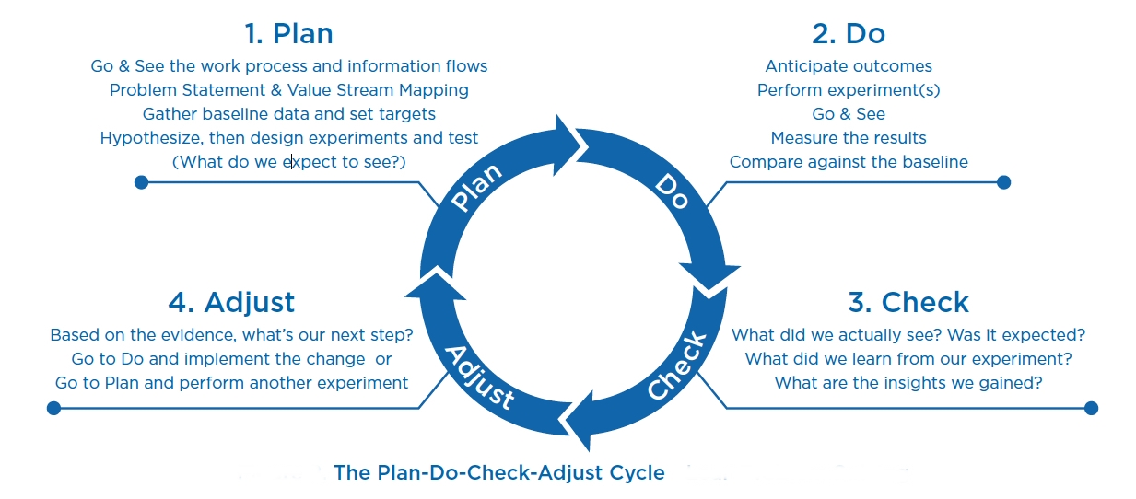

**Advantages if Dell Company is ISMS certified**

Certification of ISMS brings several advantages;

* Provides a structured way of managing information security within the organization
* Profits will be increased due to using ISMS
* Better human relations because of having clear policies and procedures
* Provides evidence and assurance that the organization has complied with the standards requirement.
* Enhance information security governance within the organization.
* Enhance the organization’s global positioning and reputation.
* Increase the level of information security in the organization.
* Because of having a ISMS Dell improved risk management and contingency planning
* Enhanced customer and organization confidence

**ISO27K Costs**

Although it costs organization a large amount of money, it will help the organization to gain best out of the organization profit.