THE IMPACT OF NATURAL DISASTERS AND HUMAN-INSTIGATED DISASTERS UPON UNITED STATES REAL GDP GROWTH

Steven Piano

**Introduction**

What humans have named a “disaster” is something which has been around since the beginning of time and is a very real concept which affects the lives of millions each and every day. A disaster itself is something which causes a serious disruption of the basic functions of a society and can involve many things from economic loss, to environmental loss, to human loss. Disasters are typically characterized in one of two categories: the natural disaster (a natural process or phenomenon which has caused economic, environmental, human and/or material loss), and the human-instigated disaster (composed of a number of things, such as economic crises, terrorist attacks, wars, riots and technological hazards, which have caused economic, environmental, human and/or material loss), both of which come about when a hazard becomes reality thanks to inappropriately managed risk.

The purpose of this paper is to analyze quantitatively the impact which natural disasters and human-instigated disasters have upon United States real GDP growth. The model which will be used to determine the effects which each type of disaster have upon real GDP growth will include variables representing the loss of life, economic loss, and frequency of each type of disaster, along with a variable showing the change in the S&P 500 index. With this goal in mind, it is important that we first take a look at any research and studies which have been performed upon the topic before going into detail about the model and its contents.

**Literature Review**

As previously stated, natural disasters have been occurring since the universe came to be (and therefore obviously before man-made disasters began to occur) and are still happening all over to this day. It is only fair then that we start by looking at natural disasters and what researchers have found are the effects which such things have upon the growth of economies.

A piece of research looking at the effects of natural disasters, the author finds that there are without a doubt notable effects which natural disasters have upon long-run growth (Popp 2006). The author of the paper goes on to state that “The macroeconomic variables that natural disasters affect are technology, human capital accumulation, physical capital accumulation, and the natural resource stock. All four … help increase long run growth.” From this statement it is clear that the author has concluded that there is significant impact from natural disasters upon economic as such disasters affect several different areas instrumental in helping to grow an economy. Since the factors affecting growth are hit by the disaster, one can surmise that GDP growth would be negatively impacted in the very least in the short term. Regarding where or not longer-term growth is positive or negative, the author goes on to say “the net effect… depends on how the recovery progresses after the disaster, where the disaster occurs, and the type of disaster that occurs.”

With the advent of technology that is becoming increasingly effective in doing its job, being easier to use, and acquire/create, the number of man-made or human-instigated disasters has increased exponentially. Therefore, there is likely to be an effect upon the economy thanks to the losses which are realized from such disasters. One of the most infamous examples of a human-instigated disaster, and one that happened only very recently if looking at the history of humankind is the September 11th attacks of 2001.

A paper by a Department of Homeland Security official (a department created as a direct result of the deadly attacks) takes an in-depth look at the macroeconomic impacts of the attacks using real-time forecasting methods (Roberts 2009). The author does so by looking at the effects of the attacks on both US real GDP growth and the unemployment rate and by “… examining how forecasts of these variables were revised after the attack occurred.” By applying this approach of analyzing the effects of the attacks the author of the paper is able to come to the conclusion that a direct result of the attack was the reduction of the real GDP growth in 2001 by 0.5%, along with the increase of the unemployment rate by 0.11% (Roberts 2009). In addition to this, Roberts found that the 9/11 attacks resulted in an immediate revision of the 2001 real GDP growth forecast from 2.7% to 1.2% for the remainder of the year. Although the forecast maintained this low number for the remainder of the year, Roberts notes that the estimate climbed back to pre-9/11 numbers, and the actual real GDP growth rate ended up being 2.4%., close to the original forecasted number. It is interesting to note that Roberts mentions in closing his article that forecasted unemployment rate in 2002 “… unlike real GDP growth, it never subsequently returned to a pre-9/11 level.”

With both of these papers in mind, each one exploring one of the two types of disasters that plague humanity, it would be appropriate to look at a study which attempts to compare the impact on economies that natural and human-instigated disasters with one another.

This paper, written by Yasuyuki Sawada, Rima Bhattacharyay, and Tomoaki Kotera of the Research Institute for Economy, Trade, and Industry (RIETI), documents a quantitative analysis that compares the impacts of various natural and human-instigated disasters (Sawada et al. 2011). Using a variety of pieces of data from the late 1960s to the early 2000s on a number of natural disasters such as geophysical, biological and climatological disasters, along with human-instigated disasters such as wars and economic crises, the authors paint a picture showing just how influential each disaster can be upon the welfare of a country’s citizens. The authors used this data to approximate econometric models which would in turn allow them to compare the impacts of the disasters with each other.

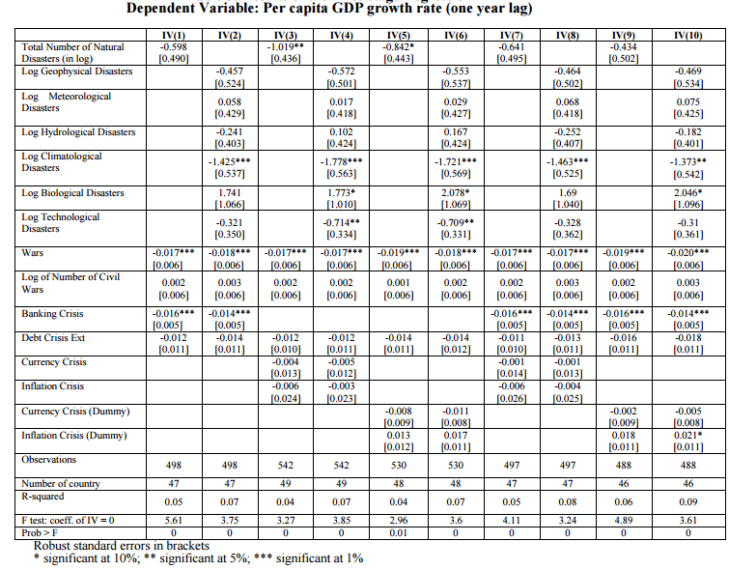

The results of the analysis (shown above) ended up being that, according to the authors’ estimations, in the short term, natural disasters end up causing the largest amount of negative welfare, which is followed by wars and economic crises. These results indicate that both natural and man-made disasters negatively affect per capita GDP growth. Looking more deeply into the data, the authors found that natural disasters decrease the per capita GDP growth rate by 0.012% points per year as the average number of natural disasters is 0.012 per year.

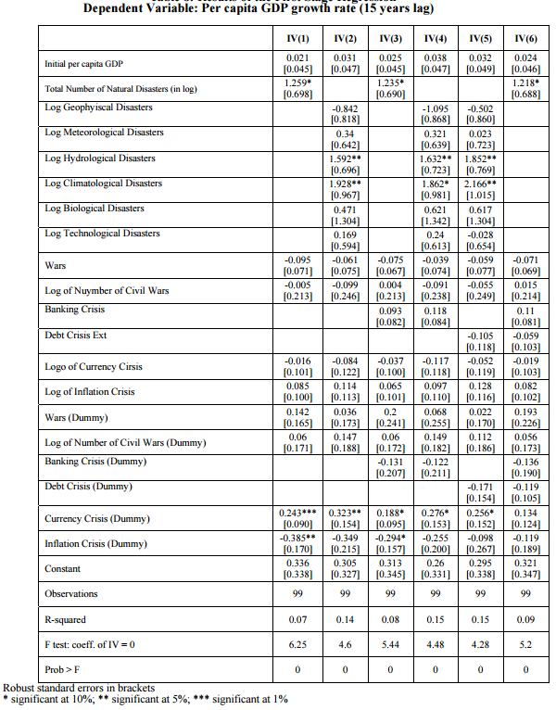

In the long term (results shown above) however, both wars and natural disasters end up having positive impacts on per capita GDP growth despite the negative connotation associated with both, along with the negative coefficients in the short term. It is also interesting to note that although wars and natural disasters end up having positive impacts upon per capita GDP growth over the long run, this is not the case for economic disasters, which have mixed impacts the longer time goes on. The authors likened this to a “Schumpeterian” creative destruction process, which other researchers such as Skidmore and Toya (Skidmore et al. 2002) have noted, in which old economic systems are “revolutionized” from within, removing the old one and replacing it with a new. The authors concluded their paper with the final note that wars “… affect large economies more than small economies while natural disasters affect small economies proportionately (Sawada et al. 2011).”

**Model**

Based on the amalgamation of the research of others provided above, along with my own research into the topic, the following section will outline the model which will attempt to quantify the effect which natural and human-instigated disasters have upon the United States real GDP growth rate. The model which will be used to determine the effects which each type of disaster have upon real GDP growth will include variables representing the loss of life from natural disasters and human-instigated disasters in the US, along with the economic loss (in thousands of dollars) from both natural disasters and human-instigated disasters in the US, the number of both natural disasters and human-instigated disasters in the US, and the change in the S&P 500 year-to-year. The following is the basic model which will be used:

$ln{RGDP}_{i}=β_{0}+ β_{1}{lnNLIFE}_{i}+β_{2}{lnHLIFE}_{i}+β_{3}ln{NECON}_{i}+β_{4}{lnHECON}_{i}+β_{5}{lnNDIS}_{i}+β_{6}{lnHDIS}_{i}+β_{7}{lnSP}_{i}+ε_{i}$

Where *RDGP* is the real GDP growth rate in the US at the end of a given year, *i* is the year, *NLIFE* and *HLIFE* are the loss of life from natural and human-instigated disasters in the US, respectively, *NECON* and *HECON* are the economic loss (in thousands of dollars) from natural and human-instigated disasters in the US, respectively, *NDIS* and *HDIS* are the total number of natural and human-instigated disasters in the US, respectively, *SP* represents the percent gain/loss in the S&P 500 at the end of a given year, and $ε$ is an error term. The years which the data is being pulled from are 1985 to 2010.

The variable representing loss of life is an obvious one to include within the equation, as more dead people means a less productive society. The work force is lowered and possibly loses very skilled individuals, and people who lose friends and family are affected psychologically, with all of these meaning a reflection in the real GDP growth rate may be shown. The amount of economic loss is also another obvious factor which needs to be included, as if disasters cause millions of dollars’ worth of property damage this will lead to funds having to be redirected to rebuild, along with the stoppage of economic activity due to the damage. The numbers of disasters hitting the country are also important, as if there is a high frequency of disasters occurring, this could also affect people psychologically and lead to higher numbers of damage, affecting the economy of any country. Finally, the variable representing the change in the S&P 500 is important as the index is known as a bellwether for the US economy, so it is helpful in creating some variation among the variables.

**Data**

The aforementioned dependent variable in the model, *RGDP* (the real GDP growth rate in the US at the end of the year) is self-explanatory. While this is true for the dependent variable, the other variables within the model, the 7 independent variables, will need to be described in some more detail here.

*NLIFE* and *HLIFE* are the variables representing the loss of life from natural and human-instigated disasters in the US, respectively. The loss of a large amount of human lives will affect many things, not only in an emotional sense for the many people of the country which it happens in, but also economically as parts of the work force are removed and people must take time to recover mentally. With that said, these two variables attempt to show what effect each of them have upon the change in real GDP growth. I would expect each of them to have a negative effect upon the dependent variable, and therefore each to have negative signs, for precisely the reasons I just mentioned.

*NECON* and *HECON* represent the economic loss (in hundreds of thousands of dollars) from natural and human-instigated disasters in the US, respectively. Being that some disasters can completely change the landscape of an area and destroy hundreds of millions of dollars of infrastructure quickly (Hurricane Katrina, 9/11), it is without a doubt important to include this variable as the loss of so much value will affect our dependent variable in some way. For both of the variables I would expect a negative coefficient as major losses such as what happened with Hurricane Katrina would slow down any economy, if only slightly.

*NDIS* and *HDIS* are variables representing the amount, or total number, of natural and human-instigated disasters in the US, respectively. If a country is repeatedly hit by a number of disasters over the course of a year, the mindsets of people might change as they are on edge constantly from them, which would in turn affect their work. As a result, real GDP growth would undoubtedly take a hit as people cannot work as efficiently as before while being stressed. In addition to this, if huge losses are being accrued due to the disasters, this will also effect the economy in a massively negative way, as it has no time to recover in between blows. This being said, I would expect a negative coefficient for both of the variables.

The final variable, *SP*, is one representing the change in the S&P 500 from the first quarter of the year to the last. Being that the S&P 500 is a bellwether for the US economy that shows how well it is faring (and therefore the real GDP growth), this variable is a fair addition to the model to create some variation in the variables all of the others had something to do with the disasters themselves. I would expect a positive coefficient for this variable, as a better performing index means a better performing economy.

**Empirical Findings**

Table 1 shows results of the aforementioned regression equation (1) after being run through STATA using the ordinary least squares (OLS) method with a double-log form. Overall, the regression is shown to be lacking in some areas, as although the R-squared is high at 0.9169, this is mostly from having a large number of independent variables. Despite this, the adjusted R-squared hits a moderate number of 0.6258, showing that a large amount of the data being looked at is still not explained with the variables in the equation. We can see that the estimated coefficients of the independent variables vary in regard to their effect upon the dependent variable. For example, it is interesting to note that only the number of natural disasters (NDIS) has a negative impact on the US real GDP growth rate, while the number of human-instigated disasters (HDIS) actually has a positive impact upon the dependent variable.

Other variables were as expected in regards to the direction of their coefficients, with the number of natural disasters variable (NDIS) being a notable example as the variable boasts the highest negative coefficient of the equation. An important observation to note is that only the variable representing the amount of economic damage caused by human-instigated disasters (HECON) was negative, while the variable denoting the same thing but from natural disasters (NECON) was positive. The variables representing the loss of life from natural and human-instigated disasters (NLIFE and HLIFE, respectively) are important to look at because of the signs of the coefficients. A negative coefficient was expected for both of the variables’ coefficients and both of the variables actually came out with negative coefficients, showing that the variables do indeed negatively impact the dependent variable.

To make sure that the equation which was run did not suffer from the ails of heteroskedasticity or multicollinearity, we performed both the Breusch-Pagan test and the White test on the regression equation results, along with the VIF test and a correlation of the variables. Looking at Tables 2 and 3, we can see that due to the chi-squared statistic being relatively low, the possibility of heteroskedasticity being an issue is ruled out. Tables 4 and 5 show the results regarding testing around multicollinearity. The VIF test shows that overall with a mean VIF of 4.31, the equation does not suffer from multicollinearity, although looking further into the results, HDIS, NECON and HLIFE are quite high, indicating some semblance of multicollinearity, but all three of the variables are important in the equation and therefore need to be kept within it.

While the coefficients of the variables are important to look at in the results, the thing that should stand out about the results are the P-values for the variables: all of the variables are insignificant at the 5% level, meaning that all are not statistically significant from 0. Of the variables, the only two which have reasonably low P-values are *SP* (or S&P 500 gain/loss) and *HECON* (or the economic loss from human-instigated disasters).

In conclusion, several of the variables tested did not result in the expected coefficients hypothesized, and most of the variables tested in the equation were not statistically significant in any way relating to the dependent variable.

**Summary**

In this paper, we compared the impacts of natural and human-instigated disasters upon United States real GDP growth quantitatively. We constructed a panel of data from 1985 to 2010 on a number of natural and human-instigated disasters and focused on three main variables for each: economic loss, human lives lost, and the number of events which happened during the year.

There were a handful of findings from the analysis, with the main finding which emerged from this analysis being that the variables which were tested from natural and human-instigated disasters did not have statistically significant effects upon the real GDP growth of the United States. In spite of this, there were some examples from the results of disasters having an effect on GDP growth. One such of these was that the effects of economic loss from human-instigated disasters upon real GDP growth in the US was negative, which was expected. In contrast, economic loss from natural disasters ended up having a positive, albeit small, impact upon real GDP growth in the US.

In conclusion, this analysis shows that while there are some signs showing a positive relationship between disasters and their effects on real GDP growth in the United States, there is no significant correlation between the two.

**Bibliography**

Popp, Aaron. 2006. *The Effect Of Natural Disasters On Long Run Growth*. University of Northern Iowa. <http://business.uni.edu/web/pages/departments/major-themes-in-economics.cfm>.

Roberts, Bryan W. 2009. *9 The Macroeconomic Impacts Of The 9/11 Attack: Evidence From Real-Time Forecasting*. Department of Homeland Security. <https://www.dhs.gov/sites/default/files/publications/ois_wp_impacts_911.pdf>.

Sawada, Yasuyuki, Rima Bhattacharyay, and Tomoaki Kotera. 2011. *Aggregate Impacts Of Natural And Man-Made Disasters: A Quantitative Comparison*. RIETI Discussion Paper Series 11-E-023. Research Institute for Economy, Trade, and Industry (RIETI). <http://www.rieti.go.jp/jp/publications/dp/11e023.pdf>.

Skidmore, Mark, and Hideki Toya. 2002. "DO NATURAL DISASTERS PROMOTE LONG-RUN GROWTH?". *Economic Inquiry* 40 (4): 664-687. doi:10.1093/ei/40.4.664.

**Tables**

**Table 1: Regression Analysis**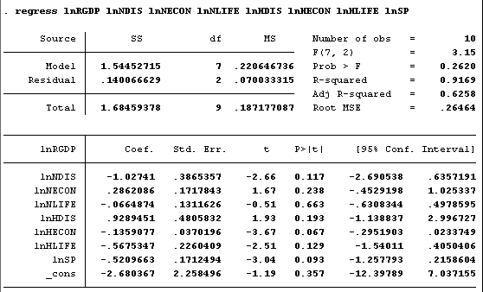

**Table 2: Breusch-Pagan Test of Heteroskedasticity**

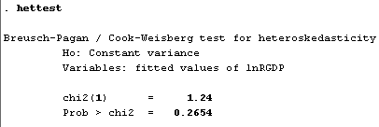

**Table 3: White Test of Heteroskedasticity**

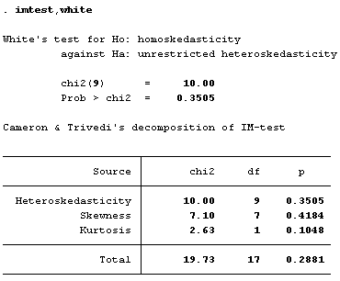

**Table 4: VIF Test of Multicollinearity**

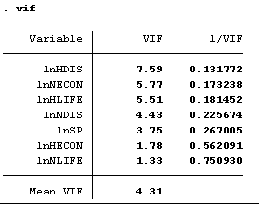

**Table 5: Correlation of Variables**

