Global Pharmacy Sales 2020-2025
Analysis insights, data quality notes and recommended actions

Executive summary
The dataset holds 175,360 clean daily sales records (after removing 2,630 exact duplicates) totalling 78.5 M units and 4,127.7 M in revenue (revenue = units x unit price; the file states no currency). Five findings matter most:
- Demand has been flat at a lower baseline since 2022. Revenue fell 38.3% from 919.5 M (2021) to 567.0 M (2022) when the COVID flag ended, and has stayed within 567-575 M since. The 2022-2025 change is +0.4%.
- Sales are strongly seasonal. In 2022-25, March sells 2.07x the units per record of September, and December-March generates 40.0% of revenue against 24.3% for July-October.
- Stock is thinnest when demand peaks. Average stock is lowest in March-April and highest in September, and records where units sold exceeded stock cluster in March-April (71 and 81) versus 3-7 in August-October.
- The 2020-21 surge exposed supply gaps. 121 of the 128 zero-stock records occurred in the COVID period, when median stock cover was 8.4 versus 14.0 afterwards.
- Product, region and age mix are not levers. Every region, category, medicine and age group sits within roughly 2.5% of an equal share, and country rankings are driven by record counts, not performance.
Top actions: (1) budget on the ~570 M baseline, (2) build stock ahead of January-April using a cover trigger, (3) write a surge playbook from the 2020-21 stock-outs, (4) validate record coverage, pricing and stock data with the data owner before country or pricing decisions.

Scope, approach and assumptions
The requirements file (req.docx) was not received, so this work covers a standard sales-performance scope: KPI dashboard, trend and seasonality, geography, product and age mix, COVID impact, and inventory and expiry. Each choice below was made by me and not specified by you; please confirm or correct them.
Topic | Assumption or decision
Revenue | Derived as units_sold x unit_price per record; no revenue, cost or margin field exists. Currency is not stated, so figures are in currency units and no profitability analysis is possible.
Duplicates | 2,630 exact duplicate rows (the same date, country, medicine and age group repeated) were removed; none remain after removal on that four-field key.
Outliers | 661 records above 3,000 units (0.38% of records, 3.5% of units) were kept; they cluster in 2020-21 and look like genuine surge sales. The dashboard reports them separately.
COVID period | covid_flag is 1 for every record from 2020-01-01 to 2021-12-31 and 0 afterwards, so I treat it as a period label, not a measured infection indicator.
Stock cover | Stock level divided by units sold in the same record. It is a ratio, not calendar days of supply. Low cover means below 5x.
Near-expiry | Records with 90 days or fewer to expiry.
Averages | Because records are not evenly spread across countries, comparisons use average units or revenue per record alongside totals.
Age groups | Bands 46-65 and 65+ overlap at 65 in the source; used as provided.

Key findings

1. Demand stepped down 38% in 2022 and has not recovered
Finding. Revenue was 922.8 M in 2020 and 919.5 M in 2021, then 567.0 M, 575.2 M, 574.0 M and 569.3 M in 2022-2025. Average units per record fell from 597.8 in the COVID period to 372.8 afterwards (the COVID uplift was +60.3%). Average unit price barely moved (52.25-52.80 by year), so the change is volume.
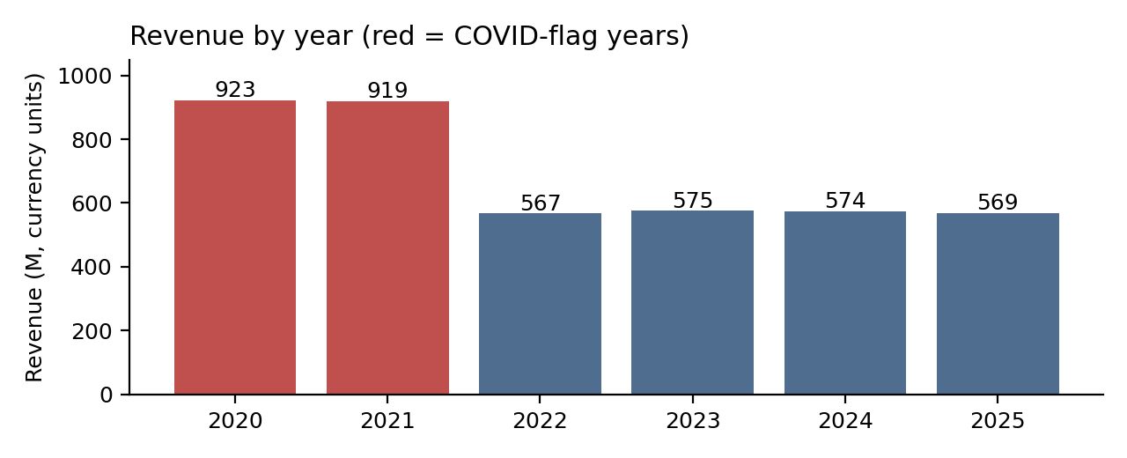
Figure 1. Revenue by year (supports Page 1: P1-V2 and P1-K5; Page 2: P2-V4)
So what. The 2020-21 level is not a baseline to plan against. Since 2022 there has been no organic growth: year-on-year moves are between -0.8% and +1.4%.
Action. Set targets and capacity on the ~570 M run rate, and identify growth levers outside the current mix.
Evidence. P1-K5, P1-K6, P2-V4, P5-K1 to K3.

2. Strong seasonality: December to April is the demand season
Finding. In 2022-25 average units per record peak at 503.6 in March and bottom at 243.5 in September, a ratio of 2.07x. December-March accounts for 40.0% of revenue versus 24.3% for July-October (both four-month windows). The same shape appears in 2020-21 at a higher level.
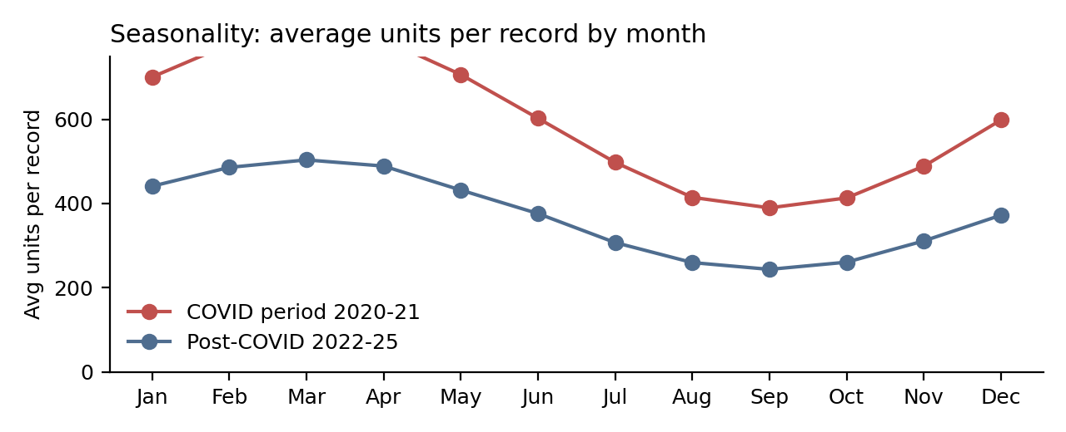
Figure 2. Average units per record by month (supports P1-V4, P2-V2, P2-V5)
So what. Revenue is concentrated in a few months, so a delay or stock gap in Q1 costs far more than the same problem in Q3.
Action. Plan staffing, promotions and replenishment around December-April, and use the Seasonality Index (P2-V5) as the planning calendar.

3. Stock is lowest exactly when demand peaks
Finding. Post-COVID, average stock falls from 4,757 in September to 4,499 in March, while units per record rise from 244 to 504. Units and stock are strongly negatively correlated (-0.91 in 2022-25, -0.95 in 2020-21). Records where units sold exceeded stock number 71 in March and 81 in April, against 7, 7 and 3 in August-October. Across all years, 967 records (0.55%) were oversold.
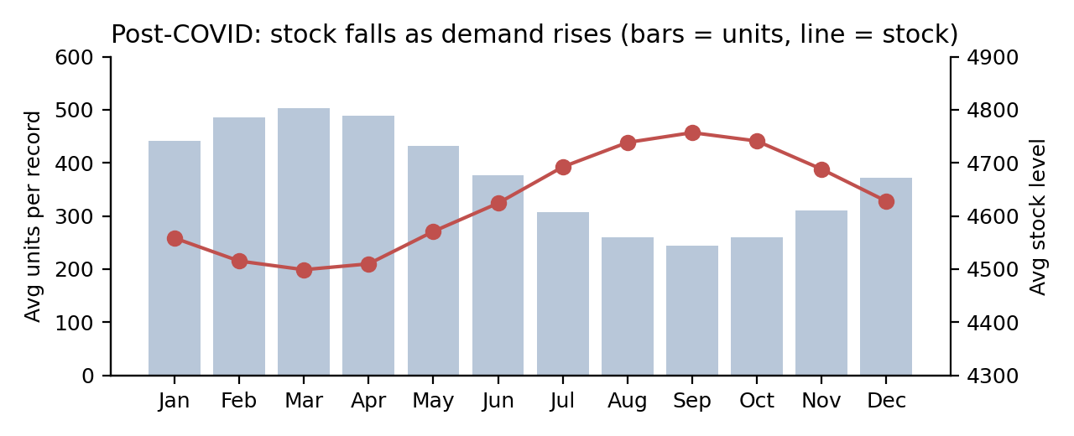
Figure 3. Post-COVID demand versus average stock (supports P6-V1 and P6-V2)
So what. Replenishment does not appear to anticipate the seasonal peak, which puts the highest-revenue months at the greatest stock risk.
Action. Raise stock targets from November and trigger reorders when stock cover falls below 5x. Caveat: a correlation this tight looks partly mechanical, so confirm how stock_level is recorded before sizing the change (see data quality).

4. The 2020-21 surge exposed supply gaps
Finding. The COVID period contains 121 of the 128 zero-stock records and 538 oversold records (0.92% of its records) versus 429 afterwards (0.37%). Low-cover records (below 5x) were 13.0% of records versus 1.4% afterwards, and median stock cover was 8.4 versus 14.0. High-volume records (above 3,000 units) numbered 423 versus 238 and made up 5.4% of units versus 2.0%.
So what. When demand jumped 60%, stock did not keep pace. Another shock of that scale would hit the same way.
Action. Write a surge playbook: a safety-stock rule tied to cover, a watch-list for records above 3,000 units, and pre-agreed emergency sourcing.
Evidence. P5-K1 to K6, P5-V5, P6-K3 to K5, P6-V2.

5. Mix is balanced, so it is not where the opportunity is
Finding. Revenue shares sit in narrow bands: regions 12.4-12.6%, categories 19.9-20.1%, medicines 9.9-10.1%, age groups 19.8-20.3%. The largest gap between best and worst is 2.5% (age groups) and 2.1% (medicines). The COVID uplift is also uniform: every category rose 59-62%, and every region 59-63%.
So what. No product, region or age group is under-performing enough to justify reallocation, and no single product creates concentration risk.
Action. Focus on timing (finding 2) and stock (findings 3-4) instead of mix shifts. Evidence: P1-V3, P3-V1, P4-V1 to V5.

6. Country totals reflect record coverage, not performance
Finding. Ten countries have about 10,750-11,200 records each and nine have about 7,150-7,450. Brazil leads on revenue (264.0 M, 6.4%) and India is last (167.0 M, 4.0%), yet revenue per record differs by only 2.9% across all 19 countries (23,192 to 23,869; Brazil 23,653, India 23,289).
So what. Ranking countries on total revenue would wrongly penalise the nine lower-coverage countries.
Action. Compare countries on revenue per record (P3-V3, not P3-V2) and ask the data owner whether the nine countries have partial coverage.

7. Price is flat and unrelated to volume; expiry risk is structural
Finding. Weighted average price is 52.56. Price and units are uncorrelated (r = 0.0003), and every medicine spans the full 5-100 range with a mean of 51.9-52.9. Separately, 15,834 records (9.0%) have 90 days or fewer to expiry, carrying 371.6 M of revenue (9.0%). The share is 9.0% in both periods and is spread evenly across categories (3,129-3,204 records each).
So what. There is no evidence on price sensitivity from this data, and near-expiry exposure is a standing issue, not a seasonal or category one.
Action. Do not make pricing decisions from this field until validated. Apply a first-expiry-first-out rule across all categories and track Near-Expiry % (P1-K8, P6-V3).

Data quality issues and limitations
Issue | Detail and handling
Missing requirements | req.docx was not received; scope and definitions are my assumptions (above).
Duplicates | 2,630 exact duplicates removed (1.5% of rows). Totals would otherwise be overstated by about 1.5%.
Partial coverage | Each day holds about 81 records out of 950 possible country x medicine x age combinations, so totals are sums of the records present, not complete market sales. Country record counts differ (7.2-11.2 k).
No currency, cost or margin | Revenue is in unspecified units; profitability cannot be assessed.
Price field | Every medicine spans 5-100 with near-identical means, which is unusual for real pharmacy prices. Treat price insights with caution.
Stock field | Stock is near-perfectly inverse to units sold (r about -0.9). This may be an artefact of how it is recorded. Zero-stock rows (128) are kept as reported.
COVID flag | A clean step on 1 Jan 2022, not a gradual wave; it cannot separate COVID effects from anything else that changed at the year boundary.
Outliers | 661 records above 3,000 units kept; removing them would lower units by 3.5%.
Age bands | 46-65 and 65+ overlap at age 65.

Recommended actions
# | Action | Why | Supporting visual
1 | Budget and capacity on the ~570 M post-2022 baseline | Revenue flat within +/-1.4% since 2022 | P1-V2, P2-V4
2 | Build stock before Dec-Apr; reorder when cover falls below 5x | Peak months have the lowest stock and most oversold records | P6-V1, P6-V2
3 | Write a surge playbook (safety stock, high-volume watch-list) | 2020-21: 121 of 128 stock-outs | P5-V5, P6-K3
4 | Validate coverage, price and stock fields with the data owner | Findings 3, 6 and 7 rest on fields with caveats | P3-V3, P7-V1
5 | Apply first-expiry-first-out across all categories | 9.0% of records near expiry in every category | P6-V3, P1-K8
6 | Do not reallocate by region, category or age | All within ~2.5% of an equal share | P3-V1, P4-V1 to V5

