Ice Cream Sales 2024
Executive summary: what the data says and what to do about it
Scope: 1,000 transactions, 1 Jan - 31 Dec 2024, 4 cities (Mumbai, Pune, Delhi, Bengaluru), 6 flavours, 3 channels. All values in INR. Companion workbook: Ice_Cream_Sales_2024_Analysis.xlsx (pivot references in brackets, e.g. [PT1]).

1. The bottom line
The business is healthy at the unit level but fragile in its calendar and geography. It earned Rs 77.89 lakh revenue and Rs 34.97 lakh profit (44.9% margin), and every flavour clears a 43-46% margin. The risk is not margin; it is that results hinge on (a) four hot months, (b) one city and (c) two volume flavours. Growth will come from raising order size outside the peak, earning more per scoop on the biggest flavours, and closing a few clear city, flavour and channel gaps. Together these levers are worth roughly Rs 3.03 lakh of extra profit (about 9% of 2024 profit) on illustrative assumptions set out in section 4.
Revenue | Profit | Margin | Units sold | Avg units / order
Rs 7,789,500 | Rs 3,497,485 | 44.9% | 79,453 | 79.5

2. Five problems the data exposes
Each problem is framed as: what we see, why it happens, what to do, and how to know it worked.

Problem 1 - Revenue depends on four months
- What we see: Mar-Jun delivers 51.7% of annual revenue (Rs 4,028,820). April alone is Rs 1,337,740, 5.2x the weakest month, November (Rs 258,190). Q2 = 40.5% of the year, Q4 = 15.1%. [PT1]
- Why it matters: Stock, freezers, staff and delivery capacity have to be sized for the peak and sit under-used for the other eight months; one bad summer (late monsoon, heat-wave gap) would hit the whole year.
- What to do: Lock peak-season stock and capacity by early February; use temperature forecasts to set weekly production; pre-sell and pre-book institutional and event orders for Mar-Jun.
- Measure: share of revenue earned outside Mar-Jun (now 48.3%); stock-outs and wastage in April.
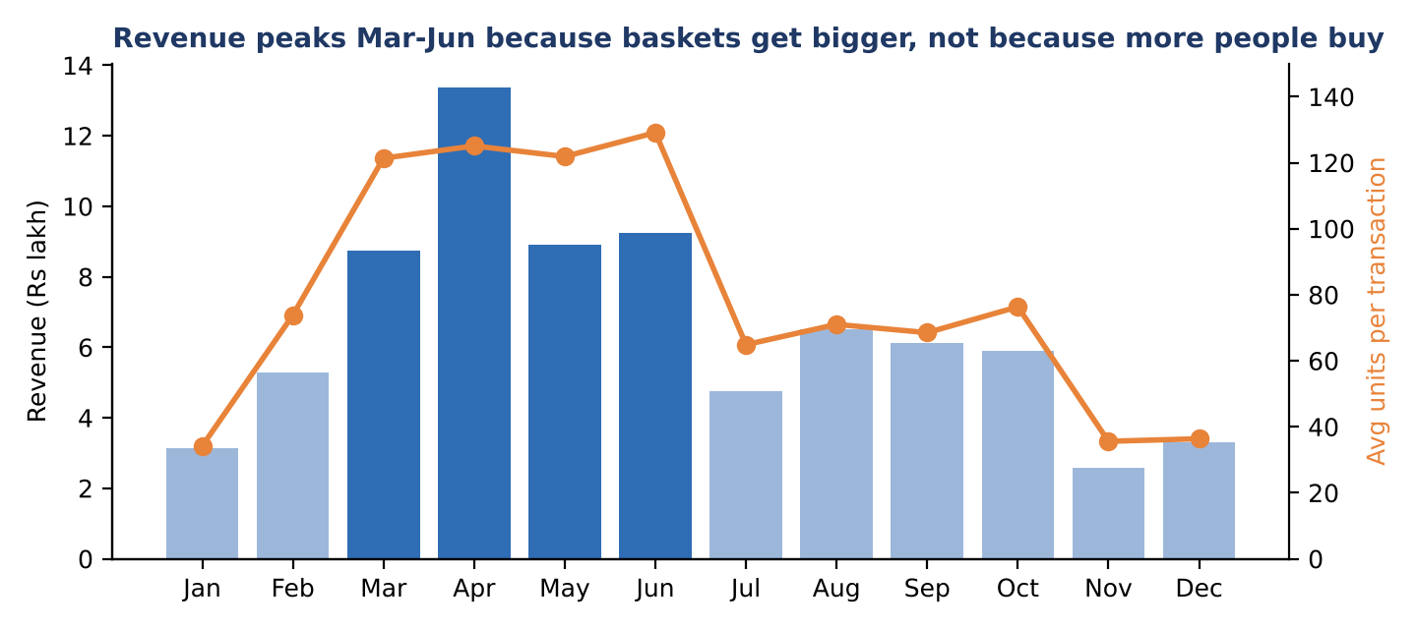
Figure 1. Monthly revenue (bars, dark = peak months) against average units per transaction (line). Source: PT1.

Problem 2 - Off-season baskets collapse, customers do not
- What we see: Transactions per month stay in a narrow band (72-107) all year, but units per transaction swing from 34 in January to 129 in June. Orders on very hot days (36C or above) average 126 units against 35 on cool days (24C or below), and temperature correlates 0.68 with units. [PT1, PT8]
- Why it matters: People still buy in Jan, Nov and Dec; they buy less each time. Those three months total only Rs 9.03 lakh (11.6% of revenue), so each extra unit per order there is cheap growth with no new customers needed.
- What to do: Introduce multi-packs, family tubs, "buy 3" bundles and winter-friendly flavours (Kesar Pista, Butterscotch) as a cool-weather range; trigger offers automatically when forecast temperature falls below about 25C; push delivery bundles for evenings and weekends.
- Measure: average units per order in Jan/Nov/Dec (target 45+ from about 35).
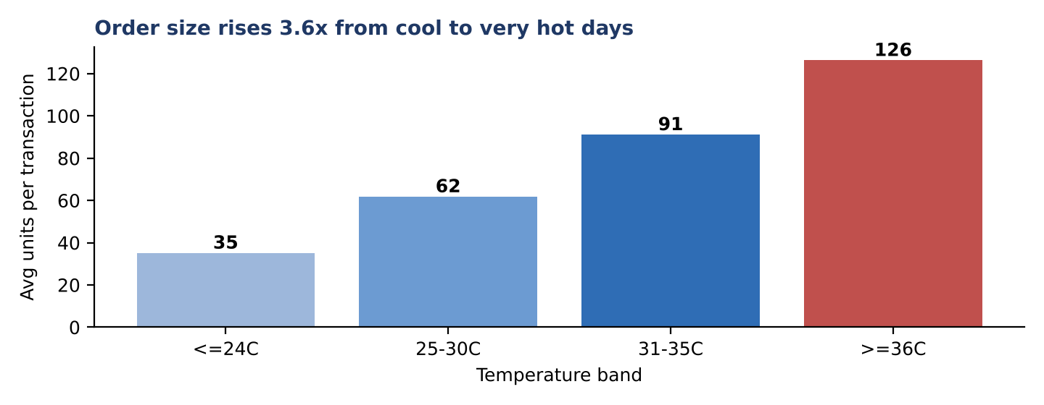
Figure 2. Average units per transaction by temperature band. Source: PT8. Temperature is the same in every city within a month, so it acts as a seasonal proxy.

Problem 3 - The best sellers earn the least per scoop
- What we see: Chocolate and Vanilla are 49.2% of units and 45.2% of revenue. Vanilla sells almost as much as Chocolate (19,444 vs 19,620 units) but earns Rs 35 per unit against Rs 45. Kesar Pista sells the second-fewest units (8,049) yet earns the most per unit (Rs 60) and out-earns Butterscotch in profit. Butterscotch is last on revenue (Rs 8.29 lakh, 10.6%). [PT2, PT3]
- Why it matters: Because margins sit in a tight 43.8-46.2% band, profit follows volume x price. The cheapest, highest-volume flavour is where a small price move matters most; the premium flavours are where each extra sale is worth most.
- What to do: Test a Rs 5 increase on Vanilla in one city (volume held flat, worth about Rs 97,220 a year); feature Kesar Pista and Mango in peak-season menus and bundle them with Chocolate and Vanilla; review whether Butterscotch needs a relaunch or a smaller menu slot.
- Measure: Vanilla volume change after the price test (stop if volume falls more than about 5%); share of profit from Kesar Pista and Mango.
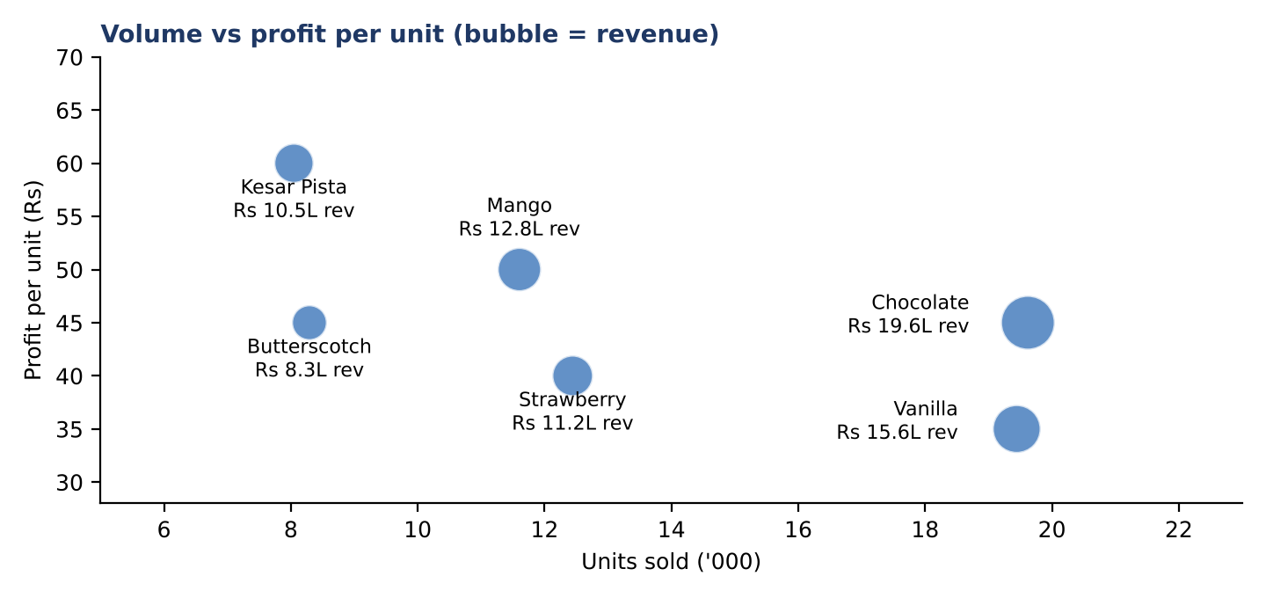
Figure 3. Units sold against profit per unit; bubble size is revenue. Source: PT2, PT3.

Problem 4 - One city carries a third of the business, and city-flavour gaps are uneven
- What we see: Mumbai = Rs 2,612,250 (33.5% of revenue) and is 41% ahead of Pune; Delhi and Bengaluru each contribute about 21%. Mumbai wins on transaction count (342 of 1,000), not basket size; Delhi has the largest baskets (82 units vs 78). [PT4]
- Gaps: Pune sells 36% less Kesar Pista than Delhi (Rs 171,860 vs Rs 266,890); Delhi sells 55% more Strawberry than Bengaluru (Rs 288,720 vs Rs 186,840); Delhi Butterscotch is the weakest city-flavour cell (Rs 149,400). [PT5]
- Why it matters: A Mumbai-specific shock (a supply disruption, a weak summer, a competitor) would move the whole company. The gaps show where distribution or listing, not demand, may be holding sales back.
- What to do: Set Delhi and Bengaluru growth targets and copy Mumbai's outlet density; check availability and listing for Kesar Pista in Pune and Butterscotch in Delhi before assuming it is taste; replicate Delhi's Strawberry execution in Bengaluru.
- Measure: Mumbai share of revenue (target below 30% within 12 months, by growth elsewhere rather than shrinkage); gap to best-peer city per flavour.
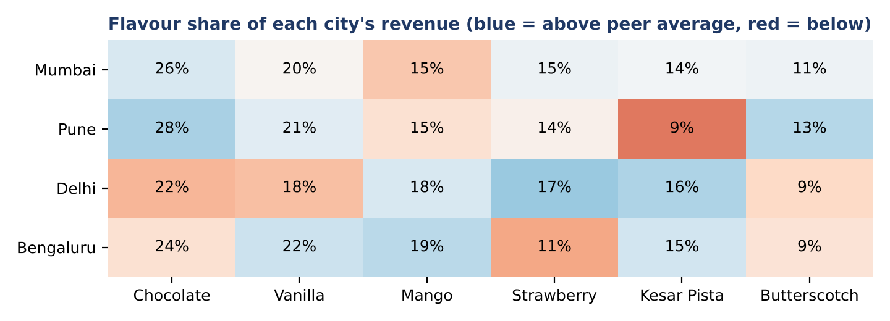
Figure 4. Each flavour as a share of its city's revenue. Source: PT5.

Problem 5 - Online Delivery lost share through the year
- What we see: In-Store 49.4%, Online Delivery 37.3%, Kiosk 13.3% of revenue. Online share fell from 40.3% in Q2 to 32.9% in Q4 while In-Store rose to 54.3%. Delhi is the most online-led city (39.4% of its revenue). Kiosks bring only 13% from 136 transactions. [PT6, PT7]
- Why it matters: Had online held its Q2 share in H2, it would have added about Rs 180,461 of revenue. The cause is unknown from this data: cool weather, fewer promotions, delivery coverage or aggregator ranking are all possible.
- What to do: Investigate the H2 decline (order funnel, delivery times, promotions, app rankings); run a cool-season delivery bundle; review kiosk locations and hours given their small share.
- Measure: online share by quarter (target 38%+ in Q3/Q4); orders per delivery zone.
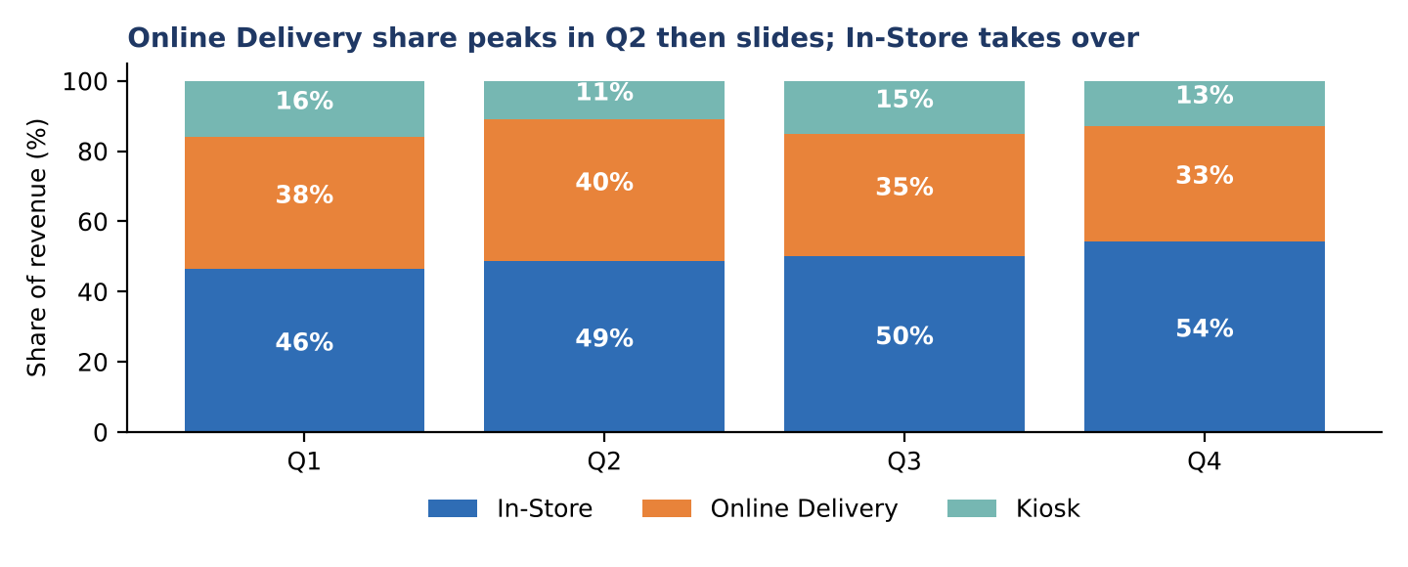
Figure 5. Revenue mix by channel and quarter. Source: PT7.

3. Action plan
Priority | Action | Impact | When
1 | Plan peak capacity and stock from forecasts; pre-book bulk orders | Protects 52% of revenue; cuts stock-outs | By early Feb
2 | Off-season multi-packs and bundles; temperature-triggered offers | Lifts Jan/Nov/Dec baskets | Before Oct
3 | Vanilla +Rs 5 test; premium flavour push | Higher profit per unit | Q1 test, roll out by Q2
4 | Close Pune Kesar Pista, Delhi Butterscotch and Bengaluru Strawberry gaps | Mix and distribution gains | Next 2 quarters
5 | Diagnose and fix the H2 online decline | Recovers online share | Next quarter
6 | Reduce Mumbai dependence via Delhi/Bengaluru targets | Lower concentration risk | 12 months
7 | Capture delivery fees, commissions and kiosk rent in the data | True channel profit | Immediately

4. How big is the prize? (illustrative, not a forecast)
Lever | Assumption | Extra profit
Off-season baskets | Jan, Nov, Dec revenue (Rs 9.03 lakh) up 20% at the 44.9% margin | Rs 81,068
Vanilla price | +Rs 5 per unit, volume unchanged | Rs 97,220
Pune Kesar Pista | Brought to Delhi's level at Rs 60 profit per unit | Rs 43,860
Online share recovery | H2 online share held at the Q2 level (40.3%) at the 44.9% margin | Rs 81,027
Total |  | Rs 303,175 (about 9% of 2024 profit)

The levers are not guaranteed and may overlap; price elasticity and the cost of promotions are not in the data, so test small before scaling.

5. Data notes and caveats
- Data quality is high: no blanks or duplicate rows; revenue, cost and profit reconcile on all 1,000 rows; one price and cost per flavour; no outliers. Dates were stored as text and were converted in a separate Clean_Data sheet; your original sheets are unchanged.
- 30 combinations of date, city, flavour and channel repeat with different quantities; they were treated as separate sales. Only 336 of 366 days have records, so this looks like a sample of transactions and absolute totals may understate the business; the percentages and patterns are the reliable part.
- Costs are product cost only. Delivery fees, aggregator commissions, kiosk rent and labour are missing, so channel profitability, especially Online Delivery, is overstated.
- Temperature is identical across cities in any given month, so it is a seasonal proxy rather than a local weather reading. The relationship with demand is strong but not proof that temperature alone causes it.
- Findings describe 2024 only. A second year of data would confirm whether this seasonality and the H2 online decline are structural.

