分散式演算法HW3 報告

資工所 0656017 顏義洋

(a)

$ ./HW3a.py < test1.txt | sort | uniq -c

472 [0, 3, 4, 5, 7, 8]

528 [1, 4, 5, 7, 8, 9]

$ ./HW3a.py < test1.txt | sort | uniq -c

508 [0, 3, 4, 5, 7, 8]

492 [1, 4, 5, 7, 8, 9]

$ ./HW3a.py < test1.txt | sort | uniq -c

501 [0, 3, 4, 5, 7, 8]

499 [1, 4, 5, 7, 8, 9]

$ ./HW3a.py < test2.txt | sort | uniq -c

1000 [4, 5, 6, 8]

According to the test, test1.txt will generate 2 correct MWIS with 50% for each, test2.txt will generate 1 correct MWIS with 100% probability.

(b)

$ ./HW3b.py < test1.txt | sort | uniq -c

494 [0, 3, 4, 5, 7, 8]

506 [1, 4, 5, 7, 8, 9]

$ ./HW3b.py < test1.txt | sort | uniq -c

509 [0, 3, 4, 5, 7, 8]

491 [1, 4, 5, 7, 8, 9]

$ ./HW3b.py < test1.txt | sort | uniq -c

519 [0, 3, 4, 5, 7, 8]

481 [1, 4, 5, 7, 8, 9]

$ ./HW3b.py < test2.txt | sort | uniq -c

1000 [4, 5, 6, 8]

According to the test, test1.txt will generate 2 correct MWIS with 50% for each, test2.txt will generate 1 correct MWIS with 100% probability, the result isn't affected by probability p.

(c)

Test1.txt

Averaged total weight

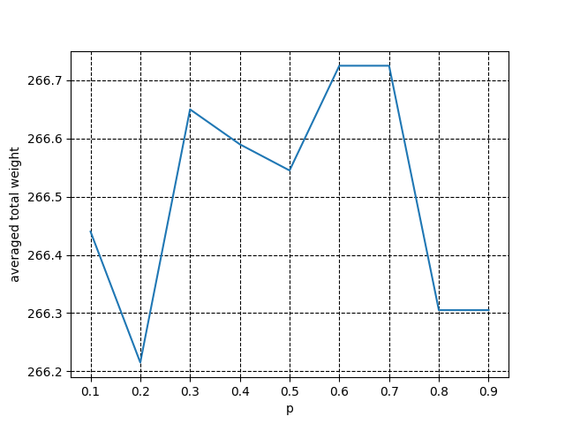

Averaged convergence time

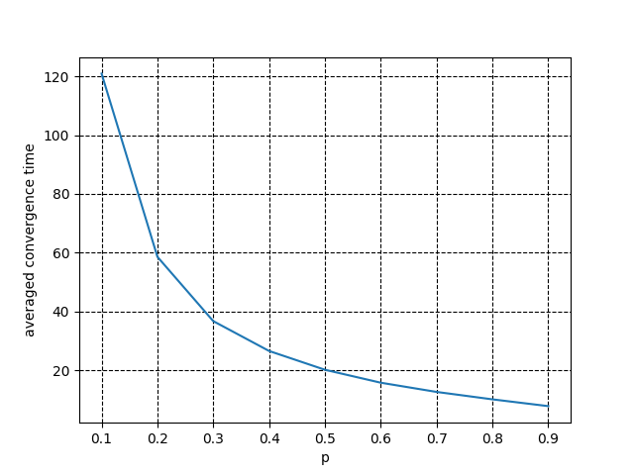

Test2.txt

Averaged total weight

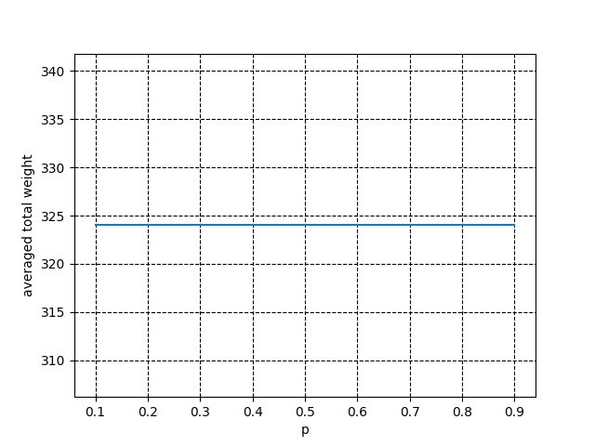

Averaged convergence time

